光學參數整理

1. skin

* Absorption coefficient:

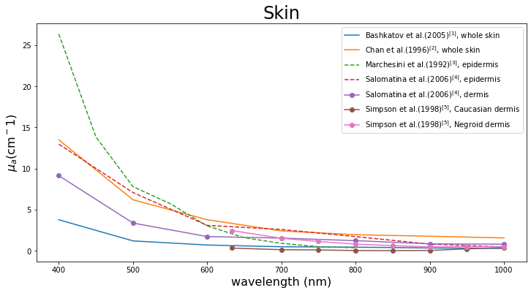

* Reduced scattering coefficient

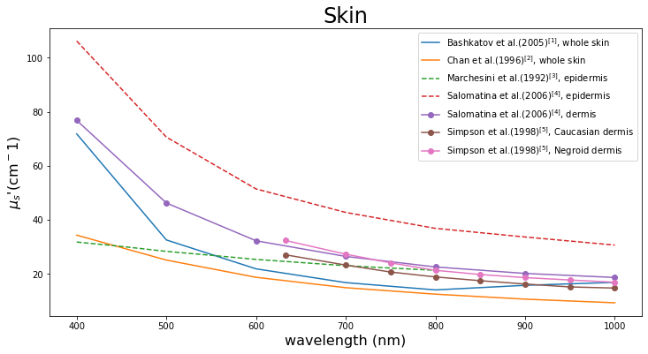

備註:

|  |  |  |
| --- | --- | --- |
| Reference | Method | Sample |
| A. N. Bashkatov et al. [1] | IS, IAD | in vitro with skin samples obtained from postmortem examinations |
| Chan et al. [2] | IS, IAD | obtained from the skin bank. (Tissues were harvested within 24 hr postmortem) |
| R. Marchesini et al. [3] | IS, 1D diffusion approximation | in vivo; from 10 Caucasian patients who underwent oncological surgery. |
| E. Salomatina et al. [4] | IS, IMC | Freshly discarded specimens of normal and cancerous human(from the surgeries) |
| C. R. Simpson et al. [5] | IS, IMC | from plastic surgery or post-mortem |

[1] A. N. Bashkatov, E. A. Genina, V. I. Kochubey, V. V. Tuchin "Optical properties of human skin, subcutaneous and mucous tissues in the wavelength range from 400 to 2000 nm." (2005)

[2] E. K. Chan, B. Sorg, D. Protsenko, M. O'Neil, M. Motamedi, A. J. Welch "Effects of compression on soft tissue optical properties. " (1996)

[3] R. Marchesini, C. Clemente, E. Pignoli, M. Brambilla, "Optical properties of in vitro epidermis and their possible relationship with optical properties of in vivo skin." (1992)

[4] E. Salomatina, B. Jiang, J. Novak, A. N. Yaroslavsky, "Optical properties of normal and cancerous human skin in the visible and near-infrared spectral range." (2006)

[5] C. R. Simpson, M. Kohl, M. Essenpreis, M. Cope, "Near-infrared optical properties of ex vivo human skin and subcutaneous tissues measured using the Monte Carlo inversion technique." (1998)

1. subcutaneous adipose

* Absorption coefficient

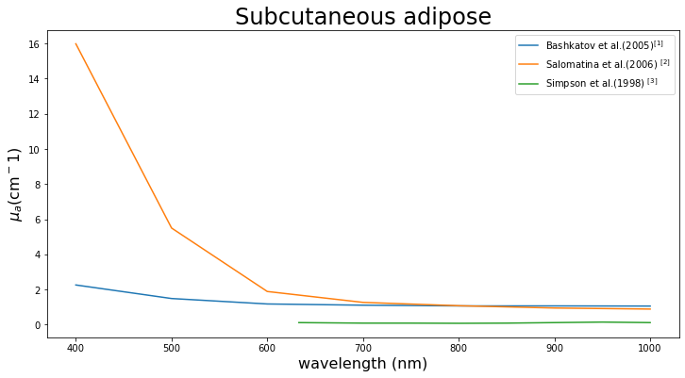

* Reduced scattering coefficient

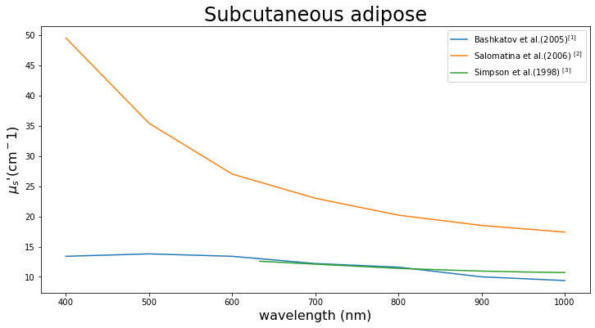

備註:

|  |  |  |
| --- | --- | --- |
| Reference | Method | Sample |
| A. N. Bashkatov et al. [1] | IS, IAD, in vitro | Fresh human subcutaneous adipose tissue samples (from the peritoneum area of patients during planned surgery.) |
| E. Salomatina et al. [2] | IS, IMC | Freshly discarded specimens of normal and cancerous human(from the surgeries) |
| C. R. Simpson et al. [3] | IS, IMC | from plastic surgery or post-mortem |

[1] A. N. Bashkatov, E. A. Genina, V. I. Kochubey, V. V. Tuchin "Optical properties of human skin, subcutaneous and mucous tissues in the wavelength range from 400 to 2000 nm."(2005)

[2] E. Salomatina, B. Jiang, J. Novak, A. N. Yaroslavsky, "Optical properties of normal and cancerous human skin in the visible and near-infrared spectral range."(2006)

[3] C. R. Simpson, M. Kohl, M. Essenpreis, M. Cope, "Near-infrared optical properties of ex vivo human skin and subcutaneous tissues measured using the Monte Carlo inversion technique."(1998)

1. Muscle

* Absorption coefficient

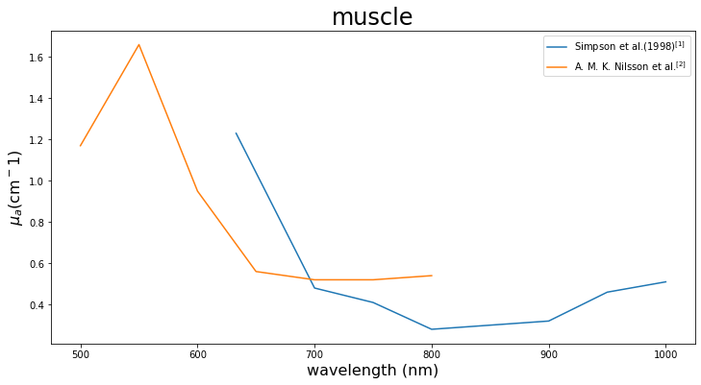

* Reduced scattering coefficient

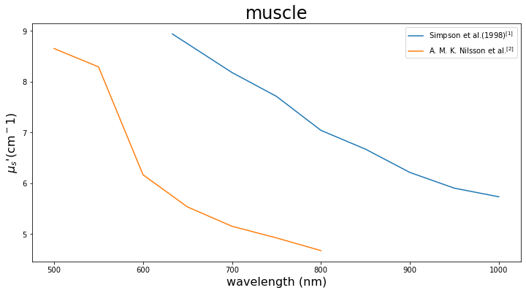

備註:

|  |  |  |
| --- | --- | --- |
| Reference | Method | Sample |
| C. R. Simpson et al. [1] | IS, IMC | from plastic surgery or post-mortem |
| A. M. K. Nilsson et al. [2] | IS, IMC | Rat; in vivo |

[1] C. R. Simpson, M. Kohl, M. Essenpreis, M. Cope, "Near-infrared optical properties of ex vivo human skin and subcutaneous tissues measured using the Monte Carlo inversion technique." (1998)

[2] A. M. K. Nilsson, R. Berg, S. Andersson-Engels, "Measurements of the optical properties of tissue in conjunction with photodynamic therapy." (1995)

1. Blood

* Absorption coefficient

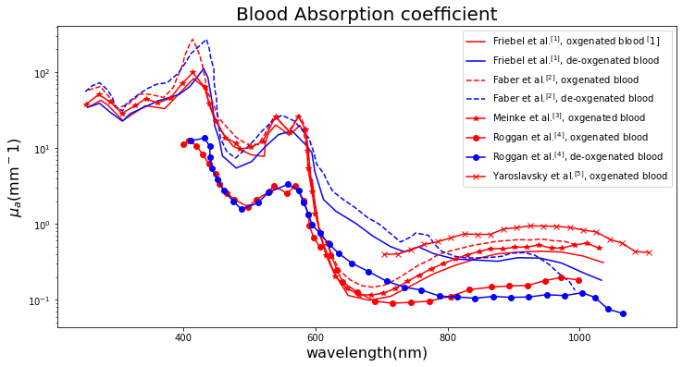

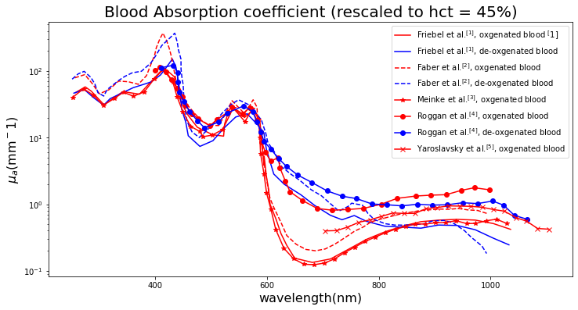

* Reduced scattering coefficient

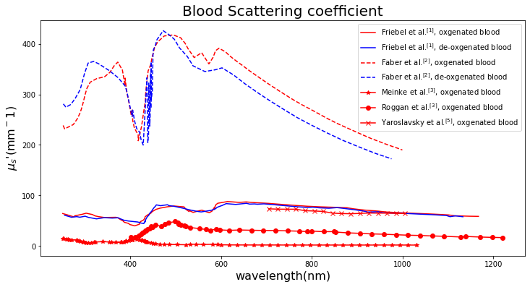

備註:

|  |  |  |
| --- | --- | --- |
| Reference | Method | Sample |
| Friebel et al. [1] | IS with inverse MC | Fresh RBCs (human) in phosphate buffer; hct=33.2 %; SO2=0, 100 %; in flow, T =20 °C |
| Faber et al. [2] | Mie calculations | Fresh porcine blood; hct=33 %; SO2=0, 100 % |
| Meinke et al. [3] | IS with inverse MC | Fresh RBCs (human) in phosphate buffer and saline solution/plasma ; hct 42.1%; SO2>98 %; in flow, T =20 °C |
| Roggan et al. [4] | Double IS with inverse  MC | Fresh RBCs (human) in phosphate buffer; hct=5 %; SO2=0, 100 %; in flow,; T =20 °C |
| Yaroslavsky et al. [5] | Double IS with inverse  MC | Fresh heparinized whole blood (human); hct=45 %, SO2>98 %; no flow |

[1] Friebel M, Helfmann J, Netz U, Meinke M, Influence of oxygen saturation on the optical scattering properties of human red blood cells in the spectral range 250 to 2000 nm. (2009)

[2] Dirk J. Faber, Maurice C. G. Aalders, Egbert G. Mik, Brett A. Hooper, Martin J. C. van Gemert, and Ton G. van Leeuwen, Oxygen saturation-dependent absorption and scattering of blood. (2004)

[3] Meinke M, Muller G, Helfmann J, Friebel M, Empirical model functions to calculate hematocrit-dependent optical properties of human blood. (2007)

[4] Roggan A, Friebel M, Dorschel K, Hahn A, Muller G Optical properties of circulating human blood in the wavelength range 400–2500 nm. (1999)

[5] Yaroslavsky AN, Yaroslavsky IV, Goldbach T, Schwarzmaier HJ The optical properties of blood in the near infrared spectral range. (1996)