**Bar Chart - Sample Export**

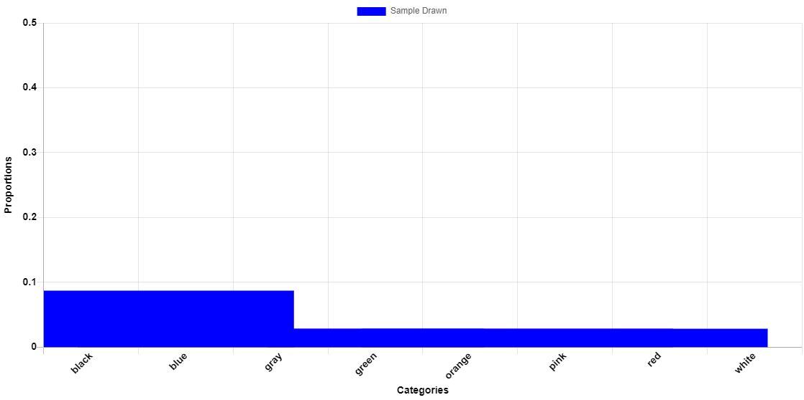

|  |  |  |  |
| --- | --- | --- | --- |
| **Index** | **Category** | **Absolute Frequency** | **Relative Frequency** |
| 1 | black | 2 | 0.4000 |
| 2 | blue | 0 | 0.0000 |
| 3 | gray | 1 | 0.2000 |
| 4 | green | 0 | 0.0000 |
| 5 | orange | 1 | 0.2000 |
| 6 | pink | 1 | 0.2000 |
| 7 | red | 0 | 0.0000 |
| 8 | white | 0 | 0.0000 |