**Correlation Visualization Export**

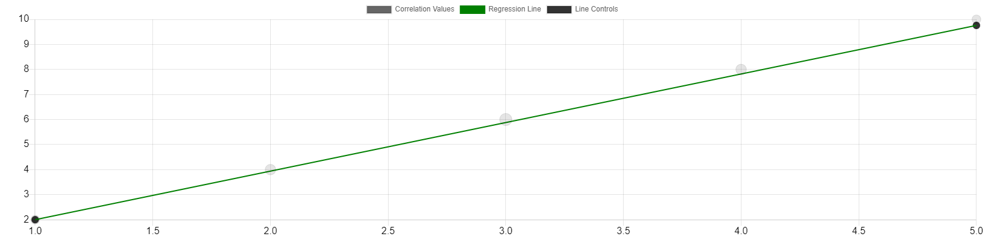

|  |  |  |
| --- | --- | --- |
| Point | X Value | Y Value |
| 1 | 1 | 2 |
| 2 | 2 | 4 |
| 3 | 3 | 6 |
| 4 | 4 | 8 |
| 5 | 5 | 10 |

**Correlation Statistics:**

Correlation Coefficient (r): 1.00

Correlation Strength: Very Strong

Direction: Positive