**Dot Plot - Input Data Export**

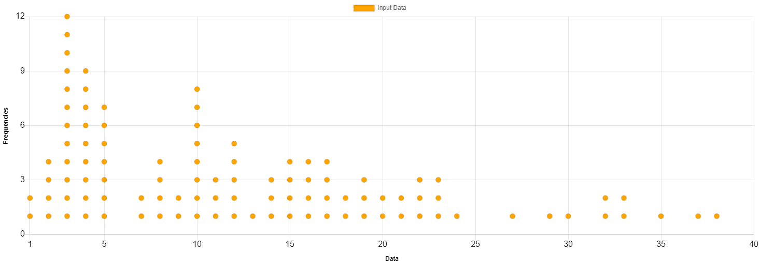

|  |  |
| --- | --- |
| **ID** | **Value** |
| 1 | 4 |
| 2 | 15 |
| 3 | 29 |
| 4 | 14 |
| 5 | 8 |
| 6 | 16 |
| 7 | 10 |
| 8 | 11 |
| 9 | 4 |
| 10 | 7 |
| 11 | 12 |
| 12 | 5 |
| 13 | 18 |
| 14 | 12 |
| 15 | 8 |
| 16 | 19 |
| 17 | 5 |
| 18 | 4 |
| 19 | 20 |
| 20 | 30 |
| 21 | 4 |
| 22 | 14 |
| 23 | 15 |
| 24 | 3 |
| 25 | 7 |
| 26 | 17 |
| 27 | 2 |
| 28 | 2 |
| 29 | 17 |
| 30 | 20 |
| 31 | 4 |
| 32 | 5 |
| 33 | 3 |
| 34 | 3 |
| 35 | 15 |
| 36 | 2 |
| 37 | 23 |
| 38 | 18 |
| 39 | 12 |
| 40 | 3 |
| 41 | 16 |
| 42 | 3 |
| 43 | 3 |
| 44 | 12 |
| 45 | 8 |
| 46 | 21 |
| 47 | 35 |
| 48 | 19 |
| 49 | 10 |
| 50 | 23 |
| 51 | 32 |
| 52 | 22 |
| 53 | 33 |
| 54 | 10 |
| 55 | 3 |
| 56 | 8 |
| 57 | 37 |
| 58 | 10 |
| 59 | 38 |
| 60 | 33 |
| 61 | 16 |
| 62 | 14 |
| 63 | 3 |
| 64 | 9 |
| 65 | 11 |
| 66 | 10 |
| 67 | 5 |
| 68 | 23 |
| 69 | 10 |
| 70 | 4 |
| 71 | 32 |
| 72 | 13 |
| 73 | 4 |
| 74 | 5 |
| 75 | 21 |
| 76 | 24 |
| 77 | 4 |
| 78 | 2 |
| 79 | 5 |
| 80 | 11 |
| 81 | 1 |
| 82 | 4 |
| 83 | 17 |
| 84 | 10 |
| 85 | 12 |
| 86 | 15 |
| 87 | 22 |
| 88 | 17 |
| 89 | 1 |
| 90 | 22 |
| 91 | 3 |
| 92 | 3 |
| 93 | 16 |
| 94 | 3 |
| 95 | 10 |
| 96 | 19 |
| 97 | 9 |
| 98 | 27 |
| 99 | 3 |
| 100 | 5 |