**Dot Plot - Distribution of Sample Means Export**

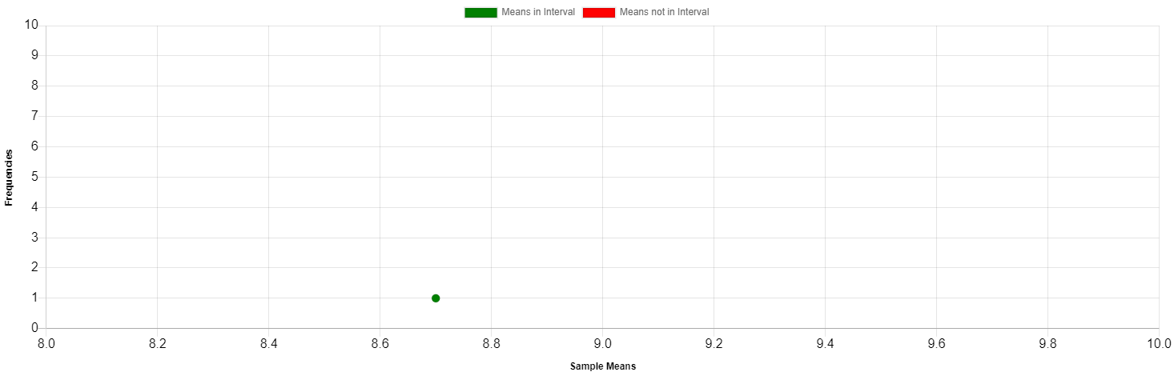

|  |  |
| --- | --- |
| **Sample #** | **Mean** |
| 1 | 8.7 |