**Dot Plot - Sample Export**

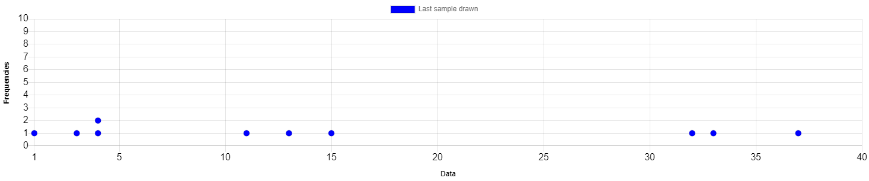

|  |  |
| --- | --- |
| **Original ID** | **Value** |
| 89 | 1 |
| 51 | 32 |
| 57 | 37 |
| 70 | 4 |
| 23 | 15 |
| 53 | 33 |
| 63 | 3 |
| 80 | 11 |
| 9 | 4 |
| 72 | 13 |