**Linear Regression Export**

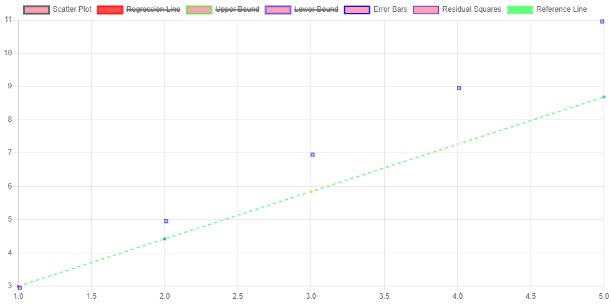

|  |  |  |
| --- | --- | --- |
| **Index** | **X Value** | **Y Value** |
| 1 | 1 | 3 |
| 2 | 2 | 5 |
| 3 | 3 | 7 |
| 4 | 4 | 9 |
| 5 | 5 | 11 |

Regression Formula: y = 2.00x + 1.00

Least Squares: 0.0000