**One Mean Confidence Interval Analysis**

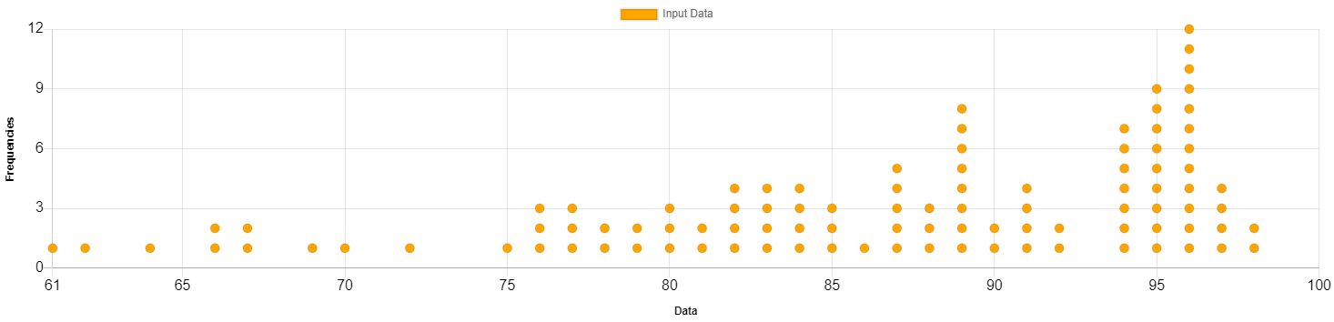

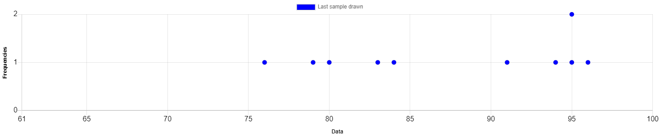

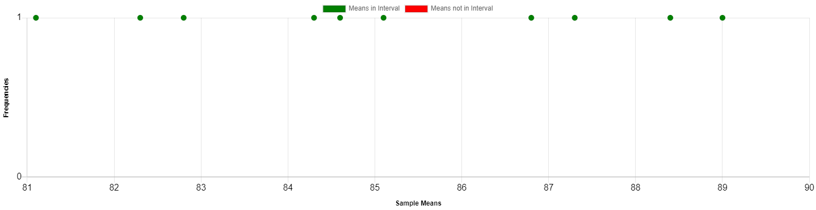

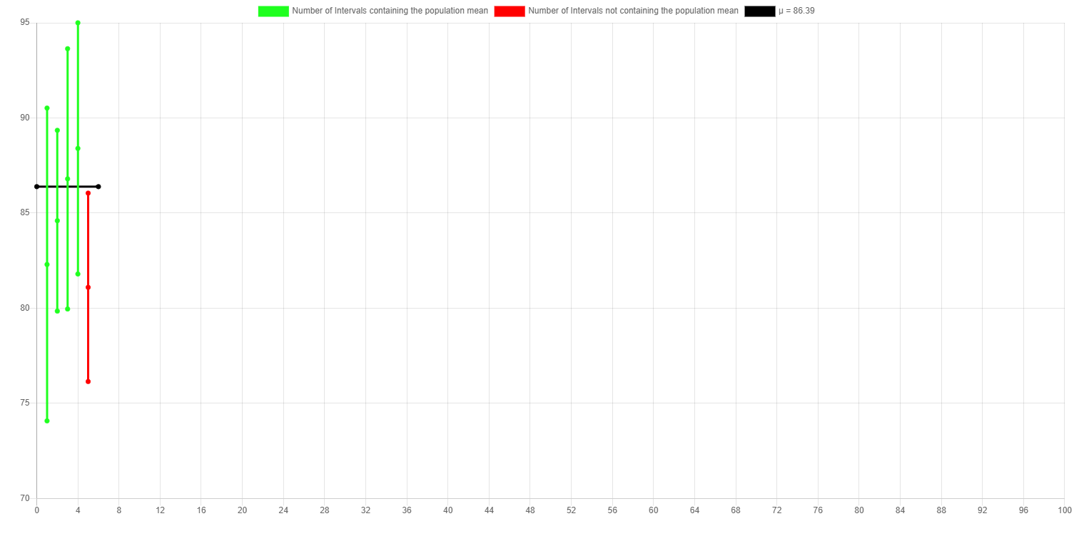

**Input Data**

|  |  |
| --- | --- |
| **Parameter** | **Value** |
| Mean (μ) | 86.39 |
| Standard Deviation (σ) | 9.24 |
| Size (N) | 100 |

**Simulation Results**

|  |  |
| --- | --- |
| **Parameter** | **Value** |
| Sample Size | 10 |
| Number of Simulations | 10 |
| Sample Mean (x̄) | 87.3 |
| Sample Standard Deviation (s) | 7.69 |

**Confidence Interval Results**

|  |  |
| --- | --- |
| **Parameter** | **Value** |
| Number of Intervals | 5 |
| Intervals Containing Population Mean | 4 |
| Intervals Not Containing Population Mean | 1 |