**One Mean Hypothesis Testing - Sampling Distribution Export**

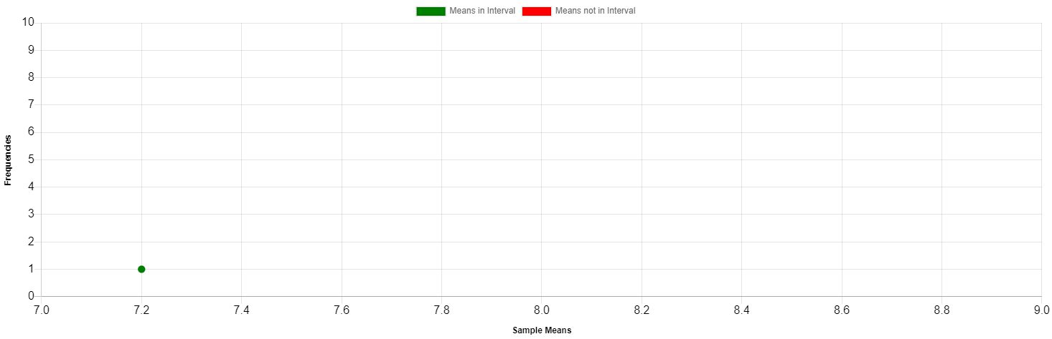

**Summary Statistics**

|  |  |
| --- | --- |
| **Statistic** | **Value** |
| Mean of Sample Means | 7.2 |
| Std Dev of Sample Means | NaN |
| Total Samples | 1 |
| Samples in Interval | 1 / 1 = 1 |
| Samples not in Interval | 0 / 1 = 0 |