**One Mean Hypothesis Testing - Sample Export**

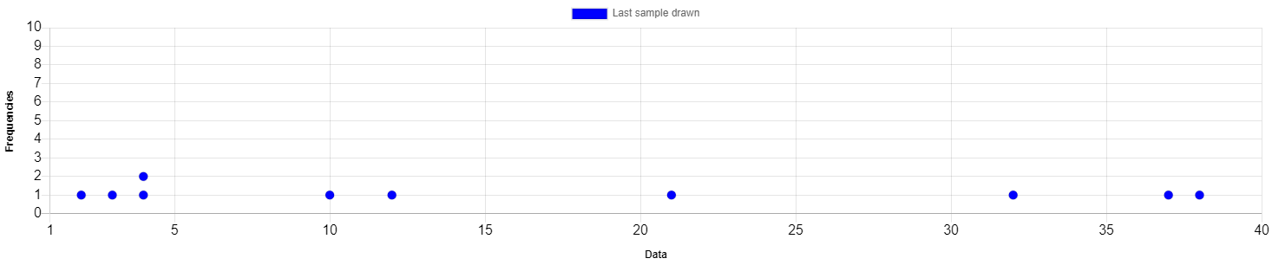

**Summary Statistics**

|  |  |
| --- | --- |
| **Statistic** | **Value** |
| Mean (x̄) | 16.3 |
| Standard Deviation (s) | 14.5682 |