**One Proportion Confidence Interval Analysis**

**Input Data (Successes vs Failures)**

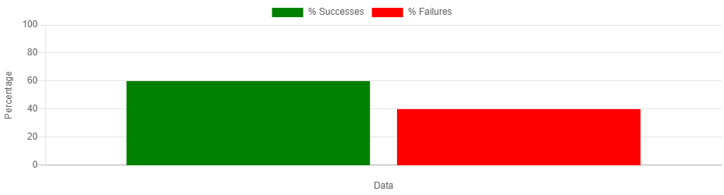

**Simulation Results**



**Sampling Distribution of Proportions**

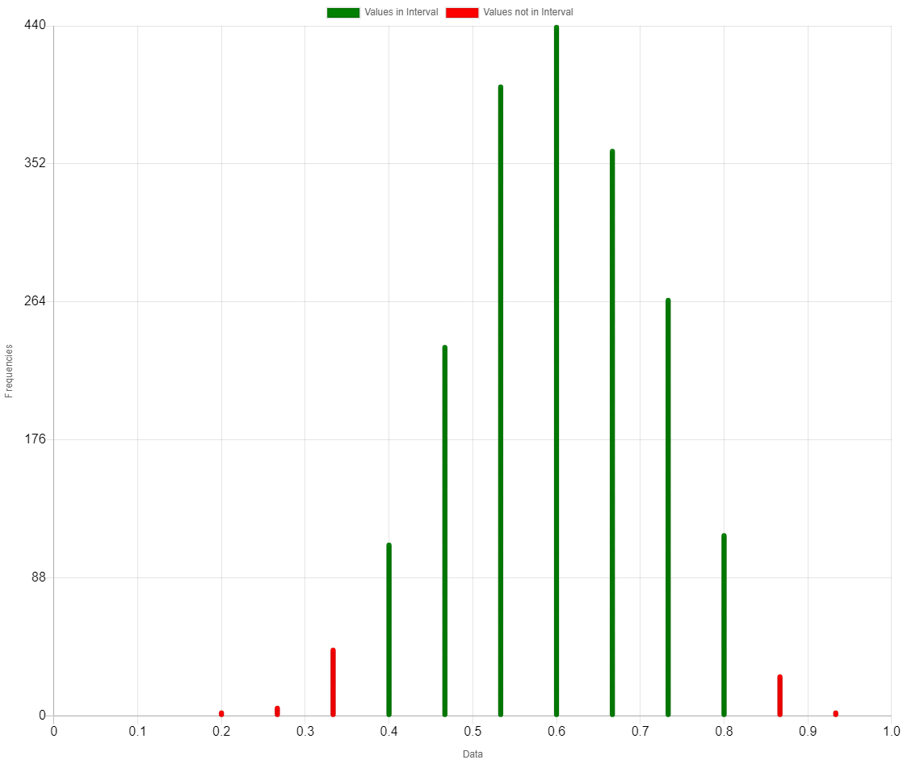

**Input Data**

|  |  |
| --- | --- |
| Metric | Value |
| Successes | 60 |
| Failures | 40 |
| Proportion of Successes | 0.6000 |

**Simulation Results**

|  |  |
| --- | --- |
| Metric | Value |
| Sample Size | 15 |
| Number of Simulations | 2000 |
| Mean of Sample Proportions | 0.5981 |
| Standard Deviation | 0.1164 |
| Lower Bound | 0.4000 |
| Upper Bound | 0.8000 |
| Total Samples | 2000 |
| Proportions Selected | 1924 / 2000 = 0.962 |
| Proportions Not Selected | 76 / 2000 = 0.038 |