**One Proportion Hypothesis Test Export**

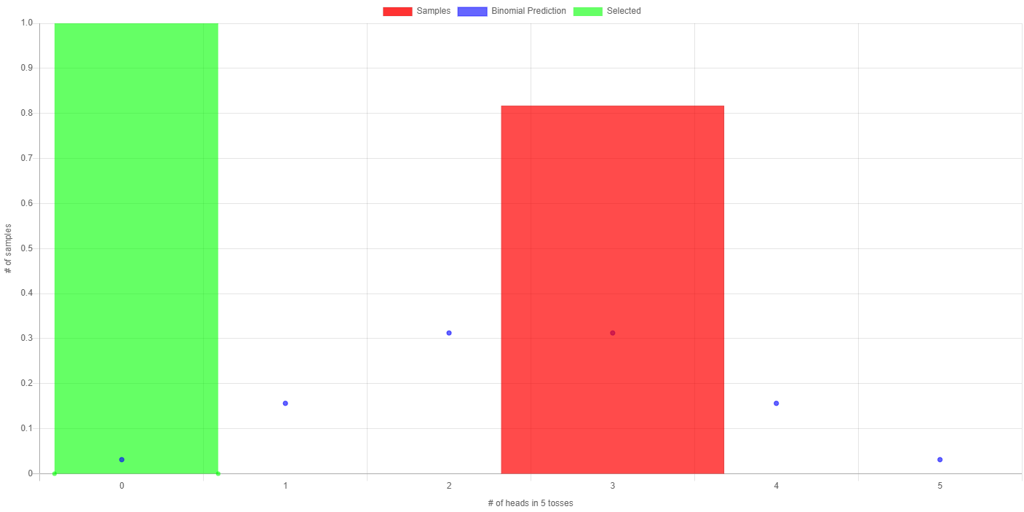

**Summary Statistics**

Total Samples: 1

Mean: 3.000

Std Dev: 0.000

|  |  |
| --- | --- |
| **Heads** | **Frequency** |
| 3 | 1 |