**Two Mean Confidence Interval Analysis**

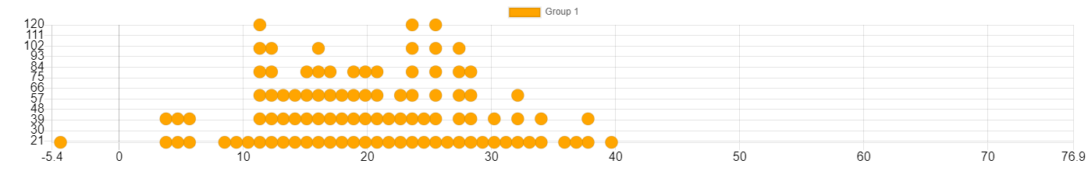

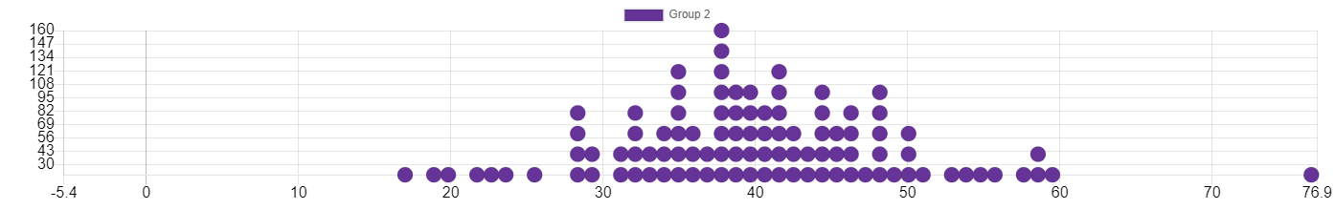

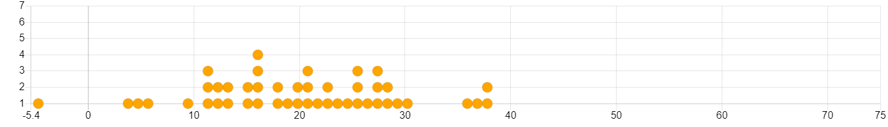

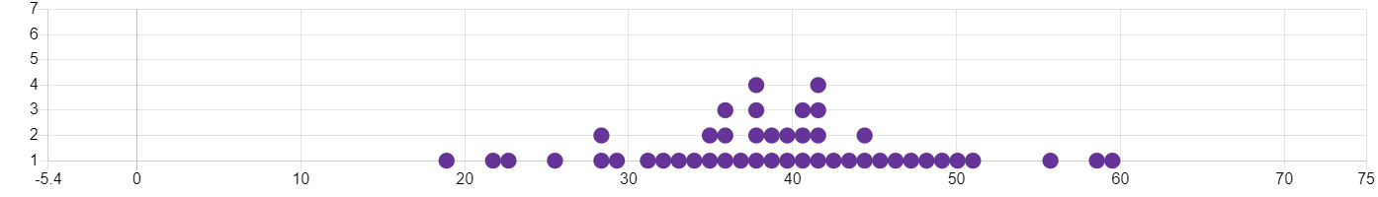

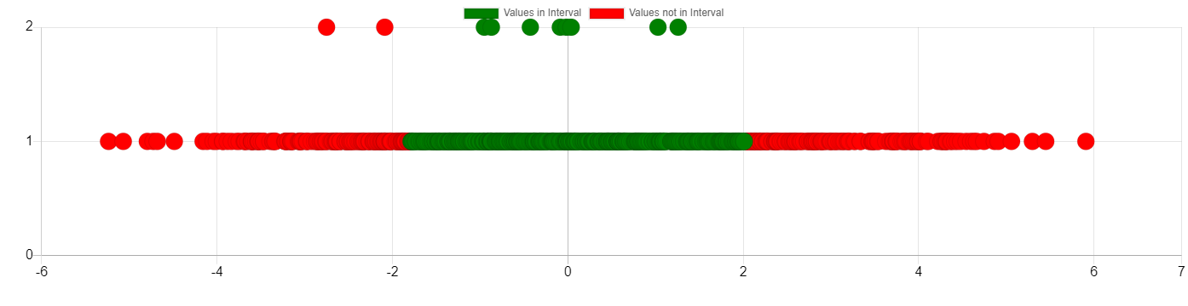

**Input Data**

|  |  |
| --- | --- |
| Parameter | Value |
| Group 1 Size (n) | 100 |
| Group 1 Mean | 20.476 |
| Group 1 Standard Deviation | 9.012 |
| Group 2 Size (n) | 100 |
| Group 2 Mean | 40.524 |
| Group 2 Standard Deviation | 9.012 |
| Difference of Means | -20.048 |

**Simulation Results**

|  |  |
| --- | --- |
| Parameter | Value |
| Number of Simulations | 1000 |
| Sample Mean 1 | 31.696 |
| Sample Mean 2 | 29.304 |
| Sample Mean Difference | -2.392 |
| Final Standard Deviation | 1.976 |

**Confidence Interval Results**

|  |  |
| --- | --- |
| Parameter | Value |
| Confidence Level | 65% |
| Lower Bound | -1.788 |
| Upper Bound | 2.012 |
| Total Samples | 1000 |