**Two Means Significance Test - Data Export**

**Group 1 Data**

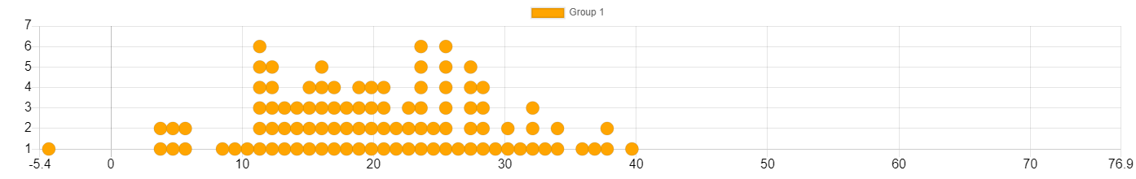

**Group 2 Data**

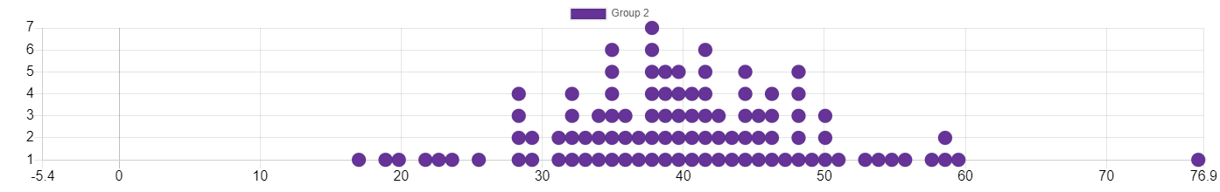

**Summary Statistics**

|  |  |
| --- | --- |
| **Statistic** | **Value** |
| Size n (Group 1) | 100 |
| Mean 1 (Group 1) | 20.476 |
| Size n (Group 2) | 100 |
| Mean 2 (Group 2) | 40.524 |
| Difference of Means (Mean 1 - Mean 2) | -20.048 |