**Two Means Significance Test - Sampling Distribution Export**

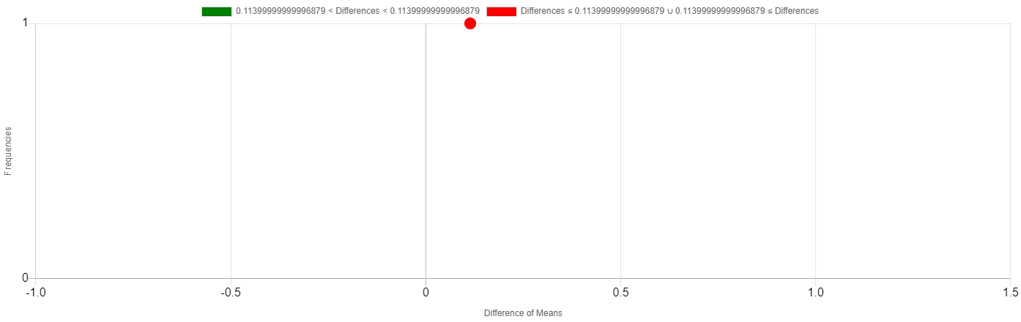

|  |  |
| --- | --- |
| **Simulation #** | **Difference of Means** |
| 1 | 0.1140 |