**Two Means Significance Test - Simulation Export**

**Resampled Group 1**

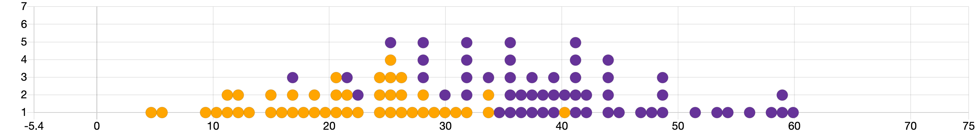

**Resampled Group 2**

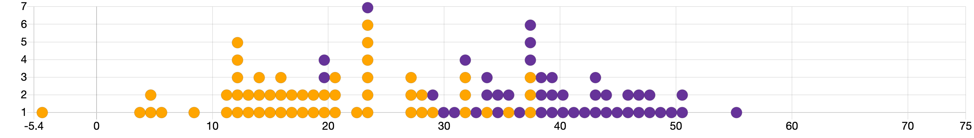

**Summary Statistics**

|  |  |
| --- | --- |
| **Statistic** | **Value** |
| Mean (Resampled Group 1) | 32.595 |
| Mean (Resampled Group 2) | 28.405 |
| Difference of Means | -4.19 |