**Two Proportions Confidence Interval Analysis**

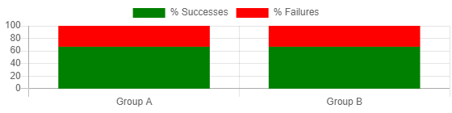

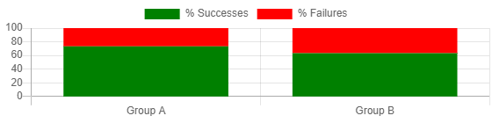

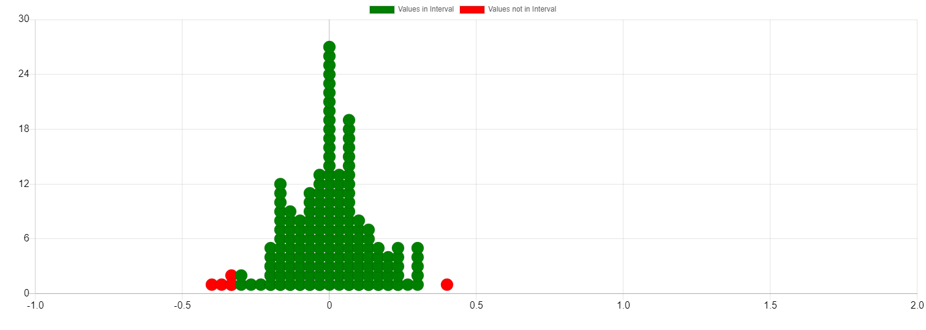

**Input Data**

|  |  |
| --- | --- |
| **Parameter** | **Value** |
| Group A Successes | 10 |
| Group A Failures | 5 |
| Group B Successes | 20 |
| Group B Failures | 10 |
| Proportion Group A | 0.6666666666666666 |
| Proportion Group B | 0.6666666666666666 |
| Difference (pA - pB) | 0 |

**Simulation Results**

|  |  |
| --- | --- |
| **Parameter** | **Value** |
| Number of Simulations | 200 |
| Mean of Sample Differences | 0.0016666666666666707 |
| Standard Deviation | 0.14215601757693316 |
| Total Number of Samples | 200 |

**Confidence Interval Results**

|  |  |
| --- | --- |
| **Parameter** | **Value** |
| Confidence Level | 95% |
| Lower Bound | -0.30000000000000004 |
| Upper Bound | 0.30000000000000004 |