**Two Proportion Hypothesis Testing - Data Export**

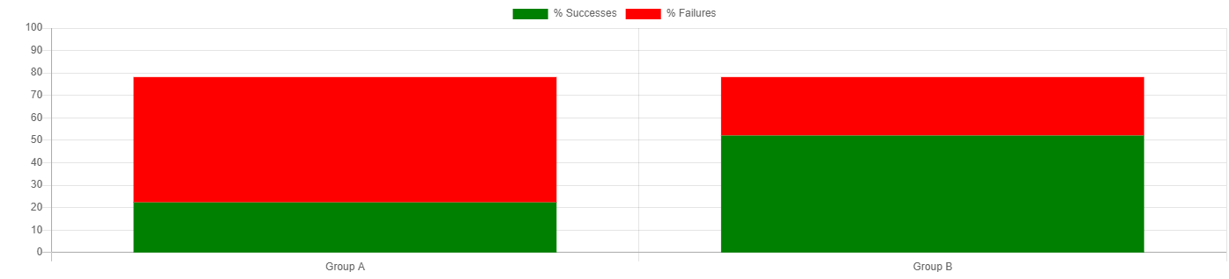

**Summary Statistics**

|  |  |
| --- | --- |
| **Statistic** | **Value** |
| Successes (Group A) | 20 |
| Failures (Group A) | 50 |
| Successes (Group B) | 30 |
| Failures (Group B) | 15 |
| Proportion A (pA) | 0.29 |
| Proportion B (pB) | 0.67 |
| Difference (pA - pB) | -0.38 |