**Two Proportion Hypothesis Testing - Sampling Distribution Export**

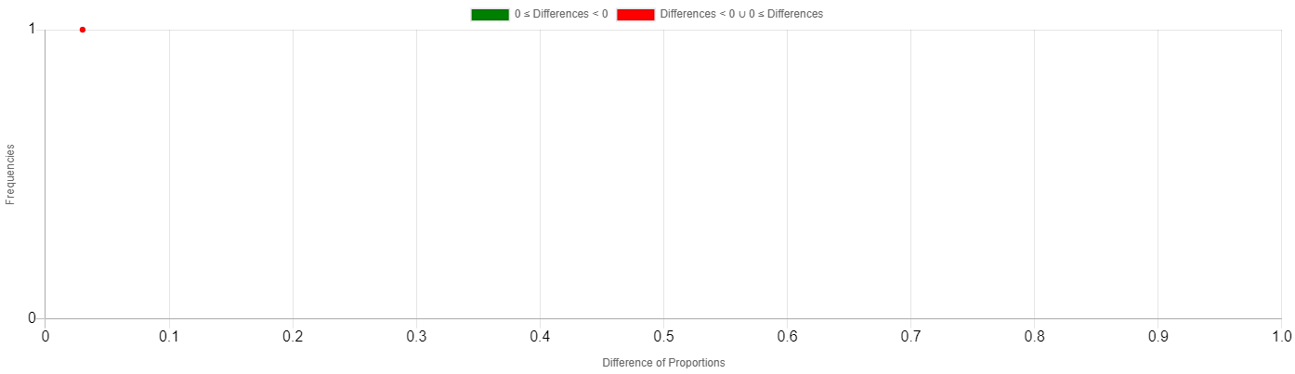

|  |  |
| --- | --- |
| **Simulation #** | **Difference of Proportions** |
| 1 | 0.0300 |