**Two Proportion Hypothesis Testing - Simulation Export**

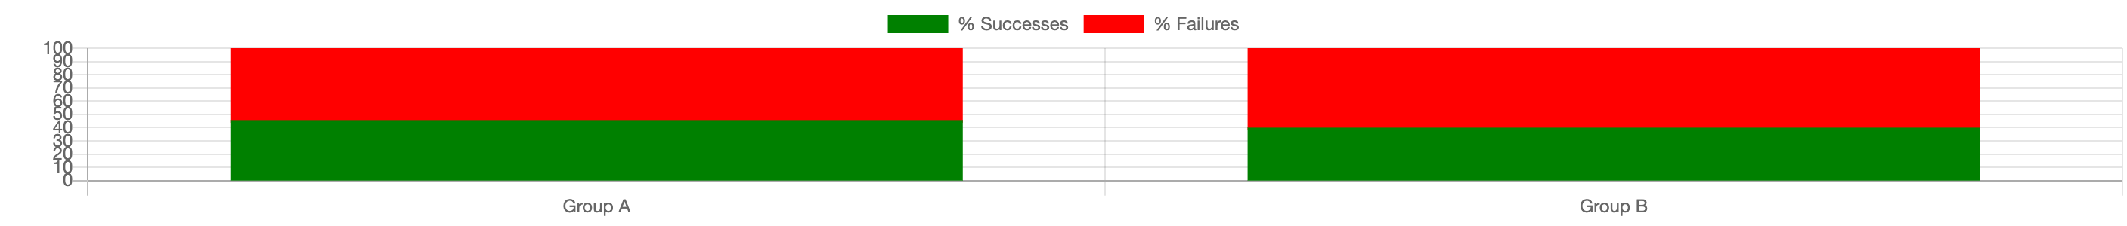

**Summary Statistics**

|  |  |
| --- | --- |
| **Statistic** | **Value** |
| Random Proportions (Group A) | 0.46 |
| Random Proportions (Group B) | 0.4 |
| Difference of Proportions | 0.12 |