Flag 1 – Prepare Your Environment
Objective: Install Node.js.
Screenshot:
- The command/The installer required for installing Node.js
- Run :
node -v
npm -v

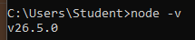

Flag 2 — Unlock the Forge
Objective: Install Angular CLI.
Screenshot:
- The command to install the CLI
- Then run:
ng version

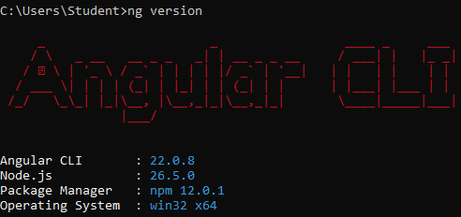

Flag 3 — Forge Your Project
Objective: Create your first Angular project.
Screenshot:
- The command to create the project
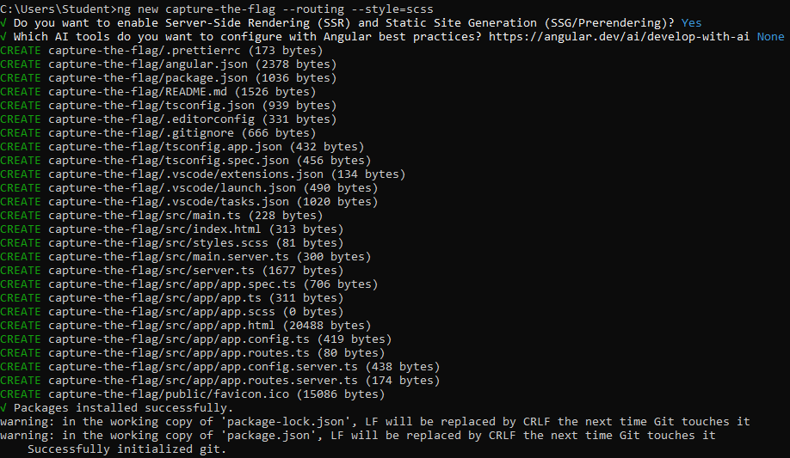
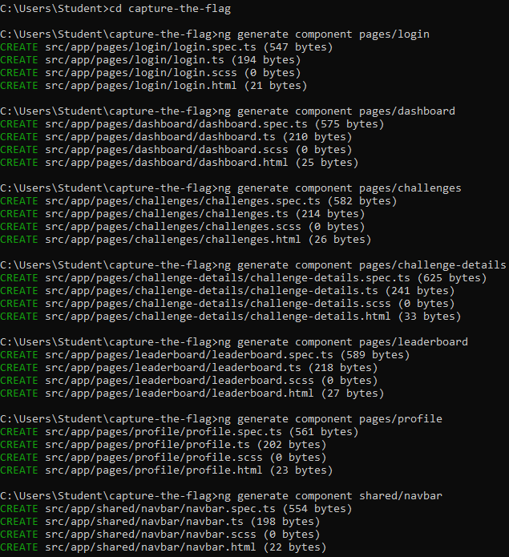
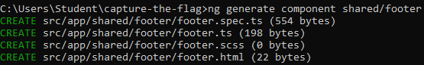
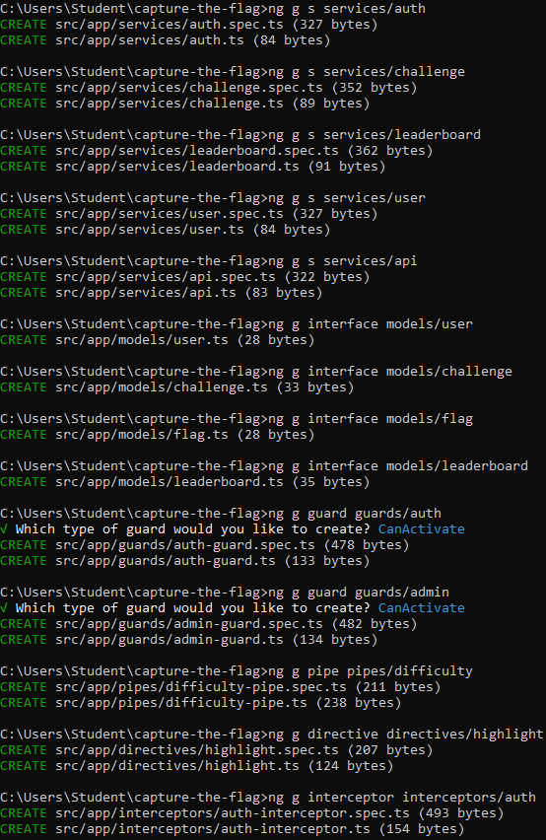
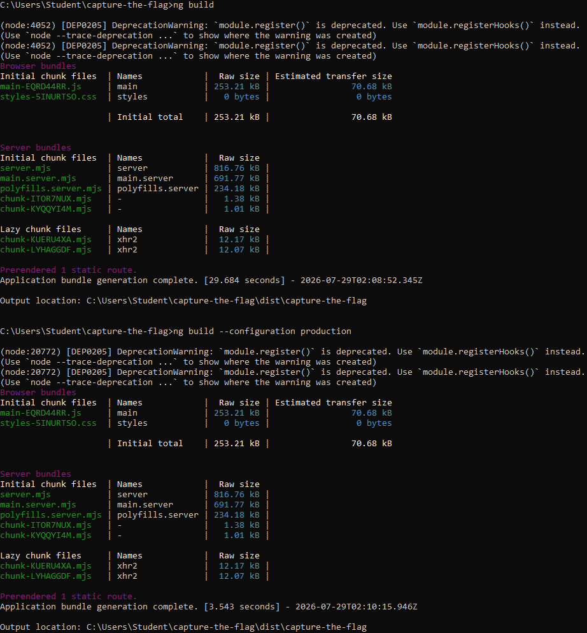
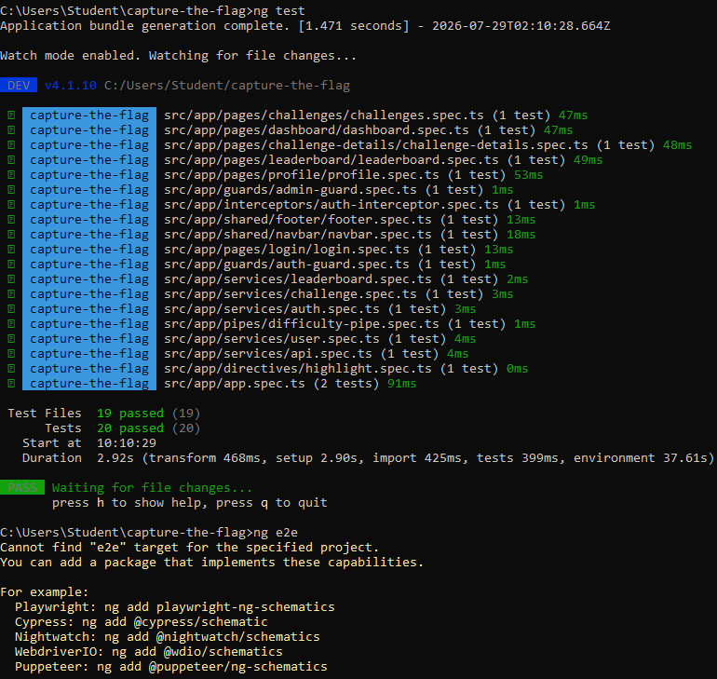
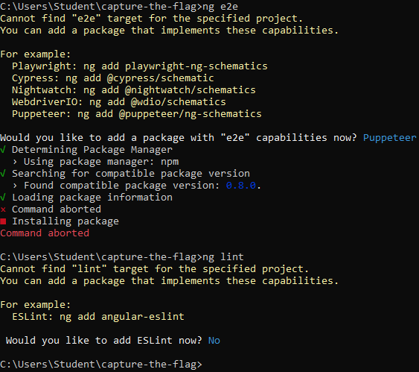

Flag 4 — Power Up
Objective: Open the project in VS Code.
Screenshot:
- Your VS Code containing the new project
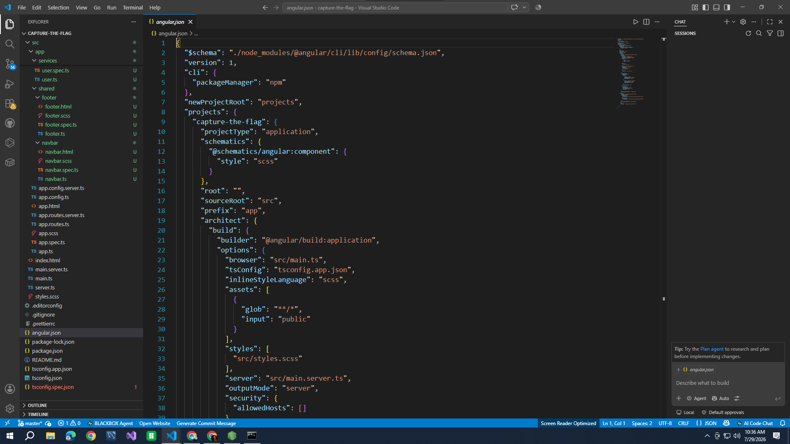

Flag 5 — Launch
Objective: Run the development server.
Screenshot:
- The command to run the development server
- The success message
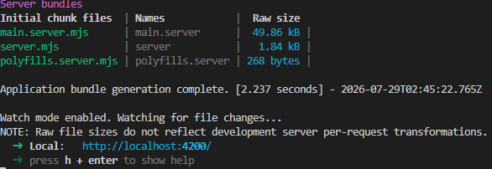

Flag 6 — I See It
Objective: Open the application.
Screenshot:
- The browser
- The port it opened
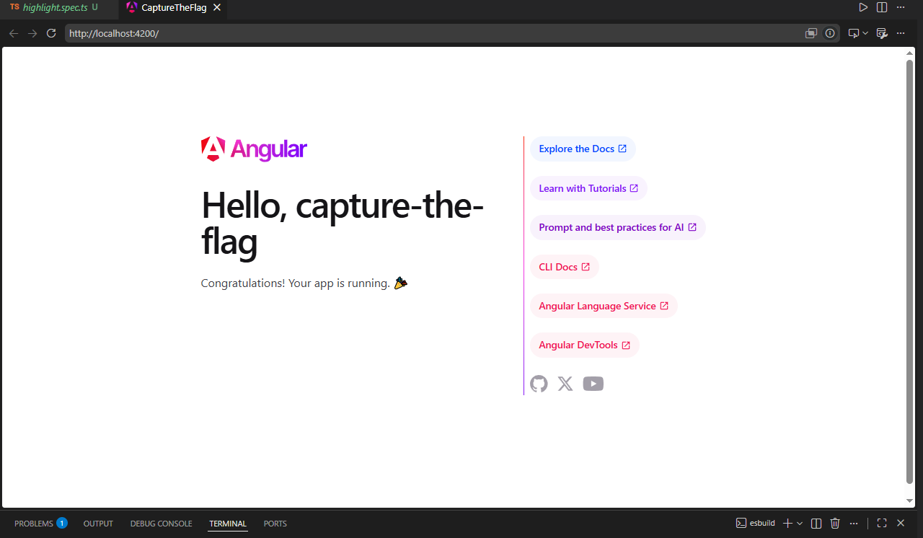

Flag 7 – Find the Entry Point
Objective: Figure out where the default Angular page comes from.
Screenshot:
- The location of the file where the default page is from
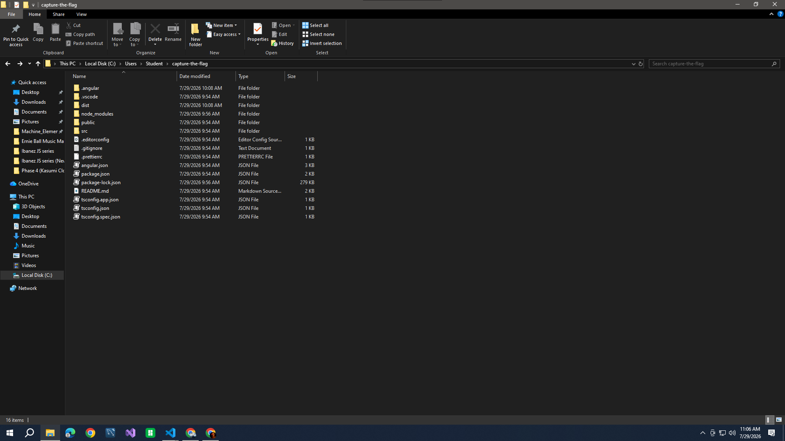

Flag 8 – Claim Your App
Replace the default content with:
- Your full name
- Your course & section
- "My First Angular Application"
- Today's date
Screenshot:
- Your updated content of the code
- The updated browser UI

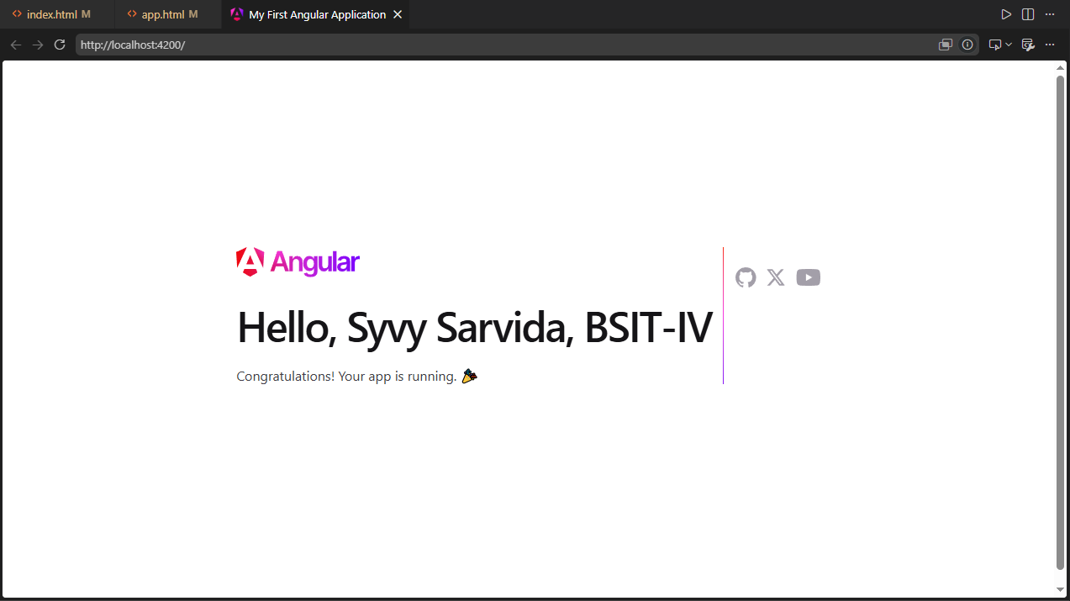

Flag 9 – Personalize It
Without following a step-by-step tutorial, make at least three visual changes by researching how.
Examples:
- Change the background colour.
- Change the text colour.
- Centre the content.
- Increase font size.
- Add a border or rounded card.
- Change the font.
- Add an emoji or icon.
Screenshot:
- The code changed for personalizing
- The updated browser UI
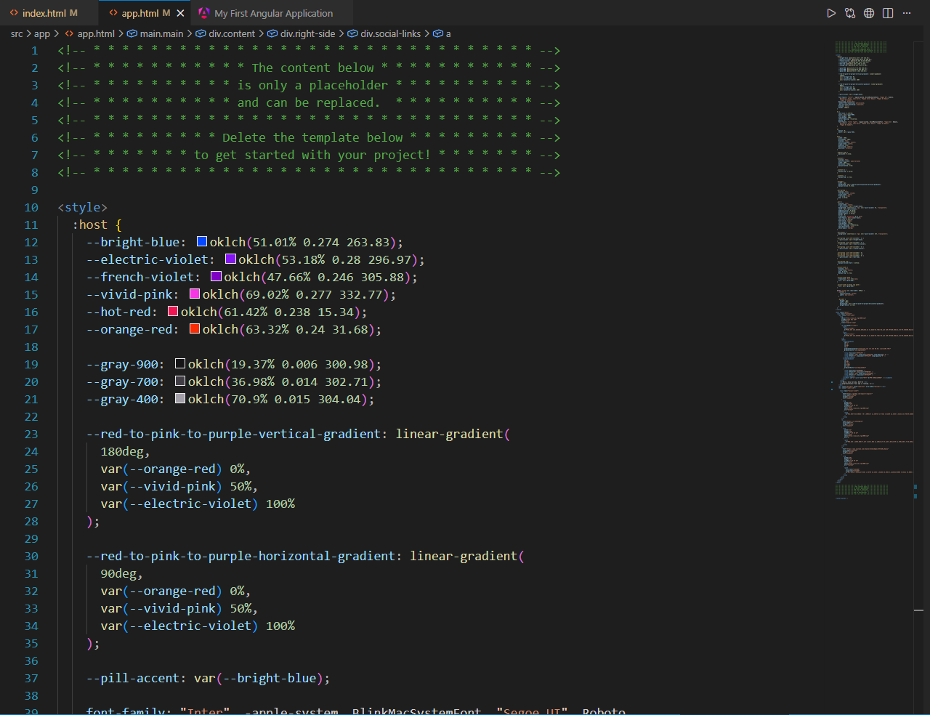

Flag 10 – Add an Image
Research how to display an image in Angular.
It can be:
- Your favourite programming logo.
- Your favourite animal.
- Your own avatar.
- Any royalty-free image.
Screenshot:
- The code changed when adding an image
- The updated browser UI

