**Homework Assignment #1**

Yeon Wook Sung

1. **What are three conclusions we can make about Kickstarter campaigns given the provided data?**
   1. Kickstarter projects that were created in May has the highest success rate and projects that were started in December has the lowest success rate.
   2. Kickstarter projects in music category has the highest success rate and projects in food category has the lowest success rate.
   3. Kickstarter projects in Plays sub-category is dominant in terms of the number of projects over the other sub-categories.
2. **What are some of the limitations of this dataset?**
   1. For the campaigns that were successful, we cannot tell how long it took for the donation amount to reach the goal amount.
   2. For the campaigns that were canceled, we cannot tell how long they were live before they were canceled.
   3. With the given dataset, we cannot tell how many backers were from the same country and how many backers were foreigners.
3. **What are some other possible tables/graphs that we could create?**
   1. Number of campaigns over campaign duration graph

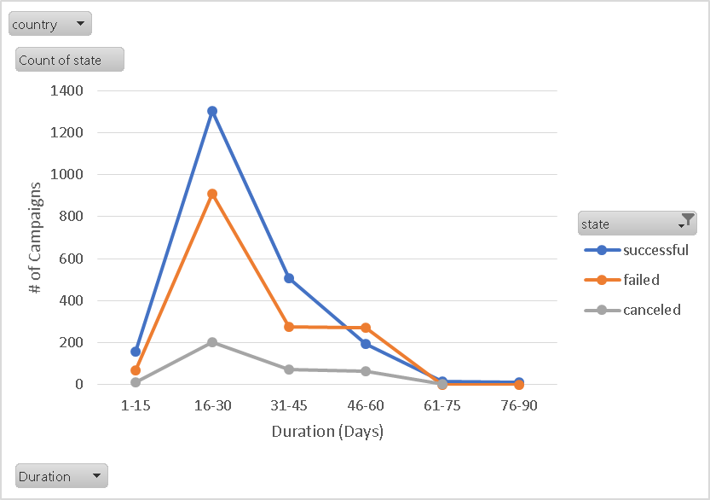

* + - Most campaigns were 16-30 days long and campaigns that were 46-60 days long have more failed cases than successful cases.
  1. Number of Spotlight cases per category

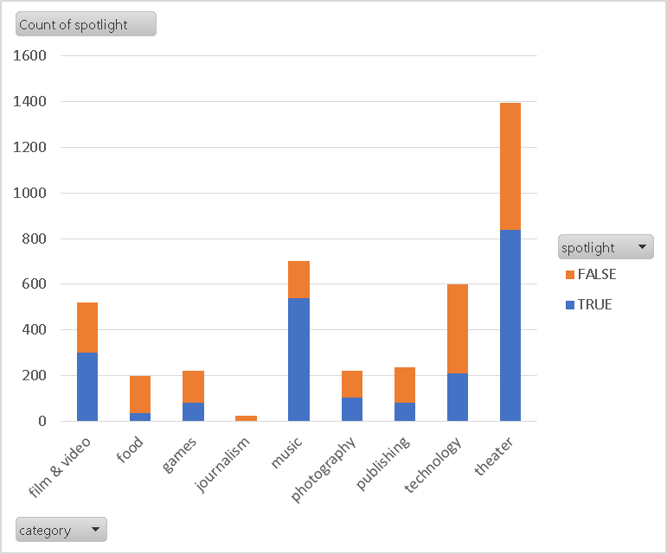

* + - Campaigns in music category has the highest spotlight rate.
  1. Number of campaigns that were funded over 200% per categories

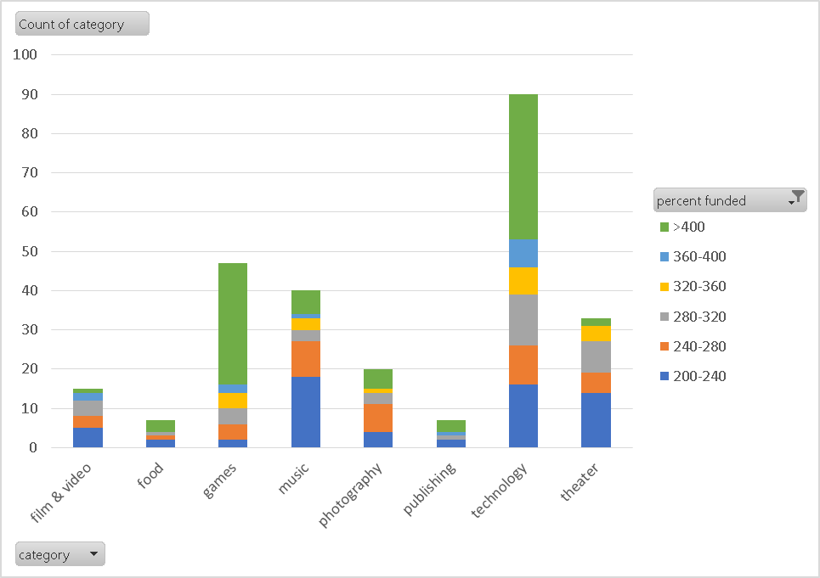

* + - Campaigns in technology and games categories have the most cases of being funded more than 400%