Nondominated solution-based multi-objective evolutionary greedy algorithm for optimal sensor placement problem

# Main idea

1. In this paper, we aim to propose a new algorithm, i.e., introduce the evolutionary mechanism into the original greedy algorithm proposed by Nakai et al. (2022) to scale up the greedy algorithm so that it can be applied to large-scale problems.
2. We will focus on the synthetic case to compare the algorithms. After proving the superiority of the new algorithm, we will apply it to the real-world case (HK sewage network). This is the main difference from our previous paper.

# Experiment design

## Synthetic case: algorithm comparison and parameter sensitivity

* RQ 1: how does the evolutionary greedy algorithm perform compared with the original greedy algorithm on networks with different sizes?

Can also consider other greedy family algorithms

* RQ 2: how does the parameter 'new_plans' affect the performance of the evolutionary greedy algorithm?

Test different values of 'new_plans' in the evolutionary greedy algorithm, and compare the performance of the algorithm with the original greedy algorithm (measure it using the difference between evolutionary and original greedy)

* Dataset: network sizes ranging from 30 to 3000, 100 different networks for each network size

Example:

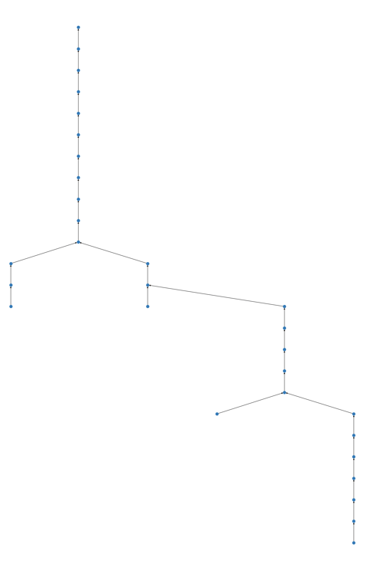 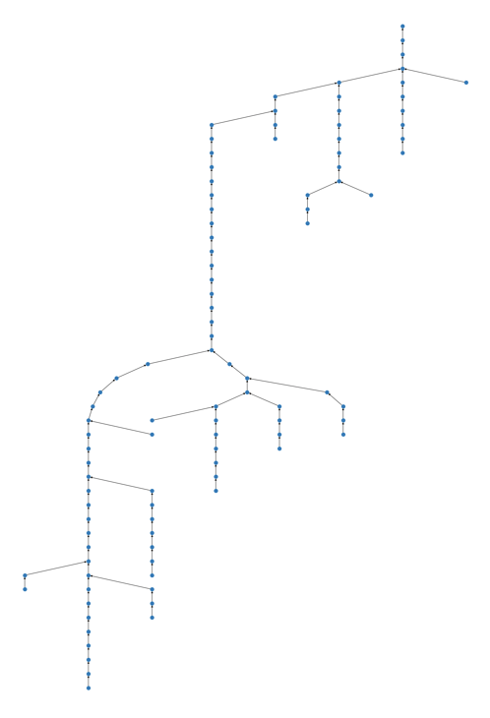

## Real-world case: application

* RQ 3: how can the evolutionary greedy algorithm be applied to solve the real-world problem?

## Problem formulation

Find the location of the S sensors in the sewage network that can maximize the sensing coverage and minimize the expected search cost.

Given a sewage network with $M$ manholes, let $X=(x_{1}, x_{2}, …, x_{M})$ denote a sensor placement plan, where $x_{i}=1$ denotes a sensor placed at manhole $i$ and $x_{i}=0$ denotes a manhole without a sensor. Let $δ_{ij}$ be a binary variable, where $δ_{ij}=1$ represents the manhole $j$ is upstream of manhole $i$ and $δ_{ij}=0$ otherwise. Furthermore, we adopt the concept of entry set proposed by Nourinejad et al. (2021) to approach the upstream-downstream relationship between sensors. The entry set of sensor $j$ is composed of the manholes for which sensor $j$ is the first to detect the presence of the virus originating from those manholes. We use $m_{j}$ to denote the size of the entry set of sensor $j$. The optimization problem can be formulated as follows:

$$maximize \sum_{i=1}^{M}{m_{i}}$$

$$minimize \sum_{i=1}^{M}{\frac{m_{i}}{\sum_{i=1}^{M}{m_{i}}}∙\log_{2}(m_{i})}$$

$$s.t. \sum_{i=1}^{M}{x_{i}}=S,$$

$$m_{i}=\sum_{j=1}^{M}{δ_{ij}}-\sum_{j=1}^{M}{δ_{ij}m_{j}}x_{j} ∀ i, j$$

$$x_{i}=\left\{0, 1\right\}, m_{i}∈Z ∀ i.$$

## Algorithm

Main difference:

* original greedy algorithm iterates all the potential solutions and selects from the newly generated solutions until the number of selected indices reaches a predefined number p
* modified greedy algorithm doesn’t iterate all the potential solutions and selects from the combination of newly generated solutions and solutions in the last iteration. Select the top solutions at each step and check whether they satisfy the constraints. If satisfied, add to the final solution, and delete it. After that, re-rank the remaining solutions and select the top solutions for the next iteration. The terminate condition is the number of solutions in the final solution reaches the predefined number.

Original algorithm proposed by Nakai et al. (2022)

the main idea is greedy algorithm, introduce non-dominated sorting when selecting solutions in each step

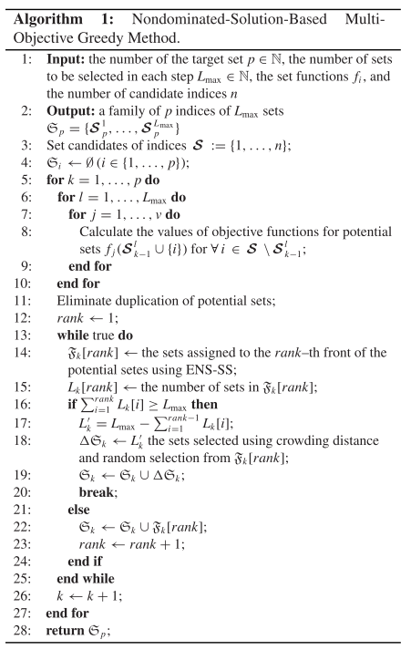

Adapted algorithm

# Reference

Nakai, K., Sasaki, Y., Nagata, T., Yamada, K., Saito, Y., & Nonomura, T. (2022). Nondominated-Solution-Based Multi-Objective Greedy Sensor Selection for Optimal Design of Experiments. *IEEE Transactions on Signal Processing*, *70*, 5694–5707. https://doi.org/10.1109/TSP.2022.3224643

Nourinejad, M., Berman, O., & Larson, R. C. (2021). Placing sensors in sewer networks: A system to pinpoint new cases of coronavirus. *PLOS ONE*, *16*(4), e0248893. https://doi.org/10.1371/journal.pone.0248893