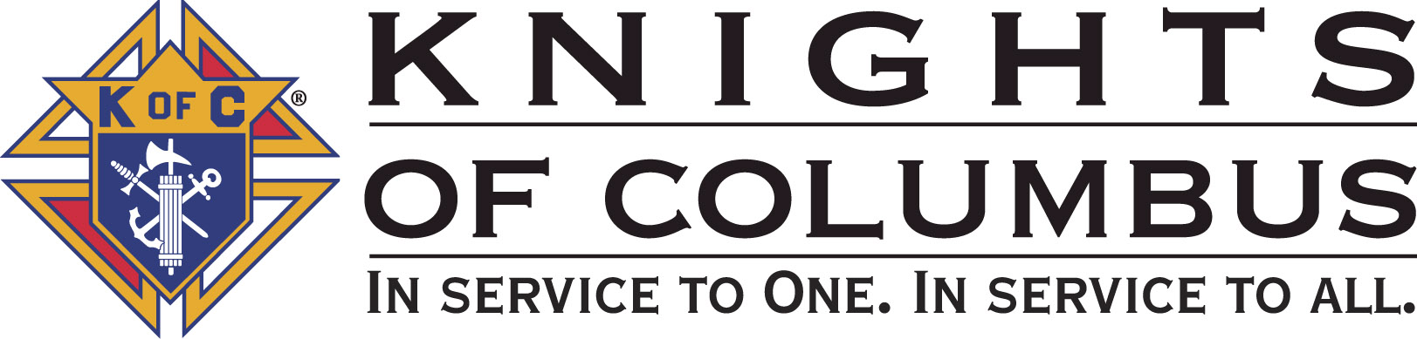

Council #13672 at Divine Savior Fr. Neil W. Seidl
Orangevale, CA
April 2010 Volume 8, #3

Monthly Grand Knight’s Message

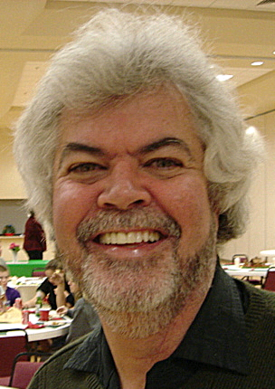
Greetings Brother Knights:
Grand Knight Charlie McDermott

Dep. Grand Knight Bruce Pyle

Fin. Secretary Micheal Wagner

Treasurer Allen Brown

Chancellor Tom Hogan

Warden Bob Reilly

Advocate Dave Brodie

Recorder Ray Coughlin

Trustee 1st Year Bill Windle (PGK)

Trustee 2nd Year Mike Duskus (PGK)

Trustee 3rd Year Joe Luchi (PGK)

Inside Guard Steve Mann

Outside Guard Douglas Copley

Chaplin Fr. Roman Mueller

Lecturer Tom Lawson

Field Agent Tony Magdaleno

The Knights of Columbus Council #13672 at Divine Savior Fr. Neil W. Seidl Chapter meets Monthly on the First Tuesday of each month at 7:00 p.m.
Please join us to help our Catholic Community.
For insurance needs, please contact our Field Agent Tony Magdaleno at 470-9205 or by mail at
P.O. Box 2737
Rancho Cordova, CA 95741

Our journey of service was a bit quieter this past month, but we still had a Pancake Breakfast, a Corporate Communion and added (2) 1st Degree Knights to our Council. Behind the scenes, the month of March gave our Program Director and Service Program Directors time to complete their final service event write-ups for the past April ’09- April’10. I am very pleased to announce that we have mailed off a total 28 Service Event Activities and Fundraisers to the State Service Program Committees. I am very proud of their work and the work that each and every one of you contributed- we couldn’t have done it without you. Look for more to come by June in sharing the service event write-up details by June.

Please note that there are additions/modifications to last months Event Calendars. Please ensure you mark your personal calendars accordingly!

During our recent Business Metering we heard about the following:

- Events and activities over the next few months from our Service Program Managers.
- From our Worthy Membership Director Ray Coughlin- we are still need candidates to ensure we make Star Council this Columbian year and start us off well for next Columbian year.
- Our Worthy Field Agent Tony Magdaleno on our upcoming Knights of Columbus Information Night.
- Finally, we heard from our Council Officers on their responsibilities. I encourage all members of the Council to consider serving as an officer during the next Columbian Year. If you have any questions or are interested in a particular Officer position, please contact the Council’s Election Committee Chairman, Bob Reilly (988-1040).

This concludes the Grand Knight’s Report. God Bless us all.
God Bless us all.

Charlie McDermott,
Grand Knight

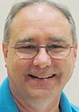
Treasurer Report
(Presented by Allen Brown)

KOC Council No. 132672 – Date balanced: 4/6/2010

Checkbook & CD Balances:
Business: $7,750.24
CD50 - 52: $3,223.48
Charity: $1,514.00
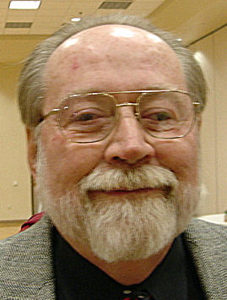
Total: $12,487.72

Financial Secretary’s Corner
(Presented by Michael Wagner)


2010-2011 Budget
I am starting the budget for next year and would like your input on the charities we donate to next year. Anyone wanting to suggest items for the next budget can either call me (966-6733) or email me (MrWiggi@sbcglobal.net) with the idea. All suggestions will be considered.
.

February Receipts
Batch 31 $987.00
Spaghetti Dinner $987.00
Batch 32 $631.65
Spaghetti Dinner $591.00
Dues $37.00
365 Club $3.65
Batch 33 $624.12
Charity Account
Charity Account
Funding $624.12
Batch 34 $633.05
Dues $555.00
365 Club $58.70
American Wheelchair
Mission $19.35
February Total $2875.82

March Receipts
Batch 35 $628.35
Spaghetti Dinner $234.42
Product Rebate $6.38
Raffle Proceeds $29.00
Dues $333.00
365 Club $25.55
Batch 36 $2200.00
Charity Account
Charity Account
Funding $2200.00
Batch 37 $709.95
Pancake Breakfast $504.00
Spaghetti Dinner $27.00
Dues $148.00
Initiation Fee $20.00
365 Club $10.95
Batch 38 $2439.12
Golf Tournament $2254.00
Spaghetti Dinner $2.47
Dues $148.00
Initiation Fee $40.00
365 Club $3.65
Batch 39 $49.00
Raffle Proceeds $49.00
Batch 40 $40.65
Dues $37.00
365 Club $3.65
Batch 41 $622.84
Charity Account
March Total $6689.91

Grand Total $9565.73

Knight of the Month
(Presented by Charlie McDermott)

- BRUCE PYLE

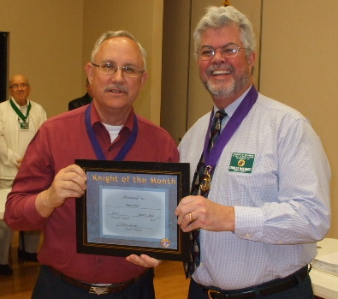
Our Knight of the Month for April is Bruce Pyle. Bruce has been a very active Service Program Director- overseeing the many events and activities within our Council’s Service Programs. He is to be commended for his work with the Church, Council, Community / Prolife, Family and Service Program Directors to ensure detailed service event award write-ups were completed in a timely manner. It has been an honor to work with him as my Deputy Grand Knight and appreciate all he has personally contributed to the success of our Council. Please join me in congratulating Bruce Pyle as our “Knight of the Month”

Families of the Month

(Presented by Charlie McDermott)

- VINNY, KAREN AND DOMINIC PAPPA

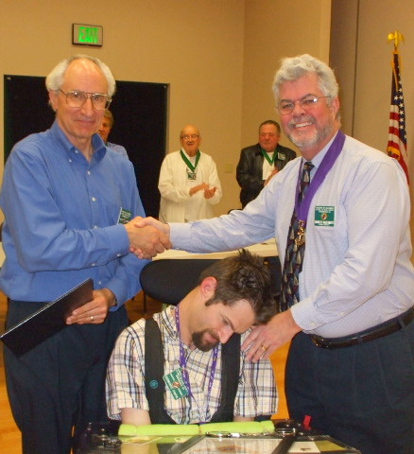
He is a third degree member of the Knights and our Council representative to the Columbian Retirement Home in Marysville, CA. He has assisted the KofC and the parish by his work at the Hoe Down, Tootsie Roll Drive for the Mentally Handicapped, desserts for the Corporate Communion Mass, Spaghetti Dinner, Pancake Breakfast and Treasure Fest. Also, he provides and distributes flowers on Mother's Day. His wife who is definitely his better half has enriched our parish by being a lector, Lay Eucharistic Minister and through her leadership in organizing and serving communion to parishioners in their homes and assisted living locations. This family represents a total commitment to participate and improve the quality of life in our parish.
This brother Knight has a son who is also a Knight; having both joined the KofC on July 2004 and both are members of our Council. He assists our Council in the following manner: He attends Knights of Columbus meetings, sells roses or Mother's Day, assists at the Tootsie Roll Drive for the Mentally Handicapped, and always attends Mass. Currently, he is attending classes in the area of Criminal Justice at Folsom Community College and has attended other community colleges in the Sacramento area. He is a courageous and inspirational member of the Knights of Columbus. This person and his family are to be commended for their strength, wisdom and total support of our parish. Please join me in congratulating our “Co- Family of the Month” VINNY AND KAREN PAPPA AND THEIR SON Dominic Pappa .

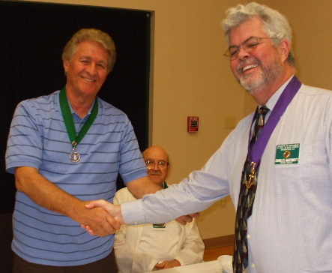
New Knights
(Presented by Charlie McDermott)

Please welcome to our Council our new Brother Knight- Sam Cimino!!!

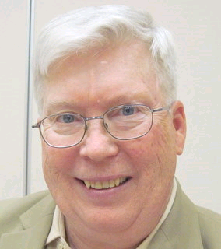
Recorder’s Motions
(As presented by Ray Coughlin)

Motions at March Meeting

The following motions were approved at the April 6th, 2010 general membership meeting:
- Under old business, the general membership present voted to advance Michael Duskus, SK Bill Wagner and/or the Mather Golf Course up to $8,000.00 for expenses relating to the golf tournament. This is a budgeted item at $5,600.00 and was made, and seconded at the March meeting to be published prior to voting.
B) Under new business, the general membership present voted to:
1) Approve payment of the monthly bills presented to the general membership and reviewed by the Trustees,
- Send Grand Knight Charles McDermott and Past Grand Knight Robert Cunha, as delegates, to the 2010 State Convention scheduled for May 20 - 23, 2010 in San Jose, CA. The Council to pay for the transportation, lodging and meals for the delegates, less any reimbursement by California State Council or Northern California Chapter. In event, either delegate cannot attend, the Grand Knight has appointed alternate delegates of DGK SK Bruce Pyle and FS SK Michael Wagner. Council to advance each attending delegate $500.00 to cover projected expenses. This is a budgeted item for $1,000.00. Maker: SK Michael Wagner; seconded by: SK Ray Coughlin. Type of Funds: General,
- advance SK Ray Coughlin $100.00 to purchase food, drinks and supplies for the insurance information night scheduled for May 4th. This is an unbudgeted item. Maker: SK Ray Coughlin; seconded by: SK Bruce Pyle. Type of Funds: General, and
- donate $25.00 to the K of C Northern Californai Chapter to assist in paying for a plaque to honor Bishop Weigand noting the completion of the renovation of the Cathedral of the Blessed Sacrament. This is a request from Chapter President SK John Norwood and is an unbudgeted item. Maker: SK Michael Wagner; seconded by: SK Ray Coughlin. Type of Funds: Charity.
C) The following motion was made, seconded, and to be published prior to being voted upon at the next general membership meeting: advance SK Bruce Pyle and /or SK Bill Wagner up to $1,200.00 for pre-sales expenses for the fireworks booth. These expenses are equipment rental (storage bin, generator, lights, fan, etc.) and license and inspection fees. Also, pay to Phantom Fireworks up to $12,000.00 for the cost of fireworks and service rendered. Also, pay to California Board of Equalization up to $2,200.00 for the 8.75% state sales tax on gross sales. Projected gross sales at $22,000.00 with a 50/50 split of gross sales. This is an approved event but an unbudgeted item. Maker: SK Bruce Pyle; seconded by: SK Bill Wagner. Type of Funds: General.

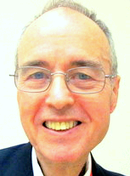

District Deputy News
(Presented by Eldon Hancock, District Deputy)

Eldon announced that this was going to be his last year serving as District Deputy. The new District Deputy is going to be John Norwood. The 2nd Monday of the Month is the 1st Degree Ceremony. There is an upcoming Chapter Meeting at St. Rose’s on May 1st. There is an upcoming State Convention in San Jose. Each Council needs to have two representatives in attendance at the Convention.

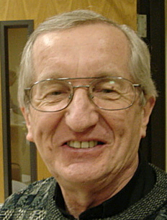
Reflections from the Chaplain
(Fr. Roman Mueller, SDS)

No reflections for this meeting

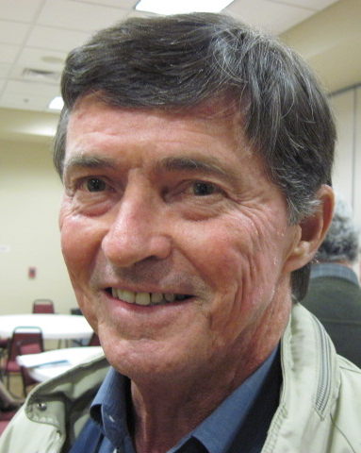
Let the Sunshine
(As presented by Tom Hogan)

Cards are available to be sent out to members and families in need. For future need, please remember to contact Tom Hogan with any sunshine activity or prayer cards that need to be sent.

You can contact Tom at 916-988-2184 or 1mosel@comcast.net.

Remember that we really don’t know how far a little kindness will go.

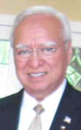
District Insurance News
(Presented by Tony Magdaleno)

KNIGHTS OF COLUMBUS INSURANCE

Making a difference for life

FRATERNAL YEAR – STAR COUNCIL:

Now is the time to be looking ahead and taking stock of attaining your council’s Coveted Star Council Award Goals. The June 30, 2010 deadline will come quickly enough. I will help you in any way I can to meet those goals for the 2009-2010 Fraternal year. I’m certainly committed to helping on the insurance side, but I’ll be glad to help on the membership side as well.

If you know an eligible Catholic man who might be interested in joining the Order (and who among us doesn’t), he’s probably just waiting to be asked. I can help you, either by approaching him myself, or by “coaching” you – transferring sales skills that you can use to recruit him and other prospects. As always, I’m at your service.

Let’s continue our momentum for attaining those goals and objectives that are so critical to the growth of your council: Recruitment, Insurance members and council activities.

With all of us working together, our fraternal leaders and our professional field force, we can help the Order to continue to grow and obtain the Coveted Start Council Award.

I’m at (916) 470-9205 or tony.magdaleno@kofc.org. Call me – let’s talk.

God bless you all.

Fraternally, Your Brother and Field Agent,

Tony Magdaleno (916) 470-9205
FA 14661
CA Lic. #OG27147
P.S. NEW MEMBERS, ASK ABOUT OUR NEW MEMBER ANNUITY PLAN!!!

Committee Report - Membership
(Presented by Ray Coughlin)

We are still in need of approximately 2 New Members by the end of April- WE NEED EVERYONE’S HELP!

Our membership tally is now at 125 members. If you know of someone who would like to join our council, please refer them to Ray Coughlin at (916) 989-

4226 or Tony Magdaleno at (916) 470-9205.
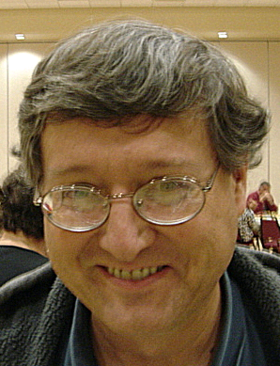

Committee Report - Youth
(Presented by Bill Manos)

.

Bill Manos reported the all is quiet on the Youth Program… at least for now. Bill Manos at 965-3834 with any Youth Service Program questions
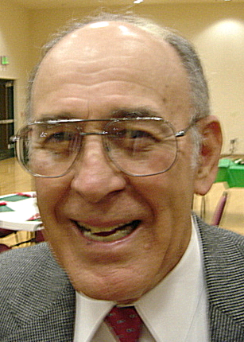

Committee Report - Family
(Presented by Guy Sanchez)

Guy Sanchez announced the plans for our Spring Social event. On May 7, we can all attend the River Cats Game. Arrangements are being made for a chartered bus. The bus will depart from Divine Savior at 5:10 pm and will cost a paltry $12 round trip per person. A bargain compared to expending your gas and paying for parking! Game time is 7 pm. Hot dogs and ice cream are only $1. Further details will appear in an email/flyer.
.
Please contact Guy Sanchez at 965-3834 with any Family Service Program questions.

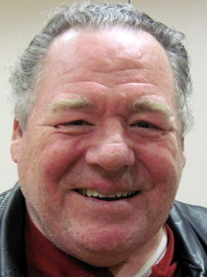

Committee Report – Council
(Presented by Bill Windle)

Bill Windle announced that the next Pancake Breakfast and Blood Drive will be May 16th. Please contact chairman Joe Rapier to assist with the breakfast, and chairman Andy Ventimiglia to donate blood.
Our last breakfast, March 21, we served 117 paid diners. This next time we’ll be changing the meat to ham.
Recycle Day is scheduled for May 8th. Times will be from 10am to 2pm. Contact our co-chairman Rob Cunha for further info and to assist.
Vinny Papa reported on the Columbian Retirement Home in Marysville. They still have room available and cost is cheap compared to other similar commercial operations.
Since Council Elections are nearing, Bob Reilly reported that there are several positions for which we need nominees. Anyone interested in holding office, or in nominating someone, should contact Bob.
The annual State Convention will be May 20-23 in San Jose.

Please contact Bill Windle at 988-2239 with any Council Service Program questions.

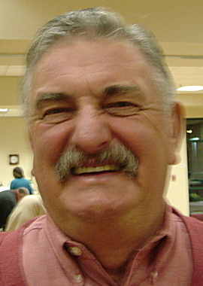

Committee Report – Church
(Presented by Dan Freeman)

Dan Freeman thanked all the brothers, 14 of them, who assisted with the environmental arrangements in the church for the various Easter services. Special mention was made about those who helped set up the hall at 4 am on Easter morning.
Our corporate communion on March 14th (11:30 mass) was not attended as well as those in the past. Our next council Corporate Communion will be Nov. 21.
As we do each year, the council will distribute Mother’s Day Roses after masses on May 8-9.
April 24: Our council will be moving a pile of tiles from the vacant lot into storage at/near the hall. It’s estimated that the job, starting at 9 am, will be concluded in less than 3 hours. A couple pickup trucks and several brothers are needed to make light work of this effort. Call Bill Windle.

Please contact Dan Freeman at 987-0908 with any Church Service Program questions

.

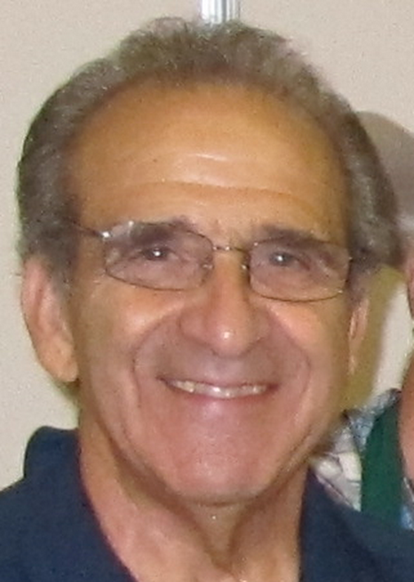
Committee Report - Community
(Presented by Tony Aiello)

Tony Aiello reported that efforts to develop a community marketing program will be deferred until next term.
May 21 is our council-sponsored Golf Tournament. Mike Duskus and Bill Wagner are chairing and they need help soliciting businesses as sponsors.
Bruce reported on the 40-days for life efforts. On 3 Fridays during lent, members of our council attended mass, received a special blessing from Fr. Roman, and held a prayer vigil at the abortion clinic on Sunrise in Roseville. Those who attended agreed that this was a moving and most worthwhile use of our time.
Pro-Life events for April were summarized. There are state constitutional initiatives in the works regarding the definition of a person and the prohibition of abortion for unemancipated minors. We are encouraged to sign these petitions and support these efforts.
Bruce and Bill Wagner talked about our proposed Fireworks Booth, planned for the week leading up to Fourth of July. Locations are being negotiated. Signups are needed to sell, for daily set-up and teardown, and for night security. The sales shifts will be 3 hours. This could be our largest fund-raiser of the year. We need plenty of help. Contact Bruce or Bill to assist.

Please contact Tony Aiello at 987-0908 with any Community/Pro-life Service Program questions

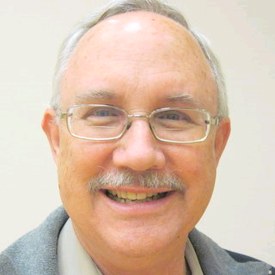
Future Council Planning Report
(Presented by Bruce Pyle)

Bruce thanked all who had accepted nominations and encouraged everyone to think about serving our council in some capacity this coming Columbian year. He also asked that anyone interested in being a Service Program Director or other event chairman to please talk to him.


Committee Report – Pro-Life
(Presented by Mike Schafer)

PRO-LIFE NEWS & ACTIVITIES for APRIL 2010

As Knights are truly a Pro-Life organization, please participate, and invite others to join you, in a PL activity this month.

The number one cause of death in America is ABORTION- the needless sacrifice of our unborn children at the ‘altar of convenience’. Please remember that ‘abortion is NOT healthcare’!

It is very important that each of us contact our representatives in Congress to vote ‘NO’ on the National Health Care bill which now still includes funding for abortion. The congress could be voting on this in the next few days. Phone numbers include: Senator Boxer @ 916/448-2787; Senator Feinstein @ 202/224-3841; and House Speaker Nancy Pelosi @202/225-4965.

The 2010 ‘40 Days-For-Life’ ended March 28th. Thank you Knights for your participation at any of the four abortion clinics in the Sacramento-Roseville area. We’ve heard that some 458 babies have been saved nationwide, and know that at least one was saved at the Sacramento Planned Parenthood abortion clinic this lental period.

Local abortion clinics that continue to need prayerful presence include (Please call as clinic hours vary):

- Choice Medical Clinic @ 2322 Butano Dr., Sacramento (across from the old Gottschalks, west of Watt Ave); (call Karen at 916/396-7997 for info)

- Sacramento Planned Parenthood @ 29th & B St; (call Charles at 916/396-7997 for info)

- Women Health Specialists @ 1750 Wright St; (call Mary at 916/254-4444 for info)

- Roseville Planned Parenthood @ 729 Sunrise Blvd; (call David at 916/784-0765 for info)

Abortion doesn’t only break the Fifth Commandment, ‘Thou shall not kill’. It breaks all the Commandments. Father Frank Pavone of Priests for Life has written an article demonstrating this on his website, Priestsforlife.org/articles/document.

Upcoming Pro-Life events:
Please sign the two initiative measure petitions now being circulated:

- Change State Constitutional definition of a PERSON to include equal protection to all fertilized human eggs from the commencement of biological development. (Human Rights Amendment). Please take one or more petitions home with you and have your neighbor’s friends and co-workers sign also. They are on the side table.


Special Prayer Intentions

Please keep the following people in your prayers:

- Debbie McDermott- wife of Charlie McDermott (Neurological Disorder)
- Linda Aiello- wife of Tony Aiello (surgery)
- Julia Rapier- mother of Joe Rapier (memory)
- Earl Varney (pneumonia/out of the hospital)
- Sick: Tony Magdaleno, Paul Hoefling, Barbara Lawson, Paul Pyle, Ladene Carvalho, Ernie Deus, Eldon Hancock, Martin Jennings, Jack Joiner and Beverly Ridge
- Deceased: Margaret Quigley, Bob Brodie, Toodie Jennings and George Mann

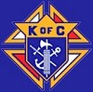

Primary Duties of Council Officers

Father Neil W. Seidl Council No. 13672

Grand Knight: The Grand Knight (GK) is the Chief Executive Officer of the Council. He presides over all meetings of the Council and officers, appoints committees, appoints non-elected officers, recommends appointments, secures a Chaplin, appoints committee chairman, countersigns orders drawn for payment of Council funds, countersigns checks, responsible for a Council budget, prepares a Council activity calendar, provides a monthly GK report to the Council newsletter editor, assures that all moneys sent to the treasurer by the financial secretary are deposited, reads or has read any notices pertinent to the Council, represents the Council at state meetings, is chairman of the board of trustees, and is a member pro-tem of all committees and any other duties the Order may impose. For more information, contact Worthy GK Joe Luchi.

Deputy Grand Knight: The Deputy Grand Knight (DGK) is second in command. He assists the GK with Council affairs and fulfills all duties assigned to him by the GK. Should the Grand Knight be absent from a Council meeting, the DGK will preside. He is chairman of the Council’s retention committee and serves as Program Director. For more information, contact Worthy DGK Charlie McDermott.

Chancellor: The Chancellor has a variety of responsibilities. Primarily, he assists the GK and the DGK in the execution of their duties and oversees the Council in both their absences. He is charged with strengthening the members’ interests in Council activities. For more information, contact Worthy Chancellor Guy Sanchez.
Warden: The Warden is the "watchdog" for Council property and degree paraphernalia, except the property of the Financial Secretary, Treasurer and Recorder. He is also responsible for setting up the Council chambers for meetings and ceremonial work, confirms all present at meetings are possessed of the current membership, has charge of and keeps in proper condition all Council property, except for moneys and accounts and record books of the officers. For more information, contact Worthy Warden Don Marnach.
Financial Secretary: The Financial Secretary (FS) is not elected by the Council; but, instead is appointed by the Supreme Knight, upon recommendation of the GK. The term of office is three years. The FS’s main area of responsibilities is maintaining all financial and membership records. The FS collects and receives all moneys from all sources, including annual dues from Council members. He also handles supply orders for the Council officers and members, filing the Report of Officer (#185), and submitting all membership transactions to the Supreme Council. The FS delivers all collected Council funds to the Treasurer at the end of each meeting and keeps Council records, including: number and names of candidates for admission, elected candidates, and initiates. The FS, in coordination with the GK and the Treasurer, prepares the Council budget. For more information, contact Worthy Financial Secretary Mike Wagner.
Treasurer: The Treasurer is responsible for the safekeeping and maintaining of records of all Council funds and accounts. He is responsible for depositing money into the Council’s accounts and provides a certificate of such monies to the GK. He is also responsible for payment of all expenses. He receive all Council funds from the FS, deposits all funds in a bank in a Council account, assists in preparation of the Council budget, and disburses funds from the Council account only with a properly completed Order on Treasurer and co-signature of the GK. For more information, contact Worthy Treasurer Don Rose.
Recorder: The Recorder is similar to a court reporter or a secretary. He is responsible for maintaining a true record of all actions of the Council and its correspondence. The Recorder keeps an accurate record of the doings of his Council, reads all bills, and conducts all correspondence of the Council. For more information, contact Worthy Recorder Ray Coughlin.
Advocate: The Advocate is the legal representative of the Council and serves as the Council’s attorney at trials and investigations of any interest to the Council. While he does not need to be a member of the legal profession, he should be familiar with the Council by-laws, the Order’s Charter, Constitution and Laws (#30), Methods of Conducting a Council Meeting (#1937), and Robert’s Rules of Order. For more information, contact Worthy Advocate Dave Brodie.
Trustees: The Board of Trustees consists of three members elected by the Council and the GK, who serves as chairman of the board. They oversee the work of the Financial Secretary and Treasurer, and with the DGK serve on the Council’s retention committee. During Council elections, only the three-year trustee is voted on, with the others moving on to become two and one-year trustees, respectively. For more information, contact Trustee 1st Year and PGK Dan Freeman, Trustee 2nd Year and PGK Bill Windle, or Trustee 3rd Year and PGK Mike Duskus.
Inside and Outside Guard: The Guards have similar responsibilities, but distinct differences. The Outside Guard tends to the outer door admitting visitors and members to the inner door. Once at the inner door, the Inside Guard checks to make sure membership cards are current. For more information, contact Worthy Inside Guard Bob Reilly or Worthy Outside Guard Steve Mann.
Lecturer: The Lecturer is appointed by the GK to provide both educational and entertaining programs to the Council. He is responsible for the "Good of the Order" portion of Council meetings. In order to provide members with informative and educational programs, he must be knowledgeable and aware of all Council programming. For more information, contact Worthy Grand Knight Joe Luchi.

April / May Birthday List

Name Birthday
John Fontana 6-Apr
Michael McCormack 9-Apr
Brian Pertl 22-Apr
We would like to wish each of the members listed a Happy Birthday!!!
John Ridge 23-Apr
Alvin Baughman 25-Apr
Robert Cunha 25-Apr
Dennis Harrington 25-Apr
Charles (Charlie) McDermott 30-Apr
Peter Burriesce 1-May

Tony Magdaleno 2-May
Dominic Papa 3-May
Joseph (Joe) Rapier 6-May
Robert Howe 21-May
Raymond Torres 21-May
Charles Lyons 22-May
James Haak 24-May
Don Rose 30-May

Our Upcoming Events

Date Event Day(s) Location Charity Focus

April
6-Apr Business Meeting Tuesday Parish Hall
24-Apr Recycle Day Saturday Saturday Church St. Vincent DePaul
Parking Lot
29-Apr Officers Meeting Thursday

May
4-May Business Meeting Thursday Parish Hall
4-May KofC Information Night Thursday Parish Hall
7-May Social- Baseball Saturday River Cats
8-May Council Social Friday Parish Hall
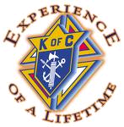
8-May Mother Day Roses Saturday & Vestibule
Sunday
16-May Blood Drive Sunday Parish Hall
16-May Pancake Breakfast Sunday Parish Hall
21-May Golf Tournament Friday Mather
27-May Officers Meeting Thursday Parish Hall

June
1-June Business Meeting Tuesday Parish Hall
1-June Election of Officers Tuesday Parish Hall
5-June Membership Weekend Saturday & Vestibule
Sunday
24-June Officers Meeting Thursday Parish Hall
26-June Officer Installation Saturday Church
Council Barbeque Saturday Freeman’s
28-June 4th of July Fundraiser Begins
July
5-July 4th of July Fundraiser Ends
6-July Business Meeting Tuesday Parish Hall
10-July Officer’s Installation Saturday Main Church
18-July Pancake Breakfast Sunday Parish Hall

