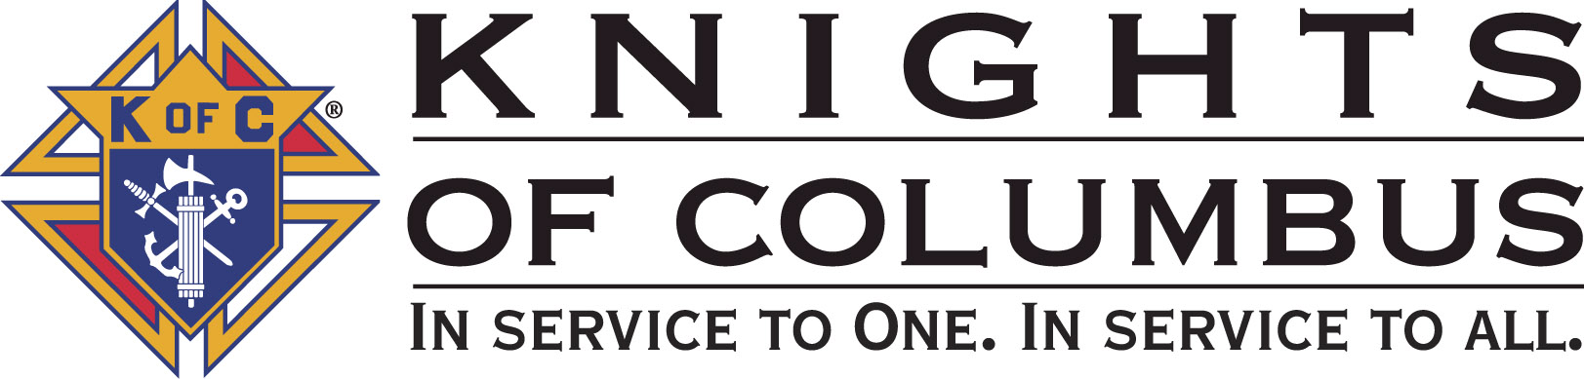

Council #13672 at Divine Savior Fr. Neil W. Seidl
Orangevale, CA
December 2010 Volume 9, #6

Monthly Grand Knight’s Message

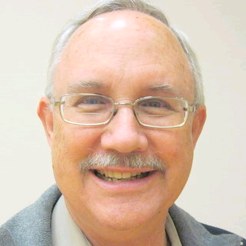
Grand Knight Bruce Pyle

Dep. Grand Knight Tony Aiello

Fin. Secretary Micheal Wagner

Treasurer Allen Brown

Chancellor Jack Hill

Warden Bob Reilly

Advocate Dave Brodie

Recorder Ray Coughlin

Trustee 1st Yr Charlie McDermott

Trustee 2nd Year Bill Windle

Trustee 3rd Year Mike Duskus

Inside Guard Douglas Copley

Outside Guard John Carvalho

Chaplain Fr. Roman Mueller

Lecturer Sam Cimino

Field Agent Tony Magdaleno

The Knights of Columbus Council #13672 at Divine Savior Fr. Neil W. Seidl Chapter meets Monthly on the First Tuesday of each month at 7:00 p.m.
Please join us to help our Catholic Community.
For insurance needs, please contact our Field Agent Tony Magdaleno at 470-9205 or by mail at
P.O. Box 2737
Rancho Cordova, CA 95741
Greetings Brother Knights:

December, we’re into Advent and Christmas is rapidly approaching. To recap the past month…

- We celebrated Veteran’s Day and our council hosted a reception for the parish. A great pair of events, and big thanks to Joe Luchi and the team.
- Mike and Tony represented us at Chapter (Grass Valley, 11/20).
- Our Corporate Communion and Memorial Mass was well attended on the 21st. Thank you Dan Freeman for coordinating that one.
- The vacant lot is more vacant (except for Freddie Sigur’s truck) thanks to the hard work of a few dedicated Knights.
- The church is beautiful thanks to Dan and the decoration team.
- The Christmas social was superb. Thanks to Guy and Sandra Sanchez, their son Chuck, our baker extraordinaire (Doug Copley) and all who helped, brought food and nativity scenes, and shared the beginning of the season.
- We participated in the advent masses the 4th and 5th with readings and candle processions.

We welcomed 4 new members to the council on Saturday morning (Dec. 4th) at the 1st degree presented at St. John’s, Folsom. Please welcome: Ed Feldmann, Jim Grove, John Okaru and Bernie Sabonis.

This month, there is plenty to help with. To participate in Posada after mass on the 18th or to help set up the church for Christmas at 3 pm the 19th, call Dan Freeman (987-0908). And, to set up chairs in the church (9 am the 22nd), or take them down (9 am the 27th), call Dan. To help with the CYM potato bar (5-8:30 pm the 12th), call Bill Manos (965-3834). And to sign up for the San Francisco Walk for Life on Jan 22nd (busses are filling fast), call Mike Schaefer (988-3171).


Merry Christmas!
Thanks to all who have helped on our events. Once again, we have beautifully demonstrated our principles of Charity, Unity and Fraternity. To all, I wish you the happiest and holiest of Christmas seasons

Fraternally yours,

Bruce Pyle, Grand Knight

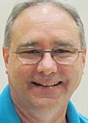

Treasurer Report
(Presented by Allen Brown)

KOC Council No. 132672 – Date balanced: 12/7/2010

Business: $9,969.58
CD 50 - 52: $3,249.79
Charity: $23.00
Total: $13,242.37

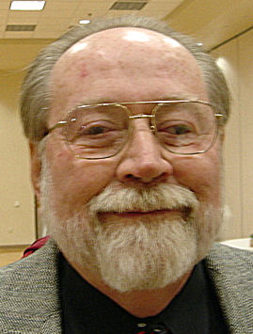

Financial Secretary’s Corner
(Presented by Michael Wagner)

Batch 68 $585.99
Christmas Social $126.00
Product rebate $5.99
Fireworks booth $400.00
Raffle $39.00
Oktoberfest $15.00
Batch 69 $672.00
Christmas Social $672.00
Batch 70 $1127.58 (Charity Account)
Charity Account Funding $1127.58
Grand Total $2385.57


2011 Dues
It is that time again; the 2011 Dues letters will be mailed around December 15th. Dues for 2011 are $37.00 and are due on January 1, 2011. As in years past, a voluntary request for a $3.65 donation to the California Columbian Charities (365 Club) will be included. Also, the 2010 Survey of Fraternal Activity will be included.

Please consider paying your dues and completing and returning the Fraternal Activity survey by January 15, 2011; this will allow us to tabulate the numbers and file our council report by the January 31 deadline.

California Columbian Charities Request (365 Club)

At this time of the year, we are making an appeal to members of the Knights of Columbus to join the “365 Club”. Your donation of $3.65 (one penny a day) will go to California Columbian Charities, Inc., which provides emergency assistance to needy California Knights and their families. This past year utilizing funds provided by Councils during the Parade of Grand Knights held annually at the State Convention, California Columbian Charities disbursed almost $200.000 in grants to California Knights of Columbus members and their families in distress. Please join in helping your Brother Knights by your participation in this most worthy program.

Our founder, Fr. McGivney, started the Knights of Columbus to provide for widows and families in need by collecting donations from all of his members and disbursing them to the needy families. Columbian Charities is continuing this act of “Charity” by assisting Brother California Knights and their families in need. Through your desire and willingness to help your Brothers in need and the guidance and Blessing of our Lord and Savior, we can continue to assist our Brothers and their families in need.

Thank you in advance for your generous donation and participation in the 365 Club.

2010 Survey of Fraternal Activity
Last year, the Knights of Columbus donated more than $130 million to charitable and benevolent causes and 61.1 million hours of volunteer community service to aid the less fortunate. To help prepare our Fraternal Survey for the Supreme Council office, you will be asked to complete the “Individual Member Worksheet” that will be mailed with your dues letter in December. Please spend a few moments over the next few weeks thinking about our volunteerism for calendar year 2010. This information will assist us in determining the total number of hours of community service volunteered by our members in 2010.

Your volunteerism hours are not limited to Council functions, please consider and report ALL of your volunteer hours whether they were at the parish, your work, your children/grand children’s school, or any other location or sponsor. Sick and bereavement visits include visits to brother knights, your family and friends, neighbor, co-workers and even strangers.

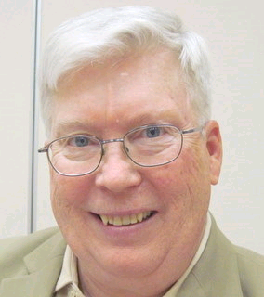

Recorder’s Motions
(Presented by Ray Coughlin)

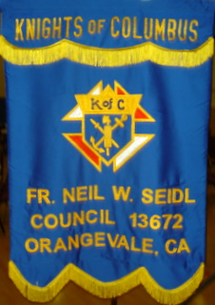
The following motions were presented, seconded, and passed by the general membership present at the meeting held on December 7th, 2010:

A) All monthly bills presented to and recommended for payment by the Trustees; and B) That the Council donate $423.45 to Camp ReCreation. This is the net proceeds from the Octoberfest Dinner less $475.00. The $475.00 is being held to fund 1 camper from the parish, if he/she is selected to attend camp in 2011. This is an unbudgeted item. ( If no selectee to the camp, then the $475.00 will be donated to the Camp). Maker: Michael Wagner; seconded by: Ray Coughlin. Type of Funds: Charity.

On December 4th at St. John the Baptist in Folsom, our Council had 4 new Knights added to our membership- the largest single induction in years. I ask all Knights to welcome Ed Feldmann, John O'Karu, Jim Grove, and Bernard Sarbonis when you see them. This marks a great start for our recruitment efforts for the coming new year. The Admissions chairmen wish a Holy and Merry Christmas and a Happy New Year to all!

Knight of the Month
(Presented by Bruce Pyle)

Our Knight of the Month will be highlighted in the January Newsletter.

Family of the Month

(Presented by Bruce Pyle)

Our Family of the Month will be highlighted in the January Newsletter.

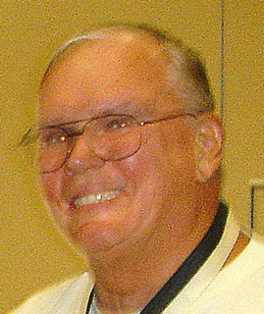

Let the Sunshine
(Presented by Jack Hill)

Cards are available to be sent out to members and families in need. For future need, please remember to contact Jack Hill with any sunshine activity or prayer cards that need to be sent.

You can contact Jack at 916-989-2106 or jack014@aol.com.

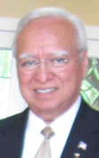
District Insurance News
(Presented by Tony Magdaleno)

KNIGHTS OF COLUMBUS INSURANCE
“YOUR SHIELD FOR LIFE”

The Holidays Are Fast Approaching!! Are You Ready For Your Insurance Check-up for 2011?
Now that the holidays are fast approaching! Can you believe it will soon be 2011? I hope that 2010 has been a healthy, prosperous year for you and your family. It’s said that time flies, and the older we get, the more that statement seems true. As we review the past year and prepare to welcome a new one, we wonder where the time goes.
If you’re like most people, you’ve made some resolutions for 2011. If I may, I’d like to make two suggestions regarding your resolutions.
First, write them down. A resolution is really a goal for the year and, until you commit a goal to writing, it may only be a wish. Writing a resolution down is the first step towards achieving it. Whether your goal is to lose weight, contribute more time and money to charity, read more or watch less television, you’re more likely to accomplish it if you write it down.
Second, schedule some time to visit with me, your professional Supreme Knights of Columbus Field agent. The “insurance check-up” that I’ll provide Free, can quickly identify any gaps in your family’s protection programs. Filling any gaps now is better than later. Unlike many other products, you need more than money to obtain life insurance. You also need good health, and you won’t get a warning when yours is about to change.
Knights of Columbus life insurance offers something precious few other financial products can – Guarantees. As long as you pay your premiums, the policy proceeds will be there for your loving family went the time comes. We call that peace of mind, to you now and to those left behind that is Priceless.
This Holiday Season, remember the real meaning of CHRISTmas. Keeping CHRIST in CHRISTmas. Take time to enjoy your family and friends. Think of those things God has given us. Remember, YOU are the one your family counts on for tomorrow’s support. The Knights of Columbus is here to help assure YOUR mission is met.

Please feel free to contact me any time for a Free evaluation of your family’s converge. I can be reached anytime on my cell phone, (916) 470-9205.

Fraternally, Your Brother and Field Agent,

Tony Magdaleno
Field Agent #14661 CA Lic. # OG27147

Committee Report - Membership
(Presented by Ray Coughlin)

On December 4th at St. John the Baptist in Folsom, our Council had 4 new Knights added to our membership- the largest single induction in years. I ask all Knights to welcome Ed Feldmann, John O'Karu, Jim Grove, and Bernard Sarbonis when you see them. This marks a great start for our recruitment efforts for the coming new year. The Admissions chairmen wish a Holy and Merry Christmas and a Happy New Year to all!

If you know of someone who would like to join our council, please refer them to Ray Coughlin at (916) 989-4226 or Tony Magdaleno at (916) 470-9205.

Welcome New and Returning Knights
(Presented by Mike Wagner)
Four new brother Knights, Edwin Feldmann, James Grove, John Okaru, and Bernard Sabonis, went to St John the Baptist on December 4th to attend their first degree exemplification. They were escorted by GK Bruce Pyle, PGK Dave Brodie, DGK Tony Aiello, Membership Director Ray Coughlin, and FS Micheal Wagner. Congratulations to our 4 new Knights.

Tony Makarczyk has reactivated his membership in the Knights of Columbus and our council after a few years of absence. Welcome back Tony.

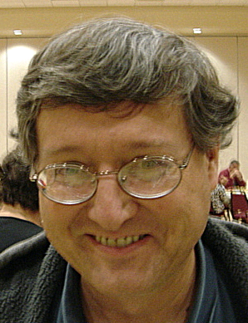

Committee Report - Youth
(Presented by Bill Manos)

Soccer Chapter semi-finals at St John’s in Folsom on Oct. 31. Divine Savior had 3 that qualified to the state finals in Napa on Nov. 7th.
Scouting Retreat at Marello Retreat Center in Loomis on Oct. 15th-17th. Three Divine Savior scouts received medals for Catholic Education and studying the church’s 7 sacraments. Bill Manos and Rob Cunha served as consolers.
CYM held their annual Potato Bar on Dec. 12th that was attended by 150 students and family. The Knights, with the help of five brothers helped prepare and serve this fun event.
The annual Basketball Challenge will begin on Jan. 9th at St John’s in Folsom. It will run from 10-2 and will include girls and boys from ages 10-14. Bill will need 5-6 Knights to help, call him 813-8864, to help.
Please contact Bill Manos at (916) 965-3834 with any Youth Service Programs questions.

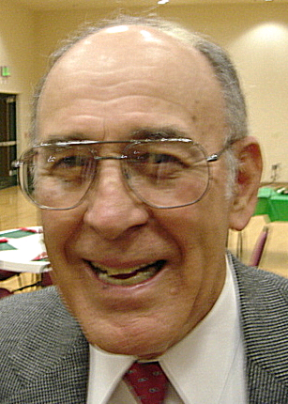
Committee Report - Family
(Presented by Guy Sanchez)

On Dec 3rd we had our annual Christmas social that was organized by Guy and Sandra Sanchez and a wonderful group of Knights and their families. The food was great, each table had an advent center piece that were made from different countries and displayed by families. Mike Wagner gave a brief talk, as well as showing pictures about his resent trip to Mexico to deliver Wheelchairs from the Knights. A special thanks to all that made this a special evening.
Please contact Guy Sanchez at (916) 965-3834 with any Family Service Program questions.

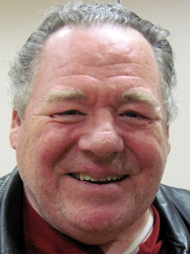

Committee Report – Council
(Presented by Bill Windle)

Mark Your January Calendar! On Sunday, January 16, 2011, our council will be hosting a Pancake Breakfast and Blood Drive from 8:00 am to 1:00 pm in the multipurpose building.

There will be a table in the vestibule after all Masses on January 1st, 2nd , 8th , and 9th to sign up for the Blood Drive. All donors who try to donate are provided a delicious free pancake breakfast consisting of pancakes, syrup, scrambled eggs, hash brown potatoes, ham, a fruit cup, coffee, and juice.

For more information on the Blood Drive, please contact Andy at 728-2776 or Dave at 988-6678. To volunteer for the pancake breakfast, contact Doug Copley at 987-0455.

Save your old TV, computers, printers as well as papers to be recycled. On Sat. January 29th it will be Recycle Day at Divine Savior parking lot. Call Bill Windle for more information.
Please contact Bill Windle at (916) 965-3834 with any Family Service Program questions.

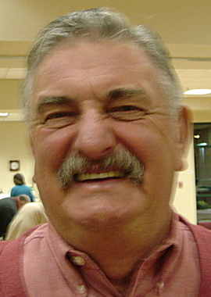

Committee Report – Church
(Presented by Dan Freeman)

Corporate Communion was held at the 7:45 mass on Nov. 21st. It was a nice turnout of Knights and their wife’s, and was followed by reception in the hall. It would be nice to double the attendance at the next one.
Veteran’s Celebration was held on Nov. 12 in the church, giving honor to that served from Divine Savior. Joe Luchi chaired this event with the help of many of our Knights. After church a reception was hosted by our chapter, and a lot of memorabilia was on display from the different wars. Don’t miss this next year.
On Nov. 27th many of our Knights help decorate the church for advent. Dan Freeman headed this special project .
Please contact Dan Freeman at 987-0908 with any Church Service Program questions.

American Wheelchair Mission
(Presented by Mike Wagner)

On February 4th, the Sacramento Kings will play the Spurs. The Kings and the Northern California Chapter of the Knights of Columbus are partnering to donate 25% of tickets sales to Knights, family and friends to the American Wheelchair Mission; The Chapter is hoping to get 200 people to the game. This is an easy way to donate money to a very worthy cause and to be able to enjoy a night of basketball. Lease contact GK Bruce Pyle, DGK Tony Aiello or FS Micheal Wagner for ticket information, as the tickets need to be purchased through the Chapter.

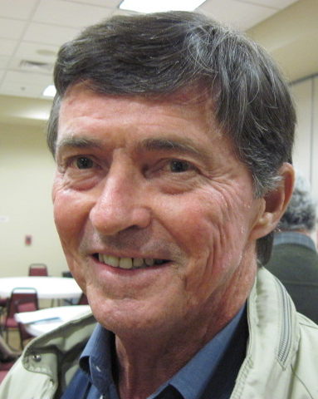
Committee Report - Community
(Presented by Tom Hogan)

Our annual ID( tootsie roll) drive was held on Oct. 15th,17th and 22nd at Vic’s and WalMart. Dave Brodie chaired this event with Bob Peterson and Dan Freeman as team leaders. We raised over $2000.00, great job everyone.
We have started planning our annual golf tournament. Brother Michael Subbotin has volunteered to chair this event. The planning committee is researching the different courses in the area. More information will be coming out as they progress. Michael will need the help many even if you don’t golf, there’s a lot to plan. He also would like the help of our woman’s auxiliary to help plan the different events.

Please contact Tom Hogan at 988-2184 with any Community Service Program questions.

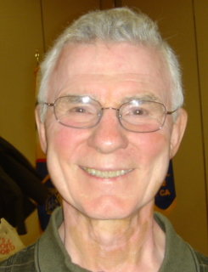


Committee Report – Culture of Life
(Presented by Mike Schaefer)

PRO-LIFE NEWS & ACTIVITIES for December 2010

If a Church said they would sacrifice a little child on their altar, the State would step in and stop that. No one would regard that action as an infringement of the separation of Church and State. Neither is it an infringement when the Church tells the State it cannot authorize the killing of children by abortion.

As Knights are truly a Pro-Life organization, please participate, and invite others to join you, in a P-L activity this month and the days ahead.

A Pro-Life Mass is held monthly (2nd Tuesday @ 6:00pm) at St Philomene’s Church located at 2428 Bell Ave. The next Mass will be December 14th. Rosary starts at 5:30pm. (Call Sally @ 916-721-0378)

At 5:00 pm on Tuesday Dec 28th, the Feast of the Holy Innocents, a candlelight procession will start at the Cathedral and will process to Our Lady of Guadalupe parish for Mass at 6:00 pm. This annual march commemorates the male infants under 2 years killed by law of King Herod over 2000 years ago, and reminds us of the 53 million babies killed by law through abortion since 1973. Candles will be provided.

The Sacramento Life Center is still in need of a few good men to volunteer 4-6 hours/week to drive their new 32 foot Mobile Medical Van in and around the Sacramento Valley area. (For further information, email Ron at ronkincaid@comcast.net)

Walk-for-Life, West Coast in San Francisco, will be held on Saturday January 22, 2011. Make plans now to get-on-the-buses at St Mel’s, Holy Family or St John the Baptist- Folsom, before they fill up. Cost is ~ $24 per person. See the WALK FOR LIFE WEST COAST website or contact David Colt (phone 916/784-0765) for all the details.

May you and your family have a Blessed and Merry Christmas!! Aren’t you glad Mary was pro-life??

Any questions to the above please contact Mike Schaefer at 916/988-3171, or: mikeret_99@yahoo.com.

Special Prayer Intentions

Please keep the following people in your prayers:

- Tom Larson (cancer)
- Rich Dean (chemo- cancer)
- Peter Burriesce (dialysis/foot healing)
- April Paulitz- wife of Patrick (cancer)
- Debbie McDermott- wife of Charlie McDermott (dementia)
- Julia Rapier- mother of Joe (memory)
- Lillian Zettel- mother of George (pelvic cancer)
- Bruce Wagner – brother of Bill
- Barbera Lawson (sick)
- Ladene Carvalho (sick)
- Martin Jennings (sick)
- Beverly Ridge (sick)


December / January Birthday List

Michael Schaefer | 2-Dec
Earl Varney | 5-Dec
Kenneth Hurst | 12-Dec
John Chavez | 13-Dec
Gary Stout | 16-Dec
Abraham Rodriguez | 19-Dec
Joseph (Joe) Luchi | 21-Dec
Father Patrick Nelson (SDS) | 21-Dec
Ernest Deus | 25-Dec
Pierre Mesa | 26-Dec
Robert (Bob) Peterson | 29-Dec
John Hill | 4-Jan
Michael Lawson | 11-Jan
Vincent Papa | 15-Jan
Allen Brown | 24-Jan
Daniel (Dan) Freeman | 24-Jan
Martin Jennings | 31-Jan

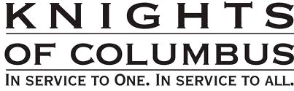
Calendar of Events and Meetings
(Revised 12/7/10)
Date | Event |  | Day/Time |  | Location
Dec 12, 2010 | CYM Potato Bar |  | Sun 5-8:30 pm |  | DS Parish Hall
Dec 18 | Posada |  | After 4:30 mass |  | DS Parish Hall
Dec 19 | Decoration comm.. |  | Sun. 3pm |  | Church
Dec 22 | Set up chairs |  | Wed 9am |  | Church
Dec 27 | Take down chairs |  | Mon 9am |  | Church
Dec 30 | Officers/Planning |  | Thurs 7:00 pm |  | DS Parish Hall
Jan 4, 2011 |  | General Meeting |  | Tues 7:00 |  | DS Parish Hall
Jan tbd |  | Free Throw
Jan 16 |  | Pancake Breakfast |  | Sun |  | DS Parish Hall
Jan 16 |  | Blood Drive |  | Sun |  | DS Parish Hall
Jan 22 |  | Walk for Life, SF |  | Sat |  | Bus to SF
Jan 27 |  | Officers/Planning |  | Thurs 7:00 |  | DS Parish Hall
Jan 29 | Recycle Event |  | Sat 10-2 |  | DS Parking lot
Feb 1 |  | General Meeting |  | Tues 7:00 |  | DS Parish Hall
Feb 4 |  | King’s Game |  | Friday eve |  | Arco Arena
Feb 5 |  | Strategic Plan’g Mtg |  | Sat 9:00 |  | Parish Office
Feb 24 |  | Officers/Planning |  | Thurs 7:00 |  | DS Parish Hall
Mar 1 |  | General Meeting |  | Tues 7:00 |  | DS Parish Hall
Mar 13 |  | Corporate Communion |  | Sun 9:30 |  | Church
Mar 24 |  | Officers/Planning |  | Thurs 7:00 PM |  | DS Parish Hall
Mar 26-27 |  | Membership Drive |  | All Masses |  | Church
Mar-Apr |  | 40 days for life
April 6 |  | General Meeting |  | Tues 7:00 |  | DS Parish Hall
April tbd |  | Information night |  |  |  | DS Parish Hall
April tbd |  | Council Social—River Cats Game
April 28 |  | Officers/Planning |  | Thurs 7:00 |  | DS Parish Hall
April 30 |  | 4th degree ceremony 4th degree dinner |  | All day  evening |  | Sacramento
May 3 |  | General Meeting |  | Tues 7:00 |  | DS Parish Hall
May 7-8 |  | Mother’s Day Roses |  | All Masses |  | Church
May 15 |  | Pancake Breakfast and Blood Drive |  | Sun |  | DS Parish Hall
May (date tbd) |  | Golf Fundraiser event
May 21 |  | Pow Wow Days |  | Sat AM |  | Greenback Lane
May 26 |  | Officers/Planning |  | Thurs 7:00 |  | DS Parish Hall
June 7 |  | General Meeting |  | Tues 7:00 |  | DS Parish Hall
June 17 |  | River Cats Bus Trip
June tbd |  | Officer Installation
June tbd |  | Installation Social |  | `
June 23 |  | Officers/Planning |  | Thurs 7:00 |  | DS Parish Hall
June 28-July 4 |  | Fireworks Booth |  |  |  | Cable Park
Sept 18 |  | Pancake Breakfast and Blood Drive |  | Sun |  | DS Parish Hall

