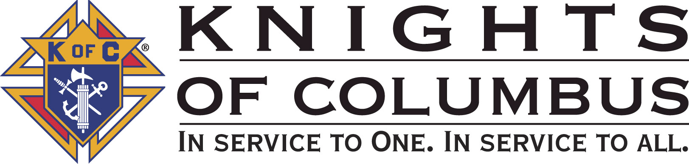

Council #13672 at Divine Savior Fr. Neil W. Seidl
Orangevale, CA
February 2010 Volume 7, #2

Monthly Grand Knight’s Message
Grand Knight Charlie McDermott

Dep. Grand Knight Bruce Pyle

Fin. Secretary Micheal Wagner

Treasurer Allen Brown

Chancellor Tom Hogan

Warden Bob Reilly

Advocate Dave Brodie

Recorder Ray Coughlin

Trustee 1st Year Bill Windle (PGK)

Trustee 2nd Year Mike Duskus (PGK)

Trustee 3rd Year Joe Luchi (PGK)

Inside Guard Steve Mann

Outside Guard Douglas Copley

Chaplin Fr. Roman Mueller

Lecturer Tom Lawson

Field Agent Tony Magdaleno

The Knights of Columbus Council #13672 at Divine Savior Fr. Neil W. Seidl Chapter meets Monthly on the First Tuesday of each month at 7:00 p.m.
Please join us to help our Catholic Community.
For insurance needs, please contact our Field Agent Tony Magdaleno at 470-9205 or by mail at
P.O. Box 2737
Rancho Cordova, CA 95741

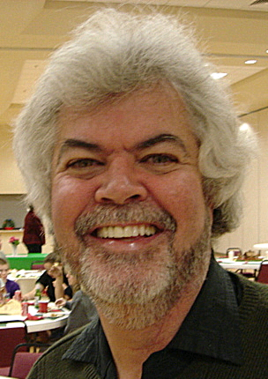

Greetings Brother Knights:

Due to my being under the weather a bit, I will keep this short.

Our membership efforts starting to pay off! Thanks to those who have taken the call to duty in asking men within our parish to consider joining the Knights of Columbus.

I made the mistake at our last Business Meeting that February is our last official Membership Drive, turns out there is one in June, but insufficient time to credit this Columbian Year. So February is critical for this Columbian Year.

Spaghetti Feed: Well done! Thanks to all for of the leaders and laborers in the well planned event. The biggest turnout of all the fundraisers this year- so much for the 200-ticket glass ceiling!

More events are on the horizon, so let us continue our journey of service; let us continue to make a difference!

This concludes the Grand Knight’s Report. God Bless us all.
God Bless us all.

Charlie McDermott,
Grand Knight

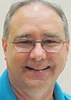
Treasurer Report
(As presented by Allen Brown)

KOC Council No. 132672 - Checkbook & CD Balances:

Date balanced: 2/2/2010

Business: $8,989.20
CD50 - 52: $3,223.48
Charity: $ 790.28
Total: $13,002.96

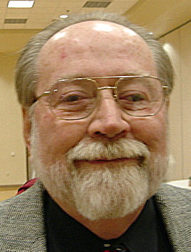

Financial Secretary’s Corner
(As presented by Don Rose for Michael Wagner)

January Receipts
Batch 25 $386.75
Free Throw Contest $36.00
Raffle $49.50
365 Club Dues $21.90
Dues $259.35
Initiation Fees $20.00
Batch 26 $933.60
365 Club Dues $107.60
Dues $826.00
Batch 27 $1432.00
Pancake Breakfast $566.00
Spaghetti Dinner $866.00
Batch 28 $1099.23
Pancake Breakfast $180.48
Spaghetti Dinner $342.00
365 Club Dues $58.40
Dues $518.38
Batch 29 $150.00 (Charity Account)
American Wheelchair Mission $150.00
Batch 30 $587.55
Spaghetti Dinner $246.00
65 Club Dues $25.55
Dues $296.00
Initiation Fees $20.00
Batch 31 $987.00
Spaghetti Dinner $987.00
Grand Total $5576.13


Knight of the Month

(As presented by Bruce Pyle on behalf

of Charlie McDermott)

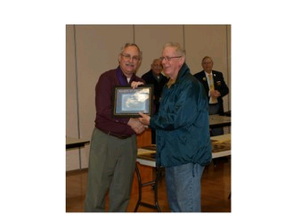
- JOHN RIDGE

This brother Knight is one of the longest sitting committee chairmen in our Council. He has done an admirable job of representing our Council during those times when a fellow knight needs it the most - When someone is sick or has passed away. His cards and words of compassion and kindness were of great comfort those who received them. It has been an honor to work with him this year and while he has decided to pass the baton as the chair of the Sunshine Committee. Please join me in congratulating Mr. Sunshine himself- John Ridge as our “Knight of the Month”

Family of the Month

(As presented by Bruce Pyle on behalf of Charlie McDermott)

- JOE AND TERESA LUCHI
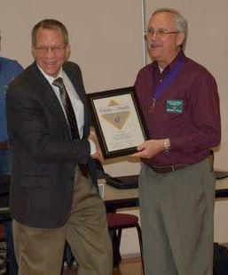

Joe and Teresa are contributing factors to the success of Fr. Neil W. Seidl KofC Council 13672.

He is a fourth degree Knight and is not only a charter member of our Council, but has served diligently and unselfishly as Treasurer, Deputy Grand Knight

and Grand Knight and is currently a Trustee. He has coordinated the Spaghetti Dinner (fundraiser), initiated the parking lot retaining wall project, and has facilitated at the pancake breakfasts, October Fest and Environmental Committee. She has been instrumental (Co-Chairperson) in the success of the Environmental Committee and decorating the church for the appropriate liturgical seasons.
Through her pet therapy program, she and her colleagues have provided warmth, companionship and healing to homebound and assisted living community members. Their contributions continue to set a positive example for our Council. Indeed, we are fortunate to have them- please join me in congratulating JOE AND TERESA LUCHI as our Family of the Month.

New Knights:
(As presented by Charlie McDermott)

No new Knights at this meeting.

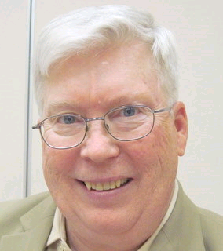
Recorder’s Motions
(As presented by Ray Coughlin)

The following motions were presented, seconded and passed by the general membership present at the 2/2/10 general membership business meeting:

1) The monthly bills presented and recommended by the Trustees, and

2) That the membership authorizes the investigation to and establishment of a July 4th fireworks booth for this year and future years. Maker: Bruce Pyle; seconded by: Bill Amantea. Type of funds: General.

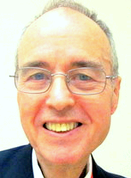
District Deputy News
(As presented by Eldon Hancock, District Deputy)

Topics from District Deputy have been included in other parts of the Newsletter.

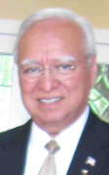
District Insurance News
(As presented by Tony Magdaleno)


KNIGHTS OF COLUMBUS INSURANCE
Making a difference for life

Beneficiaries… Your Loved Ones ♥♥

Valentine’s Day will soon be here! Do you know who the beneficiary is on your life insurance policy? Sometimes it is easy to overlook the simplest of things.

Why is it so important to know and to have your beneficiary information updated? A life insurance policy protects the financial status of another person – or people – in the event of your death.

When Purchasing Knights of Columbus insurance policy, you have selected a primary beneficiary, and if you desire, a contingent, or secondary beneficiary. It’s always a wise choice to have a contingent beneficiary because you may outlive your primary beneficiary. A contingent beneficiary is the person designated to receive life insurance policy proceeds if the primary beneficiary dies.

By being specific as possible in the wording your beneficiary designation you make sure that the life insurance proceeds will be available to your wife, daughter, son, etc., in a timely manner when needed most.

Your life situation will undoubtedly change over time. Plan to update your beneficiary designations periodically. This will ensure that your life insurance coverage will protect those you love and want to protect.

Changing your beneficiary is fairly simple. I can provide you with the necessary forms, and can help you fill them out. I can also help you with all of your life insurance policy beneficiary designations for any life insurance policy you hold - regardless of the company that issued the policy.

To contact me with regards to any of your insurance needs, please call me at (916) 470-9205 or e-mail me at tony.magdaleno@kofc.org

God bless you all.

Fraternally, Your Brother and Field Agent,

Tony Magdaleno (916) 470-9205
FA 14661
CA Lic. #OG27147

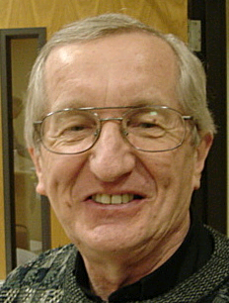
Reflections from the Chaplain
(Fr. Roman Mueller, SDS)

No reflections for this meeting

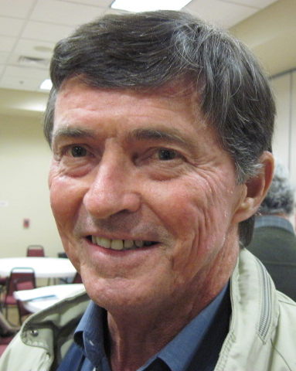

Let the Sunshine
(As presented by Tom Hogan)

Cards were sent out to Mike Wagner, Linda Aiello, Margaret Quigley For future need, please remember to contact Tom Hogan with any sunshine activity or prayer cards that need to be sent.

You can contact Tom at 916-988-2184 or 1mosel@comcast.net.

Remember that we really don’t know how far a little kindness will go.

Committee Report - Membership
(As presented by Ray Coughlin)

We are still in need of approximately 6 New Members by April- WE NEED EVERYONE’S HELP! The next second and third degree exemplification is March 6th in Carmichael. The membership team will be contacting all first degree Knights soon to schedule their exemplification.

Our membership tally is now at 125 members. If you know of someone who would like to join our council, please refer them to Ray Coughlin at (916) 989-4226 or Tony Magdaleno at (916) 470-9205.

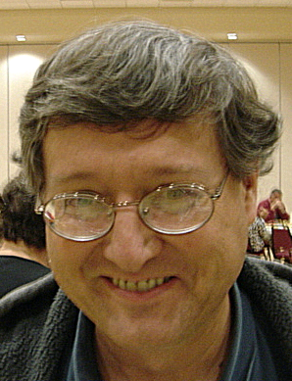
Committee Report - Youth
(As presented by Bill Manos)

Our council will be awarding 4 scholarships this Spring (2 grammar school at $250, and 2 high school @ $500). Announcement is in the church bulletin. Applications will be in the church narthex and at the office.
The free throw competition started at the local level on January 10 and will conclude February 14th.

The council has decided not to cook for the cub scouts blue & gold event. We don’t have the resources needed to take on this very large event.

Please contact Bill Manos at 965-3834 with any Youth Service Program questions.

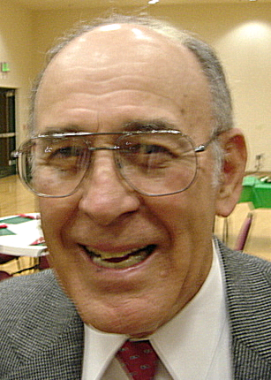

Committee Report - Family
(As presented by Guy Sanchez)

No updates for February.

Please contact Guy Sanchez at 965-3834 with any Family Service Program questions.

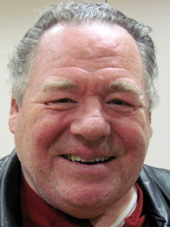
Committee Report – Council
(As presented by Bill Windle)

- Kelvin Joiner has departed the council for a permanent relocation to the Midwest. His replacement as Council Program Director is Bill Windle.
- The Spaghetti Dinner fundraiser was a rousing success with over 250 in attendance. Joe Luchi received a standing ovation for chairing this fabulous event. Kudos to all who helped.
- The January 17 Pancake Breakfast was another success. Chairman Joe Rapier reported that the next breakfast will be March 21.
- Also on January 17 was our blood drive. Andy Ventimiglia reported that there were 51 donors signed up, 43 pints were collected, and we had 8 new donors.
- John Ridge received our thanks for chairing the sunshine committee. With his retirement from this position, we welcomed Tom Hogan as the new chair.

Please contact Bill Windle at 988-2239 with any Council Service Program questions.

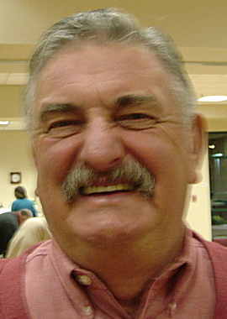
Committee Report – Church
(As presented by Dan Freeman)

- Dan Freeman solicited volunteers to help the Parish Environmental Committee in preparing the church for Lent. This light work will take place on Feb 15 or 16. Also, on April 3, we’ll need to decorate the church for Easter.

- Dan also reported that our next council Corporate Communion will be March 14, at the 11:30 mass.

Please contact Dan Freeman at 987-0908 with any Church Service Program questions

.
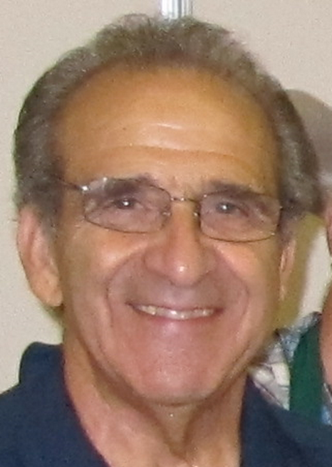

Committee Report - Community
(As presented by Tony Aiello)

- Community Service Program Director, Tony Aiello, and his team are working on several items.
- Planning is underway for our Golf Tournament in May.

- The committee is discussing ways of marketing to the community by bringing the community into our events.

Please contact Tony Aiello at 987-0908 with any Community/Pro-life Service Program questions


Committee Report – Pro-Life
(As presented by Dave Brodie for Mike Schafer)

- No Pro-Life events updates at this meeting

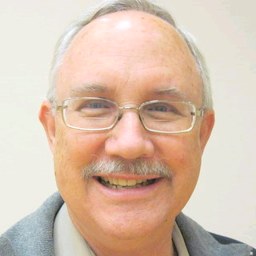
Future Council Planning Report
(As presented by Bruce Pyle)

Please remember to take photos at our events. We can share them at our after meeting social hour and we need them for our annual award reports.

Chairmen/director please include all hours (including planning and pre-event hours) in those annual award reports so we have a clear picture of the resources required to present our events.


Special Prayer Intentions

Please keep the following people in your prayers:

- Margaret Quigley (mother-in-law of Allen Brown) (deceased)
- Linda Aiello (surgery)
- Mike Wagner (surgery)
- Julia Rapier- mother of Joe Rapier (memory)
- Earl Varney (pneumonia/out of the hospital)
- Sick: Tony Magdaleno, Paul Hoefling, Barbara Lawson, Paul Pyle, Ladene Carvalho, Ernie Deus, Eldon Hancock, Martin Jennings, Jack Joiner and Beverly Ridge
- Deceased: Bob Brodie, Toodie Jennings and George Mann


February / March Birthday List

Name Birthday
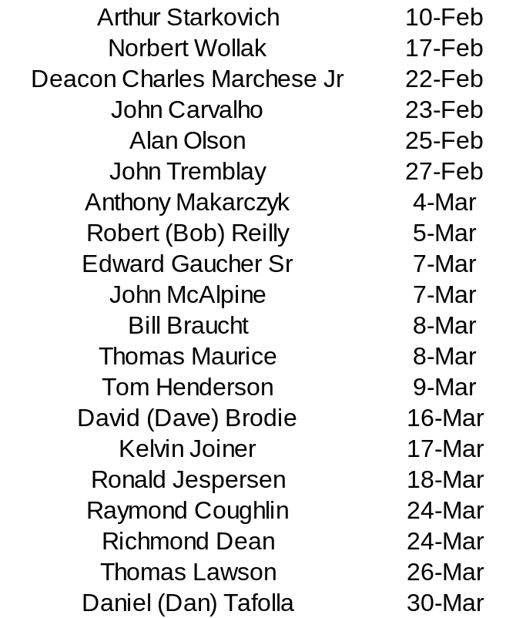

We would like to wish each of the members listed a Happy Birthday!!!

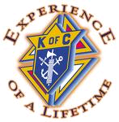
Our Upcoming Events

Date Event Day(s) Location Charity Focus

February
2-Feb Business Meeting Tuesday Parish Hall
20-Feb Membership Weekend Saturday & Vestibule
Sunday
25-Feb Officers Meeting Thursday

March
2-Mar Business Meeting Tuesday Parish Hall
21-Mar Pancake Breakfast Sunday Parish Hall Columbian Retirement Home
25-Mar Officers Meeting Thursday
28-Mar Corporate Communion Sunday Main Church

April
6-Apr Business Meeting Tuesday Parish Hall
16-Apr Council Social Friday Parish Hall
24-Apr Recycle Day Saturday Saturday Church St. Vincent DePaul
Parking Lot
29-Apr Officers Meeting Thursday

May
4-May Business Meeting Thursday Parish Hall
8-May Mother Day Roses Saturday & Vestibule
Sunday
16-May Blood Drive Sunday Parish Hall
16-May Pancake Breakfast Sunday Parish Hall
21-May Golf Tournament Friday
27-May Officers Meeting Thursday Parish Hall

