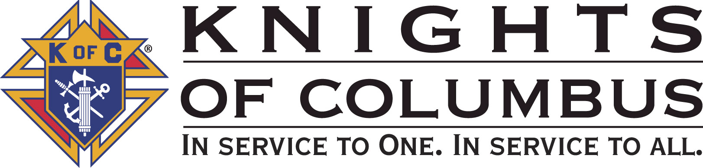

Council #13672 at Divine Savior Fr. Neil W. Seidl
Orangevale, CA
January 2011 Volume 9, #7

Monthly Grand Knight’s Message

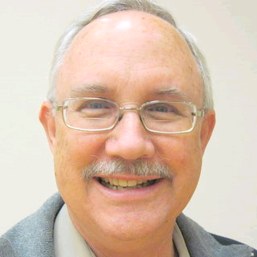
Grand Knight Bruce Pyle

Dep. Grand Knight Tony Aiello

Fin. Secretary Micheal Wagner

Treasurer Allen Brown

Chancellor Jack Hill

Warden Bob Reilly

Advocate Dave Brodie

Recorder Ray Coughlin

Trustee 1st Yr Charlie McDermott

Trustee 2nd Year Bill Windle

Trustee 3rd Year Mike Duskus

Inside Guard Douglas Copley

Outside Guard John Carvalho

Chaplain Fr. Roman Mueller

Lecturer Sam Cimino

Field Agent Tony Magdaleno

The Knights of Columbus Council #13672 at Divine Savior Fr. Neil W. Seidl Chapter meets Monthly on the First Tuesday of each month at 7:00 p.m.
Please join us to help our Catholic Community.
For insurance needs, please contact our Field Agent Tony Magdaleno at 470-9205 or by mail at
P.O. Box 2737
Rancho Cordova, CA 95741
Greetings Brother Knights:

I hope everyone had a wonderful Christmas season enjoying family and friends, and the church and parish festivities. We started the advent season with our very enjoyable Christmas social. We did readings and candle carrying at advent masses, we helped decorate the church and prepared for an overflow crowd, we participated in Posada, and we wrapped up the year with an officers/planning meeting during which we looked ahead to a wonderfully busy 2011. Note, too, that the newsletter is on a new schedule to publish the first of every month.

It’s now time to make those annual New Year’s resolutions. One could be to become more involved in Knights of Columbus activities. Everyone should plan to attend at least one or two general meetings, and to help with at least one or two activities during the year. A little help from everyone will take some of the pressure off the “same old names” while increasing the amount of help we can provide to others.

January will be full of opportunities to help including the Youth Free Throw contest, a pancake breakfast and blood drive (the first of only 3 planned for this year), the Walk for Life in San Francisco, and a most timely recycle (electronics and shredding) day.

Other major events on the 2011 calendar include corporate communion in March, a recruiting drive, Mother’s Day Roses sale, our annual golf fundraiser (which purports to be our biggest fundraiser ever), the annual fireworks booth (another major fundraiser), and a couple social events.

There are plenty of opportunities to participate with your fellow Knights and in so doing, to help people in need including the Parish, the Wheelchair Mission, Camp ReCreation and many others.


So let’s charge into 2011 with a willingness to be involved and a devotion to help others. Happy New Year!

Fraternally yours,

Bruce Pyle, Grand Knight

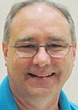
Treasurer Report
(Presented by Allen Brown)

KOC Council No. 132672 – Date balanced: 12/7/2010

Business: $9,969.58
CD 50 - 52: $3,249.79
Charity: $23.00
Total: $13,242.37

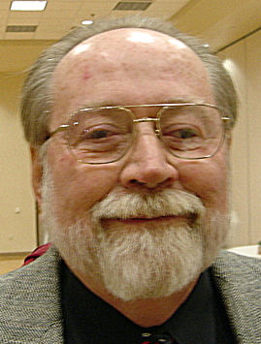

Financial Secretary’s Corner
(Presented by Michael Wagner)

Batch 71 $987.00
Dues $777.35
365 Club $76.65
Initiation Fee $80.00
Raffle Proceeds $53.00
Grand Total $987.00


2011 Dues
Dues billings have been mailed and are due on January 1, 2011. If you have not received yours, please call me at 916 966-6733.

2010 Survey of Fraternal Activity
Your fraternal Activity Survey is an accounting of you volunteerism for calendar year 2010. The questionnaire was included with your dues billing. Please complete and return it by January 15th, so the council can tabulate the council figures and file the necessary report with Supreme by January 31st. If you have any question about the form, please call me at 916 966-6733.

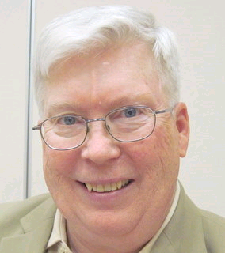

Recorder’s Motions
(Presented by Ray Coughlin)

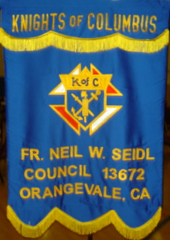
At the December meeting, the following motions were introduced, seconded, and passed by the general membership present:

- All monthly bills presented to the general membership and recommended for payment by the Trustees,
- That the Council donate $423.45 to Camp ReCreation. This is the net proceeds from the Oktoberfest Dinner less $475.00. The $475.00 is being held to fund one camper from the parish if he/she is selected to attend camp in 2011. This is an unbudgeted item. Maker: SK Michael Wagner; seconded by SK Ray Coughlin. Type of Funds: Charity.

Knight of the Month
(Presented by Bruce Pyle)

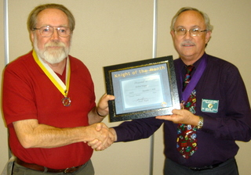
This dedicated knight attends virtually every event, giving up time with his wife and friends at our social events, breakfasts and dinners to welcome attendees and collect money. He attends all degree ceremonies as well as district, chapter and state meetings. He assures that all our reports are done timely as he serves as Financial Secretary.

But this year, Mike went the step beyond to participate in the wheelchair mission’s distribution in Mexico. Back in May, Mike and Bruce attended the state convention and were touched by the prospect of helping with this special charity. At his expense, Mike took this on and found it to be as rewarding as we thought it would be. Mike gave of himself as he gave others the gift of mobility.

Family of the Month

(Presented by Bruce Pyle)

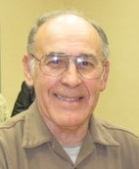
Family of the Month is Guy and Sandra Sanchez

Guy is a PGK, Fourth Degree and has been a knight for over 15 years. He and Sandra have been active in our council and parish for many years. Guy has been active in our blood drives, Treasurefest, Pancake Breakfast, Octoberfest, and virtually every other KofC activity. Sandra has been involved in the Bereavement Committee.

This year, they once again organized our Knights of Columbus Christmas Social overseeing every aspect, and with their son, Chuck, helping with communications and set-up, they made it even better than the one they did last year.

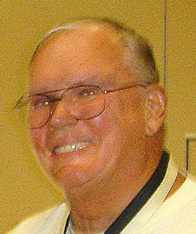

Let the Sunshine
(Presented by Jack Hill)

Cards are available to be sent out to members and families in need. For future need, please remember to contact Jack Hill with any sunshine activity or prayer cards that need to be sent.

You can contact Jack at 916-989-2106 or jack014@aol.com.

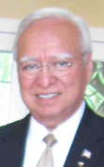
District Insurance News
(Presented by Tony Magdaleno)

KNIGHTS OF COLUMBUS INSURANCE
“YOUR SHIELD FOR LIFE”

HAPPY NEW YEAR Brother Knights - 2011!
Happy New Year to all my Brothers! As Catholics, our new year begins at Advent. We have our own special start then. As citizens we celebrate the annual festivities of a new calendar year. I want to wish you all the safest of new years and to remind all my Brothers that the safest way to start the New Year is to protect all we own. Our loved ones cling to our love and support, and when we leave they lose them both. We can show them as a Catholic Gentleman, that love and support by leaving them with Catholic Protection, the finest of Catholic protection. This will enable them to weather the storms of survival through your love and your prudent management of your assets.
♦Our annuities can be obtained in 2011 for tax obligations of 2010, but you must act quickly. This is a time sensitive decision.
♦Our Long Term Care is budget friendly and you can customize the plan to create your own affordable premium.
♦Of course, the finest of Life Insurance is available (rated AAA Standards and Poors and A++ by AM Best) and this is the time to look at the safety of a plan from your Brotherhood.
I wish you and yours a fresh start to the New Year. I am available for you at the most convenient times. I am here to serve you my Brothers and only you and your families, I am here for you FULL TIME.
Please call me for a prompt review and possible tax saving for 2011.
May the Good Lord be with you and yours this, new year and season.
Please call me at (916) 470-9205 or e-mail me at tony.magdaleno@kofc.org

Fraternally, Your Brother and Field Agent,

Tony Magdaleno
Field Agent #14661 CA Lic. # OG27147

Committee Report - Membership
(Presented by Ray Coughlin)

If you know of someone who would like to join our council, please refer them to Ray Coughlin at (916) 989-4226 or Tony Magdaleno at (916) 470-9205.

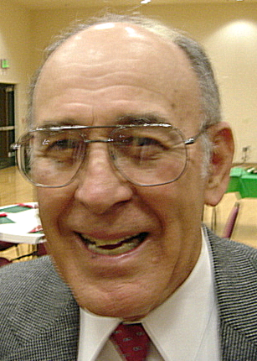

Committee Report - Family
(Presented by Guy Sanchez)

Please contact Guy Sanchez at (916) 965-3834 with any Family Service Program questions.
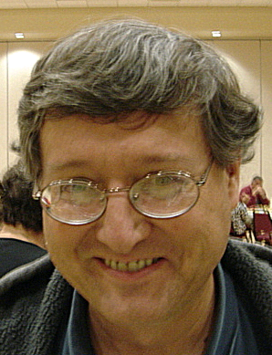

Committee Report - Youth
(Presented by Bill Manos)

CYM held their annual Potato Bar on Dec. 12th that was attended by 150 students and family. The Knights, with the help of five brothers helped prepare and serve this fun event.
The annual Basketball Challenge will begin on Jan. 9th at St John’s in Folsom. It will run from 10-2 and will include girls and boys from ages 10-14. Bill will need 5-6 Knights to help. Please contact Bill Manos at (916) 965-3834 with any Youth Service Programs questions.

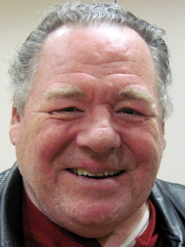

Committee Report – Council
(Presented by Bill Windle)

Mark Your January Calendar! On Sunday, January 16, 2011, our council will be hosting a Pancake Breakfast and Blood Drive from 8:00 am to 1:00 pm in the multipurpose building.

There will be a table in the vestibule after all Masses on January 1st, 2nd , 8th , and 9th to sign up for the Blood Drive. All donors who try to donate are provided a delicious free pancake breakfast consisting of pancakes, syrup, scrambled eggs, hash brown potatoes, ham, a fruit cup, coffee, and juice.

For more information on the Blood Drive, please contact Andy at 728-2776 or Dave at 988-6678. To volunteer for the pancake breakfast, contact Doug Copley at 987-0455.
Save your old TV, computers, printers as well as papers to be recycled. On Sat. January 29th it will be Recycle Day at Divine Savior parking lot. Call Bill Windle for more information.
Please contact Bill Windle at (916) 965-3834 with any Family Service Program questions.

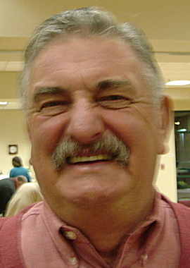

Committee Report – Church
(Presented by Dan Freeman)

Please contact Dan Freeman at 987-0908 with any Church Service Program questions.

American Wheelchair Mission
(Presented by Mike Wagner)

On February 4th, the Sacramento Kings will play the Spurs. The Kings and the Northern California Chapter of the Knights of Columbus are partnering to donate 25% of tickets sales to Knights, family and friends to the American Wheelchair Mission; The Chapter is hoping to get 200 people to the game. This is an easy way to donate money to a very worthy cause and to be able to enjoy a night of basketball. Please see the attached flyer for complete details.

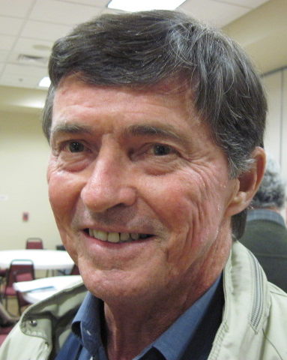

Committee Report - Community
(Presented by Tom Hogan)

We have started planning our annual golf tournament. Brother Michael Subbotin has volunteered to chair this event. The planning committee is researching the different courses in the area. More information will be coming out as they progress. Michael will need the help many even if you don’t golf, there’s a lot to plan. He also would like the help of our woman’s auxiliary to help plan the different events.
Please contact Tom Hogan at 988-2184 with any Community Service Program questions.

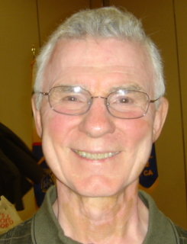


Committee Report – Culture of Life
(Presented by Mike Schaefer)

PRO-LIFE NEWS & ACTIVITIES for January 2010

When Roe v. Wade permitted abortion in 1973, it said, “The word person as used in the 14th Amendment does not include the unborn.” This was a statement of exclusion and intolerance, of prejudice and marginalization. What was our Supreme Court thinking?

As Knights are truly a Pro-Life organization, please participate, and invite others to join you, in a P-L activity this month and every month during 2011.

A Pro-Life Mass is held monthly (2nd Tuesday @ 6:00pm) at St Philomene’s Church located at 2428 Bell Ave. The next Mass will be January 11th. Rosary starts at 5:30pm. (Call Sally @ 916-721-0378)

Walk-for-Life, West Coast in San Francisco, will be held on Saturday January 22, 2011. Make plans now for reservations to get-on-the-bus at St Mel’s, Holy Family or St John the Baptist- Folsom, before they fill up. Cost is ~ $24 per person. There are 47 buses from the Sacramento area making this trip to SF this year. See the WALK FOR LIFE WEST COAST website or contact David Colt (phone 916/784-0765) for all the details.

There will be a free showing of MAAFA21 at the Colonial Theater located at 3522 Stockton Blvd Sacramento on Friday January 14, 2011 at 7:30 – 10:30 pm. This important documentary about black genocide in the 21st century exposes a hidden agenda to eliminate the African-American population by abortion and euthanasia procedures. MAAFA21 is for mature audiences only.

May you and your family have a blessed and prosperous New Year!! Have you made your new year’s resolution to be more PRO-LIFE in 2011?

Any questions to the above please contact Mike Schaefer at 916/988-3171, or: mikeret_99@yahoo.com.

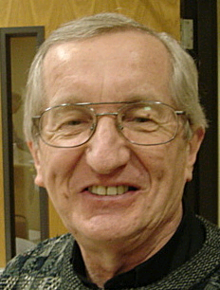
Reflections from the Chaplain
(Fr. Roman Mueller, SDS)

Dear Devoted Knights and Ladies:

As we all know, we are in the middle of the Christmas Season with its five major feasts: Christmas Day, Holy Family, Mary Mother of God, Epiphany and the Baptism of our Savior. There is certainly a lot of material for spiritual reflection and renewal.

Some spiritual writers refer to the expression “the already and the not yet”. These words have special meaning during the season of Christmas. Christ has already been born, the shepherds and wise men have already visited and He has already been baptized. It is for us to live out the “not yet” part of the mystery. We pray that we continue to reflect regularly on how deeply God loves us that God would unite Himself to us through the human birth of His own Son. It is clear how dependent God is on us to do our part of respecting life and nurturing it so that all life can be blessed with honor and dignity.

Knights can rightly say that we have “already” done much on behalf of the cause of respecting life. We are all too aware of what is “not yet” done to insure that every pregnancy is honored for the divinely created life that it is. We know that there is yet much that, once born, we can do to insure that the new life is well taken care for by being provided with a peaceful world to live in, common medicines, adequate food, shelter and potable water and the opportunity to learn and grow in God’s wisdom as did our Savior.

Knights can rightly say that we have “already” done much to foster deep devotion to our Blessed Mother, the Mother of God. Again, we also know how much has “not yet” been done to empower people to look to her for inspiration, wisdom and the courage to say “yes” to God’s desire that we do all we can to see that no women (or men) are trafficked for the raw benefit of providing slave labor or to be victims of sexual bondage.

Knights can rightly say that we have “already” done much to share our God-given talents and time with the growth of fellow nights and families as well as the support of our parish community as well as the community beyond parish boundaries. Our council can be rightly proud of how significant and central its role is in being of help to our parish. One of the more worthwhile “not yets” to consider is how a limited portion of occasional gatherings can be dedicated to sharing how one has been blessed by the activity of Christian service.

Knights can rightly say that we have “already” done much to honor the occasion of the Baptism of infants at our parish. The “not yet” part knows the limits of only our imagination in terms of all the possible ways we can continue to build a community of faith in which more and more children and their families come to know intimately and personally the goodness and kindness of God our Savior.

So, many prayers of gratitude to God for all that the Knights have been and done. We pray that this New Year truly be prosperous as we find other ways of being instruments in God’s wondrous plan of salvation.

Fr. Roman Mueller, S.D.S.

Special Prayer Intentions

Please keep the following people in your prayers:

- Tom Larson (cancer)
- Rich Dean (chemo- cancer)
- Peter Burriesce (dialysis/foot healing)
- April Paulitz- wife of Patrick (cancer)
- Debbie McDermott- wife of Charlie McDermott (dementia)
- Julia Rapier- mother of Joe (memory)
- Bruce Wagner – brother of Bill
- Barbera Lawson (sick)
- Ladene Carvalho (sick)
- Martin Jennings (sick)
- Beverly Ridge (sick)
- Lettie Duskus (bypass surgery)
- Mike Duskus (shoulder surgery)

January / February Birthday List

Name | Month
John Hill | 4-Jan
Michael Lawson | 11-Jan
Sean Anderson | 13-Jan
Vincent Papa | 15-Jan
Edwin Feldmann | 20-Jan
Earl Baker | 24-Jan
Allen Brown | 24-Jan
Daniel Freeman | 24-Jan
Martin Jennings | 31-Jan
Arthur Starkovich | 10-Feb
Norbert Wollak | 17-Feb
Charles Marchese | 22-Feb
John Carvalho | 23-Feb
Alan Olson | 25-Feb
James Bennett | 27-Feb
John Tremblay | 27-Feb


Calendar of Events and Meetings
(Revised 12/27/10)

Date | Event |  | Day/Time |  | Location
Jan 4 |  | General Meeting |  | Tues 7:00 pm |  | Parish Hall
Jan 9 |  | Free Throw |  | Sunday
Jan 15 |  | Chapter Meeting |  | All day |  | Vacaville
Jan 16 |  | Pancake Breakfast |  | Sun morning |  | Parish Hall
Jan 16 |  | Blood Drive |  | Sun morning |  | Parish Hall
Jan 22 |  | Walk for Life, SF |  | Sat all day |  | Bus to SF
Jan 27 |  | Officers/Planning |  | Thurs 7:00 pm |  | Parish Hall
Jan 29 | Recycle Event |  | Sat 10am-2pm |  | DS Parking lot
Feb 1 |  | General Meeting |  | Tues 7:00 pm |  | Parish Hall
Feb 4 |  | “Knights at the Kings” Game |  | Friday eve |  | Arco Arena
Feb 5 |  | Strategic Plan’g Mtg |  | Sat 9:00 am |  | Parish Office
Feb 12 |  | 2nd and 3rd degree |  | All Day |  | Benecia
Feb 24 |  | Officers/Planning |  | Thurs 7:00 pm |  | Parish Hall
Mar 1 |  | General Meeting |  | Tues 7:00 pm |  | Parish Hall
Mar 13 |  | Corporate Communion |  | Sun 9:30 mass |  | Church
Mar 19 |  | Chapter Meeting |  | All day |  | Sacramento
Mar 24 |  | Officers/Planning |  | Thurs 7:00 pm |  | Parish Hall
Mar 26-27 |  | Membership Drive |  | All Masses |  | Church
Mar-Apr |  | 40 days for life
April 6 |  | General Meeting |  | Tues 7:00 pm |  | Parish Hall
April tbd |  | Information night |  |  |  | Parish Hall
April tbd |  | Council Social—River Cats Game |  |  |  | Raley Field
April 28 |  | Officers/Planning |  | Thurs 7:00 pm |  | Parish Hall
April 30 |  | 4th degree ceremony & formal dinner |  | All day and  evening |  | Sacramento
May 3 |  | General Meeting |  | Tues 7:00 pm |  | Parish Hall
May 7-8 |  | Mother’s Day Roses |  | All Masses |  | Church
May 12-15 |  | State Convention |  |  |  | San Diego
May 15 |  | Pancake Breakfast and Blood Drive |  | Sun morning |  | Parish Hall
May 23 |  | Golf Fundraiser event |  | Monday
May 21 |  | Pow Wow Days |  | Sat morning |  | Greenback Lane
May 26 |  | Officers/Planning |  | Thurs 7:00 pm |  | Parish Hall
June 4 or 5 |  | Chapter Meeting |  | All day |  | St. Clare, Roseville
June 7 |  | General Meeting and election of officers |  | Tues 7:00 pm |  | Parish Hall
June 17 |  | River Cats Bus Trip
June tbd |  | Officer Installation |  | After 4:30 mass |  | Church
June tbd |  | Installation Social |  | About 6:30 |  | Parish Hall
June 23 |  | Officers/Planning |  | Thurs 7:00 |  | Parish Hall
June 28-July 4 |  | Fireworks Booth |  | Every Day |  | Cable Park
Sept 18 |  | Pancake Breakfast and Blood Drive |  | Sun morning |  | Parish Hall

