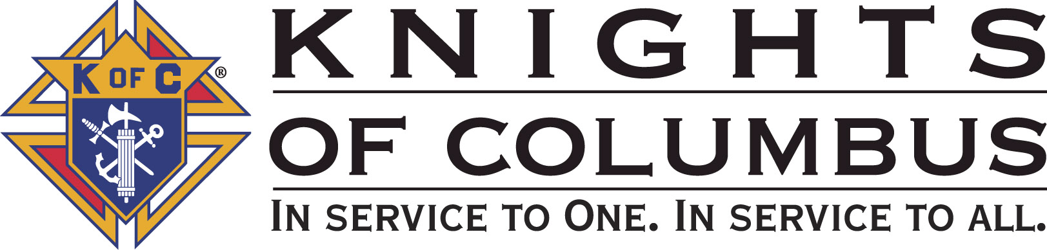

Council #13672 at Divine Savior Fr. Neil W. Seidl
Orangevale, CA
July 2010 Volume 9, #1

Monthly Grand Knight’s Message
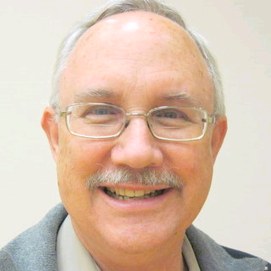

Greetings Brother Knights:
Grand Knight Bruce Pyle

Dep. Grand Knight Tony Aiello

Fin. Secretary Micheal Wagner

Treasurer Allen Brown

Chancellor TBD

Warden Bob Reilly

Advocate Dave Brodie

Recorder Ray Coughlin

Trustee 1st Yr Charlie McDermott

Trustee 2nd Year Bill Windle

Trustee 3rd Year Mike Duskus

Inside Guard Douglas Copley

Outside Guard John Carvalho

Chaplin Fr. Roman Mueller

Lecturer Sam Cimino

Field Agent Tony Magdaleno

The Knights of Columbus Council #13672 at Divine Savior Fr. Neil W. Seidl Chapter meets Monthly on the First Tuesday of each month at 7:00 p.m.
Please join us to help our Catholic Community.
For insurance needs, please contact our Field Agent Tony Magdaleno at 470-9205 or by mail at
P.O. Box 2737
Rancho Cordova, CA 95741

First, I want to thank the council for it’s vote of confidence in me and the new team of officers: Tony Aiello (DGK), Ray Coughlin (continuing as our faithful Recorder), Alan Brown (our trusted Treasurer), Bob Reilly (Warden), Tom Hogan (Chancellor), Doug Copley and John Carvalho (Inside and Outside Guards), Dave Brodie (Advocate and the guy who will keep me on track during our meetings), and our newest Trustee, Charlie McDermott.

Second, welcome to our Program Directors: Ray Coughlin (membership). He’ll work closely with our Insurance Agent, Tony Magdaleno. Bill Manos (Youth), Guy Sanchez (Family), Dan Freeman (Church), Bill Windle (Council), Tom Hogan (Community), and Mike Schaefer (Pro-Life). A big welcome back to our Chaplain, Fr. Roman and to his alternate, Deacon Charles. Dennis Harrington has agreed to continue developing and improving our newsletter. And, of course a welcome back to our continuing Trustees and everyone who makes our meetings and events possible.

A note about the position of Chancellor. Tom Hogan has agreed to take on the position of Director, Community Service Program. So, here is the official announcement: we’ll have a special election at the next meeting to elect a Chancellor. The Chancellor is third in command and will fill in for the GK and DGK should both become unavailable. No, it’s never happened in our council. The Chancellor is given “other duties as assigned.” Tom handled Sunshine and Family of the Month. Nominations will be open and the election will be held at the next meeting.

I want to acknowledge and thank Charlie McDermott for a year of stellar leadership. Charlie gave most generously of his time and talent this past year, and was a wonderful mentor to me.

Our council accomplished an incredible amount this past year. We started the year believing that if we did good things, maybe some awards would come. And, for the things we accomplished, we were recognized at the state convention. For his direction, Charlie deserves our most heartfelt thanks and best wishes. (Charlie received his new PGK badge and a nice plaque at the installation social.)

So, where are we headed under the new regime? We’ll continue with the fine traditions of this council; but at the same time, I believe that each team should build on the last. So, Tony and I will take some of Charlie’s good ideas, add some of our own, and some of yours. We’ll continue to work closely with the Parish. At the same time, I’d like to become more visible in the community. Working with the Fair Oaks Rotary on fireworks was a great example of community teamwork.

We’ll continue to help the Parish and to support our myriad charities, including Wheelchair Mission, Bishop Gallegos Home, St. Vincent de Paul, youth activities and scholarships, and the rest. We’ll have some social events including a Christmas Social (anyone want to chair that for us?). We’ve just had two big fundraisers, Golf and Fireworks, so we can back off on those, at least for a while. We’ll cut back to three pancake breakfasts and three blood drives. Other events already on the calendar will round out the year. But, there is room for more events and Tony and I are open to all good ideas. Give us your suggestions.

This year, I’d like to renew our focus on membership, with emphasis on retention and involvement. I’d like to explore ways to become more visible in the Divine Savior community and in Orangevale. I’m anxious to increase the informative value of our meetings. And, maybe most important, I want us to remember the fun and fraternal aspects of the Knights.

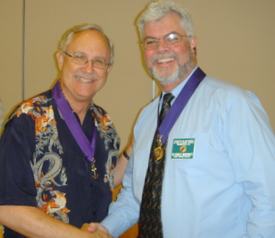
We’re members of the Knights of Columbus for all sorts of reasons. We each need to examine those reasons and renew our commitment. With your help, this will be a great year for our Council and for each of our brothers.

God Bless us all.

Bruce Pyle,
Grand Knight
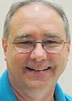

Treasurer Report
(Presented by Allen Brown)

KOC Council No. 132672 – Date balanced: 7/6/2010

Business: $27,146.07
CD50 - 52: $3,242.16
Charity: $711.64
Total: $31,099.87

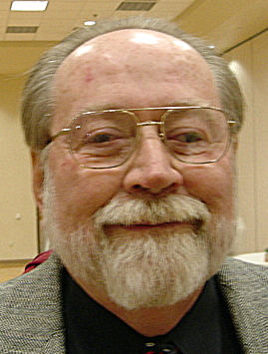
Financial Secretary’s Corner
(Presented by Michael Wagner)


2010-2011 Budget
The proposed 2010-2011 budget is included in this newsletter (see last page). Please review it and be prepared to discuss and vote on its approval at the August 3rd business meeting. Anyone questions can be directed to me at either (966-6733) or (MrWiggi@sbcglobal.net).

June Receipt

Batch 47 $1111.07
Dues $111.00
Initiation Fee $20.00
365 Club $7.30
Vocations Refund $100.00
State Convention Refund $37.23
Recycle Day $5.00
Pancake Breakfast $170.54
Social: Recognition Dinner $660.00
Batch 48 $ 247.75
Firework Both $247.75
Batch 49 $1110.86
Firework Both $1090.86
Social: Recognition Dinner 20.00
Batch 50 $866.90
Firework Both $866.90
Batch 51 $1591.61
Firework Both $1591.61
Batch 52 $483.05
Firework Both $483.05
Batch 53 $53 $15299.16
Firework Both $15299.16
Grand Total $20,710.40

Knight of the Month
(Presented by Bruce Pyle)

Knight of the Month of July is Mike Duskus, past Grand Knight, current
Trustee, and chairman of our recent Golf Tournament. That event was
enjoyed by over 60 golfers, got the Knights name into the public
realm, and raised over $2,500.

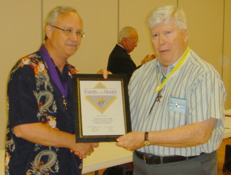

Families of the Month

(Presented by Bruce Pyle)

Family of the Month of July is Ray and JoAnn Coughlin! Family of the Month is Ray and JoAnn Coughlin. Ray is our recorder and historian, the Rose for Motherhood chairman, our membership
co-chairman, and just completed a year as Faithful Navigator of the Centennial Assembly in Folsom. JoAnn is active in the parish Social
Justice Committee and the Fair Trade Coffee promotion. Together they
enthusiastically participate in our events and are involved in Rosary
activities and Right ot Life.

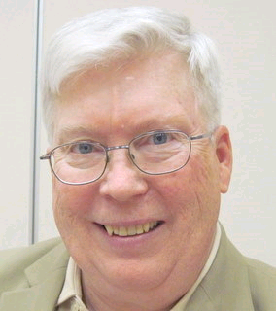
Recorder’s Motions
(As presented by Ray Coughlin)

Motions for June and July

For June, the general membership passed the following motions -- the minutes as read for April, the bills presented and recommended by the trustees, advancing Bill Wagner up to $2,200.00 for Fireworks set-up (this was read in April for passage in June), $625.00 to Divine Savior building fund, $50.00 to Don Marnach for the BBQ social, $312.00 for some of our First degree Knights to advance to the Second and Third degrees, and to donate $1,055.00 to the American Wheelchair Mission.

One motion was read in June for July voting: to authorize up to $1,400.00 for food and supplies and up to $250.00 for parish hall expenses for the Council BBQ. This was passed in July along with the approval of the June minutes and July bills presented and recommended by the trustee

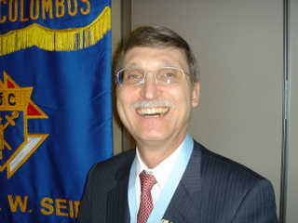

District Deputy News
(Presented by Don Harmata, District Warden)

No new District information at this time

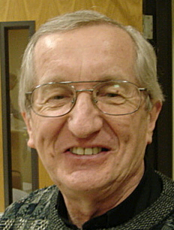

Reflections from the Chaplain
(Fr. Roman Mueller, SDS)

There are no reflections for this month.

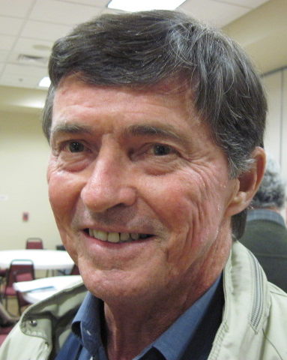
Let the Sunshine
(As presented by Tom Hogan)

Cards are available to be sent out to members and families in need. For future need, please remember to contact Tom Hogan with any sunshine activity or prayer cards that need to be sent.

You can contact Tom at 916-988-2184 or 1mosel@comcast.net.

Remember that we really don’t know how far a little kindness will go.

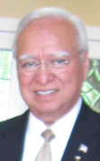
District Insurance News
(Presented by Tony Magdaleno)
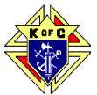

KNIGHTS OF COLUMBUS INSURANCE
“YOUR SHIELD FOR LIFE”
A NEW FRATERNAL YEAR 2010-2011
A new fraternal year is upon us. Congratulations to the newly elected Grand Knights and Deputy Grand Knight, as well as the other entire dedicated brother Knights who will serve in either an elected and appointed leadership positions. I’m sure you have a list of goals and objectives that you intend to accomplish during the coming year. You have my assurance that as your Field Agent I’m eager to help.
To attain the Star Council status it is a yearlong commitment as well as the most prestigious award the Order offers at the council level. As your Field Agent I am certainly committed to help determine how many Fraternal Benefits Nights you will want to conduct in your council during the fraternal year, and to work hand in hand with your membership committee. As well, I am committed to helping on the insurance side, but will be equally as glad to help on the membership side as well
If you know an eligible Catholic man who might be interested in joining the Order (and who among us doesn’t), he’s probably just waiting to be asked. We can help you, either by approaching him or by “coaching” you – transferring sales skills that you can use to recruit him and other prospects. As always, I am at your service.
Let’s get an early start to attain your council’s goals and objectives that are so critical to the growth of your council.
To make this fiscal 2010-2011 year “Your Shield for Life”. “The knight’s shield has long been a symbol of strength and honor,” Supreme Knight Carl A. Anderson “And those are exactly the words that best describe the Knights of Columbus insurance program. Especially in difficult economic times, our exceptional strength and our long history of integrity and service to brother Knights and their families, remind everyone that we provide the best protection available.” “ Your Shield for Life”.
Please call (916) 470-9205 or e-mail me at tony.magdaleno@kofc.org with any questions you may have. I’m your full time Field Agent…

Fraternally, Your Brother,
Tony Magdaleno
FA # 14661
CA Lic. # OG27147

Committee Report - Membership
(Presented by Ray Coughlin)

Our membership tally is now at 129 members.

If you know of someone who would like to join our council, please refer them to Ray Coughlin at (916) 989-4226 or Tony Magdaleno at (916) 470-9205.
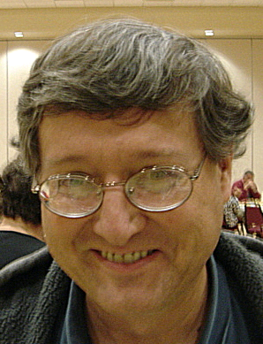

Committee Report - Youth
(Presented by Bill Manos)

.

Bill and his team will be working on the scholarship awards. Bill announced that Soccer Free Throw is coming up in October. We’ll be partnering with Folsom again.

Please contact Bill Manos at 965-3834 with any Youth Service Program questions

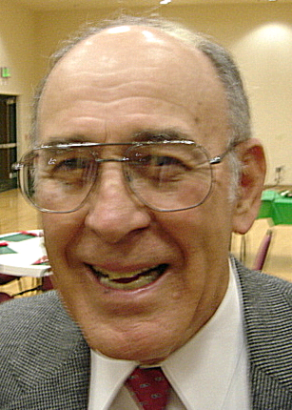
Committee Report - Family
(Presented by Guy Sanchez)

No upcoming activities at this time.
.
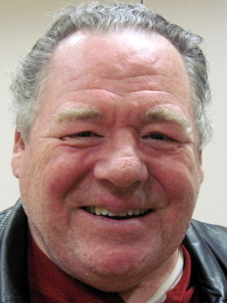
Please contact Guy Sanchez at 965-3834 with any Family Service Program questions.

Committee Report – Council
(Presented by Bruce Pyle for Bill Windle)

Our next pancake breakfast and blood drive will be Sept. 19. Doug Copley has agreed to co-chair this one. We are seeking another co-chair.

Dennis Harrington and his team are working on our website (which will feature… pictures!). We are looking for members with website building experience who would like to involved with the website creation. Please contact Dennis if you are interested in participating (772-4168).

Please contact Bill Windle at 988-2239 with Council Service Program questions.

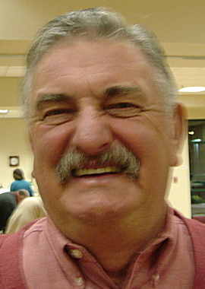

Committee Report – Church
(Presented by Bruce Pyle for Dan Freeman)

- We’ve been asked to help with the Treasurefest on the weekend of July 31-Aug 1. We’ll be moving heavier items. Also need brothers with pickups to gather donations. Again, contact Dan. This is a big money maker for the parish, so please help when you can.
Please contact Dan Freeman at 987-0908 with any Church Service Program questions.

Committee Report - Community
(Presented by Tony Aiello for Tom Hogan)

Tom Hogan is the new Director of Committee.

- Fireworks is over! Bill Wagner and Jack Hill reported that all went well, our revenue will be determined as all the bills and receipts are accounted for, but at this time it appeared that our council did well financially. Kudo’s Bill and Jack for a lot of long hours, and thanks to all whom participated.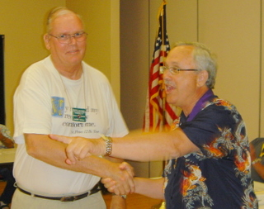
- We showed off our new K of C banner, which will start appearing at our Council events including our fireworks booths.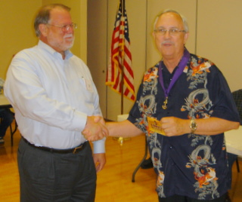

Please contact Tom Hogan at 988-2184 with any Community/Pro-life Service Program questions

Future Council Planning Report
(Presented by Bruce Pyle)

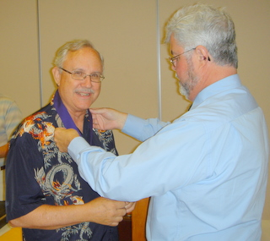

The new officer installation and catered dinner program held on June 26th were a big hit. During the dinner we recapped our events and successes from the past Columbian year.

Please contact Bruce if you are interested in a Service Program Director, a back up or other event chairman.

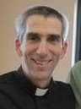
News From Father Tom

Dear Brother Knights,

I hope you all had a wonderful Fourth of July! I did. In a new assignment!

I am at St. Patrick Parish, Whitewater, Wisconsin... about an hour southwest of Milwaukee. It is a college town with an active Newman ministry. The parish is small and vibrant. There is one mass in Spanish and three in English. I am the parish administrator, which is like a pastor, but with a shorter assignment period. I enjoy it tremendously. Please do remember me in your prayers, thanks. I'll remember all of you in mine.

Peace always,
Tom Perrin, SDS

Contact info: Fr. Tom Perrin, SDS
126 S Elizabeth St., Whitewater, WI 53190
(262) 473-3143 or cell: (920) 650-8920

Feel free to give me a call, write an email, or a letter!
~~ We are the people God has chosen to be God's own! ~~
~~ Let us rejoice and be glad! ~~


Committee Report
(Presented by Mike Schaefer)

PRO-LIFE NEWS & ACTIVITIES for JULY 2010

As Knights are truly a Pro-Life organization, please participate, and invite others to join you, in a PL activity this month, this week and, especially, today. The number one cause of death in America is ABORTION, with 4000+ abortion-deaths being performed every day in the U.S. This needless sacrifice of our unborn children is at the ‘altar of convenience’. Local abortion clinics continue to need our prayerful presence.

Currently $23+ million of our CA state tax dollars are spent each year to pay for 80,000 "free" abortions. Surely, these millions of dollars can be better-spent helping women and children, rather than destroying life and hurting women for a lifetime! Be a Voice for Life and contact your assemblyperson and tell him/her your thoughts on pro-life and how to cut the State’s deficit.

Let us remember: When someone is pregnant, she is not “expecting a child”- she already has one. She is not “going to be a mother” –she already is a mother. The baby is not “on the way” –the baby has already arrived. (Re: PRO-LIFE REFLECTIONS FOR EVERY DAY, Fr Frank Pavone, and Priests for Life).

Plan to attend a Workshop titled, STOPPING PLANNED PARENTHOOD which is being presented by Jim Sedlak, American Life League, and David Bereit, founder of 40 Days for Life. This is being held in the large conference room at St Joseph Catholic Church, Auburn, CA on July 13, August 10 and September 14 (2nd Tuesdays of the month) at 7:00pm. (Call Penny @ 530-885-9055).

Also plan to attend the Bishop Gallegos Maternity Home annual fund raising dinner on September 26 at the Dante Club on Fair Oaks Blvd starting at 5:00pm. Fr Patrick Lee will be honored for his pro-life activities. (Call Kathy @ 916-337-6824).

Any questions to the above can be addressed to Mike Schaefer at 916/988-3171.


Special Prayer Intentions

Please keep the following people in your prayers:

- Zoe Mann- wife of Steve (Kidney removal)
- Tom Lawson (cancer)
- Rich Dean (chemo- cancer)
- Mary Trujillo- wife of Peter (asthma)
- Peter Burriesce (dialysis/foot healing)
- Denise Ash- sister of Bill Wagner (cancer)
- April Paulitz- wife of Patrick (cancer)
- Debbie McDermott- wife of Charlie McDermott (dementia)
- Julia Rapier- mother of Joe Rapier (memory)
- Sick: Barbara Lawson, Paul Pyle, Ladene Carvalho, Eldon Hancock,
Earl Varney, Martin Jennings, Jack Joiner and Beverly Ridge
- Deceased: Frank Stuto- father of Tom & Barbara Lawson
- Deceased: Robert Howe

July / August Birthday List


Name | Birthday
Edward Barbero | 4-Jul
Father Roman Mueller | 9-Jul
Michael Knepshield | 10-Jul
Richard Nodlinski | 10-Jul
James Strand | 10-Jul
Peter Trujillo | 10-Jul
Richard Gast | 11-Jul
Michael Subbotin | 15-Jul
William (Bill) Amantea | 16-Jul
Terry Wilderman | 21-Jul
Joseph (Joe) Joyce | 22-Jul
Timothy McReynolds | 23-Jul
Delano Schweiger | 25-Jul
Michael (Mike) Ryan | 28-Jul
Mario Mladineo | 29-Jul
Joseph Ames | 30-Jul
James Morgan | 5-Aug
Donald (Don) Marnach | 6-Aug
David Noble | 8-Aug
Arturo (Art) Reyes | 8-Aug
Ryan Mascarenhas | 11-Aug
John Mercurio Sr | 20-Aug
Michael (Mike) Duskus | 31-Aug
We would like to wish each of the members listed a Happy Birthday!!!



Proposed 2010-2011 Budget
Category | Sub Category | Receipt | Expense |  | Category | Sub Category | Receipt | Expense
365 Club |  | $400 | $400 |  | Dues |  | $3,330
Chapter Fees |  |  | $60 |  | Dues | Initiation Fee | $160
Charity Expense | Alter Server Party |  | $100 |  | Event | Air Show
Charity Expense | Am Wheelchair Mission - PassThru | $500 | $500 |  | Event | Corporate Communion (2) |  | $175
Charity Expense | American Wheelchair Mission |  | $500 |  | Event | Fireworks Booth | $58,000 | $44,000
Charity Expense | Bishop Gallegos Home |  | $100 |  | Event | Free Throw Contest |  | $100
Charity Expense | Bishop's Fund |  | $250 |  | Event | Golf | $8,600 | $6,000
Charity Expense | Boy Scouts Troop 310 |  | $100 |  | Event | Hospitality Room |  | $150
Charity Expense | California Marriage |  | $200 |  | Event | Officer Installation |  | $75
Charity Expense | Christmas Basket |  | $250 |  | Event | Oktoberfest Dinner | $5,000 | $3,000
Charity Expense | Columbian Retirement Home |  | $50 |  | Event | Pancake Breakfast 32 | $650 | $350
Charity Expense | Grace Home |  | $200 |  | Event | Pancake Breakfast 33 | $650 | $350
Charity Expense | Miscellaneous |  |  |  | Event | Pancake Breakfast 34 | $650 | $350
Charity Expense | Parish Building Fund |  | $500 |  | Event | Pow Wow Days
Charity Expense | Parish Improvements |  | $500 |  | Event | Recycle Day 1 | $700 | $50
Charity Expense | Parish Youth |  | $100 |  | Event | Soccer Challenge |  | $100
Charity Expense | Sacramento Life Center |  | $100 |  | Event | Spaghetti Dinner
Charity Expense | Scholarships |  | $2,750 |  | Event | Veteran Dinner
Charity Expense | Special Olympics |  | $100 |  | Event | ID Drive | $1,500 | $1,500
Charity Expense | St Vincent de Paul |  | $500 |  | F/S Compensation |  |  | $350
Charity Expense | Stanford Settlement Center |  | $50 |  | Office Expense | Bank Fee |  | $75
Charity Expense | Vocations | $100 | $500 |  | Office Expense | Postage |  | $300
Council Expense | C of C Dues |  | $75 |  | Product Rebate |  | $20
Council Expense | Chapter |  | $60 |  | Raffle Proceeds |  | $432
Council Expense | Council Supplies |  | $600 |  | Social | April Social | $540 | $480
Council Expense | Deceased Brothers Plaque |  | $0 |  | Social | BBQ
Council Expense | Gifts |  | $250 |  | Social | Christmas Social
Council Expense | Insurance |  | $1,000 |  | State Fees | State Per Capita |  | $1,300
Council Expense | Miscellaneous |  |  |  | Supreme Fees | Catholic Adv. Fund |  | $150
Council Expense | Parish Hall Usage |  | $1,000 |  | Supreme Fees | Culture of Life |  | $375
Council Expense | Recruitment |  | $250 |  | Supreme Fees | Per Capita Fee |  | $425
Council Expense | Second & Third Degrees |  | $210
Council Expense | State Convention |  | $1,000 |  | Total |  | $81,232 | $72,150
Council Expense | Web Site |  | $240 |  | Overage/Shortage |  |  | $9,082

