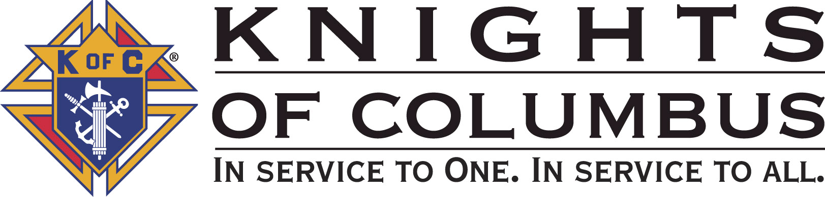

Council #13672 at Divine Savior Fr. Neil W. Seidl
Orangevale, CA
June 2010 Volume 8, #5

Monthly Grand Knight’s Message

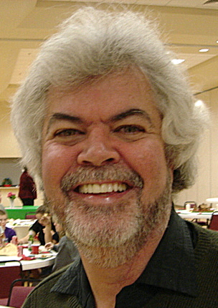
Greetings Brother Knights:
Grand Knight Charlie McDermott

Dep. Grand Knight Bruce Pyle

Fin. Secretary Micheal Wagner

Treasurer Allen Brown

Chancellor Tom Hogan

Warden Bob Reilly

Advocate Dave Brodie

Recorder Ray Coughlin

Trustee 1st Year Bill Windle (PGK)

Trustee 2nd Year Mike Duskus (PGK)

Trustee 3rd Year Joe Luchi (PGK)

Inside Guard Steve Mann

Outside Guard Douglas Copley

Chaplin Fr. Roman Mueller

Lecturer Tom Lawson

Field Agent Tony Magdaleno

The Knights of Columbus Council #13672 at Divine Savior Fr. Neil W. Seidl Chapter meets Monthly on the First Tuesday of each month at 7:00 p.m.
Please join us to help our Catholic Community.
For insurance needs, please contact our Field Agent Tony Magdaleno at 470-9205 or by mail at
P.O. Box 2737
Rancho Cordova, CA 95741

Our journey for the 2009 – 2010 Columbian year is quickly winding down. During our June meeting we held our Election of Officers for the 2010 – 2011 Columbian Year. All 2009 – 2010 Columbian Year fundraising activities and events have been successfully completed. I would like to thank Joe Rapier, Andy Ventimiglia and Dave Brodie and all of Knights that made our May Pancake Breakfast and Blood Drive another wonderful success. And I also would like to recognize PGK Mike Duskus and Brother Bill Wagner for their efforts in organizing the Council’s May golf tournament. I will say that an enjoyable day was had by all- even if your team came in last place! You will hear more about how we did on both of these events a little later tonight.

Bruce Pyle, Mike Wagner, Allen Brown and I have met and determined the final checks to be written for charity causes this Columbian year; including our Co-Charities of the Year- the Parish Building Fund and American Wheelchair Mission. We will be voting on those motions tonight. Although I have not completed my final reports, I will say this:

- Financial Balances:
  - The Council Accounts stand at $10,000
  - An additional $1250 set aside for scholarships

- Charity Causes:
  - More funds given to charities this year than in any year since the inception of our Council

- Membership / Insurance Growth:
  - 3 New Insurance Members
  - 11 New Members added
  - 3 Inactive Members suspended
  - 8 = Star Council

- Event Planning:
  - Plan in place from beginning of Columbian Year
  - Focus was on implementation
  - Lot of Leadership, Lot of Work, Lot of Fraternity
  - We did what we planned
  - And yes we did have some fun along the way!

- State Awards.
  - To be announced at our Installation of Officers and Recognition Dinner on June 26^{th-}- be there!!!

- Summary will be provided at the July Business Meeting and Newsletter

Finally, as this particular report will be my last one as your Grand Knight, I would like to take a moment to express my sincere thanks and deepest appreciation to all of you (our members) for entrusting me with the responsibilities of Grand Knight for our Council. The experience for me was fast, fun, but most of all very rewarding in terms of being of service to our Church and helping others in need through our charity works. To me, there is no better feeling than giving the gift of giving! And I am so proud to be with you all and be part of a fraternal order that gives every day in so many ways.

I wish to thank our Worthy District Deputy, Eldon Hancock, our Council Officers, Trustees, and Service Program Directors for all that you have done over the past 12 months; without your leadership and support we would not be the strong Council we are today. Our Council is so fortunate and blessed to have each and every one of you here...

My personal thanks and best wishes to my successor Bruce Pyle. It was a wonderful year and a pleasure to work with you. You were there through thick and thin and you have demonstrated time and time again you have what it takes to carry the baton and lead the next journey….

Welcome to our new Deputy Grand Knight and Program Director Tony Aiello and our Officer team for the 2010 – 2011 Columbian Year. We look forward to continuing the focus in being of service and I know already with the planning that has taken place to date that we are continuing to head in the right direction!

Thank you all again for the honor and privilege of serving as Grand Knight.

Vivat Jesus.

God Bless us all.

Charlie McDermott,
Grand Knight
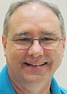

Treasurer Report
(Presented by Allen Brown)

KOC Council No. 132672 – Date balanced: 6/1/2010

Business: $9,368.74
CD50 - 52: $3,232,76
Charity: $746.59
Total: $13,348.09

PENDING CHECKS:
Business Account:
Check 1798 Mather Golf Course $5,084.00

Charity Account:
Check 1068 Nor Cal Special Olympics $100.00
Check 1080 William J Manos $100.00

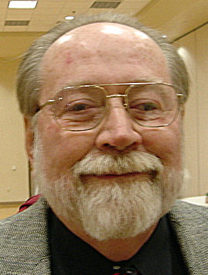
Financial Secretary’s Corner
(Presented by Michael Wagner)

May Receipt

Batch 43 $276.00
Dues $111.00
Initiation Fee $40.00
Pancake Breakfast $85.00
Raffle $31.00
Batch 44 $526.00
Pancake Breakfast $526.00
Batch 45 $687.07
365 Club $3.65
State Convention $177.22
Recycle Day $138.20
Raffle $56.00
Social: River Cats Bus $312.00
Batch 46 $3235.00
Golf Tournament $3235.00
Grand Total $4,715.07

Knight of the Month
(Presented by Charlie McDermott)


  - Knight of the Month for June on hold and not available at this time.

Families of the Month

(Presented by Charlie McDermott)

Family of the Month JUNE - DEACON CHARLES AND JOANN MARCHESE

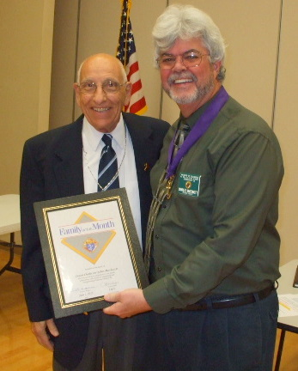
We are so blessed to have this family as our Family of the Month. He has been a Knight of Columbus for over 50 years (Honorary Life Membership). He received his Third Degree on February 1, 1958 and several years later earned his Fourth Degree. He studied for over four years to complete his Deacon Degree in the Oakland, CA area. For over 25 years he administered to the ill in hospital ministries. He has been gracious in serving our Parish’s Deacon and as backup Chaplain for our Council. He conducts the homily at least once a month at Divine Savior as well as private baptisms, weddings and funerals. The Council and Parish are fortunate to have the wisdom, courage and humor of this outstanding person. His wife, has led Bible Study classes, brought food for special activities and has been very helpful in giving her time towards Treasure Fest fundraising event. She should also have a special award for putting up with her husband’s jokes!

Please join me in congratulating our “Family of the Month” DEACON CHARLES AND JOANN MARCHESE

New Knights
(Presented by Charlie McDermott)
Will recognize at next meeting.

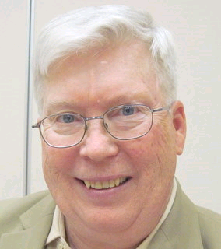
Recorder’s Motions
(As presented by Ray Coughlin)

Motions from June Meeting were not available- a separate email message will be forthcoming.

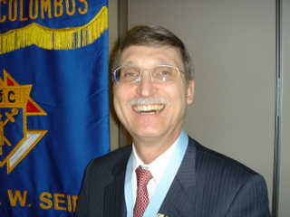
District Deputy News
(Presented by Don Harmata, District Warden)

No new District information at this time

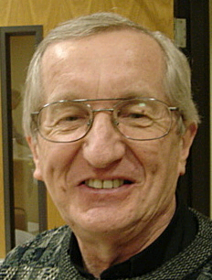

Reflections from the Chaplain
(Fr. Roman Mueller, SDS)

Dear Knights and Ladies:
It has been a few months since I have managed to provide anything for this newsletter. The present fraternal year is quickly coming to a close, and I want to thank all the Knights for all that you are and all that you do for Divine Savior Community as well as the wider community in which we live.
Perhaps the most important element I want to draw attention to is the spirit of the counsel by which you Knights are helping to build a stronger faith community without drawing undue attention to yourselves. This points out that there is a fine underpinning of humility in what is being done. Along with this, the Knights’ commitment to on-going charitable works is quite commendable.
The continued dedication of the Knights to sponsor blood drives and to provide families who are having their infants baptized with special mementoes are two more wonderful ways of supporting life and supporting young families in their great mission to form their children in the goodness and kindness of God our Savior.
Lastly, there are the “grunt” things that the Knights do. First and foremost in this regard is the new retaining wall we have along the northern and part of our western boundaries. Not only that, but the Knights contributed toward the purchase of the blocks for the wall as well as making other contributions to the parish building fund.
For me to think for a second that I would be able to list all the wonderful impact the Knights are having would be quite silly. I mention the ones that I do only as a sampling as I express my deepest thanks to all of you and offer prayers that our council will continue to be a positive, holy and healthy part of our parish.
As we look to the next fraternal year, may the focus continue to be on our using our time, talent and treasure in ways that express our profound thanks to God for all of our blessings; let us with joyful hearts put them all at the disposal of the continual building of the Body of Christ.

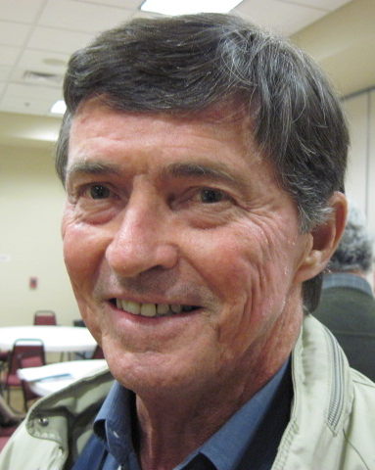
Let the Sunshine
(As presented by Tom Hogan)

Cards are available to be sent out to members and families in need. For future need, please remember to contact Tom Hogan with any sunshine activity or prayer cards that need to be sent.

You can contact Tom at 916-988-2184 or 1mosel@comcast.net.

Remember that we really don’t know how far a little kindness will go.

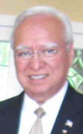
District Insurance News
(Presented by Tony Magdaleno)

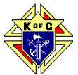

KNIGHTS OF COLUMBUS INSURANCE
Making a difference for life

If You Haven’t Visited The Knights of Columbus Web Site In A While

I encourage you to do so the next time you’re online. There are many exciting features on www.kofc.org, but there are two that I wish to bring to your attention.

The first is our member testimonial area, titled “Stages of Life.” In this multi-media area, six “real-life” stories are told – stories of people at different stages of their lives. Chances are one of them will sound a lot like yours. These people talk about how their Knights of Columbus field agent took the time to demonstrate and explain how they could cover and protect their families equitably with Knights of Columbus Life Insurance. I’d be happy to do the same for you and your family at your convenience.

(Also be sure to read, if you have not already the May 2010 Columbia Magazine. It also tells Real Life Stories and gives information about our Life Insurance, LTC and Retirement Annuities.)

The second is our Life Insurance Calculator. This handy, easy-to-use online tool was developed to allow you, in about 15-20 minutes, to estimate the amount of life insurance for you and your family. The information you’ll be asked to provide will be basic (the type most folks would tend to have at their fingertips), and secure (it’s intended to be used solely for the purposes of the online calculator – the Order won’t capture it or share it with anyone, including me!!!).

I stress that the number you’ll receive is an estimate, based on the basic information you provide. It’s not intended to take the place of the free, professional needs analysis that I’ll be happy to provide for you and your family. Please feel free to call me at (916) 470-9205 any time; I’m your FULL TIME Field Agent.

Fraternally, Your Brother,
Tony Magdaleno
FA # 14661
CA Lic. # OG27147

Committee Report - Membership
(Presented by Ray Coughlin)

Our membership tally is now at 129 members. If you know of someone who would like to join our council, please refer them to Ray Coughlin at (916) 989-4226 or Tony Magdaleno at (916) 470-9205.
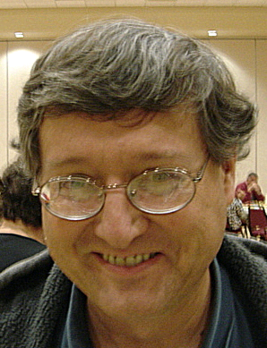

Committee Report - Youth
(Presented by Bill Manos)

.

Bill Manos and his team will be working on the scholarship awards. Bill reported on the alter server appreciation event.

Please contact Bill Manos at 965-3834 with any Youth Service Program questions

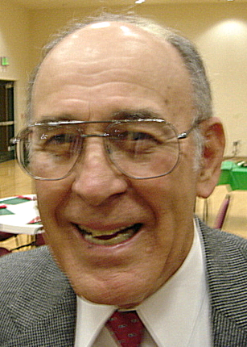

Committee Report - Family
(Presented by Guy Sanchez)

- Guy reported on the success of our River Cats game and chartered bus trip. Did anyone take pictures?
.
Please contact Guy Sanchez at 965-3834 with any Family Service Program questions.

Fun at the River Cats Game!

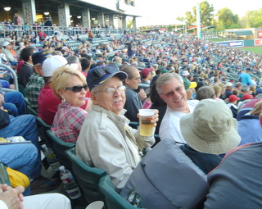
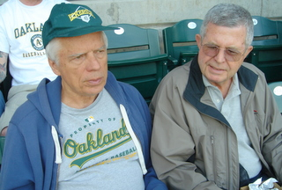
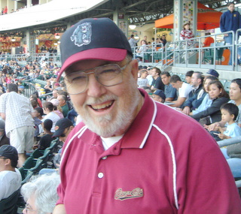
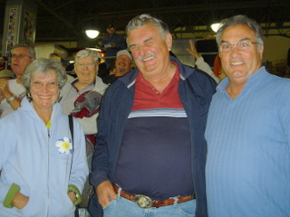
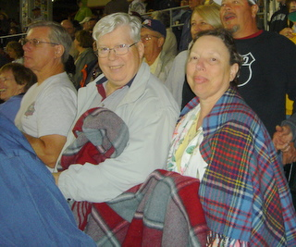
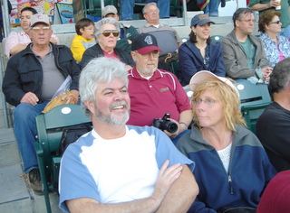

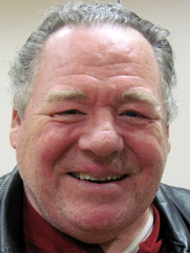
Committee Report – Council
(Presented by Bruce Pyle for Bill Windle)

Bill Windle, Director. While Bill is visiting Israel and Jordan, Bruce reported…
- The May 16 blood drive was a rousing success with over 50 donors.
- A great pancake breakfast held the same day. Attendance was off from prior breakfasts, but the diners seemed to enjoy the new item, ham. Joe Rapier, chairman for the past 3 years, is moving on to other responsibilities—anyone interested in taking that position, please contact Bruce.
- Our next pancake breakfast and blood drive will be Sept. 19.
- Recycle Day was May 8th. We will receive over $600 from the two suppliers. Our co-chairmen Rob Cunha and Rich Moran make this one look easy. It will be continued with the next being planned for this fall. Did anyone take pictures?
- Dennis Harrington and his team are working on our website (which will feature… pictures!). More later.
- The annual State Convention was held on May 20-23 in San Jose. Mike Wagner and Bruce Pyle represented our Council and will report at the next meeting. Yes, we have pictures.

Please contact Bill Windle at 988-2239 with Council Service Program questions.

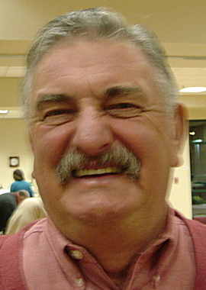

Committee Report – Church
(Presented by Bruce Pyle for Dan Freeman)

Dan Freeman, Director. Dan is vacationing in Italy, so Bruce reported…
- As we do each year, the council distributed Mother’s Day Roses after masses on May 8-9. Did anyone get pictures?
- We’ve been asked to do a little more work on the retaining wall, namely, to backfill with crushed granite. We don’t have a date or details yet.
- he May 16 blood drive was a rousing success with over 50 donors.

- The Parish is sponsoring an upcoming concert with visiting Salvatorian Joe Rodrigues on July 10th at 7pm. It should be an exciting spirit-filled event. We are looking for volunteers to help set up tables and chairs for the event in the Parish Hall.

Please contact Dan Freeman at 987-0908 with any Church Service Program questions.

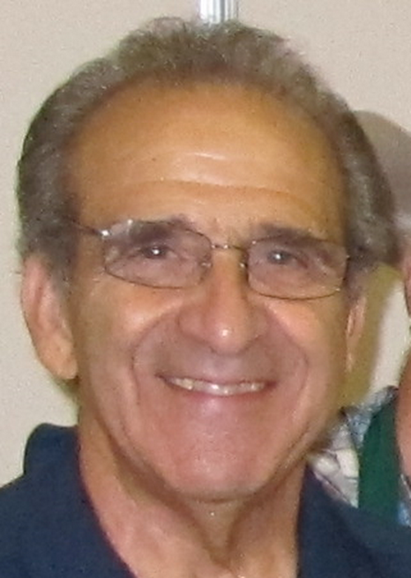
Committee Report - Community
(Presented by Tony Aiello)

- May 21 is our council-sponsored Golf Tournament. There is still time and room to sign up to play. And, we still need sponsors. Sponsorship at $100, 250 or $1000 is a major opportunity for our council to make megabucks for our charitable efforts. Contact Mike Duskus.
- Our council will have two fireworks booths this year (Greenback and Filbert, and Cable Park). In order to successfully man two locations, staffing assistance will be provided by the Fair Oaks Rotary. Nonetheless, there is still plenty of help needed to sell, for daily set-up and teardown, and for night security. The sales shifts will be 3 hours. This could be our largest fund-raiser of the year. We need plenty of help. Contact Bill Wagner to sign up.
- Our council-sponsored Golf Tournament was May 21. A great time was had by all and we raised over $2,000. Our Grand Knight interjected that even the losing team (I wonder who that was) had a lot of fun.
- Fireworks planning is well underway. There are a few opportunities left to sign up to help with sales and other support. Please call Jack Hill (989-2106) or Bill Wagner (220-2868). By making money on this event, during one short week from June 28 to July 4, we can reduce the emphasis on so many fundraisers thru the rest of the year. Let’s all pitch in.
- We showed off our new K of C banner which will start appearing at our Council events including our fireworks booths

Please contact Tony Aiello at 987-0908 with any Community/Pro-life Service Program questions

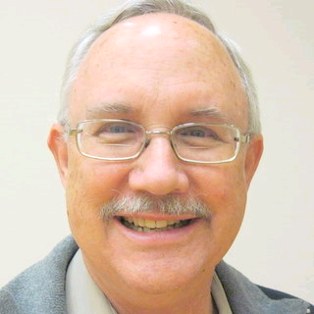
Future Council Planning Report
(Presented by Bruce Pyle)

Bruce thanked all who had accepted elected positions for this coming Columbian year. He also asked that anyone interested in being a Service Program Director, a back-up or other event chairman to please talk to him.

Bruce also encouraged all who could, to attend our installation of officers after the Saturday, 4:30 mass, on June 26. A full-blown council social will follow at the Parish Hall starting about 6:45. It will include a catered dinner and a program in which we recap our events and contributions of the past year. All family members are invited whether you can attend the installation or not. Please RSVP to Charlie by the 18th.


Committee Report
(Presented by Tony Aiello)

- Mike Schaefer reported on Pro-Life and indicated which major candidates were Pro-life.

.


Special Prayer Intentions

Please keep the following people in your prayers:

- Zoe Mann- wife of Steve (Kidney removal)
- Tom Lawson (cancer)
- Rich Dean (chemo- cancer)
- Mary Trujillo- wife of Peter (asthma)
- Peter Burriesce (dialysis/foot healing)
- Denise Ash- sister of Bill Wagner (cancer)
- April Paulitz- wife of Patrick (cancer)
- Debbie McDermott- wife of Charlie McDermott (dementia)
- Julia Rapier- mother of Joe Rapier (memory)
- Sick: Barbara Lawson, Paul Pyle, Ladene Carvalho, Eldon Hancock,
Earl Varney, Martin Jennings, Jack Joiner and Beverly Ridge
- Deceased: Frank Stuto- father of Tom & Barbara Lawson

June / July Birthday List


Name Birthday
William (Bill) Manos 4-June
Edmundo Puchi 14-June
Joe Bananno 19-June
Dougal McAlpine 20-June
Michael Wagner 20-June
Douglas (Doug) Copley 26-June
William (Bill) Wagner, Jr 26-June
Edward Barbero 4-July
Father Roman Mueller 9-July
Michael Knepshield 10-July
Richard Nodlinski 10-July
We would like to wish each of the members listed a Happy Birthday!!!
James Strand 10-July
Peter Trujillo 10-July
Richard Gast 10-July
Michael Subbotin 10-July
William (Bill) Amantea 16-July
Terry Wilderman 21-July
Joseph (Joe) Joyce 22-July
Timothy McReynolds 23-July
Delano Schweiger 25-July
Michael (Mike) Ryan 28-July
Mario Mladineo 25-July
Joseph Ames 28-July

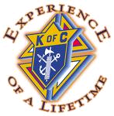
Our Upcoming Events

June
Date | Event | Day / Time | Location
6/1 | Business Meeting | Tues 7:00 | Parish Hall
6/1 | Election of Officers | Tues 7:00 | Parish Hall
6/5 | Membership Weekend | Sat & Sun | Vestibule
6/24 | Officers Meeting | Thursday | Parish Hall
6/26 | Officer Installation / Council Dinner | Saturday | Parish Hall
July
Date | Event | Day / Time | Locaton
6/28-7/4 | Fireworks | 9am - 9pm Plus Setup / Close | Cable Park; Grnback+Filbert
7/6 | General Meeting | Tues 7:00 | Parish Hall
7/17 | Annual Planning |  | Parish Hall
7/22 | Officers / Planning | Thurs 7:00 | Parish Hall
August
Date | Event | Day / Time | Locaton
8/3 | General Meeting | Tues 7:00 | Parish Hall
8/26 | Officers / Planning | Thurs 7:00 | Parish Hall
September
Date | Event | Day / Time | Locaton
9/7 | General Meeting | Tues 7:00 | Parish Hall
9/11-9/12 | Mather Air Show | Sat-Sun | Mather
9/18 | Oktoberfest | Sat | Parish Hall
9/19 | Pancake Breakfast and Blood Drive | Sun | Parish Hall
9/23 | Officers / Planning | Thurs 7:00 | Parish Hall

