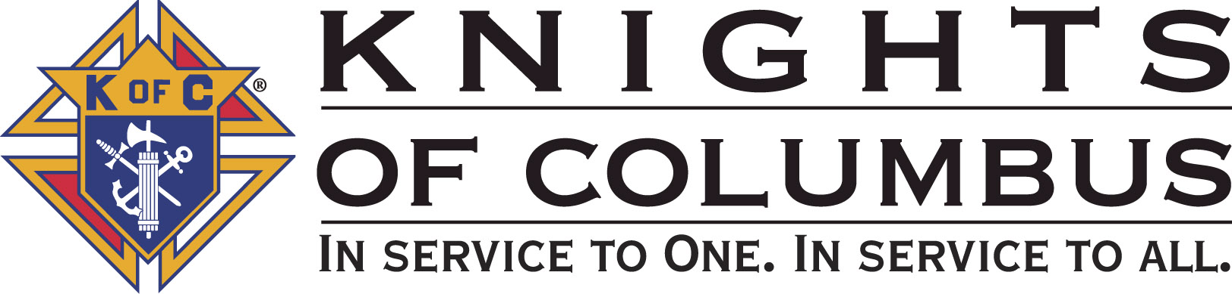

Council #13672 at Divine Savior Fr. Neil W. Seidl
Orangevale, CA
May 2010 Volume 8, #4

Monthly Grand Knight’s Message
Grand Knight Charlie McDermott

Dep. Grand Knight Bruce Pyle

Fin. Secretary Micheal Wagner

Treasurer Allen Brown

Chancellor Tom Hogan

Warden Bob Reilly

Advocate Dave Brodie

Recorder Ray Coughlin

Trustee 1st Year Bill Windle (PGK)

Trustee 2nd Year Mike Duskus (PGK)

Trustee 3rd Year Joe Luchi (PGK)

Inside Guard Steve Mann

Outside Guard Douglas Copley

Chaplin Fr. Roman Mueller

Lecturer Tom Lawson

Field Agent Tony Magdaleno

The Knights of Columbus Council #13672 at Divine Savior Fr. Neil W. Seidl Chapter meets Monthly on the First Tuesday of each month at 7:00 p.m.
Please join us to help our Catholic Community.
For insurance needs, please contact our Field Agent Tony Magdaleno at 470-9205 or by mail at
P.O. Box 2737
Rancho Cordova, CA 95741
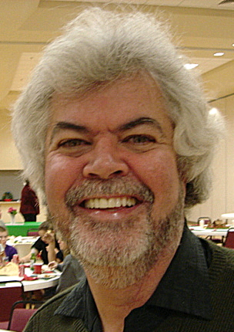
Greetings Brother Knights:

After our May Business Meeting we will have our KofC Open House/ Information Night. Our Business Meeting will last only 45 minutes. In order to ensure that critical business matters were discussed, we will be suspending a numbers of updates- primarily in the Service Program Areas. However, all service program updates are included in this newsletter.

During our Business Meeting we will hear about the following:

- From our Worthy Membership Director Ray Coughlin- we are still in need candidates to ensure we make Star Council this Columbian year and start us off well for next Columbian year.
- Summary of Service Program updates- especially in the areas of Recycle, Golf and Mother’s Day Roses.
- From our Worthy Field Agent Tony Magdaleno on our Knights of Columbus Open House/Information Night.
- May brings about the annual Knights of Columbus State Convention. DGK Bruce Pyle and our FS Mike Wagner will represent our Council.
- The California State Council Resolutions- and the each council has been directed to advise its delegates to the state convention on how to vote on the 72 “consent” resolutions.
- Finally, we heard from our Council Officers on their responsibilities. I encourage all members of the Council to consider serving as an officer during the next Columbian Year. If you have any questions or are interested in a particular Officer position, please contact the Council’s Election Committee Chairman, Bob Reilly (988-1040).

God Bless us all.

Charlie McDermott,
Grand Knight

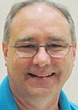
Treasurer Report
(Presented by Allen Brown)

KOC Council No. 132672 – Date balanced: 5/4/2010
Business: $8,204.78
CD50 - 52: $3,232.76
Charity: $1,587.24
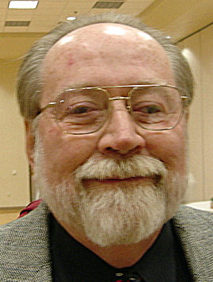
Total: $13,024.78

Financial Secretary’s Corner
(Presented by Michael Wagner)

April Receipts

Batch 42 $2995.30
Golf Tournament $2780.00
Dues $171.65
Initiation Fee $40.00
365 Club $3.65
Grand Total $2995.30

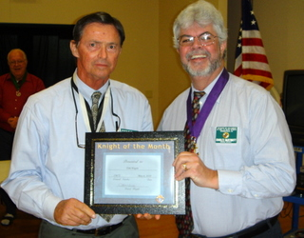
Knight of the Month
(Presented by Charlie McDermott)


Knight of the Month for May - TOM HOGAN

This knight goes about helping others in a quiet and respectful way. He is generous in donating his time to almost every event we have held this past Columbian year including the Treasure Fest, Hoedown, Oktoberfest, Spaghetti Dinner, Retaining Wall and Pancake Breakfasts. As a Scholarship sub-committee member, he actively participated and provided thoughtful insight into the formation of our Council’s Scholarship Program. At the beginning of my term as Grand Knight, I asked him if he would consider being our Council’s Chancellor and he readily accepted my invitation. He has done an excellent job in taking responsibility to obtain input from our Council Officers on our monthly Family of the Month and getting the forms into Supreme in a timely manner. Finally, when our Council needed a new Sunshine Committee Chairman, I turned to this knight because he had the right skills- kindness and compassion. Without hesitation, this knight stepped right in and made it happen. He is to be commended for all he does for our Council, but more importantly for being a sincere, kind and generous Catholic gentlemen. Please join me in congratulating Tom Hogan as our “Knight of the Month”

Families of the Month

(Presented by Charlie McDermott)

Family of the Month for May - DON AND LUPE MARNACH

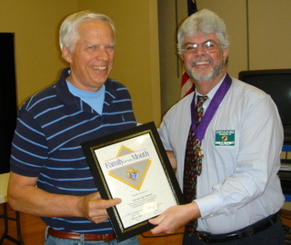
This family represents the type of enthusiasm and self-initiative that each Council and Parish desires. He is a third degree knight and has been extremely active in our Council since 2006. He has participated in the following fundraiser activities: Treasure Fest, Hoe Down, Pancake Breakfast, Spaghetti Dinner, Oktoberfest and other events. His leadership is evident in decorating for the Advent Season, Holy Week and other liturgical activities. He and Lupe are noted for coming early and staying late to ensure that an activity is successfully completed. He is responsible for beverages at each Business meeting. He is a member of St. Vincent de Paul and assists at Loaves & Fishes. Each is a Lay Eucharistic Minister as well. She has been a member of the Parish Pastoral Council and Our Lady of Guadalupe. Please join me in congratulating our “Family of the Month” DON AND LUPE MARNACH

New Knights
(Presented by Charlie McDermott)
Will recognize at next meeting.

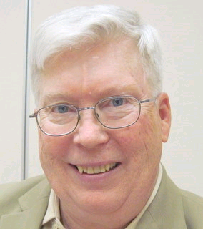
Recorder’s Motions
(As presented by Ray Coughlin)

Motions at April Meeting
Brothers, the California State Council has asked each council to advise its delegates to the state convention on how to vote on the 72 “consent” resolutions. The resolutions consist of:
- 2 – Recognition of state officers;
- 4 – Recognition of bishops;
- 4 – Recognition of state officers;
- 14 – Recognition of priests;
- 11 – Recognition of council’s 100th, 50th, 25th or 20th anniversary, (includes St
Mel’s and Arden Carmichael);
- 30 – Recognition of brother Knights for various years of service in the Knights of
Columbus;
- 7 – Minor changes to the state council bylaws.

The state resolution committee recommends approval of the first 71 resolutions and rejection of number 72. Resolution 72 deals with fund raising by the Columbian Retirement Home and will be recommended for further study.

Motion was made, seconded and approved.

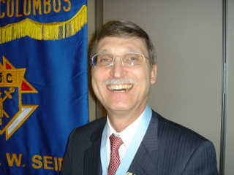
District Deputy News
(Presented by Don Harmata, District Warden)

The 2nd Monday of the Month is the 1st Degree Ceremony at St. Claires. There is an upcoming Chapter Meeting at St. Rose’s on May 1st. There is an upcoming State Convention in San Jose. Each Council needs to have two representatives in attendance at the Convention.

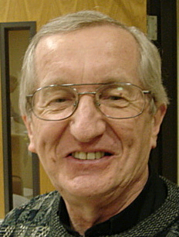
Reflections from the Chaplain
(Fr. Roman Mueller, SDS)

No reflections for this meeting

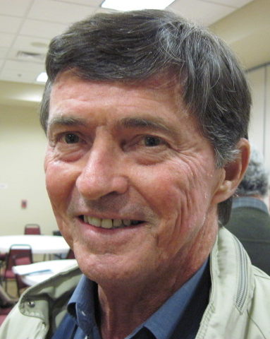
Let the Sunshine
(As presented by Tom Hogan)

Cards are available to be sent out to members and families in need. For future need, please remember to contact Tom Hogan with any sunshine activity or prayer cards that need to be sent.

You can contact Tom at 916-988-2184 or 1mosel@comcast.net.

Remember that we really don’t know how far a little kindness will go.

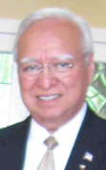
District Insurance News
(Presented by Tony Magdaleno)

KNIGHTS OF COLUMBUS INSURANCE

Making a difference for life

FRATERNAL YEAR – STAR COUNCIL:

Now is the time to be looking ahead and taking stock of attaining your council’s Coveted Star Council Award Goals. The June 30, 2010 deadline will come quickly enough. I will help you in any way I can to meet those goals for the 2009-2010 Fraternal year. I’m certainly committed to helping on the insurance side, but I’ll be glad to help on the membership side as well.

If you know an eligible Catholic man who might be interested in joining the Order (and who among us doesn’t), he’s probably just waiting to be asked. I can help you, either by approaching him myself, or by “coaching” you – transferring sales skills that you can use to recruit him and other prospects. As always, I’m at your service.

Let’s continue our momentum for attaining those goals and objectives that are so critical to the growth of your council: Recruitment, Insurance members and council activities.

With all of us working together, our fraternal leaders and our professional field force, we can help the Order to continue to grow and obtain the Coveted Start Council Award.

I’m at (916) 470-9205 or tony.magdaleno@kofc.org. Call me – let’s talk.

God bless you all.

Fraternally, Your Brother and Field Agent,

Tony Magdaleno (916) 470-9205
FA 14661
CA Lic. #OG27147
P.S. NEW MEMBERS, ASK ABOUT OUR NEW MEMBER ANNUITY PLAN!!!

Committee Report - Membership
(Presented by Ray Coughlin)

We are still in need of approximately 2 New Members by the end of April- WE NEED EVERYONE’S HELP!

Our membership tally is now at 125 members. If you know of someone who would like to join our council, please refer them to Ray Coughlin at (916) 989-4226 or Tony Magdaleno at (916) 470-9205.
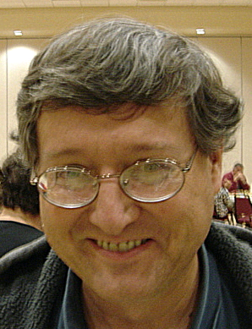

Committee Report - Youth
(Presented by Bill Manos)

.

Members of our council supported the April 17 Youth Gathering held at Divine Savior. The all day event ended with a mass celebrated by Bishop Soto, followed by dinner for the 550 youth in attendance. The K of C council from Paradise, CA, sure knows how to cook a lot of spaghetti!

Bill Manos reported the all is quiet on the Youth Program… at least for now. Bill Manos at 965-3834 with any Youth Service Program questions
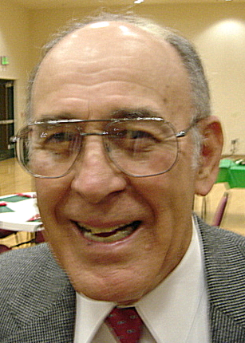

Committee Report - Family
(Presented by Guy Sanchez)

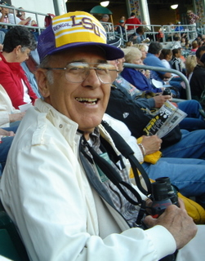

Guy Sanchez announced the plans for our Spring Social event. On May 7, we can all attend the River Cats Game. Arrangements are being made for a chartered bus. The bus will depart from Divine Savior at 5:10 pm and will cost a paltry $12 round trip per person. A bargain compared to expending your gas and paying for parking! Game time is 7 pm. Hot dogs and ice cream are only $1. Further details will appear in an email/flyer.
.
Please contact Guy Sanchez at 965-3834 with any Family Service Program questions.

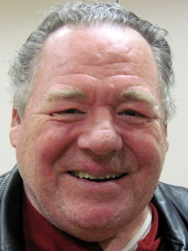

Committee Report – Council
(Presented by Bill Windle)

- The next Pancake Breakfast and Blood Drive will be May 16th. Please contact Chairman Joe Rapier to assist with the breakfast, and Chairman Andy Ventimiglia to donate blood. On a side note, the May pancake breakfast event will be the last for Joe- we thank him for all his work over the past two years.
- Recycle Day is scheduled for May 8th. Time will be from 10am to 2pm. Contact our co-chairmen Rob Cunha and Rich Moran for further info and to assist.
- Council Elections will be held at our General meeting, June 1.
- The annual State Convention will be May 20-23 in San Jose. Mike Wagner and Bruce Pyle will represent our Council.

Please contact Bill Windle at 988-2239 with any Council Service Program questions.

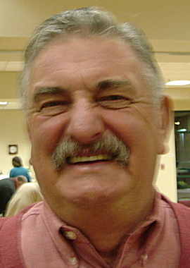

Committee Report – Church
(Presented by Dan Freeman)

- As we do each year, the council will distribute Mother’s Day Roses after masses on May 8-9. Assistance is needed. Contact Ray Coughlin.
- On April 24, members of our council moved a pile of tiles from the vacant lot into storage at/near the hall. These tiles were residual from the building of the church. With many hands helping, the job took little over an hour.

Please contact Dan Freeman at 987-0908 with any Church Service Program questions

.

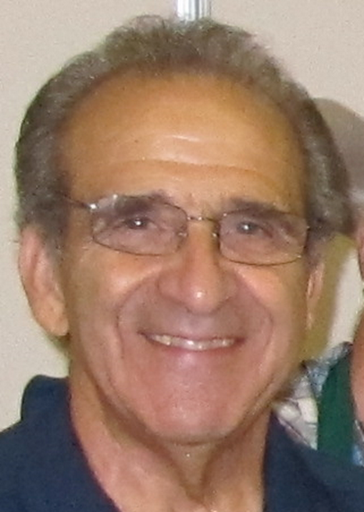
Committee Report - Community
(Presented by Tony Aiello)

- May 21 is our council-sponsored Golf Tournament. There is still time and room to sign up to play. And, we still need sponsors. Sponsorship at $100, 250 or $1000 is a major opportunity for our council to make megabucks for our charitable efforts. Contact Mike Duskus.
- Our council will have two fireworks booths this year (Greenback and Filbert, and Cable Park). In order to successfully man two locations, staffing assistance will be provided by the Fair Oaks Rotary. Nonetheless, there is still plenty of help needed to sell, for daily set-up and teardown, and for night security. The sales shifts will be 3 hours. This could be our largest fund-raiser of the year. We need plenty of help. Contact Bill Wagner to sign up.

Please contact Tony Aiello at 987-0908 with any Community/Pro-life Service Program questions

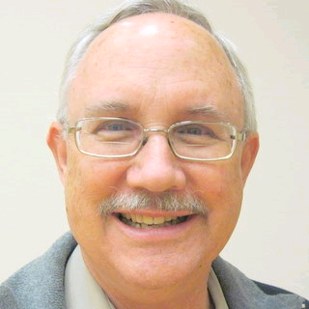
Future Council Planning Report
(Presented by Bruce Pyle)

Bruce thanked all who had accepted nominations and encouraged everyone to think about serving our council in some capacity this coming Columbian year. He also asked that anyone interested in being a Service Program Director or other event chairman to please talk to him.

Installation of officers will take place after the Saturday, 4:30 mass, on June 26. A social will follow at the home of Dan and Deanna Freeman. All Knights are invited to attend both the installation and the social. More details at the next general meeting, June 1st.


Committee Report – Pro-Life
(Presented by Mike Schafer)

PRO-LIFE NEWS & ACTIVITIES for APRIL 2010

As Knights are truly a Pro-Life organization, please participate, and invite others to join you, in a PL activity this month.

The number one cause of death in America is ABORTION- the needless sacrifice of our unborn children at the ‘altar of convenience’. Please remember that ‘abortion is NOT healthcare’!

It is very important that each of us contact our representatives in Congress to vote ‘NO’ on the National Health Care bill which now still includes funding for abortion. The congress could be voting on this in the next few days. Phone numbers include: Senator Boxer @ 916/448-2787; Senator Feinstein @ 202/224-3841; and House Speaker Nancy Pelosi @202/225-4965.

The 2010 ‘40 Days-For-Life’ ended March 28th. Thank you Knights for your participation at any of the four abortion clinics in the Sacramento-Roseville area. We’ve heard that some 458 babies have been saved nationwide, and know that at least one was saved at the Sacramento Planned Parenthood abortion clinic this lental period.

Local abortion clinics that continue to need prayerful presence include (Please call as clinic hours vary):

- Choice Medical Clinic @ 2322 Butano Dr., Sacramento (across from the old Gottschalks, west of Watt Ave); (call Karen at 916/396-7997 for info)
- Sacramento Planned Parenthood @ 29th & B St; (call Charles at 916/396-7997 for info)
- Women Health Specialists @ 1750 Wright St; (call Mary at 916/254-4444 for info)
- Roseville Planned Parenthood @ 729 Sunrise Blvd; (call David at 916/784-0765 for info)

Abortion doesn’t only break the Fifth Commandment, ‘Thou shall not kill’. It breaks all the Commandments. Father Frank Pavone of Priests for Life has written an article demonstrating this on his website, Priestsforlife.org/articles/document.

Upcoming Pro-Life events:
Please sign the two initiative measure petitions now being circulated:

- Change State Constitutional definition of a PERSON to include equal protection to all fertilized human eggs from the commencement of biological development. (Human Rights Amendment). Please take one or more petitions home with you and have your neighbor’s friends and co-workers sign also. They are on the side table.


Special Prayer Intentions

Please keep the following people in your prayers:

- Frank Stuto - Father of Tom & Barbara Lawson (deceased)
- April Paulitz - Wife of Patrick (cancer)
- Debbie McDermott - Wife of Charlie McDermott (dementia)
- Julia Rapier - Mother of Joe Rapier (memory)
- Earl Varney (pneumonia/out of the hospital)
- Sick: Tony Magdaleno, Paul Hoefling, Barbara Lawson, Paul Pyle, Ladene Carvalho, Ernie Deus, Eldon Hancock, Earl Varney, Martin Jennings, Jack Joiner and Beverly Ridge
- Deceased: Margaret Quigley, Bob Brodie, Toodie Jennings and George Mann

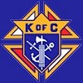

Primary Duties of Council Officers

Father Neil W. Seidl Council No. 13672

Grand Knight: The Grand Knight (GK) is the Chief Executive Officer of the Council. He presides over all meetings of the Council and officers, appoints committees, appoints non-elected officers, recommends appointments, secures a Chaplin, appoints committee chairman, countersigns orders drawn for payment of Council funds, countersigns checks, responsible for a Council budget, prepares a Council activity calendar, provides a monthly GK report to the Council newsletter editor, assures that all moneys sent to the treasurer by the financial secretary are deposited, reads or has read any notices pertinent to the Council, represents the Council at state meetings, is chairman of the board of trustees, and is a member pro-tem of all committees and any other duties the Order may impose.

Deputy Grand Knight: The Deputy Grand Knight (DGK) is second in command. He assists the GK with Council affairs and fulfills all duties assigned to him by the GK. Should the Grand Knight be absent from a Council meeting, the DGK will preside. He is chairman of the Council’s retention committee and serves as Program Director.

Chancellor: The Chancellor has a variety of responsibilities. Primarily, he assists the GK and the DGK in the execution of their duties and oversees the Council in both their absences. He is charged with strengthening the members’ interests in Council activities.

Warden: The Warden is the "watchdog" for Council property and degree paraphernalia, except the property of the Financial Secretary, Treasurer and Recorder. He is also responsible for setting up the Council chambers for meetings and ceremonial work, confirms all present at meetings are possessed of the current membership, has charge of and keeps in proper condition all Council property, except for moneys and accounts and record books of the officers.
Financial Secretary: The Financial Secretary (FS) is not elected by the Council; but instead is appointed by the Supreme Knight, upon recommendation of the GK. The term of office is three years. The FS’s main area of responsibilities is maintaining all financial and membership records. The FS collects and receives all moneys from all sources, including annual dues from Council members. He also handles supply orders for the Council officers and members, filing the Report of Officer (#185), and submitting all membership transactions to the Supreme Council. The FS delivers all collected Council funds to the Treasurer at the end of each meeting and keeps Council records, including: number and names of candidates for admission, elected candidates, and initiates. The FS, in coordination with the GK and the Treasurer, prepares the Council budget.
Treasurer: The Treasurer is responsible for the safekeeping and maintaining of records of all Council funds and accounts. He is responsible for depositing money into the Council’s accounts and provides a certificate of such monies to the GK. He is also responsible for payment of all expenses. He receive all Council funds from the FS, deposits all funds in a bank in a Council account, assists in preparation of the Council budget, and disburses funds from the Council account only with a properly completed Order on Treasurer and co-signature of the GK.
Recorder: The Recorder is similar to a court reporter or a secretary. He is responsible for maintaining a true record of all actions of the Council and its correspondence. The Recorder keeps an accurate record of the doings of his Council, reads all bills, and conducts all correspondence of the Council. For more information, contact Worthy Recorder Ray Coughlin.
Advocate: The Advocate is the legal representative of the Council and serves as the Council’s attorney at trials and investigations of any interest to the Council. While he does not need to be a member of the legal profession, he should be familiar with the Council by-laws, the Order’s Charter, Constitution and Laws (#30), Methods of Conducting a Council Meeting (#1937), and Robert’s Rules of Order.
Trustees: The Board of Trustees consists of three members elected by the Council and the GK, who serves as chairman of the board. They oversee the work of the Financial Secretary and Treasurer, and with the DGK serve on the Council’s retention committee. During Council elections, only the three-year trustee is voted on, with the others moving on to become two and one-year trustees, respectively.
Inside and Outside Guard: The Guards have similar responsibilities, but distinct differences. The Outside Guard tends to the outer door admitting visitors and members to the inner door. Once at the inner door, the Inside Guard checks to make sure membership cards are current.
Lecturer: The Lecturer is appointed by the GK to provide both educational and entertaining programs to the Council. He is responsible for the "Good of the Order" portion of Council meetings. In order to provide members with informative and educational programs, he must be knowledgeable and aware of all Council programming.

May / June Birthday List

Name Birthday
We would like to wish each of the members listed a Happy Birthday!!!
Peter Burriesce 1-May
Tony Magdaleno 2-May
Dominic Papa 3-May
Joseph (Joe) Rapier 6-May
Robert Howe 21-May
Raymond Torres 21-May

Charles Lyons 22-May
James Haak 24-May
Don Rose 30-May
William (Bill) Manos 4-June
Edmundo Puchi 14-June
Joe Bananno 19-June
Dougal McAlpine 20-June
Michael Wagner 20-June
Douglas (Doug) Copley 26-June
William (Bill) Wagner, Jr 26-June

Our Upcoming Events
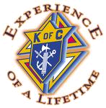

Date Event Day(s) Location

May
4-May Business Meeting Thursday Parish Hall
4-May KofC Information Night Thursday Parish Hall
7-May Social- Baseball Saturday River Cats
8-May Council Social Friday Parish Hall
8-May Mother Day Roses Saturday & Vestibule
Sunday
16-May Blood Drive Sunday Parish Hall
16-May Pancake Breakfast Sunday Parish Hall
21-May Golf Tournament Friday Mather
27-May Officers Meeting Thursday Parish Hall

June
1-June Business Meeting Tuesday Parish Hall
1-June Election of Officers Tuesday Parish Hall
5-June Membership Weekend Saturday & Vestibule
Sunday
24-June Officers Meeting Thursday Parish Hall
26-June Officer Installation Saturday Church
Council Barbeque Saturday Freeman’s
28-June - 4th of July Fundraiser Monday - Cable Park,
4-July Fireworks Sale Sunday Grnback+Filbert

July
5-July 4th of July Fundraiser Ends
6-July Business Meeting Tuesday Parish Hall
10-July Officer’s Installation Saturday Main Church
17-July Annual Planning Tuesday Parish Hall
22-July Officers Planning Thursday Parish Hall

August
3-August Business Meeting Tuesday Parish Hall
26-August Officers Planning Thursday Parish Hall

