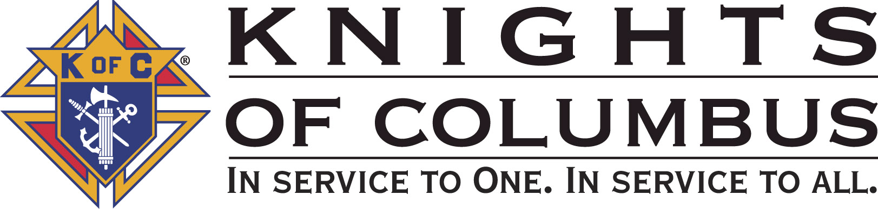

Council #13672 at Divine Savior Fr. Neil W. Seidl
Orangevale, CA
November 2010 Volume 9, #5

Monthly Grand Knight’s Message

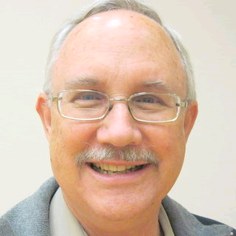
Greetings Brother Knights:
Grand Knight Bruce Pyle

Dep. Grand Knight Tony Aiello

Fin. Secretary Micheal Wagner

Treasurer Allen Brown

Chancellor Jack Hill

Warden Bob Reilly

Advocate Dave Brodie

Recorder Ray Coughlin

Trustee 1st Yr Charlie McDermott

Trustee 2nd Year Bill Windle

Trustee 3rd Year Mike Duskus

Inside Guard Douglas Copley

Outside Guard John Carvalho

Chaplain Fr. Roman Mueller

Lecturer Sam Cimino

Field Agent Tony Magdaleno

The Knights of Columbus Council #13672 at Divine Savior Fr. Neil W. Seidl Chapter meets Monthly on the First Tuesday of each month at 7:00 p.m.
Please join us to help our Catholic Community.
For insurance needs, please contact our Field Agent Tony Magdaleno at 470-9205 or by mail at
P.O. Box 2737
Rancho Cordova, CA 95741

October was another busy month. We awarded scholarship money to 6 deserving elementary students, soccer kicked off, we collected money at two locations for the ID drive, and our 40 days for life efforts continued.

We conducted a successful membership drive. That’s the first event where we showed off our new display board with photos of Council events. You’ll see this at each general meeting, also. Have any pictures to share, please send them to Bruce and Dennis.

One of our members supported the Wheelchair Mission by helping with the distribution in Mexico City. We had a briefing by our “Cabellero de Colon”, Mike Wagner, at our Nov. 2 meeting.

On Columbus Day, I attended a ceremony at the Roseville post office where the mayor laid a wreath at the base of the statue of Columbus. Present were brothers from 3 councils and 2 assemblies. A couple days later, Mike Wagner and I attended the District Deputy meeting and shared ideas with other councils.

Some important upcoming events are the Parish’s Veteran’s Day Celebration on Nov. 12 followed by a reception hosted by our council, Corporate Communion and Memorial Mass at 7:45 on Nov. 21, and the Council Christmas Social on Dec. 3rd.
So, thanks to all who have helped on our events. We continue to help others and garner good PR for the K of C. Let’s keep up the good work and I hope to see you at our coming activities.
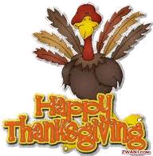
Fraternally yours,

Bruce Pyle, Grand Knight

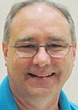

Treasurer Report
(Presented by Allen Brown)

KOC Council No. 132672 – Date balanced: 11/2/2010

Business: $10,926.63
CD 50 - 52: $3,249.79
Charity: $2,073.00
Total: $16,249.42

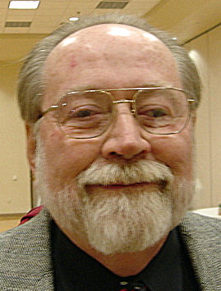

Financial Secretary’s Corner
(Presented by Michael Wagner)

Batch 64 $152.89
Raffle $56.00
Oktoberfest $36.00
Dues $20.89
Initiation Fee $40.00
Batch 65 $981.57
ID Drive $891.57
Batch 66 $236.01
ID Drive $236.01
Batch 67 $325.00 (Charity Account)
ID Drive $325.00
Grand Total $1605.46


2011 Dues
It is that time again; the 2011 Dues letters will be mailed around December 15th. Dues for 2011 are $37.00 and are due on January 1, 2011. As in years past, a voluntary request for a $3.65 donation to the California Columbian Charities (365 Club) will be included. Also, the 2010 Survey of Fraternal Activity will be included.

Please consider paying your dues and completing and returning the Fraternal Activity survey by January 15, 2011; this will allow us to tabulate the numbers and file our council report by the January 31 deadline.

California Columbian Charities Request (365 Club)

At this time of the year, we are making an appeal to members of the Knights of Columbus to join the “365 Club”. Your donation of $3.65 (one penny a day) will go to California Columbian Charities, Inc., which provides emergency assistance to needy California Knights and their families. This past year utilizing funds provided by Councils during the Parade of Grand Knights held annually at the State Convention, California Columbian Charities disbursed almost $200.000 in grants to California Knights of Columbus members and their families in distress. Please join in helping your Brother Knights by your participation in this most worthy program.

Our founder, Fr. McGivney, started the Knights of Columbus to provide for widows and families in need by collecting donations from all of his members and disbursing them to the needy families. Columbian Charities is continuing this act of “Charity” by assisting Brother California Knights and their families in need. Through your desire and willingness to help your Brothers in need and the guidance and Blessing of our Lord and Savior, we can continue to assist our Brothers and their families in need.

Thank you in advance for your generous donation and participation in the 365 Club.

2010 Survey of Fraternal Activity
Last year, the Knights of Columbus donated more than $130 million to charitable and benevolent causes and 61.1 million hours of volunteer community service to aid the less fortunate. To help prepare our Fraternal Survey for the Supreme Council office, you will be asked to complete the “Individual Member Worksheet” that will be mailed with your dues letter in December. Please spend a few moments over the next few weeks thinking about our volunteerism for calendar year 2010. This information will assist us in determining the total number of hours of community service volunteered by our members in 2010.

Your volunteerism hours are not limited to Council functions, please consider and report ALL of your volunteer hours whether they were at the parish, your work, your children/grand children’s school, or any other location or sponsor. Sick and bereavement visits include visits to brother knights, your family and friends, neighbor, co-workers and even strangers.

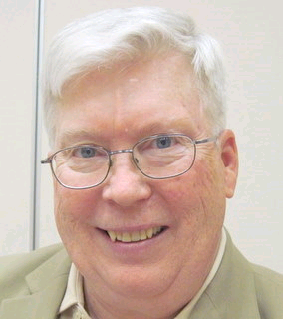

Recorder’s Motions
(Presented by Ray Coughlin)

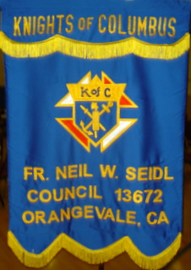
At the November general membership meeting the following motions were addressed:

A) Under Old Business the following motion was approved after being introduced, seconded at the October meeting, and published:
That the Council advance Bill Amantea $1,000.00 for food, supplies, and decorations for the Christmas social on Dec 3rd, 2010. This is an unbudgeted item. Maker: Guy Sanchez; seconded by; Ray Coughlin. Type of Funds: General.
B) For brevity, since there were many motions, I will present the summary of New Business motions: Motions approved: $300 for second & third degree lunches for attendees; $80 to Doug Copley for food & supplies & $60 to Don Marnach for drinks & supplies for Vets' day; $300 to Bob Reilly for the Christmas food program at the parish; $200 to Mike Wagner for the Grace Home; $250 per student for 6 scholarships; $100 for food & supplies for the Christmas social; approval of the Oct minutes; and, approval for all bills presented. We also accepted admission for Edwin
C) Feldmann, John O. Okaru, Augusto Elio, Jim Grave, & Bernard Sabonis to our Council

Knight of the Month
(Presented by Bruce Pyle)

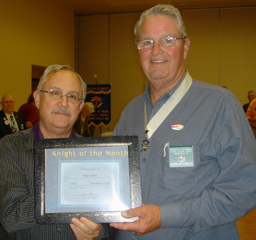
At the October meeting, we honored an important member of our Council, Brother Doug Copley. Currently serving as Inside Guard, Doug is involved in virtually every event and activity of the council. That our meeting room is always ready is due in large part to his efforts.

A member of the Oktoberfest committee, Doug obtained food, including donations, which reduced our cost and increased our revenue. He stepped up as co-chairman of the pancake breakfasts. He is a regular in our kitchen for all events.

As a baker, he provided Father Roman and the parish staff with pastries that they are still talking about.

He has become Katie and Lisa’s “best friend”. They call him with venue changes before the GK knows about them.

Congratulations and thanks to hard working and deserving Knight of the Month.

Families of the Month

(Presented by Bruce Pyle)

Our Family of the Month award will be presented at a later meeting as that Brother Knight was unable to attend this month’s meeting.

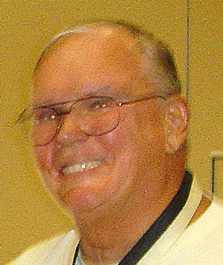

Let the Sunshine
(Presented by Jack Hill)

Cards are available to be sent out to members and families in need. For future need, please remember to contact Jack Hill with any sunshine activity or prayer cards that need to be sent.

You can contact Jack at 916-989-2106 or jack014@aol.com.

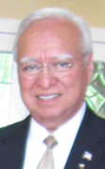
District Insurance News
(Presented by Tony Magdaleno)
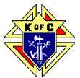

KNIGHTS OF COLUMBUS INSURANCE
“YOUR SHIELD FOR LIFE”
November - LTC Awareness Month - That Are My Risks of Needing LTC?
About 70 percent of individuals over 65 will require at least some type of long-term care services during their lifetime. Over 40 percent will need care in a nursing home for some period of time. Factors that increase your risk of needing long-term care are:

- Age - The risk generally increases as you get older.
- Marital Status – Single people are more likely to need care from a paid provider.
- Gender – Women are at higher risk than men, primarily because they tend to live longer.
- Lifestyle – Poor Diet and exercise habits can increase your risk.
- Health and Family History – also impact your risk.
This year, about 9 million Americans over the age of 65 will need long-term care services. By 2020, that number will increase to 12 million. While most people who need long-term care are 65 or older, a person can need long-term care services at an age. Forty (40) percent of people currently receiving long-term care are adults 18 to 64 years old.
If you are not currently a LTC policyholder, I suggest that we schedule some time together so that I can provide additional information on how you can avail yourself of this significant, value added benefit.
To contact me with regards to any Life Insurance, Annuity or Long Term Care needs, please call me at (916) 470-9205 or e-mail me at tony.magdaleno@kofc.org

Fraternally,
Your Brother and Field Agent,
Tony Magdaleno
Field Agent # 14661
CA Lic. # OG27147

Committee Report - Membership
(Presented by Ray Coughlin)

Our membership tally is now at 129 members.

If you know of someone who would like to join our council, please refer them to Ray Coughlin at (916) 989-4226 or Tony Magdaleno at (916) 470-9205.

Second and Third Degrees
(Presented by Mike Wagner)

Graduation Day November 2010!
Four of our Brother Knights, William Baisley, Dennis Harrington, Dennis Kulik and Matthew Peterson, went to St. Philomene Parish on November 13th to attend their second and third degree exemplification. They were escorted by DGK Tony Aiello, Membership Director Ray Coughlin, FS Micheal Wagner and one proud father, Bob Peterson. Congratulations to our 4 new third degree Knights.

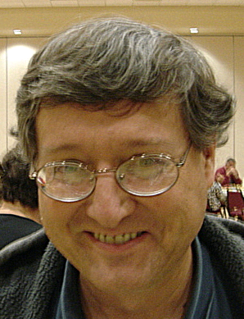

Committee Report - Youth
(Presented by Bill Manos)

Scholarships were handed out during masses by GK Bruce Pyle and Bill Manos. We touched 6 students and their families from Divine Savior.
Soccer Challenge was held at St John’s in Folsom and we had very good representation with great talent.
Free throw contest will be in January. And, he CYM Potato will be December 12th, bill will need a few Knights to help out.

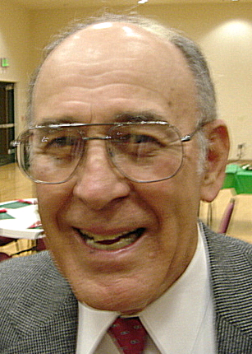
Committee Report - Family
(Presented by Guy Sanchez)
Our annual Christmas party will be held December 3rd and Guy has a 5-star committee and chairman to help put this event on. See you all there!!! To attend, please RSVP to Guy at 987-0798 by Nov. 29.
Please contact Guy Sanchez at 965-3834 with any Family Service Program questions.

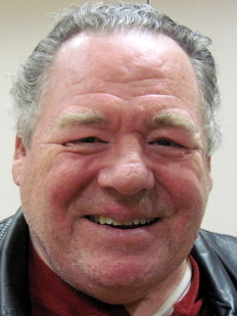
Committee Report – Council
(Presented by Bill Windle)

We had a very successful pancake breakfast and blood drive in September, thanks to Doug Copley and Andy Ventimilgia and a host of wonderful brother Knights.
We will be having a recycle day on January so start getting together all unwanted items to bring to the church parking lot.

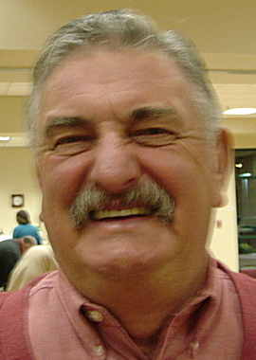

Committee Report – Church
(Presented by Dan Freeman)

Corporate communion will be held November 21st at the 7:45 mass, please come with your loved ones and support this special faith event .
The Veterans celebration was a Hugh success, thanks to PGK Joe Luchi and a group of Knights. Following the ceremony in the church, we hosted reception in the community hall.
Many of our knights participated in both events and many brought memorabilia that reminded us all of the sacrifices that were, and still are being made for our freedoms.
Please contact Dan Freeman at 987-0908 with any Church Service Program questions.

American Wheelchair Mission
(Presented by Mike Wagner)

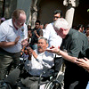
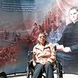
I recently had the opportunity to travel the Mexico City with fellow Knights to distribute wheelchairs to the needy at three churches. I traveled with Chris Lewis and Dan Moberg of American Wheelchair Mission, Christiana Flessner of Canadian Wheelchair Mission and brother knights from California, Florida, Texas and Tennessee. We worked with knights from local councils at each of the churches. We distributed a total of 150 wheelchairs; roughly 50 each at St. Joseph parish, Basilica of Our Lady Guadalupe and the Metropolitan Cathedral. The wheelchairs were funded by councils from California, Texas, Tennessee and Ontario Canada. All of the photographs were taken by Randy Hale, Florida State Council photographer, and can be viewed at www.photoknight.net, just click in the tag “Global Wheelchair Mission”, then “2010 KofC Mexico Wheelchair Distribution”. More pictures will by displayed at the December Christmas Social.

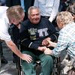
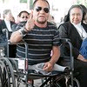
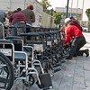
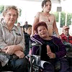

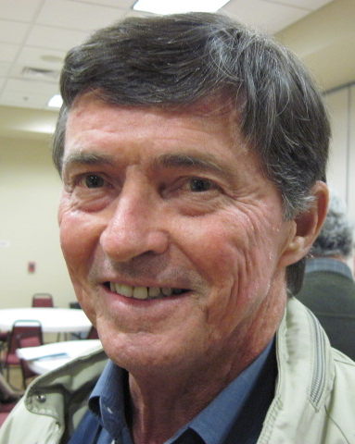

Committee Report - Community
(Presented by Tom Hogan)

We held our annual ID Drive (tootsie roll). Thanks to Dave Brodie and his co-chairmen Dan Freeman and Bob Peterson together with a group of Knights that worked the Wal-Mart and Vic’s stores.

Please contact Tom Hogan at 988-2184 with any Community Service Program questions.

The Grace Home Shopping Trip!

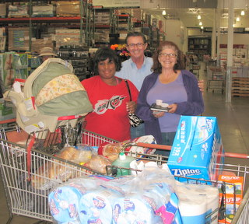
Lots of important items for babies and Moms were purchased at a recent shopping trip to Costco.

Mike Wagner and Tom Hogan (in picture) made the trip with the contacts from the Grace Home and our Council paid for the much needed items!

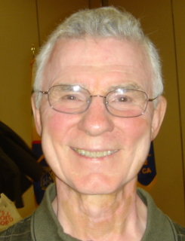


Committee Report – Culture of Life
(Presented by Mike Schaefer)

PRO-LIFE NEWS & ACTIVITIES for November 2010

If you hear of anyone choosing Planned Parenthood as their healthcare provider, there are many reasons to discourage this choice: Planned Parenthood means ABORTION of our unborn children, and they hurt women. Our unborn and all women deserve better.

As Knights are truly a Pro-Life organization, please participate, and invite others to join you, in a P-L activity this month and the days ahead.

A Pro-Life Mass is held monthly (2nd Tuesday @ 6:00pm) at St Philomene’s Church located at 2428 Bell Ave. The next Mass will be November 9th. Rosary starts at 5:30pm. (Call Sally @ 916-721-0378)

40 Days-For-Life is now over. Our Council was represented each Thursday for 1 or 2 hours at the Pregnancy Consultation Center abortion clinic at 53rd & F Street to pray the Rosary to end abortions. The next ‘40 Days…’ will be during the Lenten season in the spring 2011.

“Conceived-In-Rape” will be presented by Rebecca Kiesling, a pro-life speaker who promotes adoption rather than abortion, will be held at the Bayside Church, Roseville, on November 13 at 4:00pm. Being a survivor of rape, Rebecca was adopted herself, became a lawyer specializing in adoptions, has adopted 3 children, and wants to spread her message to all interested.

The Sacramento Life Center will hold their ‘Salute to Life Dinner & Auction’ starting at 5:30pm on Saturday, November 13. Join some 600+ friends of LIFE at the Hyatt Regency and tour the new LIFE-MOBILE. (Please call 916-451-4357 for reservations and information.)
Also the Sacramento Life Center is looking for a few good men to volunteer 4-6 hours/week to drive their new 32-foot Mobile Medical Van in and around the Sacramento Valley area. (For further information, email Ron at ronkincaid@comcast.net)

Walk-for-Life, West Coast in San Francisco, will be held on January 22, 2011. Make plans now to get-on-the-buses at St Mel’s or St John the Baptist, Folsom before they fill up. See the WALK FOR LIFE WEST COAST website or contact David Colt (phone 916/784-0765) for all the details.

Any questions to the above can also be addressed to Mike Schaefer at 916/988-3171.

Special Prayer Intentions

Please keep the following people in your prayers:

- Tom Larson (cancer)
- Rich Dean (chemo- cancer)
- Peter Burriesce (dialysis/foot healing)
- April Paulitz- wife of Patrick (cancer)
- Debbie McDermott- wife of Charlie McDermott (dementia)
- Julia Rapier- mother of Joe (memory)
- Lillian Zettel- mother of George (pelvic cancer)
- Bruce Wagner – brother of Bill
- Barbera Lawson (sick)
- Ladene Carvalho (sick)
- Martin Jennings (sick)
- Beverly Ridge (sick)


November / December Birthday List

Name | Birthday
Sam Bianco | 1-Nov
Arnold (Arnie) Boehm | 9-Nov
Steve Mann | 9-Nov
Michael Wafer | 9-Nov
Paul Romani | 10-Nov
Stan Lenshyn | 13-Nov
Wilfred (Bill) Schulte | 16-Nov
John Padden | 19-Nov
Bruce Pyle | 20-Nov
William Hadwen Jr | 26-Nov
Guy Sanchez | 26-Nov
Thomas Connolly | 27-Nov
Michael Schaefer | 2-Dec
Earl Varney | 5-Dec
Kenneth Hurst | 12-Dec
John Chavez | 13-Dec
Gary Stout | 16-Dec
Abraham Rodriguez | 19-Dec
Joseph (Joe) Luchi | 21-Dec
Father Patrick Nelson (SDS) | 21-Dec
Ernest Deus | 25-Dec
Pierre Mesa | 26-Dec
Robert (Bob) Peterson | 29-Dec

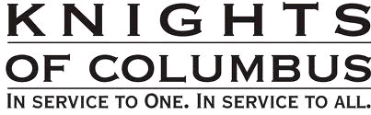
Calendar of Events and Meetings
(Revised 11/20/10)

Date | Event |  | Day/Time |  | Location
Nov 2, 2010 | General Meeting |  | Tues 7:00 |  | DS Parish Hall
Nov 9 | ProLife Mass |  | Tues 6 PM |  | St. Philomene Church
Nov 12 | Veteran’s Celebration, and Reception |  | Friday 6:30, and 7:30 |  | Church,  and Hall
Nov 18 * | Officers/Planning |  |  | Thurs 7 PM | DS Parish Hall
* Date change due to Thanksgiving
Nov 20 | Chapter Meeting |  |  | All day | Nevada City
Nov 21 | Corp Communion & Memorial Mass |  |  | Sun 7:45 AM | Church
Nov 24 | Thanksgiving Dinner for the needy |  |  | Set up 11/23 | DS Parish Hall
Nov 27 | Decorating for Christmas |  |  | Sat 9:00 | Church
Dec 3 | Christmas Social |  | Friday 5:30 |  | DS Parish Hall
Dec 7 | General Meeting |  | Tues 7:00 |  | DS Parish Hall
Dec 12 | CYM Potato Bar |  | Sun. eve. |  | DS Parish Hall
Dec 30 | Officers/Planning |  | Thurs 7:00 |  | DS Parish Hall
Jan 4, 2011 |  | General Meeting |  | Tues 7:00 |  | DS Parish Hall
Jan tbd |  | Free Throw |  |  |  | St. John’s
Jan 16 |  | Pancake Breakfast |  | Sun |  | DS Parish Hall
Jan 16 |  | Blood Drive |  | Sun |  | DS Parish Hall
Jan 22 |  | Walk for Life, SF |  | Sat |  | Bus to SF
Jan 27 |  | Officers/Planning |  | Thurs 7:00 |  | DS Parish Hall
Jan 29 | Recycle Event |  | Sat 10-2 |  | DS Parking lot
Feb 1 |  | General Meeting |  | Tues 7:00 |  | DS Parish Hall
Feb 5 |  | Strategic Plan’g Mtg |  | Sat 9:00 |  | Parish Office
Feb 24 |  | Officers/Planning |  | Thurs 7:00 |  | DS Parish Hall
Mar 1 |  | General Meeting |  | Tues 7:00 |  | DS Parish Hall
Mar 13 |  | Corporate Communion |  | Sun 9:30 |  | Church
Mar 24 |  | Officers/Planning |  | Thurs 7:00 PM |  | DS Parish Hall
Mar 26-27 |  | Recruitment Drive |  |  |  | Church
Mar-Apr |  | 40 days for life |  |  |  | April 6
April 6 |  | General Meeting |  | Tues 7:00 |  | DS Parish Hall
April tbd |  | Information Night |  |  |  | DS Parish Hall
April 28 |  | Officers/Planning |  | Thurs 7:00 |  | DS Parish Hall
April 30 |  | 4th degree ceremony
May 3 |  | General Meeting |  | Tues 7:00 |  | DS Parish Hall
May 7-8 |  | Mother’s Day Roses |  | All Masses |  | Church
May 15 |  | Pancake Breakfast and Blood Drive |  | Sun |  | DS Parish Hall
May 20 ??? |  | Golf
May 21 |  | Pow Wow Days |  | Sat AM |  | Greenback Lane
May 26 |  | Officers/Planning |  | Thurs 7:00 |  | DS Parish Hall
June 7 |  | General Meeting |  | Tues 7:00 |  | DS Parish Hall
June 17 |  | Council Social—River Cats Game
June tbd |  | Officer Installation
June tbd |  | Installation Social |  | `
June 23 |  | Officers/Planning |  | Thurs 7:00 |  | DS Parish Hall
June 28-July 4 |  | Fireworks Booth
Sept 18 |  | Pancake Breakfast and Blood Drive |  | Sun |  | DS Parish Hall

