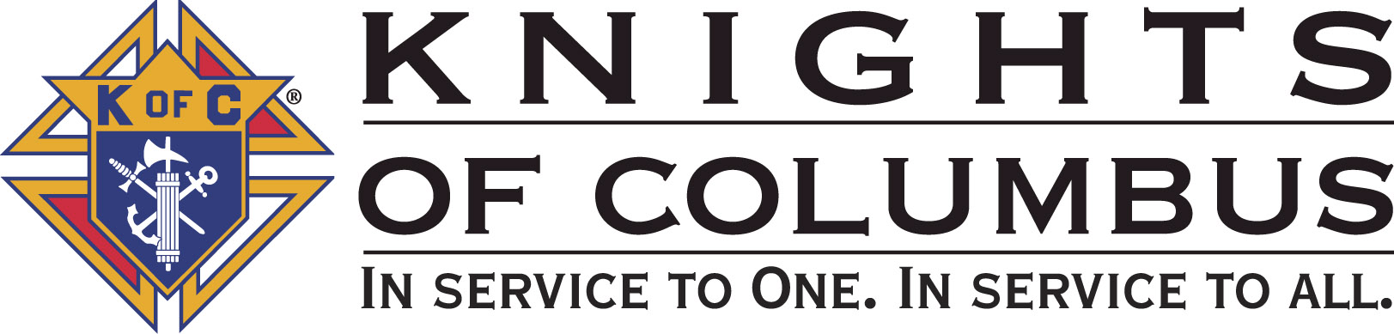

Council #13672 at Divine Savior Fr. Neil W. Seidl
Orangevale, CA
October 2010 Volume 9, #4

Monthly Grand Knight’s Message

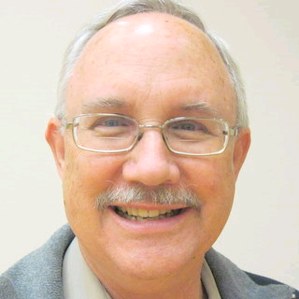

Greetings Brother Knights:
Grand Knight Bruce Pyle

Dep. Grand Knight Tony Aiello

Fin. Secretary Micheal Wagner

Treasurer Allen Brown

Chancellor Jack Hill

Warden Bob Reilly

Advocate Dave Brodie

Recorder Ray Coughlin

Trustee 1st Yr Charlie McDermott

Trustee 2nd Year Bill Windle

Trustee 3rd Year Mike Duskus

Inside Guard Douglas Copley

Outside Guard John Carvalho

Chaplain Fr. Roman Mueller

Lecturer Sam Cimino

Field Agent Tony Magdaleno

The Knights of Columbus Council #13672 at Divine Savior Fr. Neil W. Seidl Chapter meets Monthly on the First Tuesday of each month at 7:00 p.m.
Please join us to help our Catholic Community.
For insurance needs, please contact our Field Agent Tony Magdaleno at 470-9205 or by mail at
P.O. Box 2737
Rancho Cordova, CA 95741

September was a busy month with Council members supporting the Soccer Challenge, Mather Air Show, Octoberfest, Pancake Breakfast and Blood Drive, Strategic Planning Meeting, BGMH Shower, and 40 days for life. We donated a lot of time and made some money for our charities. In short, we worked hard to help others.

This month marks the 6th anniversary of our Council; and, it’s another busy month. We already supported the outdoor mass and we had a successful membership drive. We’ll crank up the ID drive, and we are continuing our 40 days for life prayer vigil. We’re also supporting the Wheelchair Mission… with one of our own going to Mexico City.

We have an information night planned for October 25th. This is for all Knights, family members, and prospective members. We’ll review our activities and events, our charities, and the benefits of being an active Knight. This is a great way to learn more about our council while showing others why they should be involved. Bring a friend, church acquaintance or other prospective member.

This past month, I presented a very nice check to the Rotary Club of Fair Oaks representing their share of our joint Fireworks venture. I also attended the Bishop Gallegos Maternity Home Shower and presented $100 check to the housemother, Lenore Malarkey. It’s always a rewarding experience to work with BGMH.

Karen and I had a great time at our Octoberfest and I thank all who worked on it; and a big thanks goes to chairman, and Knight of the Month, Allen Brown. Our newsletter was out mid-month. Kudos to Dennis Harrington and all our contributors. Our goal is to get it out by the 15th.

I’m very proud of this council… and all we do to help others. I invite all members to attend a meeting once in a while and to help with an activity or event. It may not guarantee our acceptance into heaven; but it sure is rewording to be involved in what is arguably the best K of C council in the area.

God bless us all.

Fraternally yours,

Bruce Pyle,
Grand Knight

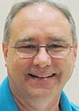

Treasurer Report
(Presented by Allen Brown)

KOC Council No. 132672 – Date balanced: 10/6/2010

Business: $9,214/54
CD50 - 52: $3,249.79
Charity: $1,741.07
Total: $14,205.40

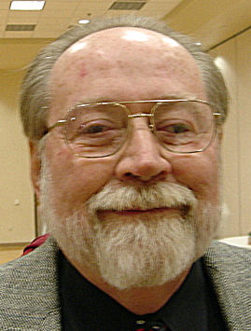

Financial Secretary’s Corner
(Presented by Michael Wagner)

Batch 58 $163.00
Batch 59 $900.00
Batch 60 $2,149.00
Batch 62 $1,038.00
Batch 65 $544.00

Grand Total $4,794.02

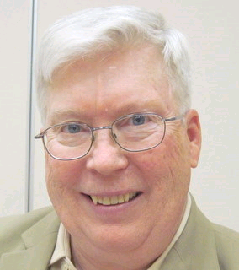

Recorder’s Motions
(As presented by Ray Coughlin)

1) As Recorder: At the General Membership meeting held on Tuesday, September 7th, the following motions were passed: a) payment of all monthly bills presented, b) That the Council approve the Oktoberfest dinner on Sept 18th. Advance Doug Copley $1,000.00 for the purchase of food, supplies, and decorations. Advance Don Marnach $300.00 for drinks and bar supplies. Approve up to $400.00 for payment of parish hall usage and attendant fees. Also, pay Kevin McKnight $700.00 for the services of the Die Alpine Band for 4 hours at the Oktoberfest dinner; payment to be made the night of the performance. This Oktobetfest dinner is an unbudgeted item. Maker: Allen Brown; seconded by: Ray Coughlin. Type of Funds: General, and c) that the Council advance Doug Copley $350.00 to purchase food and supplies for the Pancake Breakfast on Sept 19th. This is a budgeted item. Maker: Doug Copley; seconded by: Ray Coughlin. Type of Funds: General.

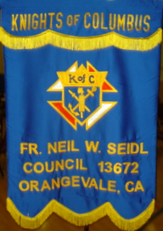
2) At the General Membership meeting held on Tuesday, October 5th, the following motions were passed: a) payment of all monthly bills presented, and b) That the Council donate $25.00 for the Bishop's Dinner for the Priests. This is a request from Jack Willoughby, Northern California Chapter President. This is an unbudgeted item. Maker: Michael Wagner; seconded by: Ray Coughlin. Type of Funds: Charity. The following motion was read to the General Assembly present for the purpose to be published and voted upon at the next month's General Membership meeting: That the Council advance Bill Amantea $1,000.00for the purchase of food, supplies, and decorations for the Christmas social on December 3rd, 2010. This is an unbudgeted item. Maker: Guy Sanchez; seconded by: Ray Coughlin. Type of Funds: General.

3) As Admissions Chairman: The Council will conduct another Information Night on Monday, October 25th, at 7:00pm in the Hall nearest the Kitchen to inform all eligible men over the age of 18 of the advantages of joining our Council. Any member who is aware of an eligible candidate, please urge him to attend this short meet. Even think of attending yourself with the eligible person(s)!

Knight of the Month
(Presented by Bruce Pyle)

Knight of the Month for the month September is Allen Brown.

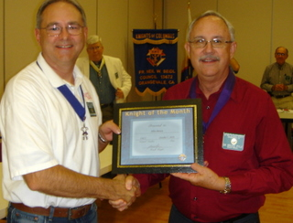
Currently serving his second term as Council Treasurer, he’s involved in virtually every event and activity of the council. And in Mid-August he agreed (or was cajoled) into chairing September’s Octoberfest (which coincided with the 200th anniversary Oktoberfest in Munich).

In less than 5 weeks, Allen Brown led a team of strong Knights (including at least a couple PGK’s) in presenting a very successful event. With a week to go, we hoped to break even. Instead, we raised a nice amount of money, which will benefit Camp ReCreation.

I watched the process from planning to completion to follow-up, and I observed what appeared to be a very relaxed and effective Knight in action. Congratulations and thanks to a most deserving Knight of the Month.

Families of the Month

(Presented by Bruce Pyle)

The Family of the Month for October will be presented next month.

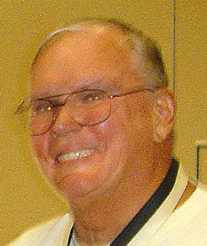

Let the Sunshine
(As presented by Jack Hill)

Cards are available to be sent out to members and families in need. For future need, please remember to contact Jack Hill with any sunshine activity or prayer cards that need to be sent.

You can contact Jack at 916-989-2106 or jack014@aol.com.

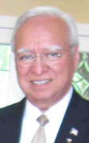
District Insurance News
(Presented by Tony Magdaleno)
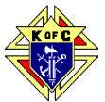

KNIGHTS OF COLUMBUS INSURANCE
“YOUR SHIELD FOR LIFE”
October – LTC Awareness Month.
What Are My Risks of Needing LTC?
About 70 percent of individuals over 65 will require at least some type of long-term care services during their lifetime. Over 40 percent will need care in a nursing home for some period of time. Factors that increase your risk of needing long-term care are:
- Age - The risk generally increases, as you get older.
- Marital Status – Single people are more likely to need care from a paid provider.
- Gender – Women are at higher risk than men, primarily because they tend to live longer.
- Lifestyle – Poor Diet and exercise habits can increase your risk.
- Health and Family History – also impact your risk.
This year, about 9 million Americans over the age of 65 will need long-term care services. By 2020, that number will increase to 12 million. While most people who need long-term care are 65 or older, a person can need long-term care services at an age. Forty (40) percent of people currently receiving long-term care are adults 18 to 64 years old.
If you are not currently a LTC policyholder, I suggest that we schedule some time together so that I can provide additional information on how you can avail yourself of this significant, value added benefit.

To contact me with regards to any Life Insurance, Annuity or Long Term Care needs, please call me at (916) 470-9205 or e-mail me at tony.magdaleno@kofc.org
Fraternally,
Your Brother and Field Agent,
Tony Magdaleno
Field Agent # 14661
CA Lic. # OG27147

Committee Report - Membership
(Presented by Ray Coughlin)

Our membership tally is now at 129 members.

If you know of someone who would like to join our council, please refer them to Ray Coughlin at (916) 989-4226 or Tony Magdaleno at (916) 470-9205.

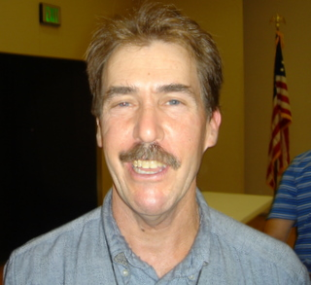
Welcome Transfer Knight

Please welcome Nathaniel Harris to our Knights of Columbus Council #13672!

Second and Third Degrees

Invitation to all First Degree Knights!
Attention all First Degree Knights, the next second and third degrees are November 13th in Sacramento. Please look at your calendar, as someone will be calling you soon to invite you to attend.

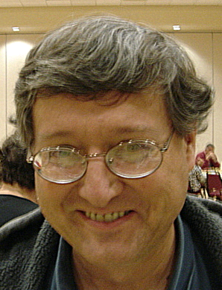

Committee Report - Youth
(Presented by Bill Manos)

We have received 6 applications scholarships and will be meeting with Trustees to choose the winners. On October 10 there will be a soccer challenge at St John in Folsom and we could use some help, call me at 965-3834 if you could help.
We are working on a Free Throw contest in January as well as a Boy Scout retreat.

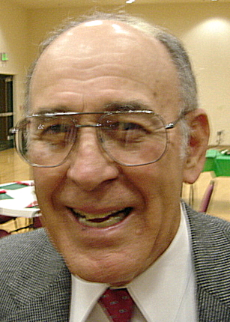
Committee Report - Family
(Presented by Guy Sanchez)
As the Christmas season approaches, we are planning our annual party for Dec. 3rd. We have two brothers who will serve as co-chairs, but they will be in need of some help to make this very smooth.
Those of you that went last year will remember what a great time we all had. So mark that date in your calendar.
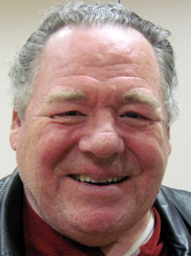
Please contact Guy Sanchez at 965-3834 with any Family Service Program questions.

Committee Report – Council
(Presented by Bill Windle)

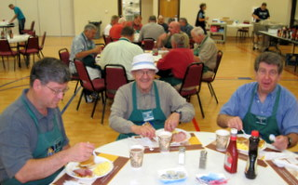
Our Pancake breakfast and Blood drive where successful and we were told that the food was wonderful, thanks to Doug Copley, Andy Ventimilgia and Dave Brodie for their help and leadership, together with the help of all our volunteers that made it a hit.
We will be having another Recycle day on Jan. 29th at Divine Savior parking lot, so start getting together the items you need to un load. More info will be coming.
Please contact Bill Windle at 988-2239 with Council Service Program questions.

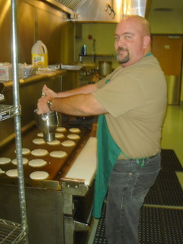
Many Thanks to All Those Who Helped with the Pancake Breakfast!

Bill Baisley
Edward Barbero
Alvin Baughman
David Brodie
Allen Brown
John Carvalho
John Chavez
Sam Cimino
Doug Copley
Michael Duskus
John Fontana
Dan Freeman
James Haak
Dennis Harrington
Joe Joyce
Joe Luchi
Bill Manos
Patrick Paulitz
Robert Peterson
Joe Rapier
Bob Reilly
Tom Sekel
Peter Trujillo
Andy Ventimiglia
Bill Wagner
Mike Wagner
Bill Windle

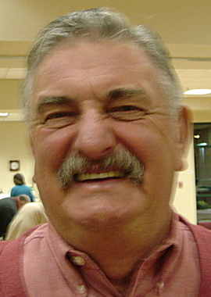
Committee Report – Church
(Presented by Dan Freeman)

Even though we put it together in only a month, our October fest was a success. We were able to donate approx. $900.00 to the ID/tootsie roll drive. The band was awesome and so was the food. It was a great time for all. Congratulation to Allen Brown and his majestic committee.
We held our semi-annual Strategic Planning session and many good ideas and suggestions were brought out. More will follow on this meeting.
Corporate communion & Memorial Mass will at the 7:45am mass on Nov. 21st, please plan to attend and bring family members as well.
On Nov.12 there will be a Veteran’s celebration and get together at Divine savior. This is to give thanks for all those who have served as well as those who gave their lives for our freedoms. The Knights will host a reception right after the church event. Joe Luchi will chair this event, but he could use some help, call him at 984-4854.
We could use some help to put up the Christmas decorations (Advent) on Nov. 27th, call Dan at987-0908.
Please contact Dan Freeman at 987-0908 with any Church Service Program questions.

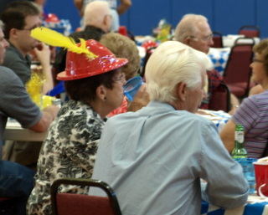
Fun at Oktoberfest!

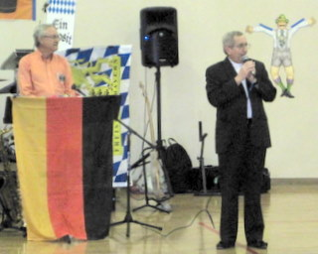

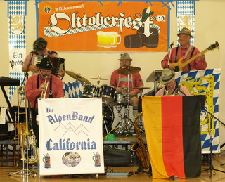
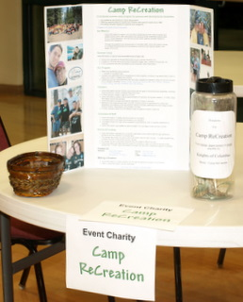

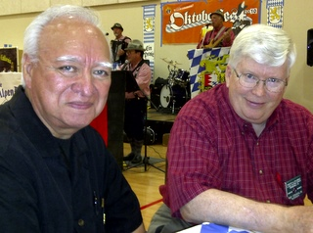

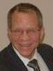
Veterans’ Reception
(Presented by Joe Luchi)

In conjunction with the Divine Savior Parish's prayer service in honor of veterans on Friday, November 12, our Council will be hosting a reception immediately following that service in the Parish's Multi-Purpose Building. The prayer service is scheduled to begin at 6:30 pm and conclude about an hour later.

Everyone who attends the church service will be invited to move to the hall for the reception. All Knights, spouses, and family members, especially those who served this country as members of the military services, are encouraged to attend both the prayer service and the reception.

The parish has asked the Knights of Columbus to provide a few readers and a flag carrier for the prayer service. Our Council also is seeking volunteers to help with setup and takedown for the reception and memorabilia to use as decorations for the reception. Setup is scheduled for noon on November 12. Please contact Joe Luchi at either 984-4854 or jl1954@comcast.net if you would like to help with the prayer service as a reader or flag carrier, volunteer for setup and takedown for the reception, and/or have any items you would like to donate for the reception

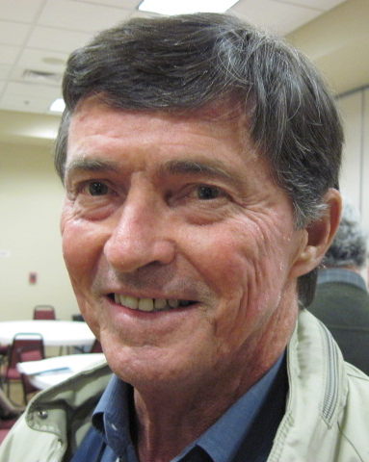

Committee Report - Community
(Presented by Tom Hogan)


The annual Mather air show was bigger and better than last year; we had 6 brother work a pizza and water booth for two days. Thanks to them and Joe Luchi who organized it for us. I’m sure we will do it again next year, thanks to all.
The ID/Tootsie Roll drive will be on October 15-17 and 22. Call Bob Peterson, 988-4710 to work at Vic’s and Dan Freeman, 987-0908 to work at Wal Mart. The shifts are for 2 hrs only. Thanks to Dave Brodie for organizing this event.
Please contact Tom Hogan at 988-2184 with any Community Service Program questions.


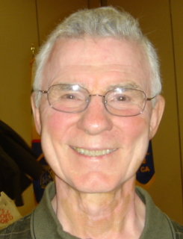
Committee Report – Culture of Life
(Presented by Mike Schaefer)

PRO-LIFE NEWS & ACTIVITIES for October 2010

One myth used to kill Terri Schiavo was that food and water are ‘medical treatments’. When we come back from a meal, we don’t say, “I just had my latest medical treatment”. Rather, we say, “I just had breakfast, lunch or dinner”. Food and water are ordinary means of care, which may not be taken away from the sick.

As Knights are truly a Pro-Life organization and October is Pro-Life Month in the United States, please participate, and invite others to join you, in a P-L activity this month and the days ahead.
A Pro-Life Mass is held monthly (2nd Tuesday @ 6:00pm) at St Philomene’s Church located at 2428 Bell Ave. The next Mass will be October 12th. (Call Sally @ 916-721-0378)

40 Days-For-Life is scheduled for September 22nd to October 31st. Our Council will be represented each Thursday for 1 or 2 hours at the Pregnancy Consultation Center abortion clinic at 53rd & F Street to pray the Rosary to end abortions. We start by attending Mass at 8:30 am at Divine Savior, ask for Fr Roman’s blessing, and then travel in a car-pool to the clinic. This is a family activity, so spouses and friends are welcomed. A sign-up sheet is available at the Oct business meeting. The closing gathering for 40 Days will be Nov 1st at St Anna’s Greek Orthodox Church, 1001 Stone Canyon Drive in Roseville.

The Bishop Gallegos Maternity Home Annual Fund Raising Dinner on September 26 was a success with 240 people attending. Fr Patrick Lee was honored for his pro-life activities. (Call Kathy @ 916-337-6824 for more details)

The Diocese is sponsoring a Euthanasia Conference on Oct 7th at the Pastoral Center from 6:30-9:00pm. Learn about the Catholic Church’s teachings on this topic for our age group. (Call 916-480-9525 for info)

There will be a Bishop Gallegos Maternity Home walk-a-thon on Sat.10-30-2010 at Elk Grove Park starting at 8:00 am. (Call Joe Madruga at 916-685-5679 for more details)

The Sacramento Life Center will hold their Salute to Life Dinner & Auction on Saturday November 13. (Please call 916-451-4357 for information.)

Elections are quickly approaching (November 2nd). Become astute listeners to the campaign promises being made. Remember, there are 5 NON-NEGOTIABLE issues that the Catholic Church lists as intrinsically evil as they conflict with moral law and cannot be condoned or deliberately performed under any circumstances. These are: ABORTION, EUTHANASIA, EMBRYONIC STEM CELL RESEARCH, HUMAN CLONING AND HOMOSEXUAL MARRIAGE. A booklet titled, VOTER’S GUIDE FOR SERIOUS CATHOLICS, is available at the business meeting or in the vestibule of Divine Savior Church.

Any questions to the above can be addressed to Mike Schaefer at 916/988-3171.

Special Prayer Intentions

Please keep the following people in your prayers:

- Tom Larson (cancer)
- Rich Dean (chemo- cancer)
- Peter Burriesce (dialysis/foot healing)
- April Paulitz- wife of Patrick (cancer)
- Debbie McDermott- wife of Charlie McDermott (dementia)
- Julia Rapier- mother of Joe (memory)
- Lillian Zettel- mother of George (pelvic cancer)
- Bruce Wagner – brother of Bill
- Barbera Lawson (sick)
- Ladene Carvalho (sick)
- Martin Jennings (sick)
- Beverly Ridge (sick)


October / November Birthday List

Frank Donner Jr | 6-Oct
Michael Dreiling | 8-Oct
Clemente Torres Sr | 9-Oct
William (Bill) Smith | 13-Oct
Andrew Ventimiglia | 14-Oct
William (Bill) Windle | 27-Oct
Jack Dube | 30-Oct
Sam Bianco | 1-Nov
Stanley Lenshyn | 1-Nov
Arnold (Arnie) Boehm | 9-Nov
Steve Mann | 9-Nov
Michael Wafer | 9-Nov
Paul Romani | 10-Nov
Wilfred (Bill) Schulte | 16-Nov
John Padden | 19-Nov
Bruce Pyle | 20-Nov
William Hadwen Jr | 26-Nov
Guy Sanchez | 26-Nov
Thomas Connolly | 27-Nov

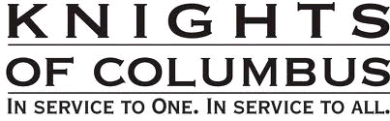
Calendar of Events and Meetings
(Revised 10/10/10)

Date | Event |  | Day/Time |  | Locaton
Oct 5 | General Meeting |  | Tues 7:00 |  | DS Parish Hall
Oct 7, 14 ,21, and 28 | Pro-Life Mass and Prayer Vigil |  | 8:30 AM |  | Church and 53rd & F
Oct 9-10 | Membership Drive |  | After mass |  | DS Church Narthex
Oct 10 | Soccer Challenge |  | Sat 11-3 |  | St. John Baptist
Oct 13 | KC District Mtg |  | 7:00 PM |  | St. Clare Church
Oct 15 & 16 | IR (Tootsie Roll) |  | All day |  | Vic’s Market
Oct 15 & 22 | IR (Tootsie Roll) |  | All day |  | WalMart
Oct 16-17 | Boy Scout Retreat
Oct 28 | Officers/Planning |  | Thurs 7:00 |  | DS Parish Hall
Oct 25 | Information (K)night |  | 7:00 PM |  | DS Parish Hall
Nov 2 | General Meeting |  | Tues 7:00 |  | DS Parish Hall
Nov 12 | Veterans Celebration and Reception |  | Friday 6:30 |  | Church and Hall
Nov 18 * | Officers/Planning |  | Thurs 7:00 |  | DS Parish Hall
Nov 20 | Chapter Meeting |  |  | All day | Nevada City
Nov 21 | Corp Communion & Memorial Mass |  |  | Sun 7:45 AM | Church
Dec 3 | Christmas Social |  | Friday |  | DS Parish Hall
Dec 7 | General Meeting |  | Tues 7:00 |  | DS Parish Hall
Dec 30 | Officers/Planning |  | Thurs 7:00 |  | DS Parish Hall
Jan 4, 2011 |  | General Meeting |  | Tues 7:00 |  | DS Parish Hall
Jan tbd |  | Free Throw |  |  |  | St. John’s
Jan 16 |  | Pancake Breakfast |  | Sun |  | DS Parish Hall
Jan 16 |  | Blood Drive |  | Sun |  | DS Parish Hall
Jan 22 |  | Walk for Life, SF |  | Sat |  | Bus to SF
Jan 27 |  | Officers/Planning |  | Thurs 7:00 |  | DS Parish Hall
Jan 29 | Recycle Event |  | Sat 10-2 |  | DS Parking lot
Feb 1 |  | General Meeting |  | Tues 7:00 |  | DS Parish Hall
Feb 5 |  | Strategic Plan’g Mtg |  | Sat 9:00 |  | Parish Office
Feb tbd |  | Information Night |  |  |  | DS Parish Hall
Feb 24 |  | Officers/Planning |  | Thurs 7:00 |  | DS Parish Hall
Mar 1 |  | General Meeting |  | Tues 7:00 |  | DS Parish Hall
Mar 13 |  | Corporate Communion |  | Sun 9:30 |  | Church
Mar 24 |  | Officers/Planning |  | Thurs 7:00 PM |  | DS Parish Hall
Mar-Apr |  | 40 days for life |  |  |  | April 6
April 6 |  | General Meeting |  | Tues 7:00 |  | DS Parish Hall
April tbd |  | Council Social—River Cats Game
April 28 |  | Officers/Planning |  | Thurs 7:00 |  | DS Parish Hall
May 3 |  | General Meeting |  | Tues 7:00 |  | DS Parish Hall
May 7-8 |  | Mother’s Day Roses |  | All Masses |  | Church
May 15 |  | Pancake Breakfast and Blood Drive |  | Sun |  | DS Parish Hall
May 20 ??? |  | Golf
May 21 |  | Pow Wow Days |  | Sat AM |  | Greenback Lane
May 26 |  | Officers/Planning |  | Thurs 7:00 |  | DS Parish Hall
June 7 |  | General Meeting |  | Tues 7:00 |  | DS Parish Hall
June tbd |  | Officer Installation
June tbd |  | Installation Social |  | `
June 23 |  | Officers/Planning |  | Thurs 7:00 |  | DS Parish Hall
June 28-July 4 |  | Fireworks Booth
Sept 18 |  | Pancake Breakfast and Blood Drive |  | Sun |  | DS Parish Hall

* Date change due to Thanksgiving

