St. Mel School

Registration Packet

2010 – 2011



ST. MEL CATHOLIC SCHOOL
4745 Pennsylvania Avenue
Fair Oaks, California 95628
916-967-2814
www.stmelschool.org

Dear Parents,

As stated in our Mission Statement, St. Mel School “promotes academic excellence within a Catholic faith-filled environment.” This is reflected in the philosophy of the school and Student Learning Expectations which endeavors to assist the parents, as primary educators, by creating a Catholic environment which will promote the spiritual, intellectual, emotional, physical, and social growth of the child.

In order to accomplish this mission, the administration and the School Advisory Commission of St. Mel School is required to establish a budget that is fiscally sound and balanced. Tuition has not been increased for the 2010-2011 school year. Registration fees have been increased by $50.00 per student and can be financed through SMART. Additionally, fees will be required for students who participate in our Sports and Drama programs. Funding is also derived from four sources:

1) TUITION AND FEES
2) PARISH SUBSIDY
3) PARENTS CLUB FUNDRAISERS
4) SCRIP PROGRAM

We are fortunate to have a pastor who supports Catholic education. Father McSweeney gives a very generous parish subsidy to the school each year. Parents Club also plays an important role in keeping tuition costs to a minimum. They make an annual pledge that goes directly into the operating budget. In order for the Parents Club to meet this pledge, each family is assessed $350.00. This assessment is met in the following ways:
1) PARENT CLUB DUES - $50 due at Registration
2) CONTRIBUTIONS TO AUCTION *
3) CONTRIBUTIONS TO CRAB FEED *
4) CONTRIBUTIONS TO WINE EVENT*
5) CONTRIBUTIONS TO JOG-A-THON*

*Receipts for items donated to these events must be submitted with donated items for credit toward the $350.00 commitment or credit will be given for the amount the item sold for at the fundraiser (not to exceed retail value).

You will receive a summary in January and April reflecting your fulfillment of this assessment. Required Service Hours will remain the same – 45 hours for families and 30 hours for single parents. Since every family shares in the substantial benefits from the proceeds of our Catholic school’s family fundraising activities all must share equally in the labors necessary to assure their profitable operation. For those families who do not perform the required number of service hours by March 31, 2011, there will be a NON-PARTICIPATORY registration fee of $1100 for a student entering grades TK – 7th and $1150 for a student entering 8th grade for the 2011-2012 school year. It is important that all hours be completed. Partial completion of service hours will be subject to this fee. Additionally, each family will be required to participate in the Scrip Program.

We are delighted to have you as a member of the St. Mel School Community. We anticipate a vibrant and productive 2010-2011 school year. I am committed to working in partnership with all parents who have made the conscious decision to give their child(ren) the gift of a Catholic education.

Sincerely In Christ,

Mrs. Janet Nagel, Principal

ST. MEL SCHOOL

TUITION & REGISTRATION FEES

2010-2011

PARISHIONER RATES

# of Children Tuition
TK $ 2,700.00
1 $ 4,075.00
2 $ 7,425.00
3 $10,025.00
4 $11,850.00

NON-PARISHIONER RATES

# of Children Tuition
TK $ 3,175.00
1 $ 4,850.00
2 $ 8,400.00
3 $11,100.00
4 $13,600.00

Registration Fee TK-7th $350.00
Registration Fee 8th $400.00
Sports Fee (Grades 5-8) $50.00
Sports Fee (Grades 1-4) $25.00
Drama Fee $50.00
Parent Club Dues $50.00
Parent Club Contribution $300.00

St. Mel Parishioner Rate: The rate for families who are active participants in the life of this parish. “Active Participants” are that whose presence enriches the life of this parish community and who regularly attend Sunday Mass at St. Mel Church and use the Sunday envelopes. This status will be determined annually by the pastor.

St. Mel Non-Parishioner Rate: The rate for all families who do not conform to the above definition.

Please note: A $43 annual fee will be charged to each family who uses the SMART Tuition Payment Plan. This fee will be added to the first SMART payment due June 30, 2010.

St. Mel School
Registration Check List

2010-2011

Family Name: __________________________________

The following is a list of items that need to be completed and turned in at Registration. Please use this check-off list to ensure you have included all required materials.

#1. ___ Personal and Financial Commitment & 2010 - 2011 Registration Agreement
(4 pages total)

____ School Mission - Did you initial #1- #4?

____ Registration – Did you complete and initial #5 - #9?

____ Tuition – Did you initial #10 and check A,B, or C?

____ Financial Aid – Determination of Status – Did you initial #11 & #12

____ Financial Commitment – Did you initial #13 - #17?

____ St. Mel Parent Commitment – Did you initial #18 - #20?

____ Scrip Program – Did you initial #21-#22?

____ Service Hours Program – Did you initial #23 - #24 and
indicate Service Hours Commitment?

____ Did you sign-print-date the 2010 -2011 Registration Agreement?

#2. ___ Emergency Information Request Form

#3. ___ St. Mel School Directory Form - ($12 for listing; plus $15 if advertising)

#4. ___ 2010 – 2011 Computer Use Agreement

#5. ___ Service Hours Volunteer Opportunities Form

#6. ___ Website Photo Permission Form

#7. ___ Non-Public School Title I Family Survey 2010-2011

#8. ___ Diocese of Sacramento – School Volunteer Agreement Form

FAMILY NAME: __________________

ST. MEL SCHOOL
PERSONAL AND FINANCIAL COMMITMENT
2010-2011 REGISTRATION AGREEMENT

The administration, faculty, and staff of St. Mel School support the Catholic Bishops’ 1972 letter, “To teach As Jesus Did” which recognizes the parent as the primary educator. Any successful education program then depends upon the positive and active cooperation and involvement of the parents or guardians with the school. Therefore, as a registered family of St. Mel School, we agree to the following:

(Please READ and INITIAL each item)
1. _____ We/I have read and support the mission and philosophy of St. Mel School.

2. _____ We/I have read and support the rules outlined in the Parent Handbook.

3. _____ We/I agree to support and participate in school activities, Parent-Teacher
conferences, Parent Club functions, and any other meetings called by the
Principal or her representatives.

4. _____We/I understand that the family information listed in the St. Mel School Directory
(aka: Buzz Book) is to be used only for school related business and may not be
used for personal gain in any way.

REGISTRATION
5. _____We/I agree to pay the Registration fee of $350.00 for each child in grades TK-7th
identified below. Registration for students in 8th grade is $400.00 which includes Graduation and Confirmation fees identified below. This Registration fee is payable to the order of St. Mel School at the time this Agreement is signed and is non-refundable.

NAME: GRADE: AMOUNT

_______________________________ ____________ ___________________

_______________________________ ____________ ___________________

_______________________________ ____________ ___________________

_______________________________ ____________ ___________________

6. _____ We/I understand that Registration fees may be financed through SMART Tuition
Management Services.

_____ We/I choose to finance the Registration fee through SMART.

_____ We/I choose not to finance Registration fees through SMART and
my check is attached.

7. _____ We/I understand tuition is paid to SMART Tuition Management Services.
Payment may be amortized over a 10 month period, paid in full by May 4, 2011 or
in scheduled quarterly payments paid directly to St. Mel School.

8. _____ We/I understand a $43.00 annual fee will be charged to each family using the
SMART Tuition Management Services This fee will be added to the first SMART payment due June 30, 2010. (This fee will be waived if your tuition is paid in full
on Registration Day, Tuesday, May 4, 2010.)

9. _____ We/I agree to pay a late charge of $45.00 for every payment received by SMART
Tuition Management Services more than 10 calendar days after it first becomes
due.

TUITION
10. _____ We have read and understand the tuition rates, material and registration
fees, sports fee and drama fee for the 2010-2011 school year. We agree to timely pay all of the following charges:

(Please check ONLY one of the following payment options.)
A. _____ One annual payment due AT TIME OF REGISTRATION.

B. _____ Ten monthly payments through SMART beginning June 30, 2010
through March 30, 2011.

C. _____ Quarterly payments paid directly to St. Mel School. Scheduled
Payments are due by: June 1, 2010, September 1, 2010,
December 1, 2010 and April 1, 2011.

FINANCIAL AID & DETERMINATION OF STATUS
11. _____ We/I have applied for, and have been granted, Financial Aid. The
amount of this Financial Aid will be subtracted from the Tuition described above.
We/I agree to pay the difference $____________, to SMART, in full, or in
Quarterly payments as indicated above in (#10).
12. _____ Determination of status. (Please check one.)
A. _____ Our /My status has been determined by the Pastor as “parishioner.”
We/I therefore agree to pay Tuition to the school in the amount of
$_________.
B. _____ Our/My status has been determined by the Pastor as “non-parishioner”
and we therefore agree to pay Tuition to the school in the amount of $____________.

FINANCIAL COMMITMENT
13. _____ We individually understand that we are jointly liable for payment for the
entire tuition for our child(ren). If one of us fails to pay his/her portion of the tuition, the other agrees to pay the entire tuition for our child(ren).

14. _____ Withdrawal of your child(ren) prior to the end of the school year will result
in a charge equal to one (1) month’s tuition at the time of withdrawal (based on
your annual tuition divided by 10 months). Additionally, the $350.00 Parent Club
obligation and Scrip Commitment (or unmet balance remaining) is due at the time of withdrawal.

15. _____ We/I understand that upon dismissal or withdrawal of the student for any
reason there will be a pro-rated refund of tuition already received by the school.

16. _____ We/I understand that in the event of a dispute regarding payment of tuition,
and legal proceedings begin; the prevailing party shall be awarded reasonable
legal fees and costs.

17. _____ We/I understand that failure to make tuition payments will result in St. Mel
School declaring all unpaid tuition/fees due and payable. St. Mel School reserves
the right to turn over any unpaid accounts to collections, and continued enrollment
may be terminated.

ST. MEL PARENT CLUB COMMITMENT
18. _____ We/I recognize that the St. Mel Parent’s Club provides essential support
to the School. In particular, we understand that fund-raisers conducted by the
Parent’s Club provide an essential supplement to the School’s operating budget.
As an integral part of our responsibilities as parent(s) of a child(ren) enrolled in the School, we/I agree to join the Parent’s Club for the 2010 -2011 school year and to contribute a net total of at least $350.00 to the School.

19. _____ We/I understand this may be contributed through one of the following
Parent’s Club Events:
1. Parent Club Dues of $50.00 due at Registration
2. *Contributions to the Auction
3. *Contributions to the Crab Feed
4. *Contributions to the Wine Event
5. *Contributions to the Jog-A-Thon

_____*We/I understand receipts for items donated to these events must be submitted with donated items for credit toward the $350.00 commitment or credit will be given for the amount the item sold for at the fundraiser (not to exceed retail value).

20. _____ We/I agree that, at the discretion of the Principal, this obligation may be
satisfied in kind, instead of in cash. We/I further agree to satisfy this obligation by March 31, 2011.

SCRIP PROGRAM
21. _____ We/I understand each family registered at St. Mel School will be required
to participate in the Scrip program at a minimum level of $3000.00 per school year. All Scrip purchases made from April 1, 2010 through March 31, 2011 will count towards meeting the $3000.00.

22. _____ We/I understand there is an option to bypass the Scrip commitment and
participate in an Optional Buyout for $225.00.

_____ We/I am choosing to pay the Optional Buyout in the amount
of $225.00 due before March 31, 2011.

SERVICE HOURS PROGRAM

Many of our school families meet and exceed the service hours commitment of 45 hours or 30
hours for a single parent 10 hours of which must be worked in a major fundraiser (Wine
Event, Auction, Crab Feed, Jog-A-Thon). For those families who do not perform the required
number of service hours by March 31, 2011, there will be a NON-PARTICIPATORY registration
fee of $1100 for a student entering grades TK-7th and $1150 for a student entering 8th grade for
the 2011-2012 school year. It is important that all hours be completed. Partial completion of
service hours will be subject to this fee.

23. _____ We/I understand that all families of St. Mel School are expected to contribute a MINIMUM of 45 hours or 30 hours for a single parent. Each family is responsible for tracking their own hours. Since every family shares in the substantial benefits from the proceeds of our Catholic school’s family fundraising activities all must share equally in the labors necessary to assure their profitable operation.

- _____ We/I agree to actively participate in the Service Hours Program and
understand a NON-PARTICIPATORY registration fee of $1100 for a student entering grades TK-7th and $1150 for a student entering 8th grade for the 2011-2012 school year.

(Please check and initial your Service Hours Commitment.)

_____ 45 Service Hours Commitment – Family

_____ 30 Service Hours Commitment – Single Parent

Mother/Guardian Signature: _________________________________ Date: ______

Print Name: ______________________________________________

Father/Guardian Signature: __________________________________ Date: ______

Print Name: ______________________________________________

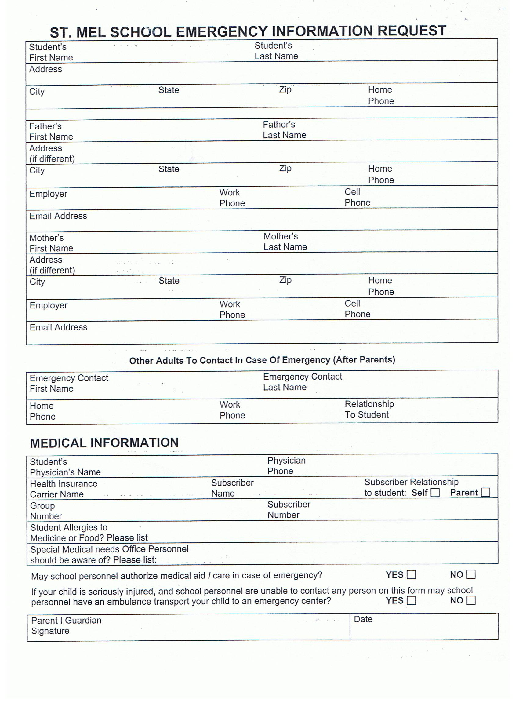
ST. MEL SCHOOL DIRECTORY
8TH GRADE FUND-RAISER
www.stmelschool.org

This year we will publish our School Directory (Buzz Book), in August and the cost is $12.00. If you wish to be listed in this directory for 2010-2011, please fill in the following:

LAST NAME:

PARENT’S NAME:

ST. MEL CHILDREN’S NAMES GRADE

ADDRESS
CITY
PHONE NUMBER
E-MAIL ADDRESS _________________________________________________

If you wish to advertise your business so that members of St. Mel School may
patronize your business, attach card here or fill in:

NAME OF BUSINESS
ADDRESS
CITY
PHONE NUMBER
E-MAIL ADDRESS

We ask, if possible, that you donate $15 for advertising. All donations are gratefully received and will be used to defray printing costs.

Please submit a check in the amount of $12.00 for the purchase of a school directory and, if you are advertising in the directory, please include an additional donation of $15.00 to ST. MEL SCHOOL..
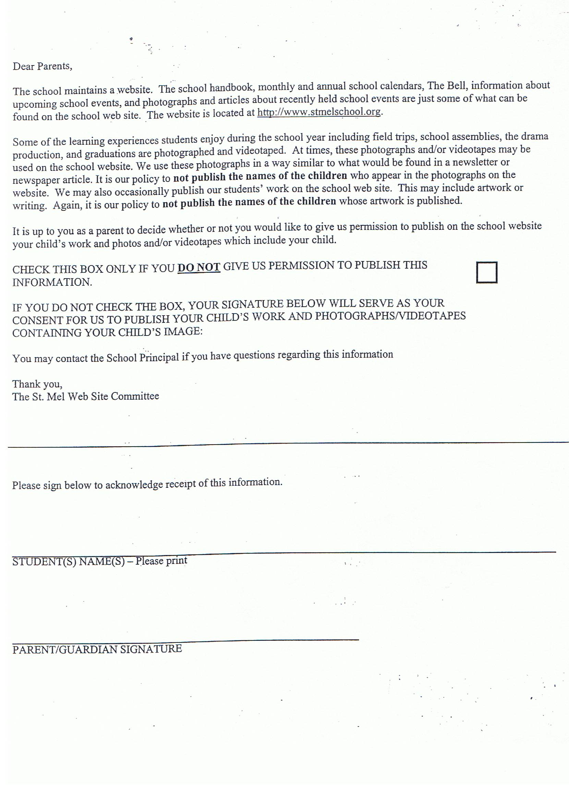

Computer Use Policy

St. Mel School

Purpose

Computers are a valuable tool for education and sharing of information. One of this school’s purposes
is to encourage the proper use of computer related technology including the Internet. Students and
all users of computer technology have a responsibility to use these tools properly and in accordance
with the policy below:

Goals

To provide a variety of electronic tools to help students and teacher develop the ability to evaluate
and synthesize information from a variety of sources and enable them to work effectively with
various computer/communications technology.

To encourage critical thinking and problem solving skills which are needed in this increasing
electronic and global society.

Responsibility of Student

With right of access comes responsibility to each student to use the source both correctly and wisely.
Access to the Internet for instance, may mean that some material found will not meet guidelines set
in our Computer Use Policy. Monitoring and controlling all such material is impossible. The school
will make every effort to discourage the appearance of such material. However, the opportunities
and information made available by the Internet make it necessary to provide access in order that our
students can take advantage of the many resources on the information superhighway.

Responsibility of Publications/Website Postings

St. Mel maintains a website. Some of the learning experiences that students enjoy during the school
year are often photographed and videotaped. We use these photographs in a way similar to what
would be found in a newsletter or newspaper article. It is our policy to not publish the names of
children who appear in the photographs on the website. Occasionally, we publish student work on the
website. This may include artwork or writing. Again, it is our policy to not publish the names of the
children whose work is published. It is up to parents to decide whether or not it is permissible to publish a child’s work or photo.

General Guidelines for use of the Internet:

    - All users are required to take simple Internet training (how to sign on, log off, etc.) from the computer instructor.

    - Only students who have completed this training may use the computers to access the Internet.

Specific Guidelines

    - Use of the stations is limited to those who have a clear need for research, with a teacher assignment to back it up. Use will be limited if necessary.

    - Transferring copyrighted material to or from a diocesan school without express permission of the owner is a violation of Federal Law. The user is deemed responsible to see that this does not occur.
    - Use of electronic mail and other Internet facilities to harass, offend or annoy other users is strictly forbidden.

    - Accessing personal e-mail through the school’s computer is forbidden.

    - Any attempt to circumvent system security, guess passwords or in any way gain access to secured resources is forbidden.

    - Use of the Internet for commercial gains or profits is not allowed from an educational site.

    - Users will not move, repair, reconfigure, modify or attach external devices to the systems.

    - Any member of the St. Mel faculty has the right to monitor all computer lab activities.

    - Additional rules and restrictions may be added at any time.

Violations of these rules will be dealt with by the administration of the school. Violation of these rules may result in any or all of the following:

Loss of Internet access
Disciplinary or legal action by the school or other involved parties

2010-2011 Computer Use Agreement

Please return this signed page with your registration information. Thank you!

In regards to technology, I have read and understood the information provided by St. Mel School and agree to the guidelines provided.

I give St. Mel permission to use work or photos of my child/children for St. Mel publications/website.

___________________________________________ _____________________________________________
Parent/Guardian Name (please print) Student Name (please print)

____________________________________________ ______________________________________________
Parent/Guardian Signature Student Signature

____________________________________________ _______________________________________________
Parent/Guardian Name (please print) Additional Student Name (please print)

____________________________________________ ______________________________________________
Parent/Guardian Signature Student Signature

_______________________________________________
Additional Student Name (please print)

_______________________________________________
Student Signature

_______________________________________________
Additional Student Name (please print)

_______________________________________________
Student Signature

Service Hours Volunteer Opportunities
To Complete Service Hours Commitment Form

Please review the following volunteer opportunities list. Please indicate how you wish to be involved in order to earn hours for the 2010-2011 school year. There will be representatives at registration to answer your specific questions about time commitment and duties. Keep in mind that some positions will already be filled at the time of registration.

LIST OF ACTIVITIES

______ Parent Club Officer

CLASSROOM ASSISTANCE
______ Classroom helper
______ Field trip driver (max 4 hours per trip)
______ Room mother coordinator
______ Room mother: Grade____
______ Class fund-raiser (Under the
direction of room mothers & teachers)

REVENUE SAVING JOBS
______ Health chairperson
______ Health committee helper
______ Parking lot coordinator
______ Parking lot greeter
______ Office helpers
______ Hot Lunch helper
______ Hours recorder
______ Library coordinator
______ Library helper
_____ IT Support
_____ Website Helper

FUNDING SUPPORT
_____ Scrip Selling
_____ Grant Writing

LAST NAME:_______________________________
(please print)

FIRST NAME_____________________________
(please print)

PHONE # ____________________________

EMAIL:__________________________________

______ School Advisory Commission

FUNDRAISING ACTIVITIES
______ Auction Chairperson
______ Auction Committee Chair
______ Auction Helper
______ Book Fair Chairperson
______ Book Fair Helper
______ Festival Chairperson
______ Festival Helpers
______ Crab Feed Chairperson
______ Crab Feed Committee Chair
______ Crab Feed Helper
______ Father-Son Event Chairperson
______ Father-Son Event Helper
______ Father-Daughter Event Chairperson
______ Father-Daughter Event Helper
______ Jog-a-thon Chairperson
______ Jog-a-thon Helper
______ Mother-Daughter Event Chairperson
______ Mother-Daughter Event Committee Chair
______ Mother-Daughter Event Helper
______ Mother-Son Event Chairperson
______ Mother-Son Event Helper
______ Wine Event Chairperson
______ Wine Event Helper
______ See’s Candy fundraiser
______ Art Docent
______ Casino Night Chairperson
______ Casino Night Helper

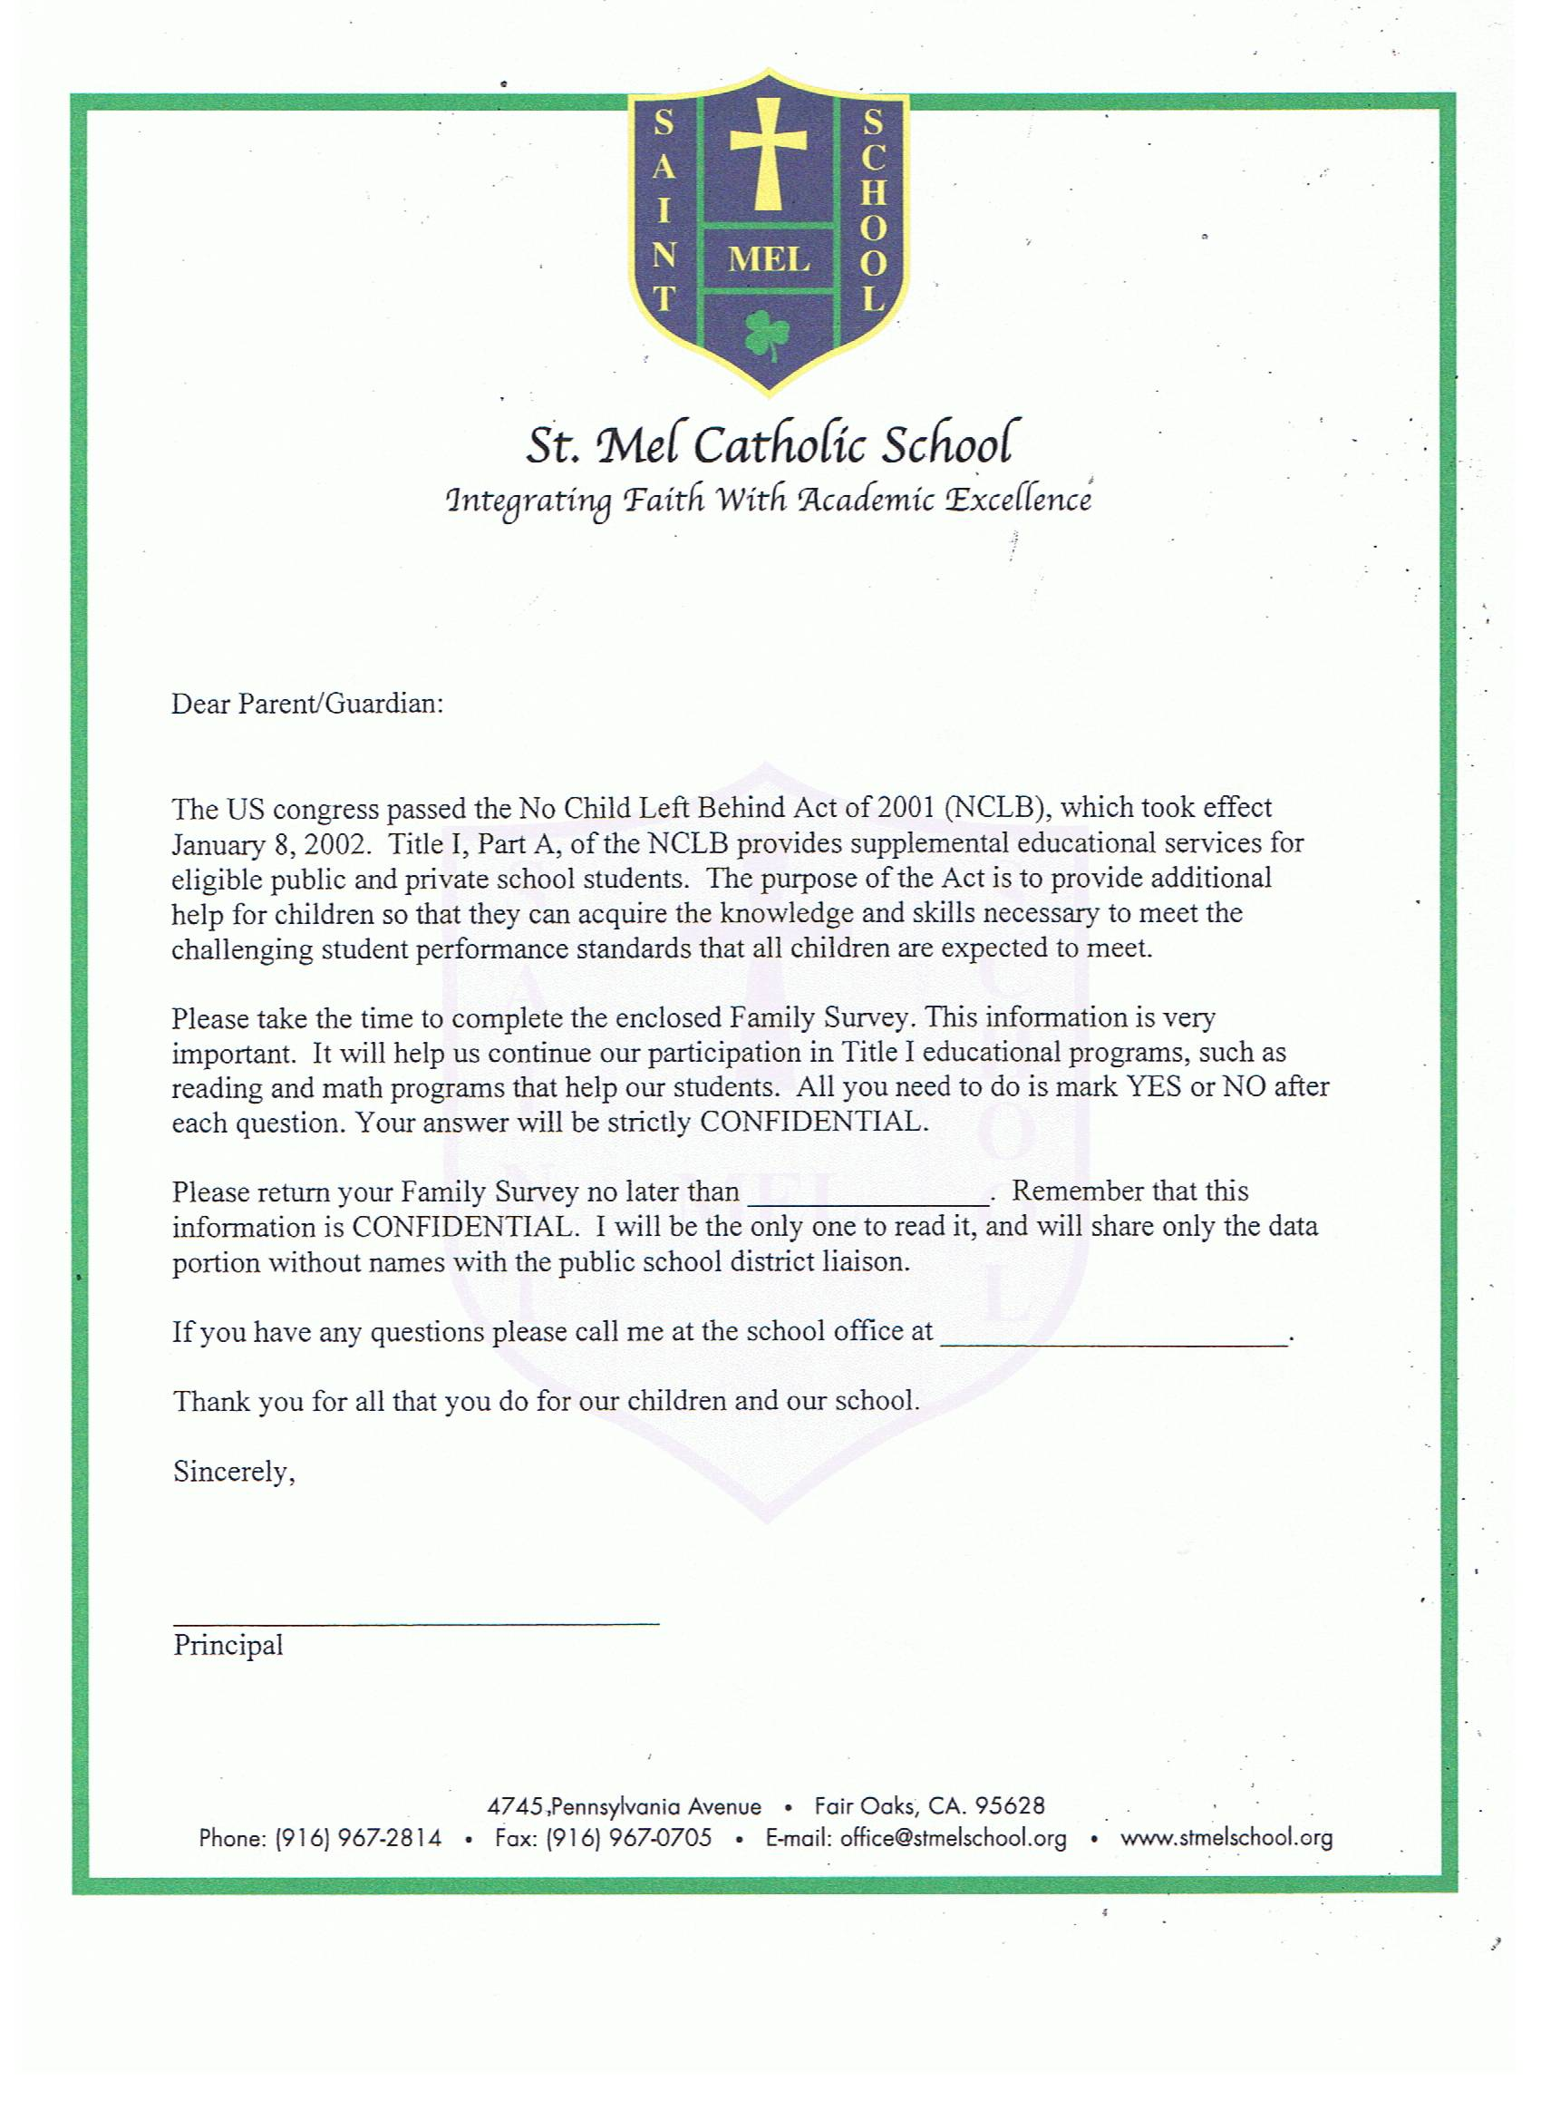
May 28, 2010
967-2814

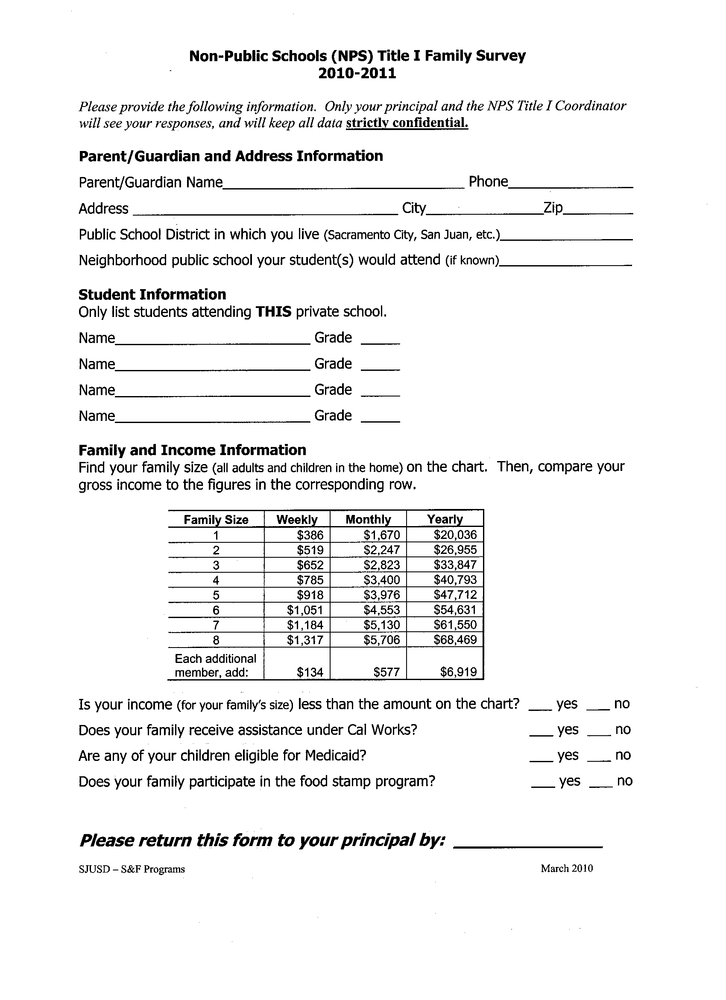
May 28, 2010

Diocese of Sacramento – School Volunteer Agreement Form

By signing this form, I _____________________________________, acknowledge that I have
(name)
chosen to volunteer at ________________________________________, as a:
(School)

_________________________________________________________________________________
(state position(s))

I understand and acknowledge that my services in this regard are being donated by me to the Diocese of Sacramento without contemplation of compensation or future employment, and that I provide these services for religious, charitable, or humanitarian reasons.

I understand that as a volunteer I will earn no wages or benefits in connection with the volunteer services I wish to provide. I further understand that I will not be entitled to unemployment insurance benefits upon the termination of my volunteer services (regardless of whether such termination is initiated by me or by the Diocese), nor will I be covered under the Diocese’s worker’s compensation insurance in the event of injury incurred during the rendering of the volunteer services I will provide.

____________________________________ ______________________
Volunteer Signature Date

____________________________________ ______________________
Principal Signature Date

