

**About Me**

A hardworking and detail-oriented individual with experience in parcel sorting, customer service, and retail assistance.Strong communication and problem-solving abilities developed through experience.

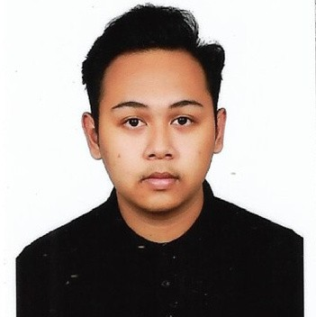

Able to work effectively in fast-paced environments, collaborate with teams, and provide excellent service to customers.with a willingness to learn and adapt to new challenges.

**Education**

MOHAMAD SYAFIQ BIN IBRAHIM

# DIPLOMA IN ENGINEERING ELECTRONICS (COMPUTER)

2023 - 2026



***POLITEKNIK SEBERANG PERAI***

# SIJIL PELAJARAN MALAYSIA (SPM)



2018 - 2023

***SMK GUAR PERAHU***



**Work Experience**



**Contact**

NO.1929 Mukim 21 Guar

 Perahu Kubang Semang 14400

Bukit Mertajam Pulau Pinang  +6017-4184197

 [syafiqsyafiq0501@gmail.com](mailto:syafiqsyafiq0501@gmail.com)



**Skills**

Proficiency in SQL Basic Computer

Mathematics & Analytical Skills



## Shopee Express 2024 - 2025

### Parcel Sorter



 Sorting & Organizing Parcels: Categorized packages based on destination and delivery route.

 Attention to Detail: Checked package labels and tracking details to avoid misdelivery.

 Team Collaboration: Worked with couriers and warehouse staff to ensure smooth parcel processing.

## RozyKozzy Cafe & Bistro 2023 - 2024



### WAITER AND CASHIER

 Customer Service: Greeted customers warmly and guided them to their tables.

 Teamwork & Efficiency: Maintained a friendly and cooperative attitude with coworkers.

 Product Knowledge: Assisted customers with product selections when needed.

## Nursery Jendela Rimbunan 2021 - 2023



### Sales Assistant / Retail Associate

 Problem-Solving: Handled customer complaints and resolved minor issues professionally.

 Inventory Control: Checked stock levels, reported low inventory, and assisted in restocking.

**Honours & Awards**

DIGITAL COMPETENCY SCORE



**References**

by achieving DIGITAL ADVANCE level

STUDENT COMMITTEE MEMBERS for MALAYSIA POLYTECHNIC BRIGED BOMBA TRAINING AND COMMISSIONING CEREMONY 2023

# JULIAH BINTI SULAIMAN

***Position: Lecturer***



***Position: Academic Advisor No. Tel : +60 13-531 7072***

***Email:*** [***Juliah@psp.edu.my***](mailto:Juliah@psp.edu.my)

# SITI ZAWANA BINTI ABDUL RANI



***Position: Lecturer***

***No. Tel : +60 19-475 4788***



**Curricular Activities**

Joined Briged Bomba in Politeknik Seberang Perai. Position: Platoon Leader (2024 - 2025)



Joined kadet Bomba in SMK Guar Perahu. Position: Vice Chairman (2023 - 2024) Joined School Prefect in SMK Guar Perahu (2018-2024)

Joined Handball in SMK Guar Perahu (2023 2024)