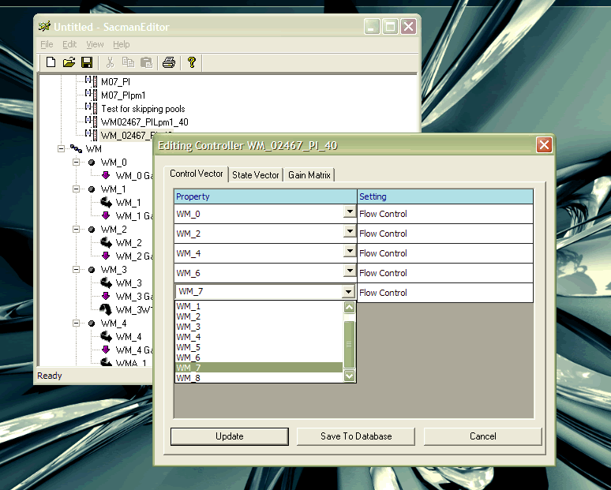

Figure Edit Control Vector

Edit Control Vector: This illustration shows the custom grid control used to edit a Control Vector object. The basic project was obtained from the Code Project web site and then modified to suit our needs.\* The following pictures illustrates that when you right click on a Controller object, you can edit the properties of its Control Vector, State Vector or Gain Matrix objects. Pressing Update saved the information in memory only. Pressing Save to Database saved the information in the MS Access database that contained all the system configuration data.

\*http://www.codeproject.com/KB/miscctrl/DataGridControl.aspx

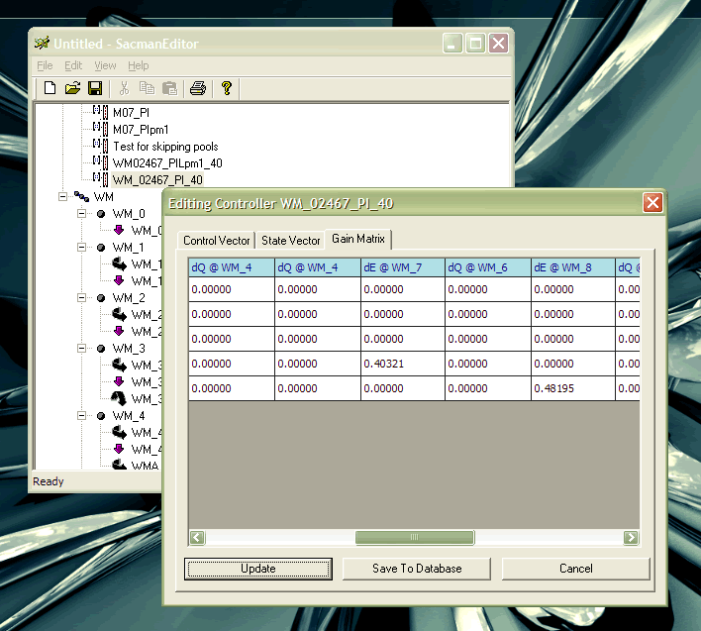

Figure 2 Edit Gain Matrix

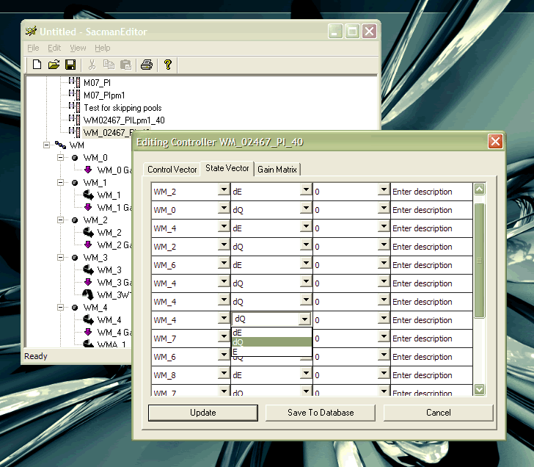

Figure Edit State Vector