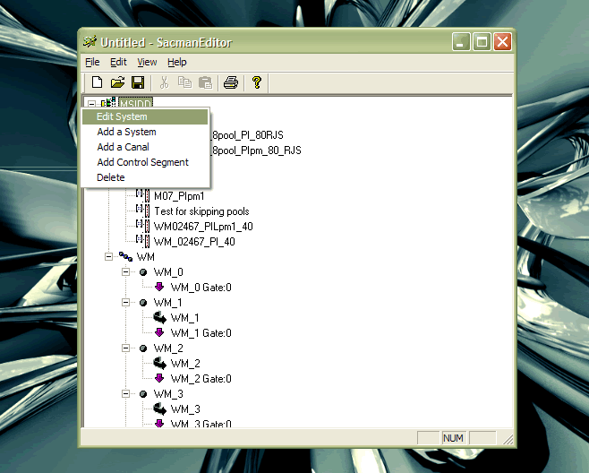

Figure Edit System Menu

This illustration shows that when you right click on a System object in the System Object tree, you can choose which object in the Tree control you want to edit or which object to delete.

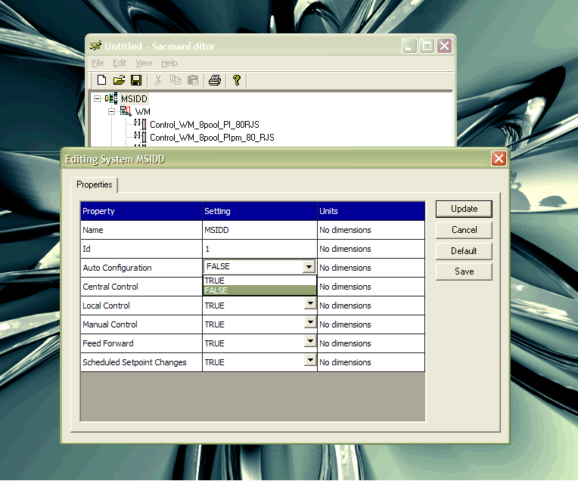

Figure Edit System Dialog

Once you choose the object you want to edit, the custom Grid Control appears allowing you to edit its properties. In this example you can manually type in the values you want to change or accept default values. Pressing Update saves the information in memory only; pressing “Save” saves the information in the MS Access database with contains the configuration data.