Edge AI & Model Compression on inGen’s Physical AI Platforms
W04 Capstone Report — v1.0 (final review: 2026-08-03)
Author: Siyu Xiang · Edge AI & Model Compression Intern Supervisor: Iqbal Patel · inGen Dynamics Program: 4-week remote internship · Repository: syyovo/siyu-ingen-edge-ai (v1.0) Scope: Quantization, structured pruning, knowledge distillation, and a GA micro-NAS sketch on a MobileNetV3-Small / CIFAR-10 baseline, benchmarked against the deployment budgets of inGen’s five physical AI platforms.

1. Executive Summary
inGen’s platforms run AI on-device, on embedded CPUs without GPUs, so every model must fit a per-platform size budget and a per-platform latency budget. Over three experimental weeks plus a Week-4 verification run, this project benchmarked the three post-training compression families — quantization, structured pruning, and knowledge distillation — plus a genetic-algorithm architecture micro-search, all on one fine-tuned MobileNetV3-Small / CIFAR-10 baseline (93.38% accuracy / 6.24 MB / ~38 ms CPU latency in clean sessions), under a fixed measurement protocol (seed 42, CPU-only, batch size 1, 10 warm-up + 100 timed runs, full 10k test split). Three findings matter most for the PIC 2.0 deployment stack.
Finding 1 — INT8 quantization fails on this backbone for a diagnosed reason, not a mysterious one. PTQ INT8 delivers large size and speed gains — 3.4x (6.24 -> 1.83 MB) and ~11x (38.5 -> 3.4 ms; more than the ~4x either hardware mechanism predicts alone, Section 10.5) — but accuracy collapses to 10–16% under every tested configuration, and a 3-epoch QAT run does not repair it (14.67%, still rising when its budget ended — Section 4.4). A seven-step diagnostic chain isolates the cause: weight-only quantization is nearly lossless (90.64%), so the failure lives in activations — the stem output’s range (~1986) is a 133x outlier against the network median (14.95), forcing a grid step (~7.8) that erases all normal-magnitude activations; FP32 fallback cannot escape it because the outlier tensor still crosses an INT8 boundary. The recommendation is architectural, not procedural: do not ship INT8 on this hard-swish/SE backbone; re-attempt it on a ReLU-based one, where the otherwise-ideal battery profile can be realized (INT4: not measurable in this toolchain; the grid-step argument extends the negative a fortiori — Section 4.5).
Finding 2 — this compact architecture has no free pruning region under the tested recovery budget, and the PELT changepoint marks where the steep decline ends, not where damage begins or stops. Across a nine-ratio structured L1 sweep with a 3-epoch x 20k recovery budget, even 10% pruning costs 3.9 pp (89.50%), and PELT (ruptures, RBF cost, stable across penalty in [0.5, 2], with Dynp agreeing on the same signal) places the changepoint at nominal ratio 0.4 (56.60%). By 0.4, coupling has physically removed 63% of parameters; beyond it the average decline halves (~9.2 -> ~4.6 pp per step) but another 22.9 pp still falls by 0.9. Operationally: 0.4 bounds the steep regime; the practical ceiling under this budget is ~10%, and every pruning step ships with a recovery fine-tuning budget.
Finding 3 — the distillation signal is real (+3.02 pp over an identically-budgeted from-scratch control) but budget-limited, making “train small directly” the validated route for the tightest budgets rather than a deployable config today. The best student (width x0.5, T=2 / alpha=0.5) reaches 50.42% / 1.74 MB / 25.8 ms versus 47.40% for the same architecture trained from scratch with identical data, epochs, and initialization. Only 2 of 9 (T, alpha) configurations beat the control — the nine-cell mean (45.97%) sits 1.43 pp below it, and each cell is a single seed-42 run — so the gain belongs to tuned KD, never to KD by default. Both post-hoc families fail through two distinct mechanisms with one shared origin — an efficiency-optimized backbone: quantization breaks on a single-tensor activation-range pathology; pruning finds no dormant capacity left to harvest. That shared origin is why the credible path to Sentinel Prime’s < 3 MB is a smaller model trained into competence, not a large model cut down.
Primary deployment recommendation. Aido Rover: structured pruning at 12% with recovery fine-tuning, measured in a Week-4 verification run at 88.45% / 4.87 MB — inside the 5 MB budget with 0.13 MB headroom, within 0.5 pp of the Week-2 extrapolation. Fari (and by extrapolation Senpai): deploy FP32 as-is — constraints non-binding, accuracy decides. Aido Humanoid: pruning <= 10% + fine-tuning, latency-first. Sentinel Prime: nothing measured deploys today; the route is distillation at a production budget, with INT8 re-tested on a quantization-friendly backbone as secondary. Every recommendation carries a hardware qualifier (Section 9): INT8 acceleration and absolute latency depend on the target ISA.

2. Edge AI Deployment Context

2.1 Why inGen needs model compression
inGen Dynamics builds physical AI — robots whose models run on their own onboard hardware rather than in the cloud (PIC 2.0 / Origami platform documentation [1]): typically an ARM CPU with no GPU, limited memory, and often a battery. That creates the gap this project measures — models accurate enough to be useful are usually too large and too slow for the processors they must run on — and compression is the set of techniques that closes it.

2.2 Platform constraint table
Each platform’s budget is derived from its sensor rate, power source, and interaction context (Week 1 landscape briefing, Section 2):
Platform | Deployment context | Max model size | Max latency | Primary compression strategy
Aido Rover (outdoor patrol) | 10 Hz real-time sensor classification, Cortex-A-class CPU | < 5 MB | < 100 ms | Quantization → pruning + ft (after W2)
Sentinel Prime AI (security) | 5 Hz event classification, battery-powered | < 3 MB | < 200 ms | INT8 PTQ → distillation route (W2–W3)
Fari (elder companionship) | Companion dialogue, consumer ARM SoC | < 20 MB | < 500 ms | Distillation → FP32 as-is (constraints non-binding)
Aido Humanoid (bipedal research) | Multi-step action classification, 10 Hz+ control loop | — (latency-critical) | < 50 ms | Pruning ≤ 10% + ft (unchanged)
Senpai (education robot) | Course-retrieval embeddings | < 20 MB | — | Embedding quantization → re-test on target (no Senpai measurement)
The “primary strategy” column records both the Week 1 plan and the post-experiment recommendation. Four of the five moved, but not in the same way: three were overturned by measurement (Rover, Sentinel Prime, Fari), and one (Senpai) was downgraded to a testing plan because no Senpai-specific experiment was run at all — an absence of evidence, not a contrary result. Only the Humanoid plan survived unchanged. The distance between the two entries is itself a result (Sections 4–6).

2.3 Hardware rationale for the budgets
Why 10 Hz requires < 100 ms. A 10 Hz sensor delivers a sample every 100 ms; inference must finish before the next one arrives or the robot reacts to where an obstacle was. The window also covers sensor reads, preprocessing, and decision logic, so the true model budget sits below the ceiling.
Why INT8 should improve latency on ARM edge CPUs even without a GPU. Three hardware mechanisms, none requiring a GPU: (1) SIMD — a 128-bit NEON register holds 16 INT8 values versus 4 FP32, so one instruction does 4x the multiply-accumulate work; (2) memory traffic — INT8 weights move 4x fewer bytes, the likelier bottleneck at batch size 1, where each weight is loaded from DRAM and used once; (3) integer ALU — integer multipliers are simpler circuits than floating-point units, costing less energy per operation, which matters on battery platforms like Sentinel Prime. Each mechanism alone caps the predicted speedup near 4x; the measured 11.3x and its attribution gap are discussed in Section 10.5. These speedups require wide integer SIMD (ARM NEON, RISC-V with V); every recommendation therefore states its hardware class (Sections 9–10).

2.4 Compression taxonomy used in this project
Following the four-category survey framing (Cheng et al. [2]): quantization (fewer bits; PTQ needs only calibration data, QAT retrains under simulated quantization), structured pruning (remove whole channels — the result stays a dense, fast model), knowledge distillation (train a small student against a teacher’s softened outputs — the one family that can change the architecture), and NAS (search architectures under a hardware budget; MobileNetV3 itself is partly NAS-found [6], so the baseline already embodies this).

3. Baseline Model and Deployment Gap

3.1 Model and dataset selection
MobileNetV3-Small (torchvision, ImageNet-pretrained) on CIFAR-10 (HuggingFace uoft-cs/cifar10), per the Week-1 criteria: CPU-trainable, publicly available, importable as a PyTorch checkpoint, and a perception task mirroring Aido Rover’s. One selection property became central later: the backbone is itself efficiency-optimized and partly NAS-designed — precisely why post-hoc compression found no slack in it (Sections 4–5).

3.2 As-loaded profile and the Week 1 deployment gap
Metric | As-loaded FP32 (ImageNet head) | Aido Rover target | Status
Parameters | 2,542,856 | — | —
FLOPs (bs=1) | ~113 M (56.5 M MACs) | — | —
Weight file size | 10.31 MB | < 5 MB | 2.1x over budget
CPU latency (bs=1, mean of 100) | 40.46 ms | < 100 ms | Passes on dev machine — see caveat
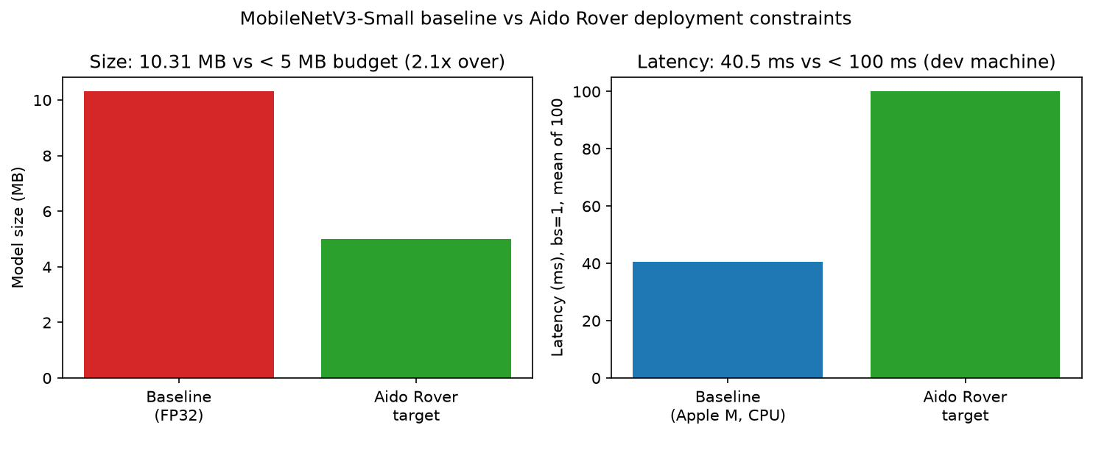
Figure 1 — Baseline vs Aido Rover budget: the Week-1 deployment gap (as-loaded profile; corrected in Section 3.3).
Size, not latency, is the blocker — with a caveat that recurs throughout this report: the development machine is an Apple M1 CPU, substantially faster than the Cortex-A-class target, so the latency margin cannot be trusted at 1:1 on real hardware.

3.3 Fine-tuned deployment baseline and the corrected gap
The as-loaded model carries a 1000-class ImageNet head that CIFAR-10 does not need. Fine-tuning (ImageNet weights -> 10-class head, 2 epochs head-only + 2 epochs full network, Adam) produced the deployment baseline used by every subsequent experiment:
93.38% test accuracy / 6.24 MB / 1,528,106 parameters / 37.3–39.2 ms CPU latency across clean sessions (see Section 3.4).
Swapping the 1000-class head for a 10-class head alone removed ~1M parameters, shrinking the file from 10.31 MB to 6.24 MB. The honest correction to Week 1: the true Aido Rover deployment gap is 1.24 MB (1.25x), not the 2.1x first reported — the W01 figure profiled the wrong head for the task. Wherever “baseline” appears from Section 4 onward, it means this fine-tuned 93.38% / 6.24 MB model.

3.4 Measurement protocol (applies to every number in this report)
Seed 42 everywhere (torch, numpy, random); PyTorch 2.12.1 CPU build on Python 3.13, Apple M1 CPU (4 threads); accuracy on the full 10k CIFAR-10 test split unless marked as a 1k quick-screen; model size = the actual state_dict file on disk (captures batch-norm buffers and format overhead, not params x 4 bytes); latency = batch size 1, 10 untimed warm-up runs, mean of 100 timed runs. Latency session note: the baseline was re-measured in every experimental session. Across the four clean sessions committed to this repository it reads 37.29 ms (1-epoch pruning probe, experiments/W02_pruning_sweep_ft.csv), 37.33 ms (Week-4 quantization re-run, experiments/W02_ptq_results.csv), 38.5 ms (W02 quantization memo session), and 39.21 ms (zero-shot pruning sweep, experiments/W02_pruning_sweep.csv) — a 5.1% spread, +-3.0% about the 38.1 ms mean. The ft3 sweep session’s latency column is excluded from the clean set: from the 20% ratio onward its readings run 32–75% above the two architecture-identical clean sessions (which agree with each other within 1.8% at every ratio), the curve is non-monotonic (20% reads slower than 10%), and the training wall-clock in logs/prune_sweep_0714.log slows at the same ratios (smaller models, longer blocks) — background load arrived mid-sweep. Every ft3 latency in this report is therefore superseded by architecture-identical clean measurements: latency depends only on the pruned graph, which recovery fine-tuning does not alter; ft3 accuracies and sizes are seed-deterministic and unaffected. The W04 verification session ran under known background load and is flagged wherever quoted. Accuracy and size reproduce exactly across sessions; latencies are quoted with their measurement session.

4. Quantization Results: PTQ INT8, QAT, and a Diagnosed Collapse

4.1 Setup
Deployment context: Sentinel Prime (< 3 MB, battery-first, always-on) is the platform whose Week-1 plan leaned hardest on INT8 (Section 2.2), so this section decides that plan. Static post-training quantization (PyTorch torch.ao FX graph mode, qnnpack backend), calibrated on 512 images drawn from the training split — never the test split. Week 1’s expectation, following the MobileNetV3 paper’s quantization-friendly design claims [6] and the Nagel et al. PTQ pipeline [3], was that per-channel INT8 would land within a few points of FP32. The measurement said otherwise, and the gap between expectation and outcome is the finding.

4.2 PTQ collapses under every configuration
INT8 delivers its size and speed gains in full — 6.24 -> 1.83 MB (3.4x) and 38.5 -> 3.42 ms (11.3x; larger than either Section-2.3 mechanism predicts alone, an attribution gap discussed in Section 10.5) — but accuracy collapses to near-random in all four tested configurations:
Weight scheme | Activation observer | Test accuracy
per-channel | Histogram | 15.91% (full test set)
per-tensor | Histogram | 10.00% (full test set)
per-channel | MinMax | 12.2% (1k quick-screen)
official default qnnpack mapping | — | 10.2% (1k quick-screen)
The direction matches Nagel et al. [3] — per-tensor < per-channel on depthwise-separable networks — but the magnitude exceeds it: even per-channel collapses.
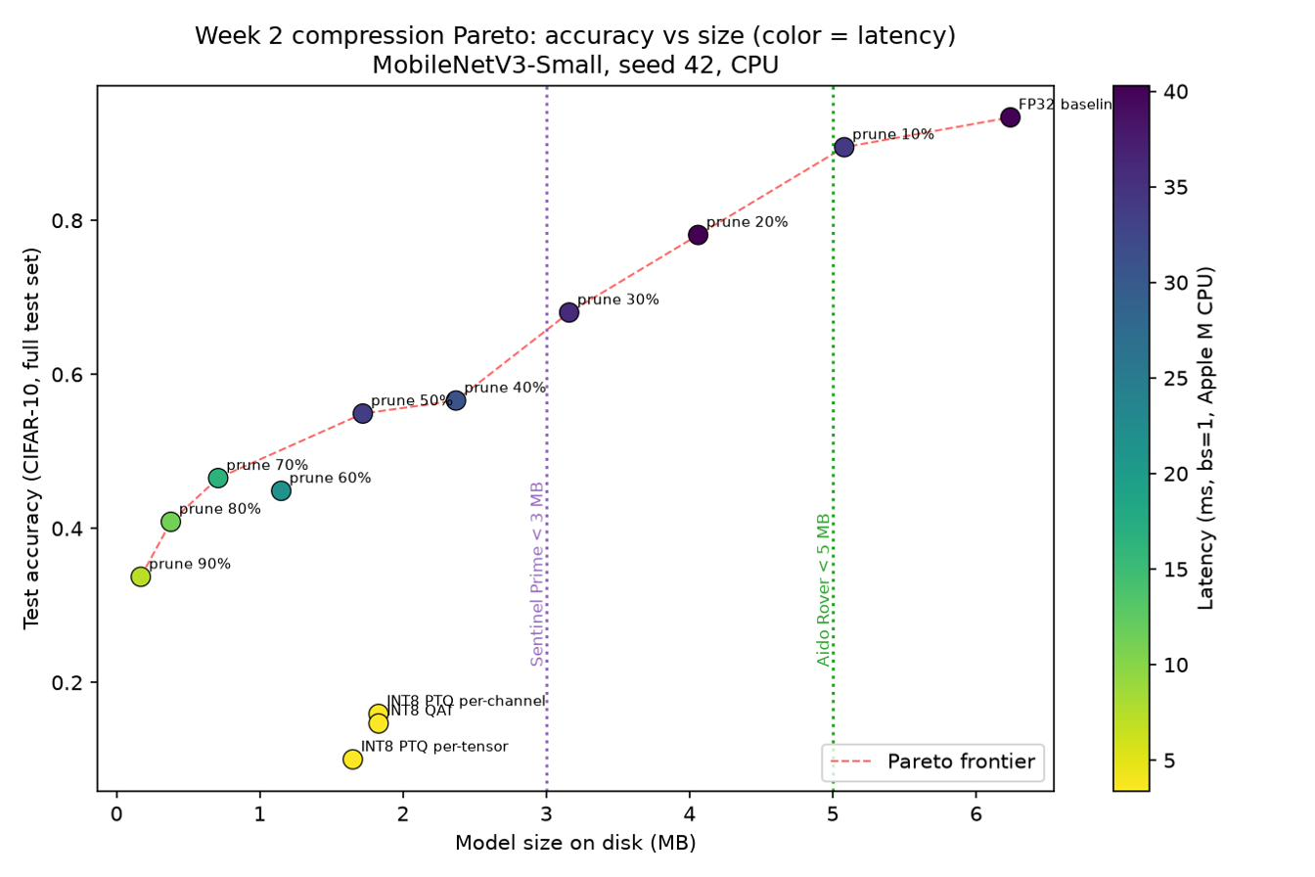
Figure 2 — Week-2 accuracy-vs-size Pareto (FP32, INT8 variants, nine ft3 pruning points; latency as color). Note: this frozen Week-2 figure’s latency colors include ft3-session readings later found load-affected from the 20% ratio onward (Section 3.4); point positions are unaffected — Figure 5 supersedes it with clean-session colors.

4.3 Root-cause diagnostic chain
Seven steps, each eliminating one hypothesis:
- Prediction distribution: the INT8 model dumps ~78% of a test batch into 3 of 10 classes — systematic output distortion, not noise.
- Single-conv sanity check: one Conv2d+ReLU quantized in isolation shows max abs error ~0.30 on outputs in [0, 4] — kernels compute correctly; toolchain bug ruled out.
- Observer swap (Histogram -> MinMax): still collapsed — calibration-strategy hypothesis ruled out.
- Official default qconfig mapping: still collapsed — misconfiguration hypothesis ruled out.
- QAT cross-check: training loss falls steadily (1.90 -> 0.58) while the simulated (fake-quant) and converted true-INT8 accuracies agree — 11.8% vs 11.6% — so the failure exists at the simulation level, independent of the qnnpack backend. Provenance: the converted-INT8 side is archived in checkpoints/qat_summary.json (1-epoch smoke-test record, best_int8_test_acc: 0.116); the paired 11.8% fake-quant reading survives only in the notebook’s narrative — the committed logs/qat_0714.log predates the per-epoch simulated-accuracy print now in scripts/qat_train.py. The step establishes the agreement of the two evaluation paths, not an accuracy level; the full run’s per-epoch converted accuracies are 12.27% / 13.12% / 14.67% (logs/qat_0714.log).
- Experiment A — weight-only quantization: 90.64% on the full test set (−2.74 pp vs baseline). Weight quantization is essentially lossless; the collapse is caused by activation quantization.
- Experiment B — per-layer activation ranges: the stem convolution output (features.0.0) spans −1073.9 … 912.2 (range ~1986) against a network-wide median of 14.95 — a 133x outlier. Its INT8 grid step is ~7.8, so all normal-magnitude activations (|x| <~ 4) collapse into a handful of bins; the wrecked stem output propagates network-wide, explaining the class-collapse of step 1. The observer table records the stem twice, and the distinction matters for the fix attempt below: features.0.0 (the convolution output, range 1986.15) and features.0.2 (its post-hard-swish output, −0.38 … 912.24, range 912.61 — hard-swish floors the negative side at −0.375). Secondary outliers (range 65–118, 4–8x the median) span features.1–.7 and features.12.
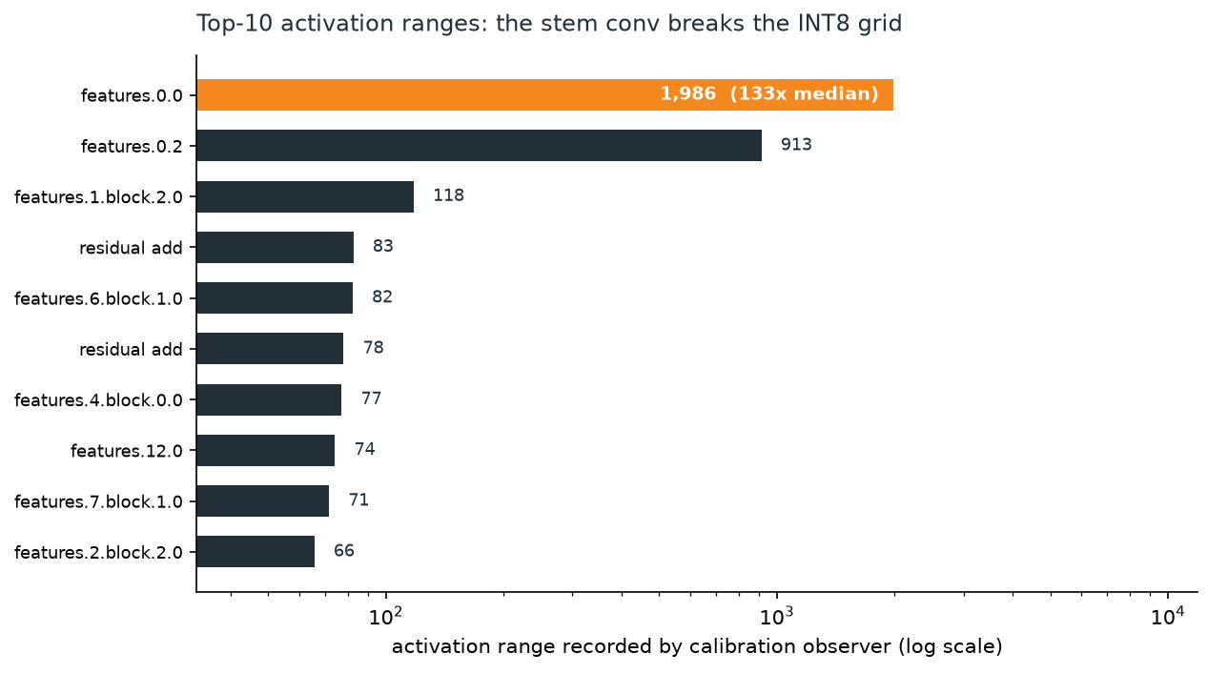
Figure 3 — Per-layer activation range profile, stem outlier annotated (log scale).
Fix attempt — selective FP32 fallback: failed, and the failure is informative. Keeping the stem block (features.0, both top outliers) in FP32 does not recover accuracy (14.7%, 1k quick-screen; module inspection confirms the fallback took effect). The pathology lives in tensors, not ops: the stem’s output must still be quantized at the boundary into the next INT8 block — the post-hard-swish tensor of step 7 (range 912.61), whose grid step (~3.6) is still coarser than the entire normal activation scale (|x| <~ 4). Escaping it would mean extending FP32 through features.1–.7, forfeiting most of the compression benefit. Closed as a genuine negative result under a pre-committed time-box.
Likely origin of the outliers. After only 4 epochs of fine-tuning, the stem retains near-ImageNet weights while inputs changed to CIFAR-10 upscaled 32 -> 224; some channels respond with extreme values, and min/max calibration stretches the grid over them — the outlier failure mode Nagel et al. [3] describe for efficient architectures, amplified here by hard-swish/SE.

4.4 QAT: a budget-limited negative result
QAT (per-channel FakeQuantize, lr 1e-4, 3 epochs from the 93.38% baseline; scripts/qat_train.py, per-epoch metrics in logs/qat_0714.log) did not recover INT8 accuracy within its budget: 12.27% -> 13.12% -> 14.67% per epoch, still rising — and accelerating (+0.85, then +1.55 pp) — when the 3-epoch budget ended, with training loss still falling. By the standard applied to pruning (Section 5.3) and distillation (Section 7.2), that is a budget-limited negative, not proof that no QAT budget can repair the pathology (a larger run was not attempted; one epoch costs ~74 min). What it establishes, with step 5, is that the failure lives at the simulation level and is not fixed by a small-budget weight adaptation.

4.5 INT4
Not attempted: no CPU INT4 inference path exists in this toolchain on macOS (bitsandbytes is CUDA-oriented). Mechanistically, a ~17x coarser grid (255 quantization steps -> 15) can only worsen the same activation-range pathology, so the negative conclusion extends a fortiori. This is stated as a toolchain-plus-mechanism argument, not a measurement.

5. Structured Pruning: Nine-Ratio Sweep, Recovery Budget, and the PELT Changepoint

5.1 Method
Structured (channel-level) L1-magnitude pruning with torch-pruning, which physically removes channels and traverses MobileNetV3’s residual/SE dependency groups — chosen over torch.nn.utils.prune, which only masks weights and therefore changes neither file size nor latency, making the eight-element table unfillable. The final 10-class Linear head is excluded (its output dimension is the task). Each ratio prunes a fresh copy of the baseline (not cumulative), so rows are comparable. A 30% single trial validated dependency-graph traversal before the sweep.

5.2 Zero-shot: no free redundancy
Zero-shot accuracy collapses at the very first ratio (10%: 93.4% -> 15.0%) and the whole 10–90% curve sits at random (~10%). Two things are at work. First, the collapse itself is the expected behavior of zero-shot structured pruning — removing whole channels breaks co-adapted weights and invalidates BatchNorm statistics (the standard explanation, not separately isolated here) — which is why recovery fine-tuning is part of the technique. It is not by itself evidence about redundancy: 95% of the drop at 10% (74.5 of 78.3 pp) is recovered by three epochs of fine-tuning without adding a single channel back (Section 5.3), so the claim that this efficiency-optimized backbone carries little dormant capacity rests on the post-recovery residual (3.88 pp at 10%), not on the zero-shot curve. Second, dependency-group coupling makes nominal ratios understate physical removal: nominal 10% removes 18.8% of parameters, nominal 40% removes 63%, and nominal 90% removes 98.6% (1,528,106 -> 21,948 parameters), because residual and SE groups shrink together. Size and latency gains are nonetheless real (50% -> 1.72 MB; 90% -> 0.17 MB and 4.89 ms against the 39.21 ms baseline of this zero-shot session). Latency scales sub-linearly — 69.6x fewer parameters buys 8.0x — because channel pruning leaves the layer count unchanged, so width-independent per-op overheads set a floor (likely, not profiled).
A methodological dead end is documented rather than hidden: PELT on this zero-shot curve is meaningless — a curve that is one long floor at random accuracy has no regimes to separate — which is what motivated the recovery-budget rerun below.

5.3 Recovery-budget experiment
A 1-epoch x 5k probe lifts 10%-pruning only to 55.0% and 20%+ not at all: that curve measures the recovery budget, not the architecture (loss was still falling when the epoch ended). The authoritative sweep therefore reran all nine ratios with a 12x budget (3 epochs x 20k images, scripts/prune_ft_sweep.py, 6.7 h unattended — 401.6 min summed over the nine ratios, logs/prune_sweep_0714.log):
Nominal ratio | Zero-shot | +1 ep x 5k | +3 ep x 20k (ft3)
10% | 15.04% | 55.01% | 89.50%
12% | — | — | 88.45% (W04 verification)
15% | — | — | 85.32% (W04 verification)
20% | 11.23% | 12.83% | 78.11%
30% | 7.63% | 12.38% | 68.04%
40% | 9.96% | 9.71% | 56.60%
50% | 10.54% | 11.27% | 54.91%
60% | 9.57% | 10.10% | 44.88%
70% | 10.00% | 10.00% | 46.54%
80% | 10.00% | 10.00% | 40.86%
90% | 10.00% | 10.00% | 33.71%
Full nine-ratio data: experiments/W02_pruning_sweep_ft3.csv; the 12%/15% rows come from the Week-4 verification run (experiments/W04_rover_verification.csv) under the identical ft3 protocol (hence the dashes in the Week-2 columns). The 60 -> 70% uptick (+1.66 pp) is a single-run observation: with one run per ratio and no measured run-to-run variance, noise and a real effect cannot be distinguished. Training loss was still falling at epoch 3 in every ratio, so the absolute recovered accuracies likely understate what a longer budget would reach — likely, not proven, since no held-out curve was tracked during fine-tuning. The shape-level conclusions (changepoint location, rankings) are expected to be budget-robust; the absolutes are not. The headline result, stated under this budget: recovery is real at low ratios, but there is no loss-free region at 3 ep x 20k — even 10% costs 3.9 pp.

5.4 Critical compression ratio (PELT)
Changepoint: nominal ratio 0.4, test accuracy 56.60% at the changepoint. Criterion, stated in advance rather than read off the plot: PELT (ruptures, RBF cost) places the changepoint at 0.4 for every penalty in [0.5, 2]; at penalty >= 3 it reports no changepoint at all rather than a different one, and exact dynamic-programming segmentation (Dynp, n_bkps = 1) — the same RBF cost on the same ten points, forced to return exactly one breakpoint — selects 0.4 as well. This is an internal-consistency check, two search strategies agreeing under one cost function, not corroboration from outside the curve (Section 10.6); with only ten points it is also the strongest check available.
Mechanism — reading the changepoint correctly. The changepoint separates steep collapse (~9.2 pp per step before 0.4: 93.4 -> 56.6) from a slower but continuing decline (~4.6 pp per step on average after — including one post-changepoint step, 50 -> 60%, that falls 10.0 pp, as steep as anything before it). It marks where the steep regime ends, not where damage begins and not a floor: by nominal 0.4, dependency-group coupling has physically removed 63% of parameters — entire feature-detector groups are gone, creating an information bottleneck that a 3-epoch budget cannot rebuild — and a further 22.9 pp of accuracy and 96% of the remaining parameters are lost between 0.4 and 0.9. Critically, the region before the changepoint is not a safe zone: degradation begins at the first step. Unlike over-parameterized networks, this curve has no pre-changepoint plateau — 0.4 is an upper bound on useful pruning, never an operating point.
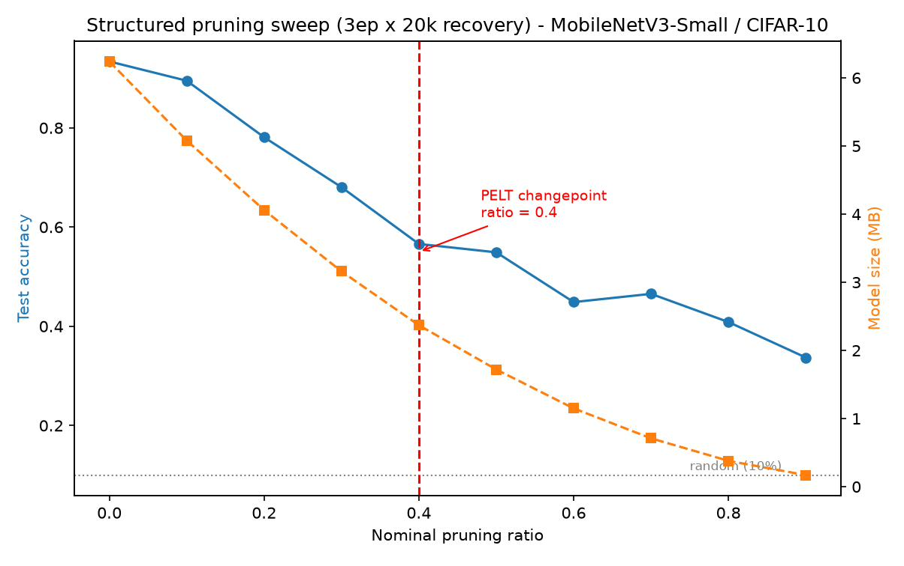
Figure 4 — Structured pruning sweep (3 ep × 20k recovery): ft3 accuracy and model size vs nominal ratio; PELT changepoint and random-guess line marked.

5.5 The Aido Rover operating point — extrapolation verified by measurement
Week 2 ended one notch short of the Rover budget: 10% + ft3 = 89.50% / 5.08 MB / 33.8 ms (clean-session latency, Section 3.4), 0.08 MB over, with ~12% extrapolated to clear 5 MB at ~88%. A Week-4 verification run closed that gap under the identical ft3 protocol (torch-pruning L1, head excluded, 3 ep x 20k, seed 42; scripts/w04_rover_verification.py), including a baseline re-check that reproduced 93.38% exactly:
Config | Test acc | Size | Params (actual removal) | Latency
Prune 12% + ft3 | 88.45% | 4.87 MB | 1,186,341 (−22.4%) | 46.62 ms (loaded session)
Prune 15% + ft3 | 85.32% | 4.56 MB | 1,109,583 (−27.4%) | 43.53 ms (loaded session)
The measurement confirms the Week-2 extrapolation — measured 88.45% vs predicted ~88% — with 0.13 MB of budget headroom. The new points slot monotonically into the W02 curve (10% → 89.50, 12% → 88.45, 15% → 85.32, 20% → 78.11) with no anomalies; nominal 12% physically removes 22.4% of parameters (dependency coupling, Section 5.2). Two caveats carry over unchanged: training loss was still falling at epoch 3 for both new points (0.527 → 0.254 at 12%; 0.759 → 0.376 at 15%), so these accuracies likely understate longer-budget recovery (Section 5.3’s caveat applies); and this session’s latencies were taken under background load (the baseline re-check read 50.61 ms vs 37.3–39.2 ms in clean sessions). The < 100 ms budget conclusion is untouched — even loaded, 46.62 ms sits far inside. A pre-presentation re-measurement (scripts/remeasure_latency.py, 2026-07-30) read 43.79 / 42.20 ms for the 12% / 15% checkpoints, but its in-session baseline control read 49.61 ms against the 37.3–39.2 ms clean cluster, so that session does not qualify as clean either; both sessions' values stand as annotated records (Section 10.1).

6. Pareto Frontier and Per-Platform Feasibility

6.1 Consolidated eight-element results
Reference: fine-tuned FP32 baseline, 93.38% / 6.24 MB. Accuracy and size are session-independent and reproduce exactly; only latency is session-dependent, so every latency below carries its session: (a) W02 quantization memo session, baseline 38.5 ms; (g) zero-shot pruning sweep, baseline 39.21 ms (experiments/W02_pruning_sweep.csv) — quoted for all pruning rows: latency depends only on the pruned graph (unchanged by fine-tuning), and the ft3 session’s latency column is load-contaminated and superseded (Section 3.4); (e) W04 verification session, run under background load, baseline re-check 50.61 ms; (f) W03 distillation session (W03_Distillation_Notebook.ipynb), which took no baseline re-check — its “before” cells quote the clean-session range, and the directly comparable pair is the student vs its control within the session. Only configurations with all eight elements measured appear here; the full sweeps live in /experiments/.
Technique | Ratio / bit-width | Base acc | Comp. acc | Acc loss (pp) | Size before | Size after | Lat. before | Lat. after
PTQ INT8 per-channel | 8-bit (size /3.4) | 93.38% | 15.91% | −77.47 | 6.24 MB | 1.83 MB | 38.5 ms (a) | 3.42 ms (a)
PTQ INT8 per-tensor | 8-bit (size /3.8) | 93.38% | 10.00% | −83.38 | 6.24 MB | 1.65 MB | 38.5 ms (a) | 3.36 ms (a)
QAT INT8, 3 ep | 8-bit | 93.38% | 14.67% | −78.71 | 6.24 MB | 1.83 MB* | 38.5 ms (a) | 3.42 ms* (a)
Prune 10% + ft3 | channels −10% (params −18.8%) | 93.38% | 89.50% | −3.88 | 6.24 MB | 5.08 MB | 39.21 ms (g) | 33.77 ms (g)
Prune 12% + ft3 (W04 verification) | channels −12% (params −22.4%) | 93.38% | 88.45% | −4.93 | 6.24 MB | 4.87 MB | 50.61 ms (e) | 46.62 ms (e)
Prune 15% + ft3 (W04 verification) | channels −15% (params −27.4%) | 93.38% | 85.32% | −8.06 | 6.24 MB | 4.56 MB | 50.61 ms (e) | 43.53 ms (e)
Prune 40% + ft3 (PELT point) | channels −40% (params −63%) | 93.38% | 56.60% | −36.78 | 6.24 MB | 2.37 MB | 39.21 ms (g) | 22.70 ms (g)
Prune 50% + ft3 | channels −50% | 93.38% | 54.91% | −38.47 | 6.24 MB | 1.72 MB | 39.21 ms (g) | 19.27 ms (g)
Prune 90% + ft3 | channels −90% (params −98.6%) | 93.38% | 33.71% | −59.67 | 6.24 MB | 0.17 MB | 39.21 ms (g) | 4.89 ms (g)
KD student, T=2 / alpha=0.5 | width x0.5 (params −73%, size /3.6) | 93.38% | 50.42% | −42.96 | 6.24 MB | 1.74 MB | 37.3–39.2 ms (clean) | 25.82 ms (f)
Same student, from scratch | width x0.5 | 93.38% | 47.40% | −45.98 | 6.24 MB | 1.74 MB | 37.3–39.2 ms (clean) | 25.81 ms (f)
* QAT produces the same quantization scheme as per-channel PTQ; size and latency measured on the per-channel artifact and reused. The retired ft3 latency column sits 32–75% above the architecture-identical clean values quoted here (50%: 33.71 ms ft3 vs 19.27 / 19.37 ms clean) — Section 3.4. (e) The W04 session ran under background load; a 2026-07-30 re-measurement read 43.79 / 42.20 ms but failed its own baseline control (49.61 ms) and is likewise session-annotated (Section 10.1). Committed-CSV note: experiments/W02_ptq_results.csv holds the Week-4 re-run (FP32 37.33 -> 3.34 ms, 11.18x); the (a) rows quote the original memo session (38.5 -> 3.42 ms, 11.3x) — accuracy and size identical, milliseconds within normal clean-session drift. The GA micro-NAS best (0.465 MB, 32.7% proxy) is excluded: its proxy metric is not comparable to full-test accuracy (Section 8).

6.2 The frontier and the empty corner
On the accuracy-vs-size plane, the Pareto frontier runs from the FP32 baseline down the pruning-recovery chain (10% -> 20% -> … -> 90%, with 60% excepted — it is dominated by 70%, which is both smaller and more accurate); the distilled student sits below the pruned model of comparable size, and the INT8 points occupy the small-size / collapsed-accuracy corner — real compression, unusable accuracy. Latency as point color shows why INT8 stays strategically interesting despite the collapse: 3.3–3.4 ms, the fastest corner measured — the speed mechanism is intact where accuracy fails.
The decision-relevant feature is the empty upper-left region: no measured configuration achieves > 85% accuracy below 3 MB. That empty corner is the Sentinel Prime infeasibility finding, and it is why the Sentinel recommendation is a route (distillation at production budget) rather than a config.
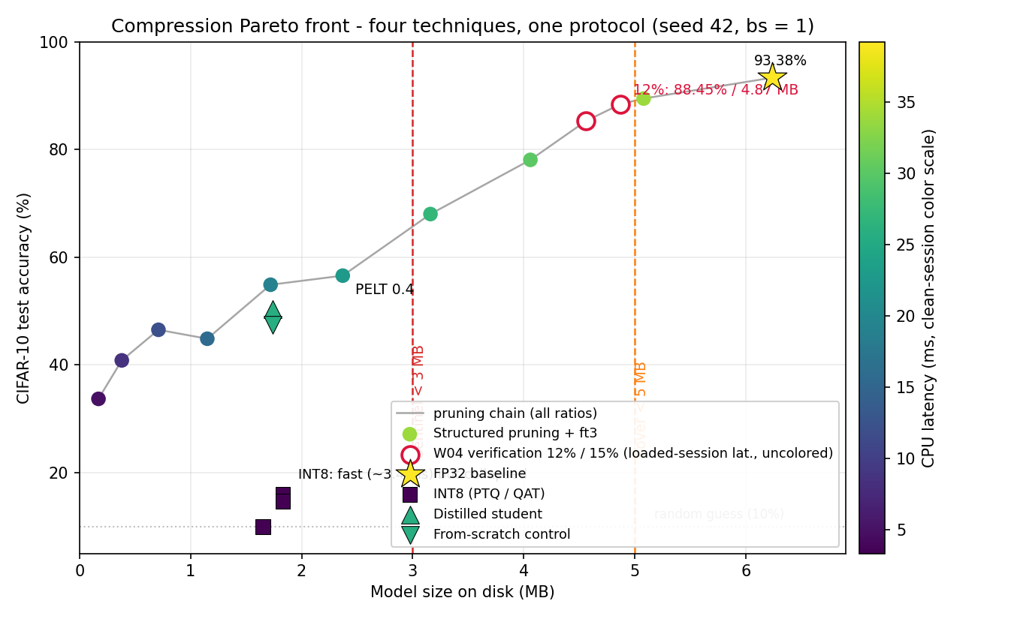
Figure 5 — Combined four-technique Pareto: accuracy vs size, points colored by clean-session latency; platform budget lines at 5 MB and 3 MB; W04 verification points drawn uncolored (loaded-session latency).

6.3 Per-platform feasibility
Platform | Budget (MB / ms) | Best measured option | Meets budget?
Aido Rover | < 5 / < 100 | Prune 12% + ft3: 88.45% / 4.87 MB / 46.6 ms (e) | Yes — 0.13 MB headroom; within 0.5 pp of the W02 extrapolation
Sentinel Prime AI | < 3 / < 200 | None viable: prune 40% fits size (2.37 MB) at 56.60%; INT8 fits size (1.83 MB) with collapsed accuracy | No — distillation route is the only credible path (Section 7, 9)
Aido Humanoid | — / < 50 | Prune 10% + ft3: 33.8 ms on dev machine (clean session) | Latency passes on dev hardware; must be re-validated on target ARM (Section 10)
Fari | < 20 / < 500 | FP32 baseline as-is: 93.38% / 6.24 MB / ~38 ms | Yes, with wide margin — constraints non-binding
Senpai | < 20 / — | Extrapolated from Fari (vision-CNN evidence only) | Testing plan, not sign-off (Section 9.5)

7. Knowledge Distillation: Teacher–Student Scheme, T/alpha Sweep, and the Four-Way Comparison

7.1 Design rationale — capacity as the only variable
Teacher: the project’s own fine-tuned baseline (93.38% / 6.24 MB; 37.3–39.2 ms across clean sessions, the latency reference here), rather than a larger public model, so the entire W1–W3 comparison chain stays anchored to one reference model. Student: MobileNetV3-Small at width_mult=0.5 — identical layer structure, half the channels: 409,394 parameters (−73.2%; within the plan’s 50–70% target). A same-family width-scaled student keeps capacity as the only variable between teacher and student — any gap is attributable to capacity plus training signal, never to architectural confounds — and stays directly comparable to the Week-2 pruned models.
Loss (Hinton et al. [5]): L = alpha * CE(student, labels) + (1 − alpha) * KL(softmax(student/T) || softmax(teacher/T)) * T^2, with teacher logits precomputed once over the 5k training subset (experiments/W03_teacher_logits_5k.pt) so the teacher never runs inside the training loop. Sweep: T in {2, 4, 8} x alpha in {0.3, 0.5, 0.7} — 9 configurations, 8 epochs x 5k images each, seed 42. Control: the identical student trained from scratch (hard labels only) with the same data, budget, and initialization seed, so the distillation signal is isolated.

7.2 A documented dead end that set the budget
The first sweep ran 3 epochs per configuration and returned 10.00% — random-guess — on its first config. A 60-step probe showed CE loss falling normally (2.15 -> 1.58), so the mechanics were sound and the failure was budget starvation, not a bug — the same lesson as the Week-2 recovery probe. The sweep was re-run at 8 epochs; the failed run is archived (experiments/W03_distill_sweep_3ep_underfit.csv) rather than deleted. The control uses the same 8-epoch budget.

7.3 Sweep results
Test accuracy | alpha = 0.3 | alpha = 0.5 | alpha = 0.7
T = 2 | 48.38% | 50.42% | 46.75%
T = 4 | 46.41% | 43.67% | 46.37%
T = 8 | 39.26% | 45.43% | 47.00%
Best distilled student (T=2, alpha=0.5): 50.42% / 1.74 MB / 25.82 +- 0.77 ms. From-scratch control: 47.40% / 1.74 MB / 25.81 +- 0.80 ms — identical within noise, as they must be for two runs of the same architecture: the distillation signal is an accuracy effect, not a latency one. It is worth +3.02 pp under this controlled comparison — but only 2 of 9 configurations beat the control, and the worst (T=8, alpha=0.3 at 39.26%) lands ~8 pp below it. The nine-cell mean is 45.97%, 1.43 pp below the control, and each cell is a single seed-42 run with no measured run-to-run variance — the +3.02 pp belongs to the tuned configuration, not to distillation by default.
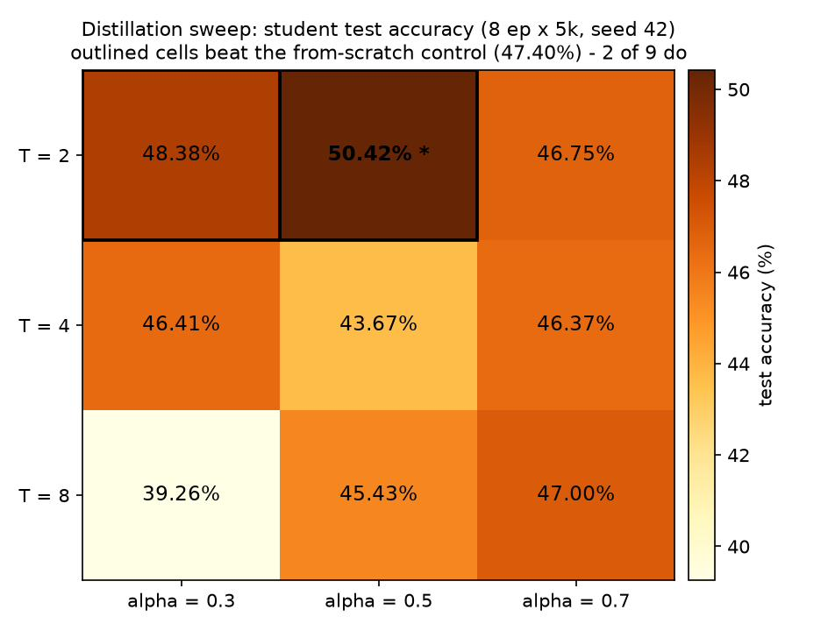
Figure 6 — T × α heatmap of student test accuracy (8 ep × 5k, seed 42); the from-scratch control (47.40%) marked — 2 of 9 cells exceed it.

7.4 Mechanism, and how distillation compares with quantization and pruning
Why low temperature wins here. The teacher is already confident (93.38%), so mild softening (T=2) transfers useful inter-class structure while preserving a strong training signal; T=8 over-smooths the teacher’s distribution into a weak, near-uniform target — the 8 pp-below-control cell is what an over-smoothed signal costs. The gain is hyperparameter-sensitive enough that a deployment pipeline should treat (T, alpha) as a swept design decision, never a default.
The inheritance gap. The capacity-matched comparison in Section 6.1 is prune-50% vs the distilled student: 403,354 vs 409,394 parameters, 1.72 vs 1.74 MB — and the pruned model leads 54.91% to 50.42%, a 4.49 pp gap for the route that keeps trained weights. Budgets remain unmatched (3 ep x 20k from the fine-tuned checkpoint, lr 1e-4, vs 8 ep x 5k from random init, lr 1e-3), so the gap is consistent with the inheritance mechanism — pruning keeps trained feature detectors; a student re-grows them — rather than proof of it; capacity is the only controlled variable. The strategic consequence stands either way: pruning wins wherever the budget permits keeping most of the trained network; distillation is the route for budgets below what light pruning can reach (Sentinel’s < 3 MB), because a student sized to the target from the start avoids the post-hoc compression penalty entirely — provided it gets a production-scale training budget rather than the exploration budget used here.

8. GA Micro-NAS Sketch: Methodology, Orienteering-Solver Mapping, and Best Architecture

8.1 Methodology
A genetic-algorithm micro-search over a small CNN space, the Aido Rover size budget wired into the objective. Chromosome: 5 genes — 4 conv-channel genes over {8, 16, 24, 32, 48, 64} + 1 FC-width gene over {64, 128, 256}. Fitness = proxy accuracy − 10 x max(0, size_MB − 5). Settings: population 10, 15 generations, seed 42; tournament selection (k = 3), one-point crossover, per-gene mutation (p = 0.2), elitism (top-2), and a fitness cache. Proxy protocol: 1 epoch on 2,000 CIFAR-10 images at 32x32, evaluated on a 1,000-image subset — proxy accuracies rank candidates within the search and are not comparable to the full-training numbers elsewhere in this report. The search runs as a script (scripts/w03_nas_ga.py); the notebook analyzes the run log (experiments/W03_nas_ga_log.csv).

8.2 Orienteering-solver mapping
The search machinery is a direct port of my orienteering-problem GA solver — the same algorithmic skeleton with a different genome:
GA component | Orienteering solver | Micro-NAS equivalent
Genome | Route encoding (node-sequence chromosome) | Architecture chromosome: 4 conv-channel genes + 1 FC-width gene
Fitness | Route score under a time/distance budget | Proxy accuracy − 10 x max(0, size_MB − 5): the Rover 5 MB budget as the “distance budget”
Selection | Favor high-scoring routes | Tournament selection, k = 3
Crossover | Route segment exchange | One-point gene crossover
Mutation | Node swap / perturbation | Per-gene random re-draw, p = 0.2
Addition beyond the solver | — | Elitism (top-2) + fitness cache to avoid retraining duplicates
The transfer is the point: a budget-constrained combinatorial search is the same problem shape whether the genome is a route or a channel-width vector.

8.3 Results — genuine selection pressure, honest non-win
Best architecture found: conv channels [64, 64, 48, 32] + FC 256 (chromosome [5, 5, 4, 3, 2]) — 0.465 MB at 32.7% proxy accuracy. The evolution trace shows genuine selection pressure rather than drift: both fitness jumps (generations 4 and 11) occurred on the same gene — the 4th conv block, growing from its generation-0 initial value of 8 channels to 24 and then 32. The GA added capacity at the bottleneck while the other genes stayed at high-capacity options — the intervention a hand-designer would apply.
As the plan anticipated, the GA did not beat the hand-designed references — and the numbers are additionally non-comparable across training protocols, which is why the GA row is excluded from the Section 6.1 eight-element table:
Model | Size | Accuracy | Training budget
GA-found best | 0.465 MB | 32.7% (proxy) | 1 ep x 2k, 32px
Hand-designed student (width-0.5 MNv3, from scratch) | 1.74 MB | 47.40% | 8 ep x 5k, 224px
Baseline (fine-tuned MNv3-Small teacher) | 6.24 MB | 93.38% | Full fine-tune
Two limitations, stated plainly. (1) The < 5 MB size penalty never activated: the search space caps out well below the budget, so the hardware constraint was non-binding in this run — a tighter budget or a latency term would make the trade-off active — the first change for a follow-up search. (2) Proxy fidelity (1 ep, 32px) is assumed, not validated. The sketch’s role is methodological — working search machinery with a hardware constraint in the fitness and a one-to-one solver mapping; a foundation, not a deployment path.
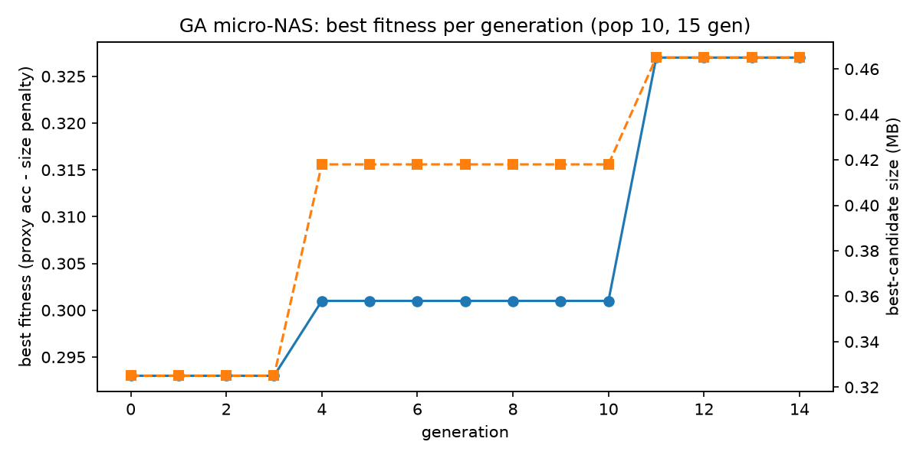
Figure 7 — GA micro-NAS: best fitness and best-candidate size per generation (pop 10, 15 gens); both jumps (gen 4 and 11) on the 4th-conv-block gene.

9. Compression Playbook: Per-Platform Recommendations
Cross-cutting finding. A compact, efficiency-optimized architecture resists post-hoc compression through two distinct mechanisms with one shared origin: INT8 collapses on a single-tensor activation-range pathology (hard-swish stem) that neither fallback quantization nor the 3-epoch QAT run repairs, and pruning shows no loss-free region under the tested recovery budget — the 3.88 pp post-recovery residual at 10% being the direct evidence that dormant capacity is scarce. The stronger routes are light pruning with a recovery budget, or training a smaller model directly (distillation — validated direction, budget-limited in Week 3). Every recommendation below states its hardware class: INT8 acceleration is ISA-dependent, and absolute latencies come from an Apple M1 dev CPU, not target silicon.

9.1 Aido Rover — outdoor patrol, onboard perception (< 5 MB, < 100 ms; ARM Cortex-A class)
Primary: structured pruning at 12% + recovery fine-tuning — measured, not extrapolated: 88.45% / 4.87 MB / 46.6 ms (loaded session; a re-measurement read 43.8 ms but failed its baseline control — Section 10.1), 0.13 MB inside budget. The Week-4 run landed within 0.5 pp of the Week-2 extrapolation; a 15% bracketing point (85.32% / 4.56 MB) prices deeper headroom at roughly 1 pp per nominal percent in this range. Quantization is excluded on this baseline (PTQ 15.91%, 3-ep QAT 14.67% — the activation pathology of Section 4; the speed mechanism itself is intact at 3.42 ms). Ratio guidance: 10–15% by accuracy-vs-headroom need (10%: 89.50% / 5.08 MB — over budget; 12%: 88.45% / 4.87 MB; 15%: 85.32% / 4.56 MB); PELT 0.4 marks the end of the steep regime, never a safe limit; every step ships with a recovery budget. Secondary: the distilled width-0.5 student (1.74 MB / 25.8 ms) if the size budget ever tightens well below 5 MB — validated route, currently budget-starved at 50.42%.

9.2 Sentinel Prime AI — battery-powered, always-on (< 3 MB, < 200 ms; ARM edge CPU)
Honest finding first: no measured W2/W3 configuration deploys today. Under 3 MB the options are pruning @ 40% (2.37 MB, 56.60%) and INT8 (1.83 MB, collapsed) — the budget-compliant pruning region (>= 40% by the size curve) lies at or past the PELT changepoint, inside the collapsed regime. Primary route: knowledge distillation into a purpose-sized student at a production training budget. The width-0.5 student fits with headroom (1.74 MB / 25.8 ms); the +3.02 pp best-cell result validates the signal (hyperparameter-sensitive — Section 7.3), but at the W3 budget it reaches only 50.42% — validated direction, insufficient budget; production-budget accuracy is TBD (90%-class is a target, not a promise). Secondary: re-attempt INT8 on a ReLU-based backbone — the 3.42 ms / 1.83 MB profile is otherwise ideal for a battery platform; a redesign recommendation, not a measured config.

9.3 Aido Humanoid — bipedal research, joint-sensor sequences (< 50 ms; ARM with NEON-class SIMD)
Latency is the binding constraint (no size budget defined). Primary: structured channel pruning <= 10% with fine-tuning — noting the W2 negative honestly: zero-shot pruning collapses at every ratio, and even with recovery 10% costs 3.9 pp (Section 5). 10% + ft3 = 33.8 ms on the dev machine (clean session), comfortably under 50 ms there; the margin must be re-validated on target ARM. Deeper pruning trades accuracy per the ft3 curve (20%: 78.11%, 30%: 68.04%); treat PELT 0.4 as the end of the steep regime, never an operating point. Secondary: a purpose-sized distilled student (25.8 ms, still inside the 50 ms budget) if the control loop tightens further.

9.4 Fari — companion device (< 20 MB, < 500 ms; consumer ARM SoC)
Primary: no compression required — deploy the FP32 baseline as-is (93.38% / 6.24 MB / ~38 ms). Both constraints are non-binding with wide margin, so accuracy decides — the uncompressed baseline wins outright. If headroom is desired, light pruning (10% + ft: 89.50% / 5.08 MB) buys ~19% size for 3.9 pp. In the secondary ranking under Fari-like constraints the pruned route also leads: at matched capacity (~1.7 MB), prune-50% (54.91%) beats the best distilled student (50.42%) by 4.49 pp — consistent with the inheritance mechanism of Section 7.4, though the training budgets differ, so indicative rather than settled.

9.5 Senpai — education robot, retrieval embeddings (< 20 MB; consumer ARM)
Extrapolation, not a separate measurement. Senpai’s budget profile is closest to Fari’s, so the Fari recommendation extrapolates: the FP32 baseline class fits as-is; light pruning is the headroom option. Two explicit caveats: (1) every number here comes from a vision CNN; embedding models are widely reported as more quantization-tolerant, so INT8 should be re-tested, not presumed broken for Senpai’s workload (Section 10.3); (2) no Senpai-specific measurement exists in W1–W3. Treat this section as a testing plan, not a deployment sign-off.

9.6 Cross-platform summary
Platform | Budget (MB / ms) | Primary recommendation | Ratio / bit-width | Expected profile (size / acc / lat)
Aido Rover | < 5 / < 100 | Light pruning + recovery ft | 12% (measured, W04 verification) | 4.87 MB / 88.45% / 46.6 ms (loaded session)
Sentinel Prime AI | < 3 / < 200 | Distillation route (production budget required) | width x0.5 student | 1.74 MB / TBD / 25.8 ms
Aido Humanoid | — / < 50 | Structured pruning <= 10%, with ft | <= 10% | 5.08 MB / 89.50% / 33.8 ms
Fari | < 20 / < 500 | Deploy FP32 as-is (constraints non-binding) | — | 6.24 MB / 93.38% / ~38 ms
Senpai | < 20 / — | Extrapolated from Fari; re-test INT8 on embeddings | — | Testing plan, not sign-off

10. Limitations, Future Work, and Cross-Domain Notes

10.1 Measurement limitations
All latency was measured on an Apple M1 development CPU, not target hardware; absolute margins must not be trusted at 1:1, and the correct next step is hardware-in-the-loop measurement on Cortex-A silicon (and any RISC-V candidate — Section 10.5). Clean-session baseline latency spans 37.3–39.2 ms (+-3.0% about the mean; Section 3.4). The ft3 sweep’s latency column was found load-contaminated from the 20% ratio onward and is superseded throughout this report by architecture-identical clean measurements (Section 3.4); the W04 verification-session latencies were taken under background load and are flagged wherever they appear. The scheduled re-measurement ran on 2026-07-30 (scripts/remeasure_latency.py): 12% = 43.79 ms, 15% = 42.20 ms, in-session baseline 49.61 ms — the control flags that session as loaded too, and the two loaded baselines agree (50.61 / 49.61 ms vs the 37.3–39.2 ms clean cluster), pointing to a persistent background condition. Both checkpoint measurements stand as session-annotated records; a verified-clean session was not obtained before sign-off, and no deployment conclusion depends on these absolute values. Accuracy and size reproduce exactly with seed 42.

10.2 Budget limitations
Recovery fine-tuning used a fixed 3 ep x 20k budget with training loss still falling at every ratio, so absolute accuracies likely understate longer-budget recovery (no held-out curve was tracked — expected, not verified); the changepoint location, rankings, and no-loss-free-region finding are statements under this budget, expected but not proven budget-robust. The distillation sweep used an exploration budget (5k images x 8 epochs); the +3.02 pp best-cell gain is tightly controlled (same data, budget, initialization) but is the maximum of nine single runs against one control run — the nine-cell mean sits 1.43 pp below control and no run-to-run variance was measured. Production deployment requires re-training at full-dataset, full-schedule budget. The Rover 12% recommendation rests on a Week-4 single-point measurement (Section 5.5) and shares the same budget caveat.

10.3 Scope limitations
Every number comes from one vision CNN (MobileNetV3-Small) on one dataset (CIFAR-10). Transfer to other families — Senpai’s embeddings, Fari’s dialogue models — is unvalidated; embedding/transformer models are widely reported as more quantization-tolerant, so the INT8 negative must not be generalized beyond this backbone. A mid-size transformer under the same eight-element protocol is the natural extension.

10.4 Toolchain and kernels
The quantization implementation uses torch.ao FX-mode, which PyTorch has marked deprecated in favor of torchao PT2E — production work should migrate. Absolute INT8 latencies are qnnpack numbers on Apple silicon; hardware-specific kernels (target-tuned INT8 GEMM/conv kernels) are required before any INT8 latency claim is transferred to deployment hardware. Ratios (size, relative speedup) transfer across hardware far better than absolutes.

10.5 A RISC-V-specific observation: why the recommendations are hardware-contingent
If Aido Rover’s compute moves from an ARM Cortex-A core (NEON SIMD) to a RISC-V embedded core, the recommendation that changes most is any quantization-based one. The measured 11.3x INT8 speedup exceeds what either Section-2.3 mechanism predicts alone — ~4x from SIMD lane width (16 INT8 vs 4 FP32 lanes per 128-bit register), ~4x from bytes moved — so roughly 2.8x of it is unattributed: plausibly qnnpack’s fused INT8 kernels against a less-optimized FP32 path, not isolated by profiling here. The ISA-contingent share is the vector-throughput part. On RISC-V that mechanism exists only with the V (vector) extension; on a base RV64GC core INT8 still buys the 4x size and traffic reduction but the throughput multiplier largely disappears — Sentinel’s secondary recommendation would demote below pruning and distillation on a vector-less target, since INT8 then buys size but little speed. Pruning’s size reduction is ISA-invariant and its latency gain survives any ISA, though absolutes must be re-measured. This is why batch-size-1 inference being memory-bound — the load/store cost model from RISC-V assembly coursework — is the most transferable insight here: on any ISA, moving fewer bytes is the reliable win; multiplying faster is the conditional one.

10.6 PELT across domains: the reservoir changepoints and the compression changepoint
The changepoint methodology of Section 5.4 transfers directly from the Journal of Lake Sciences study [7]. There, PELT segmented 2018–2021 monthly reservoir surface area (Wuhan-to-Hukou left-bank basin, Sentinel-1 SAR) into four regimes — slow decline, sharp decline from Sep 2018, a low plateau, then recovery — with the changepoints independently corroborated by changepoints in the SPEI12 drought index (Oct 2019; Jul 2020, +162.74%). Here, PELT segmented the accuracy-vs-ratio curve into two regimes at 0.4, supported by a penalty sweep and exact DP segmentation on the same signal.
Three correspondences carry across the domains. (1) A changepoint marks a completed state transition, not the onset of damage: reservoir area was already declining before Sep 2018, exactly as pruning already costs 3.9 pp at 10%; treating either changepoint as a “safe limit” misreads it. (2) Changepoints deserve corroboration — and here the two projects differ honestly: the reservoir study had genuinely external corroboration (SPEI12 — a different instrument, a different variable); this project has only internal robustness (penalty stability + Dynp on the same signal). Meeting that standard would need an independent signal changing regime at the same ratio — e.g. a per-layer feature-similarity metric. (3) The criterion must be principled, not visual: the study’s penalty beta guards against over-segmentation; this project’s criterion (penalty stability in [0.5, 2] + Dynp agreement) plays the same role. One honest difference: the study used an L2 segment cost, this project RBF — chosen because the curve’s variance differs strongly between the steep-collapse and post-changepoint regimes. In both cases PELT marks qualitative structural change — a hydrological state shift there, the removal of entire feature-detector groups here.

References
[1] inGen Dynamics — Products & PIC 2.0 (Origami) platform documentation, internship onboarding materials. [2] Y. Cheng et al., “A Survey of Model Compression and Acceleration for Deep Neural Networks,” arXiv:1710.09282. [3] M. Nagel et al., “A White Paper on Neural Network Quantization,” arXiv:2106.08295. [4] H. Li et al., “Pruning Filters for Efficient ConvNets,” arXiv:1608.08710. [5] G. Hinton, O. Vinyals, J. Dean, “Distilling the Knowledge in a Neural Network,” arXiv:1503.02531. [6] A. Howard et al., “Searching for MobileNetV3,” arXiv:1905.02244. [7] Y. Liao, X. Ding, S. Xiang, et al., “Sentinel-1 observation on inundation dynamics of drinking water source reservoirs in the middle reaches of the Yangtze River,” Journal of Lake Sciences, 2025. [8] R. Killick, P. Fearnhead, I. A. Eckley, “Optimal Detection of Changepoints With a Linear Computational Cost,” JASA, 2012 (PELT).

