**Report**

**Aim:** Build a machine learning model to detect image digit from mnist dataset. Implement logistic regression, decision tree, and svm and see which algorithm performs better.

**Used Dataset:** Mnist dataset is a dataset of 60,000 28x28 grayscale images of the 10 digits, along with a test set of 10,000 images.

**Implementing machine learning model**

Logistic Regression:

**Accuracy:  92.55%**

**Classification Report:**

| **Class** | **Precision** | **Recall** | **F1-score** | **Support** |
| --- | --- | --- | --- | --- |
| 0 | 0.95 | 0.98 | 0.97 | 980 |
| 1 | 0.97 | 0.98 | 0.97 | 1135 |
| 2 | 0.93 | 0.9 | 0.91 | 1032 |
| 3 | 0.9 | 0.91 | 0.91 | 1010 |
| 4 | 0.93 | 0.93 | 0.93 | 982 |
| 5 | 0.9 | 0.87 | 0.89 | 892 |
| 6 | 0.94 | 0.95 | 0.95 | 958 |
| 7 | 0.93 | 0.93 | 0.93 | 1028 |
| 8 | 0.87 | 0.89 | 0.88 | 974 |
| 9 | 0.91 | 0.91 | 0.91 | 1009 |

**Confusion Matrix:**

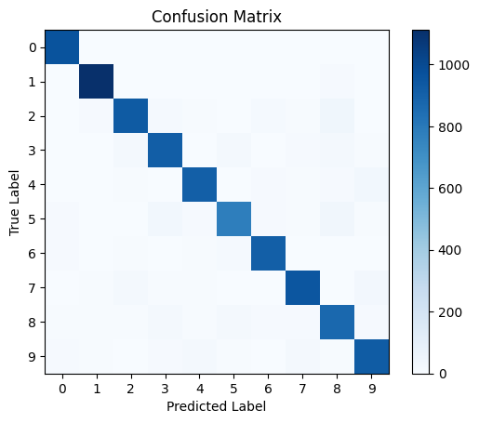

Decision Trees Model:

**Accuracy: 87.81%**

**Classification Report:**

| **Class** | **Precision** | **Recall** | **F1-score** | **Support** |
| --- | --- | --- | --- | --- |
| 0 | 0.93 | 0.94 | 0.93 | 980 |
| 1 | 0.95 | 0.96 | 0.96 | 1135 |
| 2 | 0.87 | 0.86 | 0.87 | 1032 |
| 3 | 0.84 | 0.85 | 0.84 | 1010 |
| 4 | 0.87 | 0.88 | 0.87 | 982 |
| 5 | 0.82 | 0.83 | 0.83 | 892 |
| 6 | 0.89 | 0.88 | 0.89 | 958 |
| 7 | 0.92 | 0.90 | 0.91 | 1028 |
| 8 | 0.82 | 0.80 | 0.81 | 974 |
| 9 | 0.85 | 0.85 | 0.85 | 1009 |

**Confusion Matrix:**

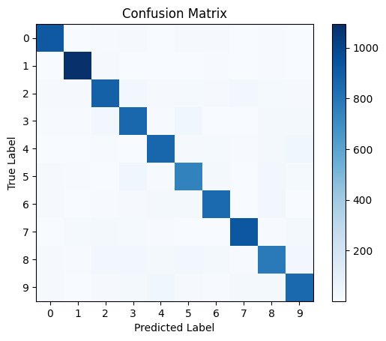

Support Vector Machines (SVM):

**Accuracy:96.95%**

**Classification Report:**

| **Class** | **Precision** | **Recall** | **F1-score** | **Support** |
| --- | --- | --- | --- | --- |
| 0 | 0.97 | 0.99 | 0.98 | 980 |
| 1 | 0.98 | 0.99 | 0.99 | 1135 |
| 2 | 0.97 | 0.97 | 0.97 | 1032 |
| 3 | 0.96 | 0.97 | 0.96 | 1010 |
| 4 | 0.97 | 0.97 | 0.97 | 982 |
| 5 | 0.97 | 0.96 | 0.97 | 892 |
| 6 | 0.98 | 0.98 | 0.98 | 958 |
| 7 | 0.97 | 0.95 | 0.96 | 1028 |
| 8 | 0.96 | 0.96 | 0.96 | 974 |
| 9 | 0.97 | 0.95 | 0.96 | 1009 |

**Confusion Matrix:**

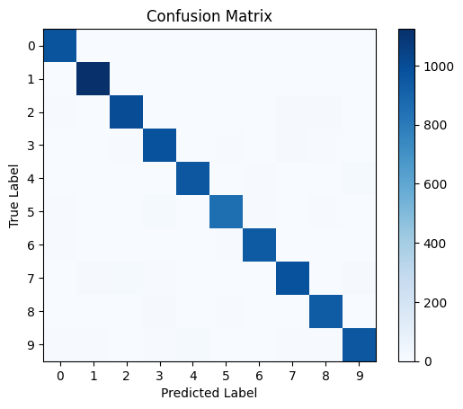

# **Conclusion:**

*Support Vector Machine (SVM) model showed best results with accuracy of* ***96.95%****, followed by Logistic regression model with accuracy of* ***92.55%****, and Decision Tree model with accuracy of* ***87.81%****.*