KING COUNTY EMS TRAINING DIVISION
BLOCK #3 COMPREHENSIVE MASTER STUDY GUIDE
Complete Core Clinical Curriculum: Chapters 20, 21, 24, 33, and 34
Textbook: AAOS Emergency Care and Transportation of the Sick and Injured (12th Edition)
Program: King County EMS / EMT-Basic (KCEMS-7CDE86)
————————————————————————————————————————————————————————————
MODULE 1: CHAPTER 20 — ENDOCRINE & HEMATOLOGIC EMERGENCIES
――――――――――――――――――――――――――――――――――――――――――――――――――
I. Endocrine System Physiology & Glucose Metabolism
- Endocrine Communication: Glands secrete chemical messenger hormones directly into the bloodstream to control metabolism, growth, and fluid balance.
- Cellular Energy: The brain and body cells require both GLUCOSE and OXYGEN for normal aerobic metabolism. While other organs can temporarily metabolize fat and protein, the BRAIN requires an uninterrupted, continuous supply of glucose.
- Pancreatic Islets of Langerhans: Specialized endocrine tissue in the pancreas contains two cardinal cell types:
- • Alpha Cells: Produce and secrete GLUCAGON, which stimulates the liver to convert stored glycogen into active circulating glucose (glycogenolysis).
- • Beta Cells: Produce and secrete INSULIN, the biological 'cellular key' that binds to cell membranes to allow glucose to enter and feed cells.
II. Diabetes Mellitus Type 1 & Diabetic Ketoacidosis (DKA)
- Pathophysiology of Type 1 DM: An autoimmune condition where the body develops antibodies that destroy its own pancreatic beta cells. Results in an ABSOLUTE deficiency of insulin. Typically diagnosed in childhood/early adulthood.
- The Classic 3 P's of New-Onset Type 1: When glucose exceeds the kidney's filtration threshold (~180 mg/dL), it spills into the urine:
- • Polyuria: Frequent, massive urination caused by osmotic diuresis (glucose dragging water with it).
- • Polydipsia: Excessive, unquenchable thirst secondary to systemic dehydration.
- • Polyphagia: Excessive, ravenous hunger because starved cellular tissues cannot access the glucose trapped in the bloodstream.
- Diabetic Ketoacidosis (DKA) Cascade: When cells cannot use glucose, the body begins rapidly metabolizing FAT stores for energy. Fat breakdown generates acidic byproducts called KETONES (acetoacetate and beta-hydroxybutyrate).
- Hallmark DKA Presentation: Blood glucose usually > 400 mg/dL; Kussmaul respirations (rapid, deep sighing breathing to blow off CO2 acid); sweet, fruity, or acetone breath odor; generalized abdominal cramping; nausea/vomiting; and progressive altered mental status.
⚠️ CRITICAL DKA CLINICAL TRAP
Rookies frequently hear rapid breathing in DKA and mistake it for asthma, hyperventilation syndrome, or an anxiety attack. Giving an Albuterol inhaler does nothing—the deep sighing Kussmaul breathing is the body's compensatory respiratory mechanism to eliminate volatile ketoacids!

III. Diabetes Mellitus Type 2 & Hyperosmolar Hyperglycemic Nonketotic Syndrome (HHNS)
- Pathophysiology of Type 2 DM: Caused by cellular resistance to insulin combined with progressive secretory defect. Strongly associated with obesity and metabolic syndrome.
- HHNS (Hyperosmolar State): Occurs in Type 2 diabetics when extreme, unmonitored hyperglycemia (BGL 600–1000+ mg/dL) drives massive osmotic water loss. Because these patients have ENOUGH circulating insulin to prevent massive lipolysis, KETOACIDOSIS DOES NOT OCCUR (no Kussmaul breathing, no fruity breath).
- HHNS Presentation: Profound dehydration (sunken eyes, tenting skin), normal or shallow respirations, tachycardia, hypotension, and marked lethargy or coma.
IV. Hypoglycemic Crisis (Insulin Shock)
- Pathophysiology: Blood glucose drops rapidly below 60 mg/dL (most commonly when a diabetic takes their prescribed insulin but skips a meal, or engages in vigorous exercise).
- Adrenaline Surge: The brain senses acute neuroglycopenia and triggers a massive sympathetic nervous system dump. Epinephrine spikes, producing: COOL, PALE, PROFUSELY DIAPHORETIC (soaked in cold sweat) skin, tachycardia (HR > 110), tremors, and dilated pupils.
- Focal Neurological Deficits (The Stroke Mimic): Severe hypoglycemia can present with unilateral facial droop, slurred speech, and hemiplegia identical to an acute CVA. ALWAYS check a fingerstick BGL before declaring a Code Stroke!
- Oral Glucose Administration Protocol: Dose: 15 to 30 grams (1 to 2 commercial tubes) administered buccally between the cheek and gum. REQUIREMENTS: Patient MUST be conscious, with an intact gag reflex and able to control their airway and swallow! If unconscious: position left lateral, open airway, request ALS for IV D10 (Dextrose) or IM Glucagon.
V. Hematologic Emergencies
- Sickle Cell Disease: An inherited autosomal recessive hemoglobin defect causing red blood cells to become oblong, rigid, and crescent/sickle-shaped. Cells clump together and lodge in microvessels, producing a VASO-OCCLUSIVE CRISIS. Hallmarks: agonizing bone/joint/abdominal pain, hypoxia, acute chest syndrome, priapism, and jaundice. EMT Treatment: High-flow O2, maintain body warmth, gentle handling, rapid transport (never apply ice packs!).
- Hemophilia: Inherited clotting factor deficiency (Factor VIII in Hemophilia A; Factor IX in Hemophilia B). Patients cannot form stable fibrin clots; minor blunt trauma causes massive, life-threatening internal bleeding into joints (hemarthrosis) or intracranial vault.
- Thrombophilia & DVT: A hypercoagulable state predisposing to excessive clot formation. Deep Vein Thrombosis (DVT) in the lower extremities can dislodge and travel to the pulmonary arterial bed, creating a fatal PULMONARY EMBOLISM (PE).

MODULE 2: CHAPTER 21 — ALLERGIC REACTIONS & ANAPHYLAXIS
――――――――――――――――――――――――――――――――――――――――――――――――――
I. Immunology & The Anaphylactic Mechanism
- Sensitization: The initial exposure to an allergen does not produce anaphylaxis. The immune system develops specific IgE antibodies that attach to the surface of circulating mast cells and basophils.
- Secondary Exposure & Degranulation: Subsequent re-exposure bridges adjacent IgE antibodies, causing immediate, catastrophic degranulation of mast cells and systemic release of chemical mediators: HISTAMINE, leukotrienes, and prostaglandins.
- Systemic Pathophysiology of Histamine:
- • Systemic Arteriole & Capillary Dilation: Pipes dilate wide open, pooling blood in peripheral beds $
ightarrow$ profound distributive shock and hypotension.
- • Capillary Permeability: Vascular walls become leaky, allowing fluid to pour into interstitial tissues $
ightarrow$ widespread angioedema and urticaria.
- • Bronchial Smooth Muscle Spasm: Airways constrict tightly $
ightarrow$ severe bronchospasm and dyspnea.
II. Assessment Findings: Localized vs. Systemic (Anaphylaxis)
- Common Triggers: #1 FOODS (peanuts, tree nuts, shellfish) account for 30% of anaphylactic fatalities; #2 MEDICATIONS (penicillin, antibiotics); #3 INSECT STINGS (hymenoptera venom); #4 LATEX.
- Skin Signs: Urticaria (hives)—raised, intensely pruritic erythematous plaques; Angioedema—deep, localized non-pitting swelling of lips, tongue, eyelids, and throat.
- Respiratory Findings: INSPIRATORY STRIDOR at the neck is the single most reliable indicator of impending upper airway laryngeal collapse! Expiratory wheezing indicates lower airway bronchospasm.
- Biphasic Reactions: A critical clinical phenomenon where severe anaphylactic symptoms RECUR 1 to 8 hours (or up to 72 hours) after initial complete resolution, without any repeat exposure! Every anaphylaxis patient must be transported to an ED.
III. Epinephrine Pharmacology & Auto-Injector Protocol
- Mechanism of Action: Potent sympathomimetic agonist:
- • Alpha-1 Stimulation: Constricts peripheral blood vessels $
ightarrow$ raises systemic blood pressure, reverses distributive shock, and shrinks swelling in the airway mucosa.
- • Beta-1 Stimulation: Increases cardiac contractility and heart rate.
- • Beta-2 Stimulation: Relaxes bronchial smooth muscle $
ightarrow$ powerful bronchodilation.
- Exact Dosing Standards:
- • Adult Auto-Injector (Yellow/Black): 0.30 mg of 1:1,000 epinephrine IM (patients > 30 kg / 66 lbs).
- • Pediatric Auto-Injector (Green): 0.15 mg of 1:1,000 epinephrine IM (patients 15 to 30 kg / 33 to 66 lbs).
- Administration Site & Technique: Inject into the lateral mid-thigh (anterolateral aspect of the vastus lateralis). Push firmly until the spring activates. HOLD FIRMLY IN PLACE FOR 3 SECONDS.
- Bee/Hornet Stinger Management: SCRAPE the stinger from the skin using a rigid flat object (credit card, tongue depressor). NEVER grasp or pinch with tweezers, which compresses the attached venom sac and injects more toxin!
- Airway Priority Rule: If a patient presents in severe anaphylaxis with cyanosis, stridor, and altered LOC, ASSIST VENTILATIONS WITH A BVM FIRST to restore alveolar oxygenation while the partner prepares the epinephrine!

MODULE 3: CHAPTER 33 — ENVIRONMENTAL EMERGENCIES
――――――――――――――――――――――――――――――――――――――――――――――――――
I. Thermoregulation & The 5 Mechanisms of Heat Loss
- 1. Conduction: Direct transfer of heat through physical contact with a colder solid object (e.g., lying on cold concrete or snow). Heat loss in cold water occurs 25 TIMES FASTER than in cold air!
- 2. Convection: Heat transfer to moving currents of air or liquid across the body surface (e.g., wind chill factor).
- 3. Evaporation: Conversion of liquid perspiration to vapor. Requires caloric heat from the skin.
- 4. Radiation: Radiant heat loss from the body directly into surrounding cooler space (uncovered head and neck account for up to 50% of radiant loss in cold weather).
- 5. Respiration: Inhaling cool ambient air and exhaling warm, humidified air, carrying heat away.
II. Systemic Hypothermia
- Definition: Core body temperature falls below 95°F (35°C).
- Mild Hypothermia (93.2°F – 98°F / 34°C – 36.7°C): Patient is alert, tachypneic, tachycardic, and exhibiting VIOLENT, ACTIVE SHIVERING.
- Moderate Hypothermia (86°F – 93.2°F / 30°C – 34°C): CRITICAL THRESHOLD: As glycogen depletes, SHIVERING CEASES COMPLETELY. Muscle activity stops, speech is slurred, apathy sets in, and mental status rapidly deteriorates.
- Severe Hypothermia (< 86°F / 30°C): Profound lethargy progressing to coma. The myocardium becomes extraordinarily cold, irritable, and electrically unstable.
⚠️ LETHAL HYPOTHERMIA TRAP: VENTRICULAR FIBRILLATION
Rough handling, sudden jarring, vigorous movement, or rapid rewarming of a patient with severe hypothermia can instantly trigger fatal VENTRICULAR FIBRILLATION (V-Fib)! Handle the patient with extreme gentleness, immobilize on a vacuum mattress or backboard, prevent rough log-rolling, and avoid active exterior heat packs on extremities.

- The 30-to-45 Second Pulse Check: Metabolic rates drop so drastically that heart rates can be 10 bpm and respirations 2/min. Always check the carotid pulse for a full 30 to 45 seconds before declaring cardiac arrest and starting chest compressions!
- Resuscitation Rule: 'A hypothermic patient is not dead until they are warm and dead!' Full resuscitative efforts must continue until core body temperature is restored.
III. Local Cold Injuries
- Frostnip: Superficial chilling of epidermal skin without permanent cell destruction (ears, nose, cheeks). Blanching skin, loss of sensation. Rewarms easily.
- Immersion Foot (Trench Foot): Results from prolonged exposure to wet, cold (non-freezing) water over days. Pale, wrinkled, numb, and macerated skin.
- Frostbite: Tissues are actually frozen, with intracellular ice crystal formation that permanently destroys cell membranes. Skin is hard, waxy, frozen, and numb. Severe cases develop blisters and gangrene.
- Field Rewarming Rules: Never rewarm if there is ANY chance of the tissue refreezing before reaching hospital care! Never rub or massage frostbitten tissue (causes ice crystals to lacerate cells). If active rewarming is required in remote settings, immerse in a circulating warm water bath maintained strictly between 102°F and 104°F (38.9°C to 40°C).
IV. Heat-Related Illnesses
- Heat Cramps: Painful involuntary spasms of skeletal muscles (calves, abdomen) caused by electrolyte depletion (sodium loss from heavy sweating).
- Heat Exhaustion: Hypovolemia from excessive sweating and peripheral vasodilation. Hallmarks: Profuse diaphoresis, cool/pale/clammy skin, dizziness, weakness, nausea, and NORMAL MENTAL STATUS.
- Heat Stroke (True Life-Threatening Emergency): Complete breakdown of hypothalamic thermoregulation; core temperature exceeds 104°F (40°C). Hallmarks: ALTERED MENTAL STATUS (confusion, delirium, combativeness, seizures, or coma). Skin may be hot and dry, OR hot and moist in exertional heat stroke (e.g., athletes, firefighters).
⚠️ HEAT STROKE MANAGEMENT PRIORITY
IMMEDIATE ACTIVE COOLING TAKES PRECEDENCE OVER TRANSPORT! Whole-body cold-water immersion or aggressive application of ice packs to the neck, axillae, and groin with vigorous fanning must be initiated immediately on scene to halt cerebral cooking.

V. Drowning, Diving & High Altitude Emergencies
- Drowning & Laryngospasm: In submersion, reflex laryngospasm initially seals the vocal cords to keep water out ('dry drowning'), but halts all airflow, producing acute hypoxia, unconsciousness, and secondary relaxation allowing fluid aspiration.
- Mammalian Diving Reflex: Cold water submersion triggers vagal bradycardia and profound peripheral vasoconstriction, shunting blood to the brain and heart, allowing extended survival underwater.
- Arterial Gas Embolism (AGE / Air Embolism): Occurs when a scuba diver panics and holds their breath while ascending. Alveoli rupture and air bubbles enter pulmonary veins $
ightarrow$ left heart $
ightarrow$ cerebral arteries. ONSET IS IMMEDIATE UPON SURFACING: Sudden sharp chest pain, dyspnea, hemoptysis (coughing blood), and stroke-like focal deficits.
- Decompression Sickness ('The Bends'): Nitrogen gas dissolved in tissues forms micro-bubbles during ascent. ONSET IS DELAYED (HOURS POST-DIVE): Severe deep joint pain, abdominal cramps, fatigue, and mottled skin. Treatment for both: High-flow O2, left lateral recumbent position, hyperbaric chamber transport.
- High Altitude Pulmonary Edema (HAPE): Occurs at > 8,000–10,000 ft from hypoxic pulmonary hypertension. Hallmarks: Dyspnea at rest, pink frothy sputum, cyanosis, and rales. Treatment: IMMEDIATE DESCENT to lower altitude and high-flow O2.
- Lightning Strike 'Reverse Triage': In a lightning mass-casualty incident, EMTs treat patients in CARDIAC OR RESPIRATORY ARREST FIRST. The massive electrical current causes temporary cardiac asystole and respiratory paralysis; the heart often restarts spontaneously, but prolonged respiratory arrest leads to secondary fatal anoxia. Providing immediate BVM ventilation saves lives.

MODULE 4: CHAPTER 24 — GYNECOLOGIC EMERGENCIES
――――――――――――――――――――――――――――――――――――――――――――――――――
I. Female Reproductive Anatomy & Normal Cycle
- Ovaries: Female gonads; produce estrogen and progesterone and release one mature ovum approximately every 28 days.
- Fallopian Tubes: CRITICAL EXAM ANATOMY: Normal fertilization of the ovum by sperm occurs in the OUTER THIRD OF THE FALLOPIAN TUBE.
- Uterus: Muscular organ; site of normal blastocyst implantation in the endometrial lining.
- Cervix: Narrow neck of the uterus that dilates during labor to 10 cm.
- Vagina: Muscular birth canal; pH is normally acidic to inhibit bacterial growth.
II. Pelvic Inflammatory Disease (PID)
- Pathophysiology: Ascending polymicrobial infection of the uterus, fallopian tubes, and ovaries originating from lower genital tract. Primarily caused by sexually transmitted infections (STIs): Chlamydia trachomatis and Neisseria gonorrhoeae.
- Hallmark Presentation: Dull, aching, diffuse lower abdominal and pelvic pain that worsens with walking or intercourse; foul-smelling yellow/green vaginal discharge; low-grade fever; and chills.
- The 'PID Shuffle': Patients walk bent forward with short, shuffling steps to minimize peritoneal vibration and pain.
- Long-Term Hazard: Fibrous tubal scarring leads to chronic pelvic pain, infertility, and a massive 7- to 10-fold increased risk of future ECTOPIC PREGNANCY.
III. Non-Traumatic Vaginal Bleeding
- Etiology: Spontaneous abortion (miscarriage), ectopic pregnancy, cervical polyps, uterine fibroids.
- The Golden Rule: NEVER pack dressings, gauze, or tampons inside the vagina under any circumstances!
- Field Care: Place external sterile sanitary pads over the perineum. Count the number of saturated pads per hour (> 1 pad/hour indicates severe hemorrhage). Treat for hypovolemic shock with high-flow O2 and warmth.
IV. Sexual Assault Protocols & Forensic Evidence Preservation
- Provider Demeanor: Provide compassionate, non-judgmental, trauma-informed psychological care. Address medical life threats (airway, external bleeding) first.
- The Paper Bag Rule: Place all collected clothing, sheets, or physical evidence in separate, clean BROWN PAPER BAGS. NEVER use plastic bags (condensation and moisture encourage bacterial mold growth that destroys forensic DNA evidence!).
- Patient Care Restrictions: Discourage the patient from showering, bathing, douching, brushing teeth, washing hands, or urinating prior to the forensic sexual assault exam. If the patient must urinate, collect the urine in a sterile specimen container.
- Transport: Transport to a designated SANE (Sexual Assault Nurse Examiner) capable emergency department.

MODULE 5: CHAPTER 34 — OBSTETRICS & NEONATAL CARE
――――――――――――――――――――――――――――――――――――――――――――――――――
I. Maternal Physiology & Pregnancy Terminology
- Maternal Blood Volume Expansion: Blood volume increases by 40% to 50% to perfuse the placenta. Resting heart rate increases by 10 to 15 bpm. CRITICAL TRAP: A pregnant trauma patient can lose up to 35% of her total blood volume before exhibiting overt signs of hemorrhagic shock! Fetal distress occurs long before maternal vitals collapse.
- Aspiration Vulnerability: Progesterone relaxes the gastroesophageal sphincter and slows gastric motility. ALL PREGNANT PATIENTS ARE CONSIDERED TO HAVE A FULL STOMACH and are high aspiration risks.
- Gravida / Para Terminology:
- • Gravida (G): Total number of pregnancies regardless of duration.
- • Para (P): Number of pregnancies carried past 20 weeks gestation to viable delivery.
- • Primigravida: Woman pregnant for the first time.
- • Multigravida: Woman who has been pregnant multiple times.
II. Supine Hypotensive Syndrome
- Mechanism: In the 3rd trimester (> 20 weeks), lying flat on the back causes the heavy gravid uterus to compress the INFERIOR VENA CAVA (IVC) against the lumbar spine, obstructing venous blood return to the heart.
- Clinical Findings: Sudden dizziness, pallor, cold clammy sweat, tachycardia, and profound hypotension.
- Treatment: ALWAYS transport pregnant patients in the LEFT LATERAL RECUMBENT POSITION. If on a backboard for trauma, wedge the board 15° to 30° to the left with rolled blankets under the right side.

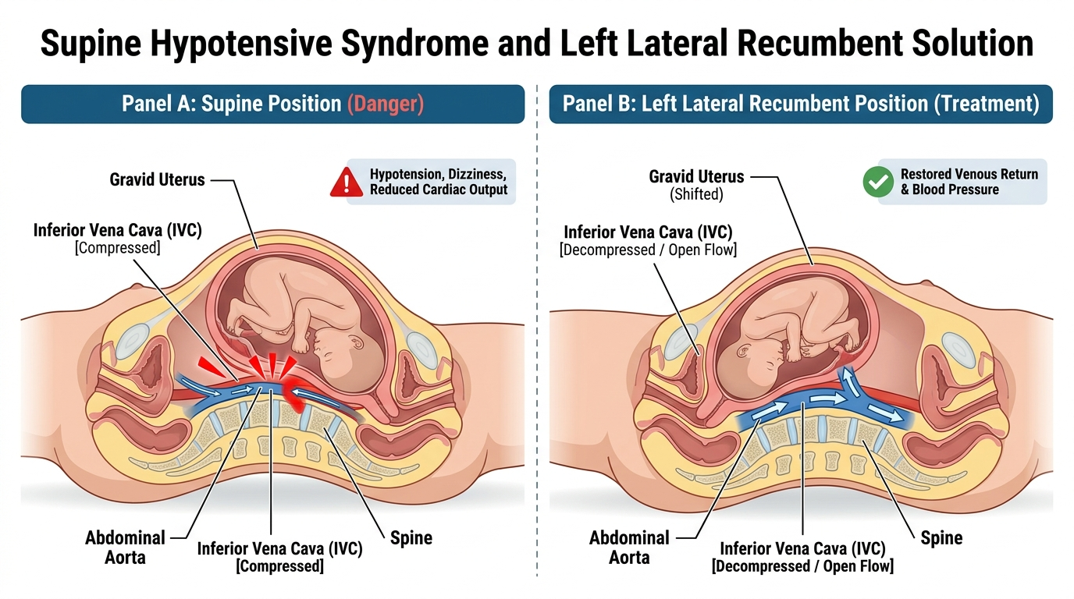
Figure 1: Mechanism of Supine Hypotensive Syndrome (IVC Compression) and Left Lateral Recumbent Relief.
III. Hypertensive Disorders of Pregnancy
- Gestational Hypertension: Blood pressure ≥ 140/90 mmHg developing after 20 weeks gestation without proteinuria.
- Preeclampsia: Hypertension (≥ 140/90) accompanied by dependent facial/hand edema and proteinuria. Symptoms: Persistent severe frontal headache, visual changes (scotoma, blurring), and right upper quadrant/epigastric pain.
- Eclampsia: Onset of generalized tonic-clonic SEIZURES or coma in a patient with preeclampsia. EMT Management: Maintain airway, left lateral positioning, high-flow O2, dim lights/sirens off, rapid ALS intercept for IV Magnesium Sulfate.
IV. The Three Stages of Labor
- Stage 1 (Dilation Phase): Begins with regular uterine contractions and ends with FULL CERVICAL DILATION (10 cm). The longest stage; amniotic sac ('water') typically ruptures.
- Stage 2 (Expulsion Phase): Begins with complete dilation and ends with DELIVERY OF THE BABY. The active pushing stage; perineum bulges and crowning occurs.
- Stage 3 (Placental Phase): Begins after the baby is delivered and ends with DELIVERY OF THE PLACENTA (takes 5 to 30 minutes). Never pull on the umbilical cord!
V. Field Delivery Assessment & Step-by-Step Procedure
- Determining Imminent Delivery (Stay & Deliver vs. Load & Go): 1) Is this your first baby? (Subsequent births happen much faster); 2) Are contractions < 2 minutes apart and lasting 60–90 seconds? 3) Do you feel the urge to push or have a bowel movement? 4) Visual inspection shows CROWNING (the head is visible at the vaginal opening). If crowning is present, prepare to deliver on scene immediately!
- Field Delivery Steps:
- 1. Support Perineum & Head: Place gentle flat-palm pressure against the crowning head to prevent explosive delivery and perineal lacerations.
- 2. Check for Nuchal Cord: Once the head delivers, slip your index finger around the neck to check if the cord is encircled. Gently slip the loop over the baby's head. If too tight, clamp twice and cut between clamps immediately.
- 3. Suction Airway: Suction mouth first, then nose with bulb syringe (M before N) if secretions obstruct.
- 4. Deliver Shoulders: Guide head gently downward to deliver anterior shoulder, then upward for posterior shoulder. Support the slippery body.
- 5. Clamp & Cut Cord: Wait 30–60s. Clamp 1st clamp 6 to 8 inches from baby; clamp 2nd clamp 2 to 4 inches further out. Cut between clamps with sterile scissors.
- 6. Postpartum Hemorrhage (> 500 mL): Perform firm circular FUNDAL MASSAGE of the top of the uterus to stimulate muscular contraction and clamp bleeding arterioles. Encourage immediate breastfeeding (stimulates maternal pituitary release of oxytocin).
VI. Abnormal Deliveries & Obstetric Emergencies
- Placenta Previa vs. Abruptio Placentae:
- • Placenta Previa: Placenta covers cervical opening. Hallmarks: PAINLESS, bright red vaginal bleeding in 3rd trimester. Uterus is soft and non-tender. Treatment: High-flow O2, left lateral position, treat for shock, rapid transport.
- • Abruptio Placentae: Premature detachment of placenta from uterine wall (often from trauma or severe HTN). Hallmarks: SEVERE TEARING PAIN, dark venous bleeding, and a RIGID, board-like abdomen. High fetal and maternal mortality.

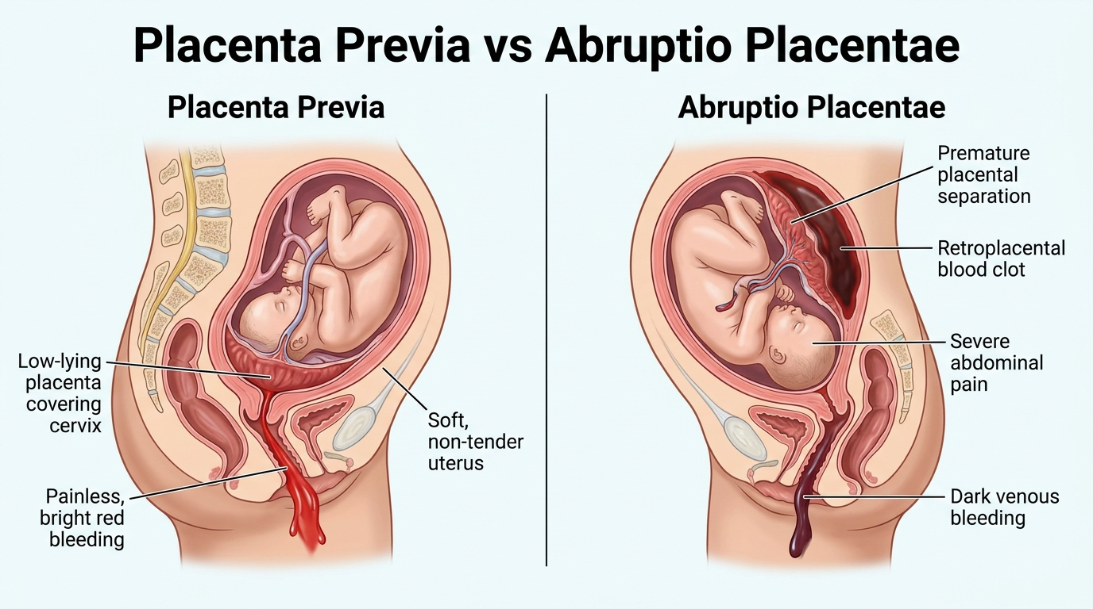
Figure 2: Comparison of Placenta Previa (Painless Bright Bleeding) vs. Abruptio Placentae (Painful Tearing).
- Ectopic Pregnancy: Embryo implants outside the uterus (usually fallopian tube). Ruptures at 6 to 8 weeks gestation. Hallmarks: Sudden sharp unilateral lower quadrant pain, missed menstrual period, syncope, Kehr's sign (referred shoulder pain from free blood under the diaphragm), and profound shock.
- Prolapsed Umbilical Cord (True Emergency): The cord slips ahead of the fetus and protrudes from the vagina. The presenting head compresses the cord against the pelvis, halting fetal perfusion.
- • ACTION 1: DO NOT PUSH THE CORD BACK IN.
- • ACTION 2: Insert a sterile gloved hand into the vagina and physically push the presenting fetal head UPWARD away from the cord.
- • ACTION 3: MAINTAIN HAND ELEVATION CONTINUOUSLY until the surgical team takes over in the Operating Room!
- • ACTION 4: Position mother in KNEE-CHEST position (hips elevated). Wrap exposed cord in moist sterile saline dressing. Immediate Code 3 transport!

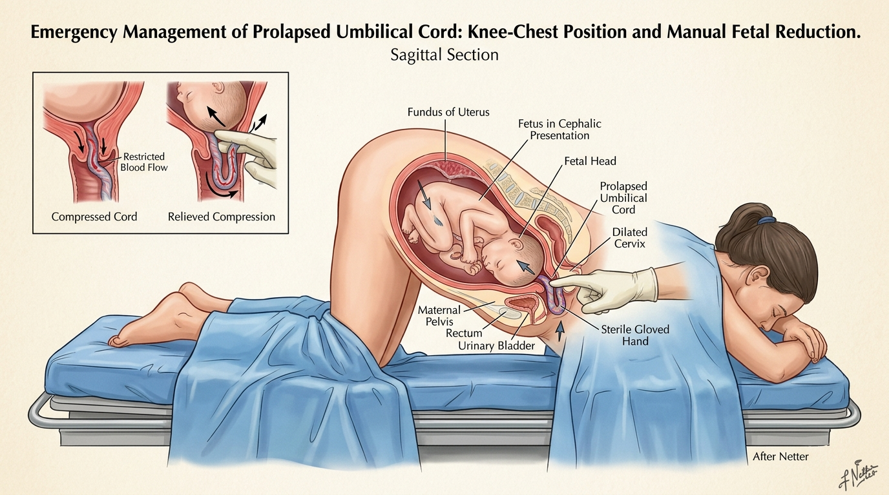
Figure 3: Emergency Management of Prolapsed Cord: Maternal Knee-Chest Position & Manual Fetal Head Elevation.
- Breech Delivery (Butt or Feet First): Allow spontaneous delivery of body. If head is trapped: Insert gloved fingers into vagina and form a 'V' over baby's mouth and nose to establish an airway space against the vaginal wall. Rapid transport.
- Limb Presentation (Single Arm or Leg): CANNOT be delivered in the field! DO NOT pull on the limb. Place mother in knee-chest position, cover limb with sterile moist dressing, and transport Priority 1 immediately.
- Meconium Staining: Passage of fetal first stool into amniotic fluid indicates fetal distress (green/dark brown pea-soup fluid). If infant is vigorous/crying: routine care. If infant is depressed (limp, no cry, HR < 100): proceed immediately with BVM ventilation!
VII. Neonatal Resuscitation Algorithm & APGAR Matrix
- The Golden Minute (First 30 Seconds): Dry thoroughly, discard wet towels, keep warm on mother's chest or radiant warmer, position airway, suction mouth then nose (if obstructed), stimulate by flicking soles or rubbing back.
- Heart Rate 60 to 100 bpm (or apneic/gasping): Begin Bag-Valve-Mask (BVM) ventilations at 40 to 60 breaths/min using room air (21% O2) for 30 seconds.
- Heart Rate < 60 bpm (despite 30s of BVM): START CHEST COMPRESSIONS IMMEDIATELY! Ratio: 3:1 (90 compressions to 30 ventilations = 120 total events/min). Switch to 100% high-flow O2.
APGAR Scoring Matrix (Assessed at 1 and 5 minutes post-birth)
Category | 0 Points | 1 Point | 2 Points
A - Appearance (Color) | Blue or pale all over | Body pink, blue hands/feet (Acrocyanosis) | Completely pink all over
P - Pulse (Heart Rate) | Absent | < 100 bpm | > 100 bpm
G - Grimace (Reflexes) | No response to stimulation | Grimace or weak whimper | Vigorous cry, cough, or sneeze
A - Activity (Muscle Tone) | Limp, flaccid | Some flexion of extremities | Active motion, well-flexed
R - Respiration (Effort) | Absent | Slow, irregular, weak cry | Strong, lusty, vigorous cry

MODULE 6: MASTER 30-QUESTION ORAL DRILL & POP QUIZ HIT LIST
――――――――――――――――――――――――――――――――――――――――――――――――――
- 1. What hormone does pancreatic alpha cells produce? Glucagon (stimulates liver glycogenolysis).
- 2. What hormone does pancreatic beta cells produce? Insulin (allows glucose to enter cells).
- 3. What is the classic triad of new-onset Type 1 Diabetes? Polyuria, Polydipsia, and Polyphagia.
- 4. What breathing pattern is characteristic of DKA? Kussmaul respirations (rapid, deep sighing).
- 5. Why does DKA breath smell fruity or like nail polish remover? Exhalation of volatile ketone bodies (acetoacetate).
- 6. What skin signs define a hypoglycemic crisis? Cool, pale, and profusely diaphoretic (sweaty).
- 7. What are the requirements to administer oral glucose? Conscious, intact airway/gag reflex, able to swallow.
- 8. What is the primary cause of pain in a sickle cell crisis? Sludging of rigid sickle cells in microvessels (vaso-occlusive crisis).
- 9. What is the #1 food trigger of lethal anaphylaxis in young adults? Peanuts and shellfish (account for 30% of deaths).
- 10. What is the most reliable sign of impending upper airway closure in an allergic reaction? Inspiratory stridor at the neck.
- 11. What is the adult epinephrine auto-injector dose and concentration? 0.3 mg of 1:1,000 IM.
- 12. What is the pediatric epinephrine auto-injector dose? 0.15 mg of 1:1,000 IM (15 to 30 kg).
- 13. How long must an EpiPen be held firmly against the thigh? 3 seconds.
- 14. How should a bee or hornet stinger be removed? Scraped off with a credit card (never squeezed with tweezers).
- 15. What is a biphasic anaphylactic reaction? Recurrence of severe symptoms 1 to 8 hours post-resolution without re-exposure.
- 16. Heat loss in cold water occurs how much faster than in air? 25 times faster (conduction).
- 17. What cardinal finding distinguishes Heat Stroke from Heat Exhaustion? Altered mental status / CNS dysfunction (confusion, seizures, coma).
- 18. What is the primary treatment for Heat Stroke on scene? Immediate active cooling (ice bath/ice packs to neck, axillae, groin) before transport.
- 19. What physical sign marks the transition to Moderate Hypothermia (< 93.2°F)? Shivering stops completely.
- 20. Why must patients with severe hypothermia (< 86°F) be handled with extreme gentleness? Rough handling easily converts an irritable myocardium into Ventricular Fibrillation.
- 21. How long must you check a carotid pulse on a hypothermic patient before starting CPR? A full 30 to 45 seconds.
- 22. What diving emergency occurs immediately upon surfacing with chest pain and stroke signs? Arterial Gas Embolism (Air Embolism / AGE).
- 23. What triage rule is applied in lightning mass-casualty incidents? Reverse Triage (resuscitate cardiac/respiratory arrest patients first).
- 24. Where does normal fertilization occur in the female reproductive tract? The outer third of the Fallopian tube.
- 25. What long-term hazard results from untreated Pelvic Inflammatory Disease (PID)? Tubal scarring leading to Ectopic Pregnancy and infertility.
- 26. How must physical clothing evidence from a sexual assault be packaged? In separate, individual PAPER bags (never plastic).
- 27. What vessel is compressed in Supine Hypotensive Syndrome, and how is it relieved? The Inferior Vena Cava (IVC); relieved by Left Lateral Recumbent positioning.
- 28. What clinically differentiates Placenta Previa from Abruptio Placentae? Previa = PAINLESS bright red bleeding; Abruptio = PAINFUL tearing dark bleeding with a rigid abdomen.
- 29. What are your immediate actions for a Prolapsed Umbilical Cord? Never push cord in; insert sterile gloved fingers to push baby's head UP off cord, knee-chest position, Code 3 transport!
- 30. In neonatal resuscitation, what heart rate triggers chest compressions, and at what ratio? Heart rate < 60 bpm despite 30s of BVM; ratio is 3:1 (90 compressions to 30 breaths).

