KING COUNTY EMS TRAINING DIVISION
OFFICIAL LECTURE STUDY GUIDE
Block #3: Chapter 24 (Gynecologic Emergencies) & Chapter 34 (Obstetrics & Neonatal Care)
Lecture Date: Thursday, October 22, 2026 | AAOS Emergency Care 12th Ed.
———————————————————————————————————————————————————————
SECTION 1: CHAPTER 24 — GYNECOLOGIC EMERGENCIES
―――――――――――――――――――――――――――――――――――――――――――――
I. Anatomy & Physiology Review
- Ovaries: Primary female gonads; produce estrogen and progesterone and release an ovum every 28 days.
- Fallopian Tubes: Muscular tubes connecting ovaries to uterus. CRITICAL EXAM FACT: Normal fertilization occurs in the outer third of the fallopian tube.
- Uterus: Muscular, hollow, pear-shaped organ where the fertilized egg implants and the fetus grows.
- Cervix: Narrow neck of the uterus opening into the vagina. Forms the protective mucous plug in pregnancy.
- Vagina: Muscular tube extending from the cervix to the exterior; serves as the birth canal.
- Perineum: Muscular area between the vaginal opening and the anus.
II. Pelvic Inflammatory Disease (PID)
- Pathophysiology: Infection of upper female reproductive tract originating from lower genital tract. Usually caused by STIs (Chlamydia and Gonorrhea).
- Hallmark Presentation: Dull, aching, progressive bilateral lower quadrant pain; low-grade fever; foul yellow/green vaginal discharge.
- The PID Shuffle: Patient walks bent forward with short, shuffling, hesitant steps to avoid peritoneal jarring.
- Long-term Hazard: Tubal scarring increases the risk of life-threatening ECTOPIC PREGNANCY by up to 10-fold.
III. Non-Traumatic Vaginal Bleeding
- The Golden Rule: NEVER pack the vagina or insert any dressing/tampons internally under any circumstances.
- Assessment: Apply sterile sanitary pads externally over the perineum. Quantify blood loss by counting soaked pads per hour (>1 pad/hour indicates significant hemorrhage).
IV. Sexual Assault & Forensic Preservation Protocols
- Medical Priorities First: Treat acute life threats (airway, severe bleeding) before evidence collection.
- Paper Bags ONLY: Place each collected article of clothing into separate clean PAPER bags. NEVER use plastic bags (condensation/moisture causes bacterial mold that destroys DNA).
- Patient Care: Discourage patient from showering, bathing, douching, brushing teeth, washing hands, or urinating prior to forensic medical exam.

SECTION 2: CHAPTER 34 — OBSTETRIC CARE & NORMAL DELIVERY
―――――――――――――――――――――――――――――――――――――――――――――
I. Normal Maternal Physiological Changes
- Blood Volume: Expands by 40% to 50%. A pregnant trauma patient can lose up to 35% of blood volume before showing signs of shock!
- Heart Rate: Increases by 10 to 15 bpm above baseline.
- Aspiration Risk: Gastric motility is slowed and the cardiac sphincter is relaxed. All pregnant patients are considered to have a full stomach!
II. Supine Hypotensive Syndrome & Management
- Mechanism: In the 3rd trimester, lying flat on the back causes the heavy gravid uterus to crush the Inferior Vena Cava (IVC) against the spine, halting venous blood return.
- Symptoms: Sudden dizziness, pale clammy skin, tachycardia, and profound hypotension.
- Treatment: Always position pregnant patients in the LEFT LATERAL RECUMBENT position (or tilt backboard 15–30° to the left).

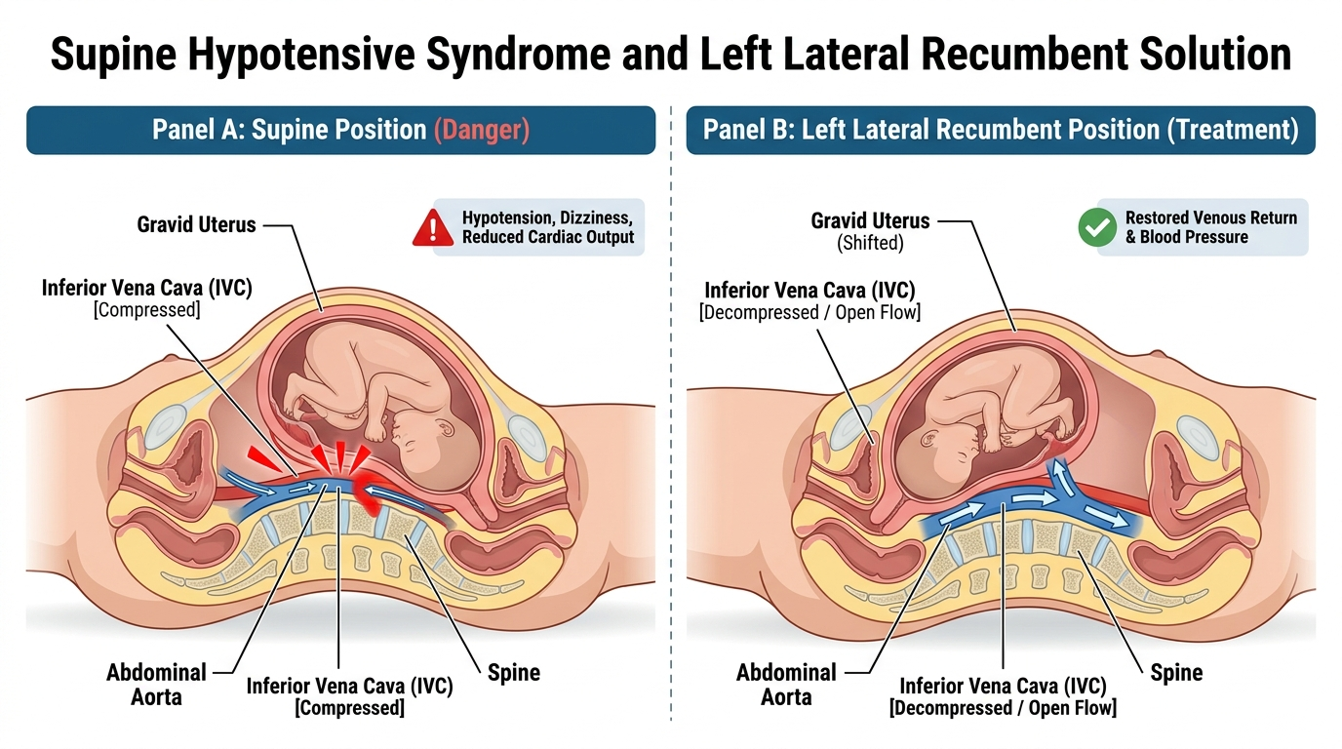
Figure 1: Mechanism of Supine Hypotensive Syndrome (IVC Compression) and Left Lateral Relief.
III. Hypertensive Disorders of Pregnancy
- Preeclampsia: Pregnancy-induced hypertension (BP ≥ 140/90) + dependent edema (face/hands) + proteinuria. Common signs: severe frontal headache, visual spots/blurring, epigastric pain.
- Eclampsia: Onset of generalized tonic-clonic seizures or coma in a preeclamptic patient. Management: maintain airway, left lateral position, high-flow O2, dim lights, ALS intercept for IV Magnesium Sulfate.
IV. The Three Stages of Labor
- Stage 1 (Dilation): Begins with regular contractions and ends with FULL cervical dilation (10 cm). Longest stage.
- Stage 2 (Expulsion): Begins with full cervical dilation and ends with delivery of the baby. The pushing stage; crowning visible.
- Stage 3 (Placental): Begins immediately after baby delivers and ends with delivery of the placenta (5–30 minutes). Never pull the cord!
V. Assessing for Imminent Field Delivery
- The 4 Questions: 1) Is this your first child? 2) How far apart are contractions? 3) Has your water broken? 4) Do you feel the urge to push or have a bowel movement?
- Visual Check: If contractions are < 2 minutes apart and the mother feels an urge to push, inspect for crowning. If crowning is present, prepare to deliver on scene immediately!
VI. Standard Field Delivery Steps & Postpartum Care
- 1. Support Perineum & Head: Place gentle flat-palm pressure against head as it crowns to prevent explosive delivery and perineal tearing.
- 2. Check for Nuchal Cord: Feel around the neck for umbilical cord. Slip over head gently. If too tight, clamp twice and cut between clamps.
- 3. Suction Airway: Suction mouth first, then nose with bulb syringe (M before N).
- 4. Deliver Shoulders: Guide head gently downward to deliver anterior shoulder, then upward for posterior shoulder.
- 5. Clamp & Cut Cord: Wait 30-60s. Clamp 1st clamp 6–8 inches from baby; clamp 2nd clamp 2–4 inches further out. Cut between clamps.
- 6. Postpartum Hemorrhage (> 500 mL): Firm circular massage of the uterine fundus (top of uterus) to clamp bleeding arterioles. Encourage immediate breastfeeding to stimulate natural oxytocin release.

SECTION 3: ABNORMAL DELIVERIES & OBSTETRIC EMERGENCIES
―――――――――――――――――――――――――――――――――――――――――――――
I. Placenta Previa vs. Abruptio Placentae
- Placenta Previa: Placenta covers cervical opening. Hallmarks: PAINLESS, bright red vaginal bleeding in 3rd trimester. Uterus remains soft and non-tender.
- Abruptio Placentae: Premature detachment of placenta from uterine wall. Hallmarks: SEVERE TEARING PAIN, dark venous bleeding, and a RIGID, board-like abdomen. Severe maternal and fetal shock.

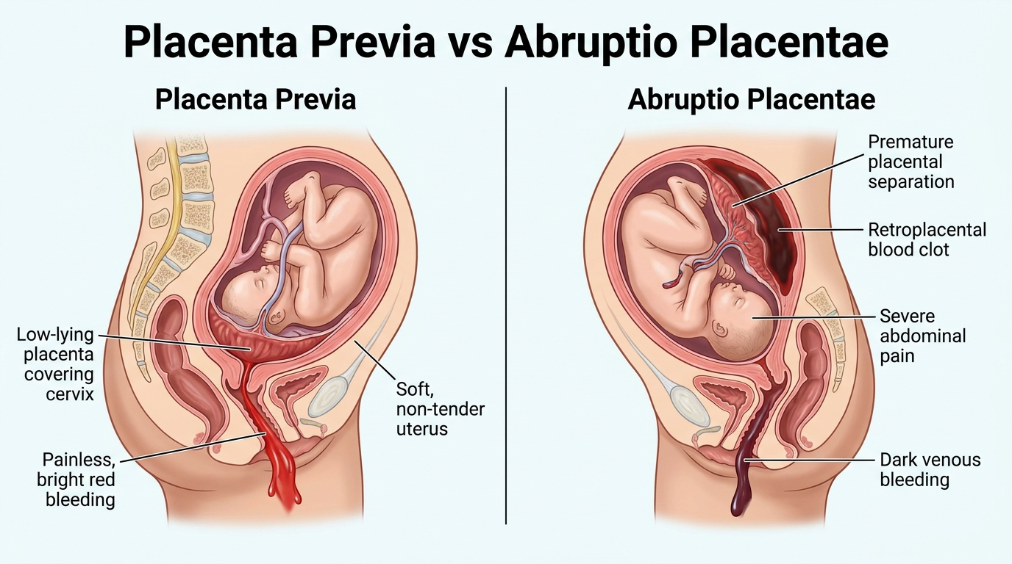
Figure 2: Clinical Comparison of Placenta Previa (Painless Bleeding) vs. Abruptio Placentae (Painful Tearing).
II. Prolapsed Umbilical Cord (Critical Emergency)
- Pathophysiology: The umbilical cord protrudes from the vagina ahead of the baby. The fetal head compresses the cord against the pelvis, cutting off all oxygen to the fetus.
- Action 1: DO NOT PUSH THE CORD BACK IN.
- Action 2: Insert a sterile gloved hand into the vagina and gently push the presenting fetal head UPWARD away from the cord.
- Action 3: MAINTAIN HAND POSITION CONTINUOUSLY until the surgical team takes over in the Operating Room!
- Action 4: Position mother in the KNEE-CHEST position (buttocks elevated) to use gravity to pull the fetus back. Wrap exposed cord in moist sterile saline dressing. Immediate Code 3 transport!

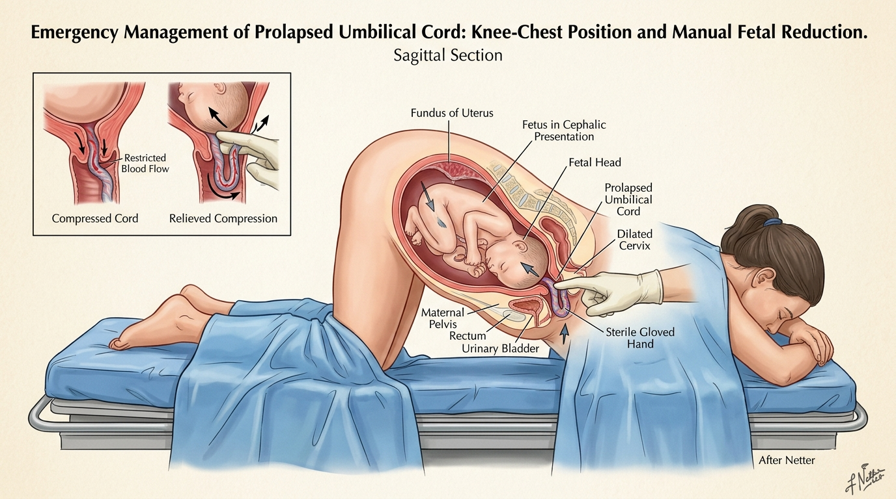
Figure 3: Maternal Knee-Chest Positioning and Manual Fetal Head Elevation for Prolapsed Cord.
III. Breech Delivery vs. Limb Presentation
- Breech (Butt or Feet first): Allow spontaneous delivery of body. If head is trapped: insert gloved fingers into vagina and form a 'V' over baby's mouth and nose to establish an airway space against the vaginal wall.
- Limb Presentation (Single Arm or Leg): CANNOT be delivered in the field! DO NOT pull on the limb. Place mother in knee-chest position, cover limb with sterile moist dressing, and transport Priority 1 immediately.

SECTION 4: NEONATAL ASSESSMENT & RESUSCITATION
―――――――――――――――――――――――――――――――――――――――――――――
I. The Golden Minute & The Rule of 60 / 100
- First 30 Seconds: Dry thoroughly, keep warm, position airway, suction mouth then nose (if obstructed), stimulate by rubbing back or flicking soles.
- If HR is 60 to 100 bpm (or apneic/gasping): Begin Bag-Valve-Mask (BVM) ventilations at 40 to 60 breaths/min with room air (21% O2) for 30 seconds.
- If HR is LESS THAN 60 bpm (despite 30s of BVM): START CHEST COMPRESSIONS IMMEDIATELY! Ratio: 3:1 (90 compressions to 30 ventilations = 120 total events/min). Switch to 100% high-flow O2.
II. APGAR Scoring System Matrix (Scored at 1 and 5 minutes)
Category | 0 Points | 1 Point | 2 Points
A - Appearance (Color) | Blue or pale all over | Body pink, blue hands/feet (Acrocyanosis) | Completely pink all over
P - Pulse (Heart Rate) | Absent | < 100 bpm | > 100 bpm
G - Grimace (Reflexes) | No response to stimulation | Grimace or weak whimper | Vigorous cry, cough, or sneeze
A - Activity (Muscle Tone) | Limp, flaccid | Some flexion of extremities | Active motion, well-flexed
R - Respiration (Effort) | Absent | Slow, irregular, weak cry | Strong, lusty, vigorous cry

⚠️ CRITICAL APGAR EXAM TRAP
Acrocyanosis (pink trunk with blue hands and feet) is completely normal in the first 5 minutes of life and scores a 1 for Appearance! A score of 7 to 10 indicates a healthy, vigorous newborn.

SECTION 5: INSTRUCTOR ORAL EXAM & POP QUIZ HIT LIST
―――――――――――――――――――――――――――――――――――――――――――――
- 1. In Supine Hypotensive Syndrome, what vessel is compressed? The Inferior Vena Cava (IVC) against the spine. Fix: Left lateral recumbent.
- 2. What differentiates Placenta Previa from Abruptio Placentae? Previa = PAINLESS bright red bleeding; Abruptio = PAINFUL dark bleeding with a rigid board-like abdomen.
- 3. A newborn has an HR of 50 bpm after 30s of BVM. What is your immediate next action? Start chest compressions immediately at a 3:1 ratio (90 compressions to 30 ventilations).
- 4. What are your immediate actions for a Prolapsed Cord? Do NOT push cord back in. Insert sterile gloved hand to elevate head off cord, mother in knee-chest position, moist dressing on cord, Code 3 transport!
- 5. How should physical clothing evidence from a sexual assault be packaged? In individual, separate PAPER bags (never plastic).

