**CSE327 Fall2023 Homework 10 (10 pts)**

**Dynamic Programming for Stereo Reconstruction**

**Due December 11th 2023 11:59PM, submitted via Brightspace**

This homework includes Disparity Space Image (DSI) computation and stereo reconstruction by applying dynamic programming.

(1) Read in two images and convert them into grayscale images. Some sample images are included in the homework directory on Brightspace. You can also try images on the Middlebury website.

(2) Compute the Disparity Space Image (DSI) for each row of images, using Normalized Cross Correlation (NCC).

(3) Apply dynamic programing on the DSI image to find the path with the minimum cost from the top-left corner to the bottom-right corner.

(4) Back-trace the path and compute the disparity.

(5) Repeat steps (2)-(4) for each row of the image.

(6) Fill-in the occlusion.

The following figure shows one example.

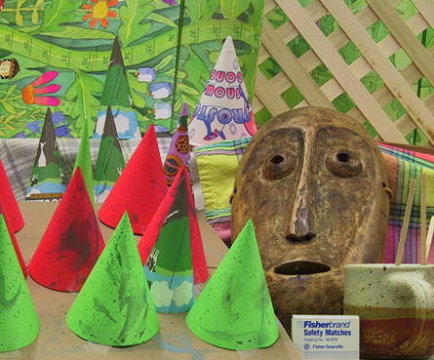 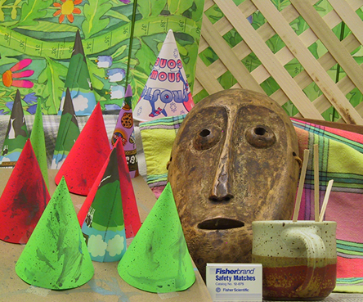

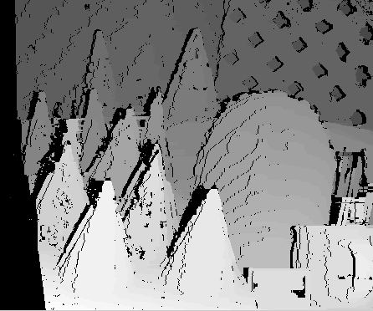 

Upload running code and a briefly written report to Brightspace by the due date/time.

**Bonus (2pts)**

Make stereo images from your own digital cameras. Keep in mind that the image pair we use in this project require that camera is shifted horizontally only, therefore the searching is performed on horizontal image scanlines.