
Ruhr Universität Bochum
Fakultät für Informatik
Systemsicherheit (211011-SS 2026)

System security assignment 3
Matias Soto
Matej Heřman
Daniel Szabo
3 Student Group 10

BOCHUM, 2026

Data-Only Attack
Using the same RUB-VPN connection we were able to connect to the network and access the exercises.

Stack frame
Using GDB we can analyze the assembly code that runs with the crackme program. From the hints we know that the secret key is checked in the verify_key function with the strcmp C function. So, if we are able to get to the data that is compared in that call then we can get the key.
With the “info address verify_key” command we can get the address of the validating function and disassemble it. In the function we found the call that executes strcmp. If we put a breakpoint before the function is called, we can see what values are pushed to the stack.
When we now run the program with a sample input AAAAA it breaks before entering the call. Here we see the exact address of the secret key. With the “x/s 0xaddr” command we see that the value is “MMNNQ”. However, if give the program this input it still says that the key is not valid.
The reasoning for that can be seen in the verify_key function. Before calling the strcmp function the input goes through a loop. Each character in the input is subtracted by their index in the string times two. When we add these to “MMNNQ” and look at the ASCII values we get the key “MORTY”. This key is validated by the program.

Analysis
In order to reconstruct the code, we have to dissemble the main function as well. We can see that there is no other function call in it. The rest of the code simply reads the input, calls the verify_key function and writes the message based on the result of it.

Stack-based Buffer Overflow
These tasks introduce the use of system calls and how this high-level concept can be exploited with binaries.

Simple Buffer Overflow
The assembly code can be written based on the Linux syscalls list and each calls manual. To write a message to a file we first need to open or create that file. Then we need to write the message into it. Save it by closing it and then exit the program. These steps can be written in with a syscall each.

NOP Sliding
The main difference between the previous task and this one is that the shell code cannot have null bytes in it as that would result in the termination of the process. The trick is to push the null bytes onto the stack and form the strings and the pointers directly onto the stack instead of in the operation.
In the task we take a look at the Linux syscall list and set the registers based on the execve call. We push the filename string, the argv array and the envp parameters to the stack and call the kernel.
After we link and run the assembly code, we can write down the bytes of the shell code from the disassembly.
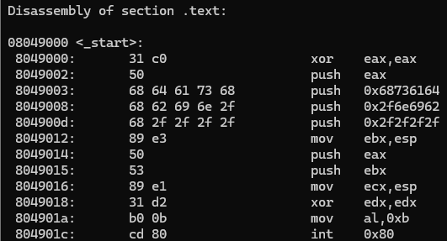

Use of Generative Artificial Intelligence
As a team we didn’t use any Generative A.I. tool in any of the thinking, writing or execution of the parts of this assignment nor documentation.

