
Ruhr Universität Bochum
Fakultät für Informatik
Systemsicherheit (211011-SS 2026)

System security assignment 2
Matias Replace
Matej Replace
Daniel Szabo
3 Student Group 10

BOCHUM, 2026

Pen & Paper tasks
In these exercises we shortly introduce the issues with the given protocols and describe a potential attack.

Authentication I
The issue with this protocol is that when the server generates and encrypted session key {K_{AB}}K_{AS} for Alice, then that key does not include Bob’s ID. This allows for a Man-in-the-Middle attack, because Alice cannot check if she is actually sending a message to Bob.
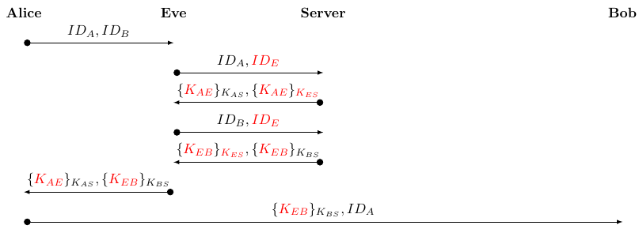
As indicated in the protocol flow chart, Eve can intercept Alice’s first message to the server and replace Bob’s ID with her own. The server then generates the session key K_{AE}, but now it is for Alice and Eve. From this point onwards, Eve could read any message coming from Alice and could impersonate Bob whenever she likes.
To trick Bob as well she starts another session but now with Bob. This way she gets the key K_{EB} to talk to Bob. Eve can then send this key to Alice as a disguised server response, so that Alice thinks that this is her session key with Bob. She then sends this to Bob, and now the session that he will use can also be decrypted by Eve.

Authentication II
The issue with this protocol is that nonce that checks the liveness of the connection between Alice and the Server is not included in the initial message to Bob. This means that Bob has no way of checking the liveness of that message, an assumes that it is correct. Thus, Eve can hijack the conversation and take the role of Alice to fool Bob.
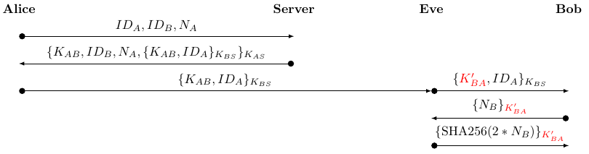
In this protocol flow chart, we can see that the first two messages are uninterrupted and Eve only intervenes when Bob is about to be contacted. Since K’_{AB} is known to Eve from a previous interaction, she can block the message from Alice and replace it with a previous one that used K’_{AB}. Now Bob sends back the request with the compromised key, so Eve can decrypt it and send back the nonce in the correct form, that Bob will accept as proof of the liveness and Alice’s identity.

Practical Tasks
(Short introduction)
This assignment was completed without the use of AI tools.

Framework
(Short description about how to set up the environment. Maybe split it up into 2.1.1 Starting the Framework and 2.1.2 Proxy Modules if need)

Tasks
Having successfully set up the framework we moved onto solving the practical tasks with the protocols.

Key Establishment
(Description about how to solve the task)

New User Interface
(Description about how to solve the task)

