
Ruhr Universität Bochum
Fakultät für Informatik
Systemsicherheit (211011-SS 2026)

System security assignment 3
Matias Soto
Matej Heřman
Daniel Szabo
3 Student Group 10

BOCHUM, 2026

Data-Only Attack
Using the same RUB-VPN connection we were able to connect to the network and access the exercises.

Stack frame
The stack frame is made up of the following contents of memory:
- Parameters: In this case the pointer to the password string.
- Return Address: Where the main function will continue after the call is finished.
- Stack frame pointer: Points to the base address of the stack frame.
- Local variables: All the variables that are declared and used only in this function.
Based on this knowledge we can fill out the stack frame and label the contents appropriately. The one and only parameter of the function is the pointer to the input string. On the other hand, there are two local variables: auth_flag and password_buffer. The first one is an integer used to determine the outcome of the function. While the other variable is a 12-byte long array used for storing the password for the strcpy() function.
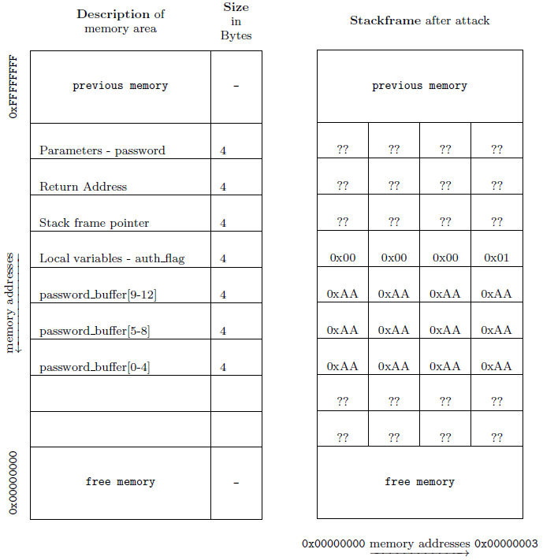
The attack in this task is a simple buffer overflow attack. Because the program uses the unsafe strcpy() function the attacker is able to alter the auth_flag variable by giving an input that is longer than 12 bytes. Let’s say that the input password is twelve 0xAA characters plus 0x01 at the end. When this code runs the twelve 0xAA characters are stored in the buffer, but 0x01 overflows to the auth_flag integer. The strcmp() comparison fails, so in theory auth_flag is not set to 1, but with this attack its value has been 0x01 since the strcpy() function.

Analysis
In order to analyze the new hardened version, we have to see what changed in the check_authentication function. Using GDB we can find the function with “info functions” and disassemble it to see the assembly code. Here it is:
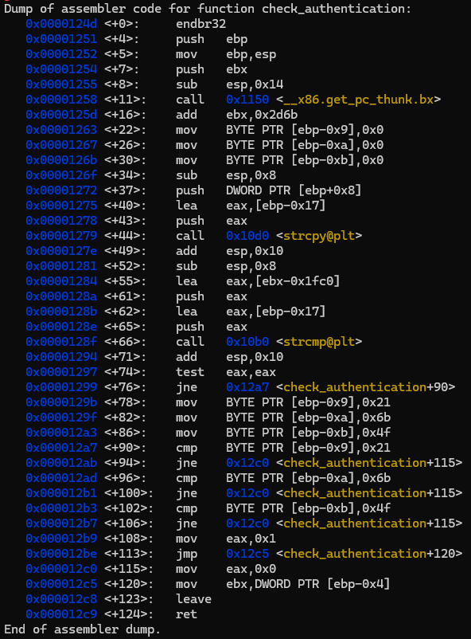
What we can deduct from this code is that instead of using a simple integer for storing auth_flag the function now uses three bytes that are set to a specific value. These are 0x21, 0x6k and 0x4f. If any of these differ then the function returns a false value.
Now to carry out our attack we need to set these 3 bytes to the correct values. For that we need to find the address of the buffer and the authenticating bytes as well. The strcpy function stores its return value in ebp-0x17 and the bytes that are compared are ebp-0x9, ebp-0xa and ebp-0xb. The difference between these addresses are 14, 13 and 12 bytes. Thus, the variables are most likely stored the same way. So, after the twelve padding A characters adding 0x4f 0x6b and 0x21 should result in a break.
Writing this string ("AAAAAAAAAAAA\x4f\x6b\x21") directly as an argument to the doa program results in a segmentation fault. That is why we use solution.txt to store our input and use "$(cat solution.txt)" to copy its values to the input, preventing the segmentation fault. In the text file we can also see that the value of the authenticating bytes is simply “Ok!”.

Stack-based Buffer Overflow

Simple Buffer Overflow
In this task we are creating bash script to be executed and used as argument in the main function of our task, so when executing we move to shell. The point is to add shell code on the starting position of our buffer and then overwriting the return address of function as position of the buffer (which is printed out and same everytime).
The flag: THAT_WAS_EASY_HUH
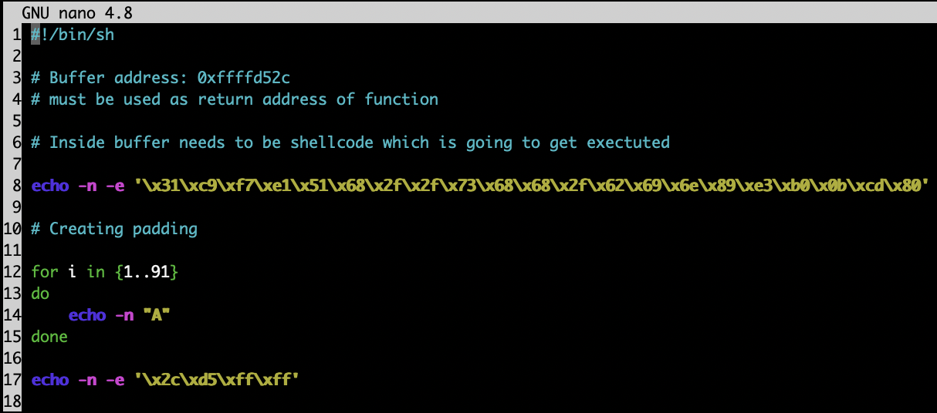

NOP Sliding
In this task we are also creating bash script which also gets us shell. We are not given exact location where we should address the return address of function, so we need to use NOP Sliding method. We fill the buffer with padding, then we find where the data is stored in memory and return our function there. In memory we create NOP Slide using ’\x90’ bytes and after them add shellbash code. The point is to hit any point in memory where the slide is and then bash itself slides down to shellcode.
The flag: THEY_SEE_ME_SLIDIN_THEY_HATIN
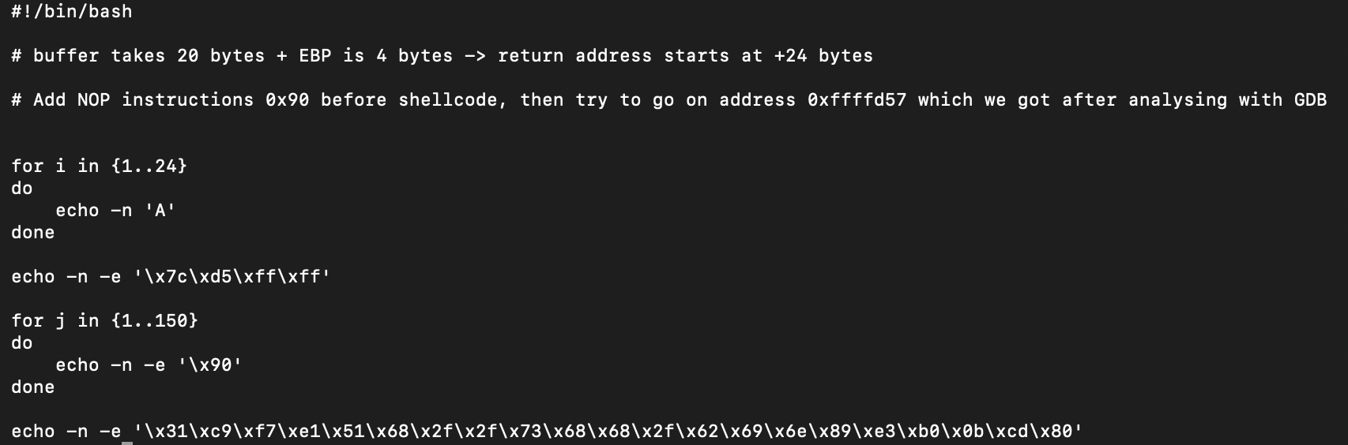

Use of Generative Artificial Intelligence
As a team we didn’t use any Generative A.I. tool in any of the thinking, writing or execution of the parts of this assignment nor documentation.

