Test::Run - a New and Improved Test Harness

Test::Run - a New and Improved Test Harness
- Shlomi Fish
- OSDC::Israel::2006

How it all Started
- I attended a presentation about TestOOB and saw that it provided colours.
- 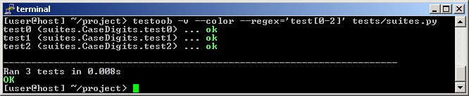
- I decided that I wanted to colour the summary line in Perl.

How Perl Testing Works
- The Perl scripts output the results of the individual tests in the TAP Format:
- Like:
1..N
ok 1 Description # Directive
# Diagnostic
....
ok 47 Description
ok 48 Description
more tests....
- The Test::Harness module runs the scripts and analyzes their TAP instructions, and produces a report.

Hacking Test::Harness
- So we need to change Test::Harness.
- Now where's the summary line?
sub _show_results {
my($tot, $failedtests) = @_;

my $pct;
my $bonusmsg = _bonusmsg($tot);

if (_all_ok($tot)) {
print "All tests successful$bonusmsg.\n"; # <--- here
}
elsif (!$tot->{tests}){
die "FAILED--no tests were run for some reason.\n";
}
elsif (!$tot->{max}) {
my $blurb = $tot->{tests}==1 ? "script" : "scripts";
die "FAILED--$tot->{tests} test $blurb could be run, ".
"alas--no output ever seen\n";
}
else {
$pct = sprintf("%.2f", $tot->{good} / $tot->{tests} * 100);
my $percent_ok = 100*$tot->{ok}/$tot->{max};
my $subpct = sprintf " %d/%d subtests failed, %.2f%% okay.",
$tot->{max} - $tot->{ok}, $tot->{max},
$percent_ok;

my($fmt_top, $fmt) = _create_fmts($failedtests);

# Now write to formats
for my $script (sort keys %$failedtests) {
$Curtest = $failedtests->{$script};
write;
}
if ($tot->{bad}) {
$bonusmsg =~ s/^,\s*//;
print "$bonusmsg.\n" if $bonusmsg;
die "Failed $tot->{bad}/$tot->{tests} test scripts, $pct% okay.".
"$subpct\n";
}
}

printf("Files=%d, Tests=%d, %s\n",
$tot->{files}, $tot->{max}, timestr($tot->{bench}, 'nop'));
}

Problems
- A monolithic function with just one line to change.
- There isn't an object instance for easy inheritance and over-riding.
- A lot of similar issues in the rest of the code.

Solution
- Let's create a better test harness, based on Test::Harness, but more:
  - Modular.
  - Object-oriented.
  - Extensible.

Let's start... coding!
- The code of Test-Harness was forked.
- It was converted to have an object interface.
  - All functions were converted to accept the |$self| object reference as a first argument.
- Large functions were broken into smaller ones.
- Hashes were converted into objects.
- Arguments passed from function to function were converted into object variables.
- Object variables became handled using Class::Accessor accessors.
- Several new classes were created.

Front-end and Back-end
- Test::Run is the back-end that does all the testing.
- Test::Run::CmdLine processes environment variables, and feeds them into Test::Run as constructor arguments.
- Test::Harness accepts several environment variables and package variables as parameters.
  - They were all converted to object variables with accessors in Test::Run.

Plugins
- One can specify plug-ins to Test::Run::CmdLine from the environment variable.
- They in turn can specify plug-ins to the Test::Run back-end.

Back to Colouring...
- Now we can write this plugin:
package Test::Run::Plugin::ColorSummary;

use warnings;
use strict;

use NEXT;
use Term::ANSIColor;

sub _report_success
{
my $self = shift;
print color("bold blue");
$self->NEXT::_report_success();
print color("reset");
}

sub _handle_runtests_error
{
my $self = shift;
my (%args) = @_;
my $error = $args{'error'};

print STDERR color("bold red");
print STDERR $error;
print STDERR color("reset");
# Workaround to make sure color("reset") is accepted and a red cursor
# is not displayed.
print STDERR "\n";
}

1;

Back to Colouring (2)...
- And get:
- 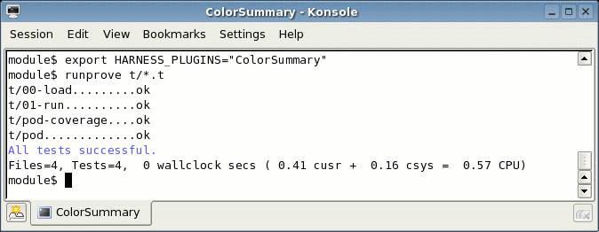

Where to find everthing.
- The most up to date versions of the modules are in the Subversion repository:
- http://svn.berlios.de/svnroot/repos/web-cpan/Test-Harness-NG/trunk/
- Also on CPAN - http://search.cpan.org/search?mode=dist&query=Test%3A%3ARun.

Thank you!

