# Practical part

## 1. Applying features from Viola-Jones article

Our first try was to apply the feature that Viola and Jones obtained from the AdaBoost. We designed the Haar features on 24x24 pixel window like they did in the article.

 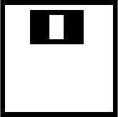

Then we apply them on picture while changing their sizes. The calculated value was stored in the matrix with the position for the top-left corner pixel. We calculated the intensity value of black and white area using integral image. Then substracted the black area from the white one and divided it by number of pixels of both areas. We calculated this value for both haar features and multiplied them so if one is big and another one as well, we get the best position of the face. This is what we obtained.

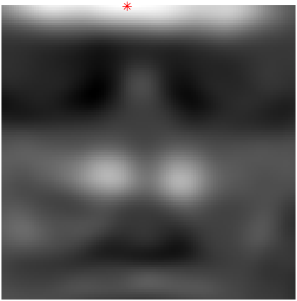 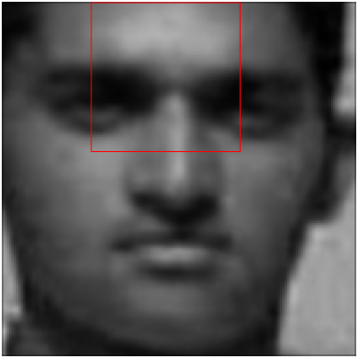

We figured that something is wrong because these haar features are calculating the intesity values, so fo example the first feature is showing us that the black area should be the dark area of the eyes and the white area should be light area of the cheecks. The darker the area of the eyes is, the smaller the intensity value should be. And the lighter the area of the cheeck is, the larger the intensity value is. But in our results we can see, that his forehead is lighter than the eyebrows so the calculated value should not be that white as we can see in (Fig. 3). What our problem was that, we were multiplying the numbers we obtained from both features. If both of the numbers were negative we got false positive values. So we changed the code and created a threshold for both features thats says that everything lower than 0 is 0. This way we obtained these results.

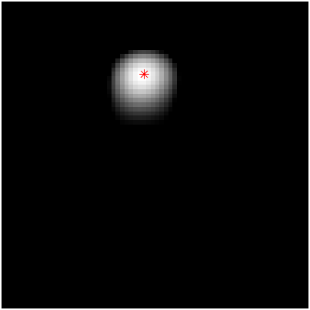 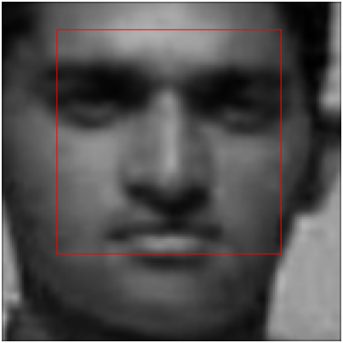

These results finally made sense but were not good enogh. When we tried to apply this to some other images these were the results we obtained.

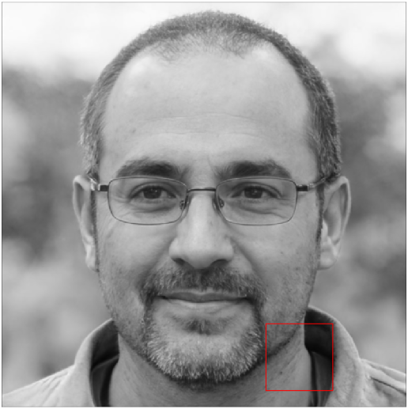 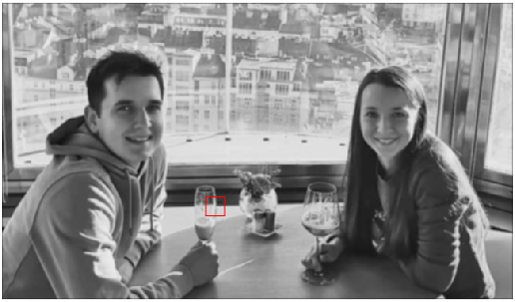 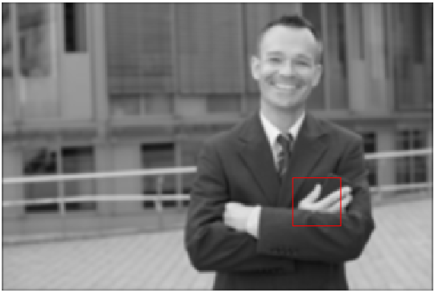

We need to look better at the close images what is happening.

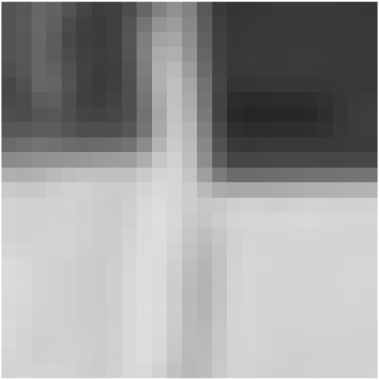 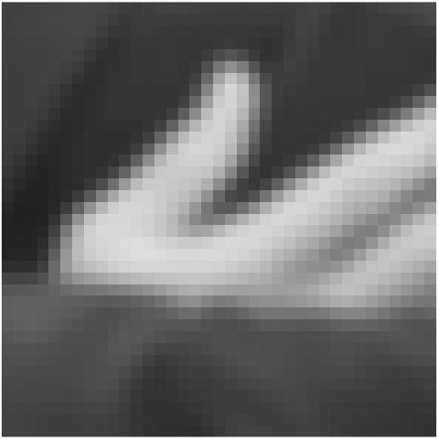 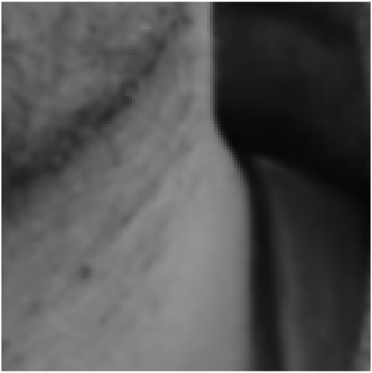

When we look at these croped images they all fullfill our two haar features. They all have upper part darker then lower at the place of our haar feature and also have a light vertical stripe in the middle. We understood that these two features are not enough. We tried to search for other features that should work, and also tried to see what is actually in Viola and Jones cascade detector but we couldn't find anything. So we decided to train our own features.

## Training Haar features

We found database of 19x19 pixel images with more than 2000 examples of face and non-face images. We can show a preview of some pictures from the database.

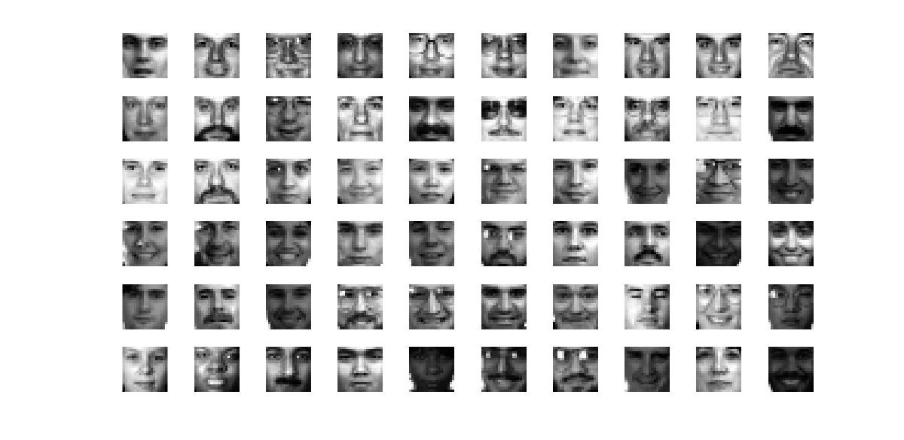

Figure. 1: Face images

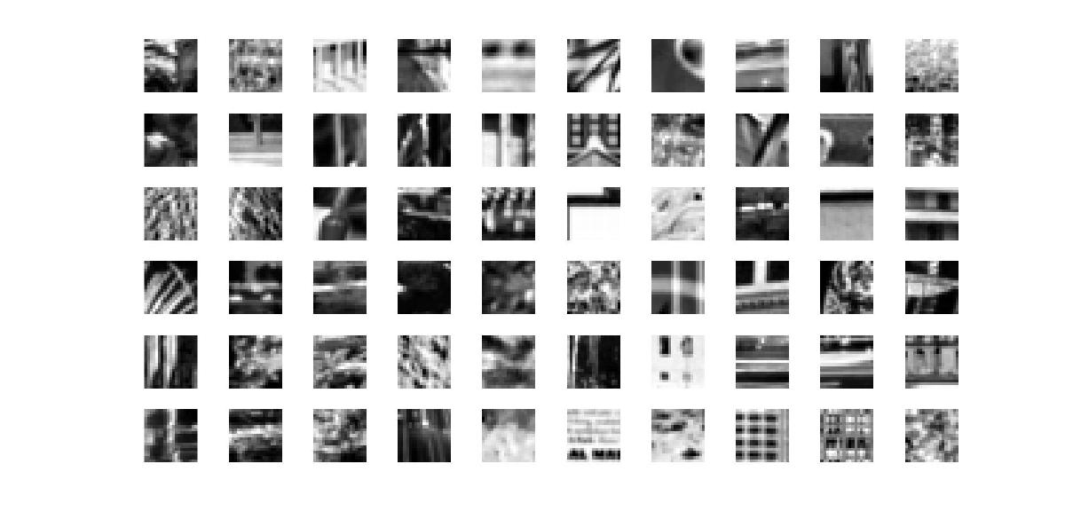

Figure. 2: Non-face images

## Calculating feature values

We created an algorithm that computes feature values for all sizes and 5 different tipes of haar features. This algorithm is written in matlab file *trainHaar.m.* We can explain how it works on the following code.

First we define on how many pictures we want to train our haar features.

% Number of training samples used

faceImages = 300;

nonFaceImages = 300;

Then we load the pictures and save them in separate databases.

fprintf(strcat('\nProcess: ***Training images inicialization***\n'))

% Loading face images

fprintf('Info: Loading face images.\n')

faceIIs = cell(1,faceImages);

for img = 1:faceImages

image_path = ['TrainingFaces\',int2str(img),'.pgm'];

I = imread(image_path);

II = integralImage(I);

faceIIs{img} = II;

end

% Loading non-face images

fprintf('Info: Loading non-face images.\n')

nonfaceIIs = cell(1,nonFaceImages);

for img = 1:nonFaceImages

image_path = ['TrainingNonFaces\',int2str(img),'.pgm'];

I = imread(image_path);

II = integralImage(I);

nonfaceIIs{img} = II;

end

Now we will inicialize our window size which is 19, because our training pictures. For faster but less precise training we can increase *haarSize* which multiplies the size of the haar features.

% We found database with 19x19 pixel size images, it would be better to use

% 24x24 pixel images because of more compatible feature sizes. In our case

% we dont calculate feature value for last row or column of pixels in with

% certain features

window = 19; % Training Image size

haarSize = 1; % Haar feature size multiplier for faster computation

Then we define haar features which are shown on the pictures below. We can also set our *first_size* of the haar feature for faster training because we know that the small 2 pixel haar feature is not gonna be very robust.

% 1 2 3 4 5

haars = haarSize*[1,2; 2,1; 1,3; 3,1; 2,2];

first_size = [3,2; 2,3; 3,3; 3,3; 4,4]; % Small haars are not robust anyways

Types of Haar features

Then we define our variable *count* to count how many features we calculated and initialize our database for features and classifiers.

count = 0; % Feature count

featureDatabase = []; % To store calculated features

classifier = []; % To store Haar type and size

And we start calculating our feature values. For each size of the haar feature we calculate feature value for all face and non-face images so in the end we have number of features for each haar feature size same as the number images we used. We have programed our own function *calcHaarVal* to calculate the value for us. This function takes Integral image, haar type, pixel x and y and size of the haar feature in x and y direction.

% In this for cycle we calculate feature value of all posible sizes and all

% possible locations of haar feature

fprintf(strcat('\nProcess: ***Calculating Haar feature values started***\n'))

for haar = 1:5 % Calculatig features for all haar types

fprintf(strcat('Info: Calculating features for Haar:',int2str(haar),'\n'))

dimX = haars(haar,1);

dimY = haars(haar,2);

fsX = first_size(haar,1);

fsY = first_size(haar,2);

for pixelY = 1:1:window-dimY+1 % +1 because the Inegral image is one dimension bigger

for pixelX = 1:1:window-dimX+1

for haarY = fsY:dimY:window-pixelY+1

for haarX = fsX:dimX:window-pixelX+1

% Counting number of features

count = count+1;

% Calculating Feature value for face images

fvectorF = ones(faceImages,1);

for img = 1:faceImages

fval = calcHaarVal(faceIIs{img}, haar, pixelX, pixelY, haarX, haarY);

fvectorF(img) = fval;

end

% Calculating Feature value for non-face images

fvectorNF = ones(nonFaceImages,1);

for img = 1:nonFaceImages

fval = calcHaarVal(nonfaceIIs{img}, haar, pixelX, pixelY, haarX, haarY);

fvectorNF(img) = fval;

end

% Creating calculated feature vector and database

fvector = [fvectorF;fvectorNF];

featureDatabase(:,count) = fvector;

% Saving Haar parameters for displayment

classifier = [classifier;pixelX,pixelY,haarX,haarY,haar];

end

end

end

end

fprintf(strcat('Info: Number of features for Haar:',int2str(haar),' is :',int2str(count),'\n'))

end

fprintf(strcat('\nProcess: ***Calculating Haar feature values ended***\n'))

Now we have obtained our features and we can start calculating which of the features works the best using AdaBoost.

## AdaBoost

% Initialization of variables

numFValues = faceImages+nonFaceImages; % Number of feature values

initialWeights = ones(numFValues,1)./(numFValues); % Initial weights are all the same

initialWeight = 1/(numFValues); % initial weight value

PvectorWeights = ones(faceImages,2); % Positive vector weights are 1

NvectorWeights = -ones(nonFaceImages,2); % Negative vector weights are -1

topClassifiers = []; % Our database where we save top 10 classifiers from each iteration

We have tried to explain everything in the code using comments and everything should be clear. In short words what our AdaBoost does is, that it takes the calculated feature values, for each size and type of the haar feature it sorts the feature values and calculates the threshold using Gini method where we take number between all of the features and see how it divided our values. Gini method looks at how many false positives and false negatives we have for each threshold and calculates Gini value. The threshold with lowest Gini value can separate the features the best. Then we take that threshold and divide our features with it again. We again calculate our Gini value that we now save. We don't have to do it again but it's clearer if we do. From all the Gini values with best threshold calculated for every size and type of feature we take the lowest again to see which type and size of haar feature could separate positive and negative samples. We store 10 best haar features to our topClassifier database. We take the best one and calculate the error it made.



Then using the formula:

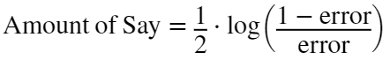

Using this Amount of Say we put create new weights where we put more weight to the wrongly classified features. Then we divide them by the sum of new weights so the sum of them would be one. With these new weights we create a new set of feature values where we put more wrongly inclassified features into the feature value database and we repeat the process. We consider that now we have calculated new feature values and we set the same initial weight as before. This is repeated by the number of iterations we set.

% Number of adaboost iterations

iterations = 50;

for stemps = 1:iterations

fprintf(strcat('Info: Iteration:',int2str(stemps),'\n'))

% For calculated feature values of each haar feature applied on our

% training images we are gonna find the best threshold for each haar

% feature and then calculate the Gini index. Then we find the lowest

% Gini index which represents haar feature that could classifi the

% sample values with least amount of incorrectly classified samples.

for f = 1:size(featureDatabase,2)

fvector = [PvectorWeights;NvectorWeights]; % This vector has 2 columns, second will be the sign

fvector(:,1) = featureDatabase(:,f); % In the fisrt column we put our calculated values

[~, order] = sort(fvector(:,1)); % We get the order in which we should sort them

fsorted = fvector(order,:); % And we sort the calculated values

avg = zeros(size(fsorted,1),1); % Initialize our vector for threshold value

GiniThreshold = zeros(size(fsorted,1)-1,1); % and also vector for Gini value

% Calculating threshold

for t = 1:size(fsorted,1)-1

avg(t) = (fsorted(t,1)+fsorted(t+1,1))/2; % Average between 2 neighbour features

lower = (fsorted(:,1)<avg(t)).*fsorted; % Features lower than calculated avg

higher = (fsorted(:,1)>avg(t)).*fsorted; % Features higher than calculated avg

lowP = length(find(lower(:,2)==1)); % False negative features

lowN = length(find(lower(:,2)==-1)); % True negative features

highP = length(find(higher(:,2)==1)); % True positive features

highN = length(find(higher(:,2)==-1)); % False positive features

GiniThreshold(t) = Gini(lowP,lowN,highP,highN);

end

% We find the lowest Gini value which is the number that

% best separates positive and negative samples

threshold = avg(GiniThreshold==min(GiniThreshold));

if length(threshold)>1;threshold = threshold(1);end

% Separating features using this threshold

lower = (fsorted(:,1)<threshold).*fsorted; % Features lower than calculated avg

higher = (fsorted(:,1)>threshold).*fsorted; % Features higher than calculated avg

lowP = length(find(lower(:,2)==1)); % False negative features

lowN = length(find(lower(:,2)==-1)); % True negative features

highP = length(find(higher(:,2)==1)); % True positive features

highN = length(find(higher(:,2)==-1)); % False positive features

GiniError(f,1) = Gini(lowP,lowN,highP,highN);

GiniError(f,2) = threshold;

end

% Saving 10 best classifiers from each iteration

[~, order] = sort(GiniError(:,1));

topOrder = order(1:10);

topClassifiers = [topClassifiers;classifier(topOrder,:),GiniError(topOrder,2)];

% We don't need to calculate new weights if this is the last iteration

if stemps == iterations

fprintf(strcat('\nProcess: ***Finished Adaboost***\n'))

break

end

% Minimal Gini value or haar feature that has least number of incorrectly

% classified samples

minGiniVal = min(GiniError(:,1));

minGiniPos = find(GiniError(:,1)==minGiniVal); % Position in Database

minGiniPos = minGiniPos(1); % If there is multiple positions of min value

threshold = GiniError(minGiniPos,2); % Taking already calculated threshold

% For better memory we calculate it one again and we don't store all

% calculated values for each feature

fvector = [PvectorWeights;NvectorWeights];

fvector(:,1) = featureDatabase(:,minGiniPos(1)); % features of best classifier

[~, order] = sort(fvector(:,1));

fsorted = fvector(order,:); % sorted features of best classifier

% Separating features using this threshold

lower = (fsorted(:,1)<threshold(1)).*fsorted; % Features lower than calculated avg

higher = (fsorted(:,1)>threshold(1)).*fsorted; % Features higher than calculated avg

lowP = length(find(lower(:,2)==1)); % False negative features

lowN = length(find(lower(:,2)==-1)); % True negative features

highP = length(find(higher(:,2)==1)); % True positive features

highN = length(find(higher(:,2)==-1)); % False positive features

% Positions of incorrectly classified samples

incorrectPos = [find(lower(:,2)==1);find(higher(:,2)==-1)];

% Calculating Amount of Say for each weight

error = initialWeight*(lowP+highN);

if error==1; error=1.01; end

AoS = 0.5*log((1-error)/error); % Amount of Say

% Weight multiplier

multiplier = ones(faceImages+nonFaceImages,1);

multiplier(:,1) = exp(-AoS);

multiplier(incorrectPos,1) = exp(AoS);

% New weights

neweights = initialWeights.*multiplier;

neweights = neweights/sum(neweights);

% Creating new collection of stamples

cum = cumsum(neweights);

newOrder = ones(numFValues,1);

for w = 1:numFValues

between = 0;

rnd = rand;

wn = 1;

while between == 0

if rnd<cum(wn)

between = 1;

newOrder(w) = wn;

else

wn = wn+1;

end

end

end

featureDatabase = featureDatabase(newOrder,:);

end

In the end we save our top classifiers so we can work with them.

save topClassifiers topClassifiers

## Obtained Haar features

These are the results we obtained when using 300 face images and 300 non-face images with 50 adaboost iterations. We display best haar feature from each iteration with their threshold on top.

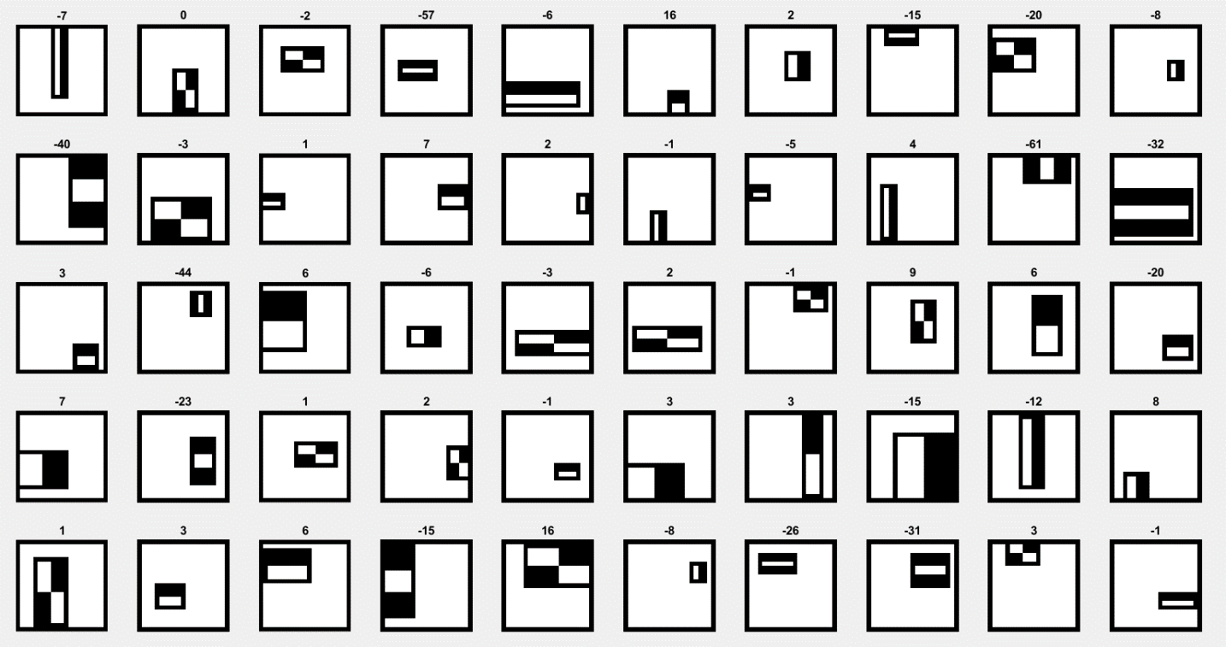We can see that some of the features we obtained are similar to the ones Viola and Jones obtained in their article. The results are dependent on the training images as well as how the new features are created in AdaBoost. Now we can try to apply some of the features we got to create our own cascade and detect images.

## Face Detection

To apply face detection we created new matlab file called *detectFaces.* In this matlab script we have written an algorithm that slides the haar feature window over every possible area and resizes it to the maximum size as well. When we apply our window, we call our cascade function which calculates the values of applied haar features and gives us 0 when it did not detect a face and some value when its possible that we have found the face.

% Loading our image database

images = 20;

fprintf('Process: Loading images.\n\n')

% Initializing databases

Is = cell(1,images);

IIs = cell(1,images);

for img = 1:images

image_path = ['images\',int2str(img),'.jpg'];

I = imread(image_path);

Ig = im2gray(I);

% Filtering image

gaussian = fspecial('gaussian',5,1);

Ig = imfilter(Ig,gaussian);

% Creating image database

Is{img} = Ig; % Gray scale images

II = integralImage(Ig); % Calculating Integral image

IIs{img} = II; % Integral images

end

% Initial size of the haar feature

start_haar = 24;

haarSize = 1;

% Initializing croped faces database

crop = {};

%

% Detection for all images in database

fprintf(strcat('Process: Starting with detection\n'))

for img = 1:images

fprintf(strcat('Info: Detecting faces on image:',int2str(img),'\n'))

I_features = {}; % We create a new DB for features for every img

[row,col] = size(Is{img}); % Size of the image

maxsize = floor(min([row/24,col/24])); % Max size for haar feature

hsize = 0; % We initialize haar size

window = []; % window is our haar feature size

for haarSize = 1:0.5:maxsize % Every iteration we make window larger by 0.5

hsize = hsize+1; % Counting window changes

window(hsize) = floor(haarSize*start_haar); % Changing window size

% Initialize matrix for calculated haar values

fval = zeros(row-window(hsize)+1,col-window(hsize)+1);

for i = 1:row-window(hsize)+1 % +1 pixel because we

for j = 1:col-window(hsize)+1 % substracted it

fval(i,j) = ourCascade(IIs{img}, haarSize, i, j);

end

end

% Saving feature matrix for each size of the haar feature

I_features{hsize} = fval;

end

% Finding the best macth

bestmatch = []; % Inicialization

% For every size of the feature we find the highest value

for f=1:length(I_features)

bestmatch(f) = max(max(I_features{f})); % Save the highest value

if bestmatch(f)==0 % if there is no match

i(f)=0; % We set the coordinates to 0 just to fill matrix

j(f)=0;

else % We save the original coordinates of the highest value

[i(f),j(f)] = find(I_features{f}==bestmatch(f));

end

end

% Finding the best from all sizes of the window

best = max(bestmatch);

p = find(bestmatch==best);

p = p(1); % if there is multiple best findings

% Croping the detected window from the image if we find the face

if i(p)==0 && j(p)==0

fprintf(strcat('Info: Could not find a face in image:',int2str(img),'\n'))

else

crop = imcrop(Is{img},[j(p),i(p),window(p),window(p)]);

Filename = sprintf('crop%d.jpg',img);

save(['C:\1. Škola\1.semester(ERASMUS)\CV\Short_project\MyDetector\cropedFaces\' Filename],"crop")

% Plotting results with map, image with bounding box and croped image

% figure

% subplot(2,2,1), imshow(I_features{p},[]), hold on

% subplot(2,2,1), plot(j(p),i(p),'r*'), hold off

% subplot(2,2,3), imshow(Is{img})

% subplot(2,2,3), rectangle('Position',[j(p),i(p),window(p),window(p)],'EdgeColor','r')

% subplot(2,2,4), imshow(crop)

% Plotting only image and bounding box

% subplot(1,3,img), imshow(Is{img})

% subplot(1,3,img), rectangle('Position',[j(p),i(p),window(p),window(p)],'EdgeColor','r')

% Plotting all croped images

subplot(1,3,img), imshow(crop)

end

end