Delve PCG

End-of-Year Project – Desktop Assistant & Cloud Sync System
Tartalom
Purpose of the Project 2
Developed by 2
Development Timeline 2
Software Used 3
Desktop Application: 3
Website: 3
External Sources 3
Music: 3
SFX: 3
Art: 3
Website Template: 3
How to Use 3
Frontend Overview 3
Backend Overview 4
Desktop Aplication 5
Main Menu: 5
Load Game: 5
Navigation 5
Gameplay 6
Phases 6
Help 8
Units: 9
Rooms 10

Purpose of the Project
This project digitizes a traditional pen & paper role-playing game. It consists of two main components:

- Desktop Application – Built with the Godot engine, it serves as an assistant for managing characters, tracking game progress, and saving locally.
- Website – Accessible at https://www.temesiszabolcsistvan.hu where users can:
- Register, log in, and reset their passwords
- Download the latest or earlier versions of the desktop app
- Save game progress to the cloud and manage it online

The goal is to provide an integrated platform combining local gameplay and secure cloud access.

Developed by
This project was made by:
- Temesi Szabolcs István – Project Lead, Desktop Application Developer, Database Developer
- Szabó Levente – Front- and Backend Developer, Database Developer

Development Timeline
- Desktop Application:
  - Start: 2024-09-07
  - End: 2025-05-04
- Website:
  - Start: *2024-10-09*
  - End: *2025-05-04*

Software Used

Desktop Application:
- Godot Engine
- Audacity
- Aseprite

Website:
- Visual Studio Code
- XAMPP
- paint.net
- ChatGPT

External Sources

Music:
- Soundimage.org
- Scottbuckley.com

SFX:
- Pixabay.com

Art:
- External artist: @marceles

Website Template:
- ThemeWagon

How to Use
- Go to https://www.temesiszabolcsistvan.hu
- Register or log in
- Download the zip file
- Unzip, launch the game and enjoy!

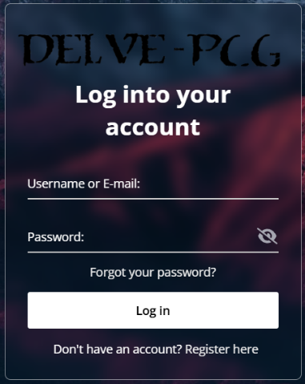
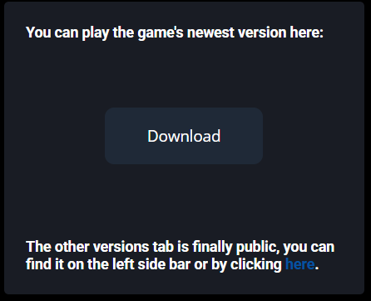
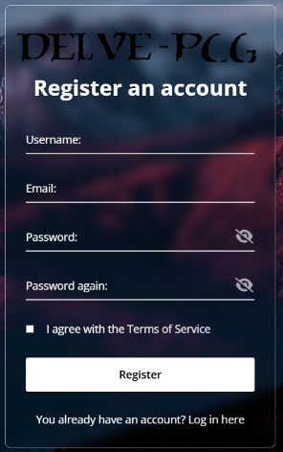
Frontend Overview
The frontend is the client-side interface of the web platform, responsible for rendering pages and collecting input. Features include:
- User Registration, Login, Password Reset
- Dashboard Page: Shows the latest available version of the desktop application
- Download Page: Access to previous releases
- General Account Info Section: Displays:
  - Email Address
  - Membership Start Date
  - Longest Playtime
  - Deactivation Status
- Links to Terms of Service and Privacy Policy: Available during registration (TOS and linked PP) and within the user interface
- Settings Section: Allows users to change username, modify password, and deactivate their account
Technologies: HTML, CSS, JavaScript

Backend Overview
The backend manages all server-side functionality, including user authentication, file distribution, and communication with the database.
- Language/Platform: Primarily written in PHP
- Security: Handles credential encryption, session management, and database validation
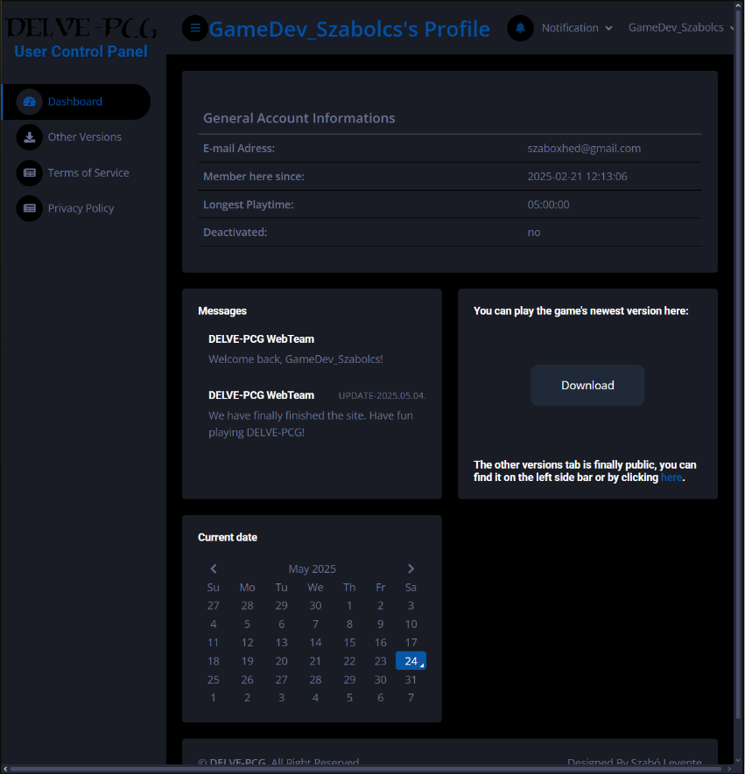
- API Service: A backend API developed using Google Cloud Services, responsible for handling data exchange between the desktop application and the database.

Desktop Aplication

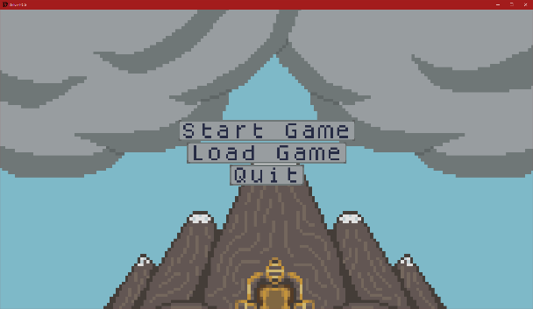
Main Menu:
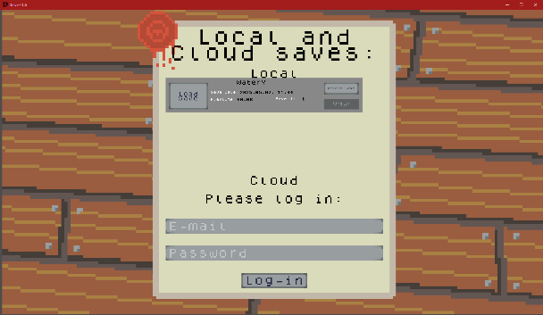
The Main Menu is the initial screen presented upon launching the game. It features three primary options for the player: Start Game, which begins a new session; Load Game, allowing players to continue from a previously saved state; and Quit, which exits the application.

Load Game:
Accessible through the Main Menu, the Load Game screen presents a list of available local save files for easy selection. Additionally, if the player is logged into their account, they gain access to manage up to three cloud save slots, enabling seamless synchronization and backup of their progress across multiple devices. Players can perform standard save file operations such as deleting local saves directly from the Load Game screen. Additionally, when logged into their account, players have the added functionality to upload and download save files to and from the cloud at any time, providing greater flexibility and ensuring their progress is securely backed up.
Navigation:
Standard navigation controls, such as close buttons (×) and directional arrows, are available throughout the interface for intuitive movement. For quick access back to the Main Menu, players can hold the Escape key for several seconds. Once the screen fades to black, the game will transition back to the Main Menu. The duration required to hold Escape varies between screens to minimize accidental exits, ensuring a smoother user experience.

Gameplay
The desktop application is a grid-based, base-building game that allows players to explore at their own pace in search of a legendary artifact known as the Void Crystal. Gameplay is structured into rounds, each consisting of several distinct phases that guide player progression and decision-making. These phases are: Exploration, Combat, Trade, Build, and Recruitment.
Phases
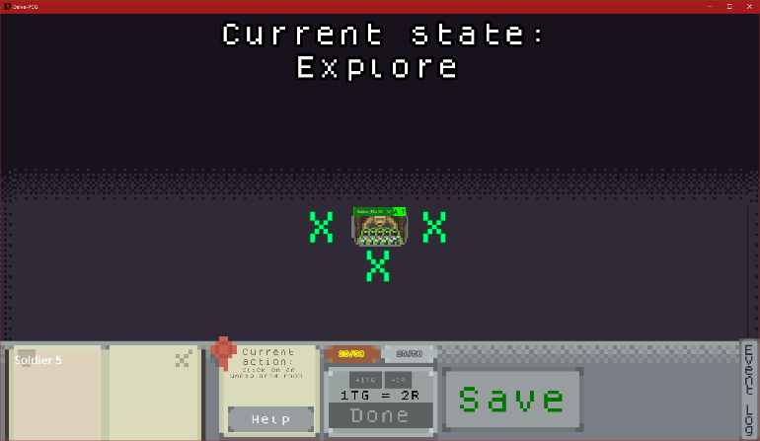
- Exploration Phase: During the Exploration Phase, the player selects and reveals a new room that is adjacent to one previously discovered. Each newly uncovered room may contain a variety of elements—some beneficial, such as resources or opportunities, and others potentially hazardous, such as hostile entities. Strategic exploration is critical, as the layout and contents of the grid are procedurally generated, adding an element of unpredictability to every session.
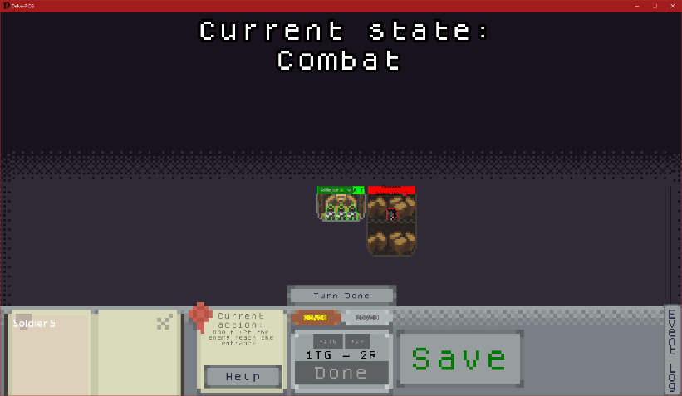
- Combat Phase: The Combat Phase is triggered when a newly revealed room contains hostile entities. Combat is turn-based, with the player and enemy units taking alternating actions. Units can move, attack, or use special abilities depending on their type and position. The objective is to eliminate all hostile forces before they reach the Entrance. Should any enemy unit breach this location, the game results in an immediate loss, emphasizing the importance of tactical foresight and defense.
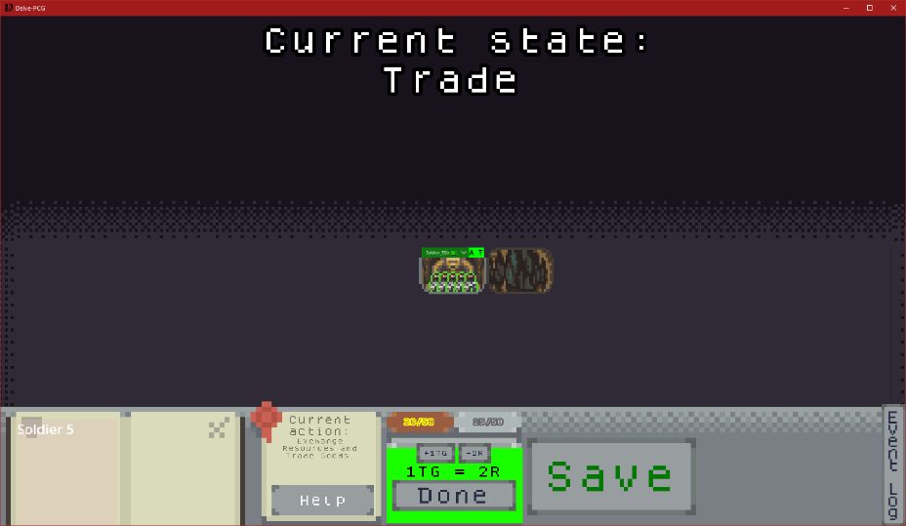
- Trade Phase: In the Trade Phase, players may exchange accumulated Trade Goods for essential Resources and vice versa. This provides flexibility in resource management, allowing players to adapt to the evolving needs of their base and strategy. The interface clearly displays the quantity of items being traded, ensuring transparency and informed decision-making during transactions.
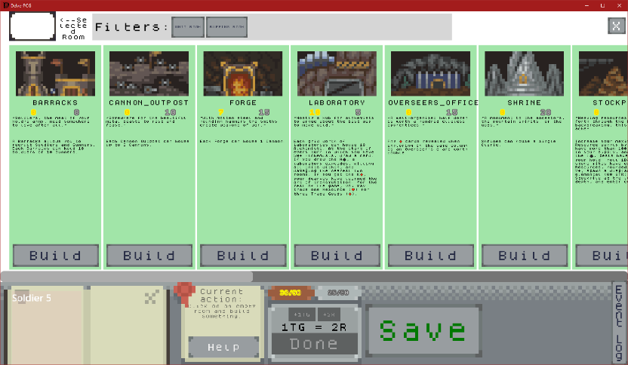
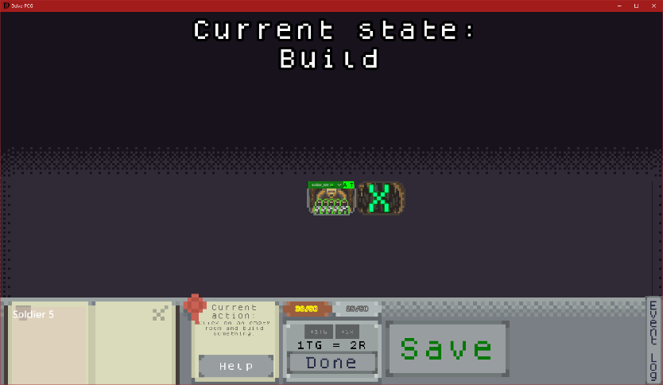
- Build Phase: The Build Phase enables the player to expand their base by constructing new rooms within previously explored areas. Room construction plays a key role in shaping the overall functionality and efficiency of the base, offering benefits such as enhanced resource production, defensive structures, or access to specialized units.
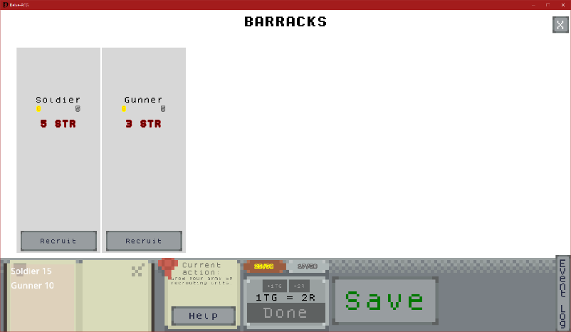
- Recruitment Phase: In the Recruitment Phase, the player can enlist new units from eligible rooms. By selecting a room capable of recruiting, players are presented with available unit types and can choose the desired option to bolster their forces. Recruiting strategically is essential for maintaining a balanced and capable team, especially as exploration reveals increasingly difficult challenges.
Help
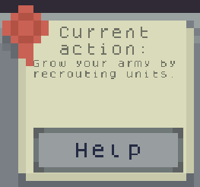
If a player is uncertain about what actions to take during a given phase, they can click the Help button for assistance. Activating this feature will momentarily highlight all interactive rooms or buttons that are relevant to the current phase, making it easier for players to identify their available options. Additionally, a brief description of the current phase is displayed above the Help button, providing a quick summary of the objectives and possible actions to guide the player's decision-making.
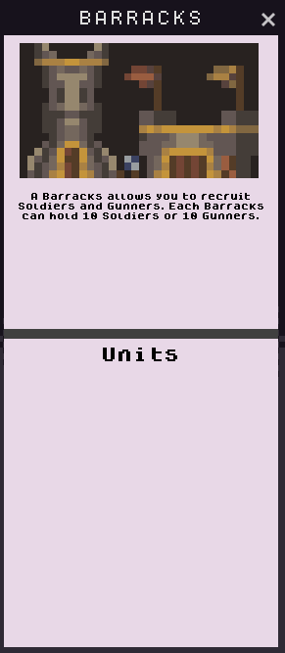
In addition to manual access, the Help feature is automatically triggered at the start of each new phase. This ensures that players are consistently guided through gameplay, with relevant rooms and actions briefly highlighted to match the current phase’s objectives—enhancing clarity and reducing confusion during transitions.
If a player is unsure about the purpose or function of a specific room, they can simply right-click on it to access detailed information. This action will open a popup window containing a concise overview of the room's properties allowing players to make more informed strategic decisions without interrupting gameplay.

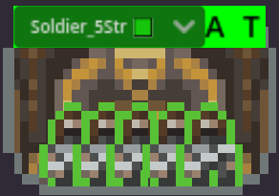
Units:
Status:


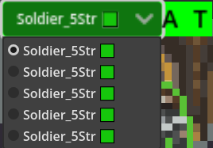
Players can quickly assess the presence and alignment of units within a room by observing the colored bar displayed at the top of the room. A green bar indicates friendly units, yellow signifies neutral entities, and red represents hostile forces. If multiple units occupy the same room, players can expand a detailed list to view all occupants, providing clear and immediate insight into the room’s status at a glance. Each unit is accompanied by a small colored rectangle that indicates its movement status during the current combat turn. A green rectangle signifies that the unit has not yet moved, while a red rectangle shows that it has already taken its movement action. Outside of combat, this indicator always appears green, as movement is unrestricted during non-combat phases.
Movement:
Friendly units can be moved using two dedicated buttons: the A button (All) moves all units from the current room to the selected room, while the T button (This) moves only the topmost unit in the room's unit list. If there is only one unit present, both buttons perform the same action. During combat, movement is limited—each unit that has not yet moved in the current combat round may only move to directly adjacent rooms, emphasizing tactical positioning and turn-based strategy.
Getting more units:
As previously mentioned, units can be recruited from designated rooms. Each room type is limited to recruiting specific unit types associated with it. Recruitment actions can only be performed during the designated Recruitment Phase, ensuring structured gameplay and encouraging strategic planning around unit acquisition.

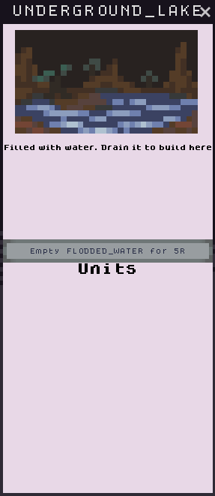
Rooms:
Statuses:
Rooms may be affected by various environmental conditions, such as being flooded with gas or lava. These status effects prevent construction within the affected room until they are cleared. To remove a status, players can right-click on the room and select the "Empty Room" option, which consumes a specified number of resources.
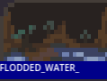

Building:
As previously mentioned, new rooms can be constructed during the Build Phase using the Build Menu. To access this menu, the player must left-click on an unoccupied, explored room during the Build Phase. Only one room may be constructed per Build Phase, so careful planning and prioritization are key to effective base development.
Unit maximum with rooms:
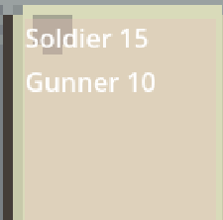
Certain rooms increase the maximum capacity for each unit type. The current capacity limits are displayed prominently in the bottom-left corner of the screen.

Website:
Registering and logging in:
If you go to https://www.temesiszabolcsistvan.hu/ you will be on the main page where you can do two things:
- If you don't have an account then, you can register an account for yourself, which will create a new user in the database linked with the website.
- If you do already have an account, you can login to that account by clicking the “Log in here” part down below the Register button.
If you clicked on “Log in here” out of curiosity, and you don't actually have an account, you can click the “Register here” part down below the Log in button. This will take you back to the previous site.

Errors:
If you don't meet the registering criterias, you will always going to get helpful error messages, trying to point at what could be the problem. Like password length error, not valid (trashmail) email address, email address already taken, username already taken, username length error or you did not agree to the Terms of Service.
The same can be said on the login site. Problems like not valid or mistyped username, mistyped password, invalid username and password combination, or that your account is deactivated.
If your account is deactivated, you cannot login into that account, as well as not being able to reset your password from which I will talk about soon as well.
Password recovery:
If you forgot your password but know the email address used to register an account, then you can head over to the "Forgot your password?" site by clicking that link, which will take you to the recovery site.
Here you can enter the email used to register your account. After that, if your email is valid, and can be found in the database, as well as not been deactivated, an email will be sent to that email address. By clicking the link found in your email address, you can securely change your password to something else. This time you will also need to follow the criterias around what does your password can or can contain, and how long can, or does it need to be.


User Control Panel:
After logging in you will see the User Control Panel, here you will see a variety of things:
First of all, you will see a sidebar containing the following:
- Dashboard
- Other Versions (of the DELVE-PCG)
- Terms of Service
- Privacy Policy

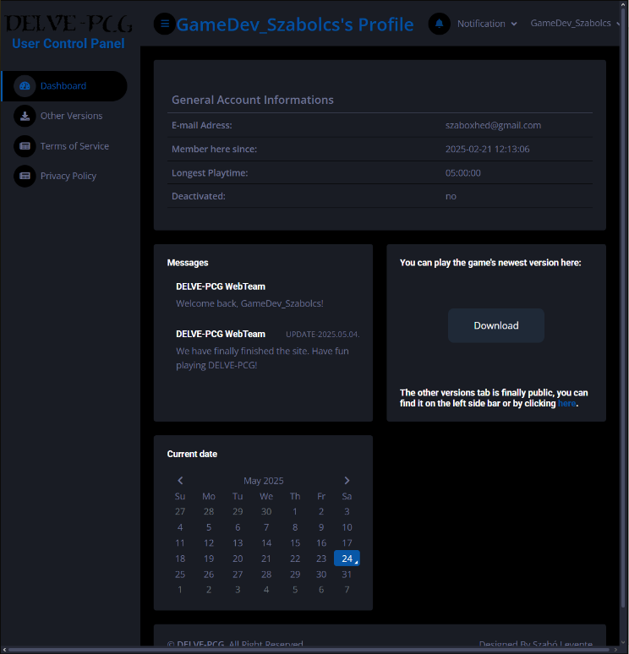
Dashboard:
On the top of Dashboard and Other Versions you will see your username, as well as [username]'s Profile. As well as a notifications bar. Next to that is a My profile dropdown menu, where you can log out and a settings option. You can also see some General Account Informations, some messages, a calendar with the current day, but the most important is what is in the middle. You can always download the latest version of the game by clicking the Download button.
Clicking on the blue "here" word below the Download button or by clicking the Other Versions site on the sidebar, you can access some older versions of the desktop game.
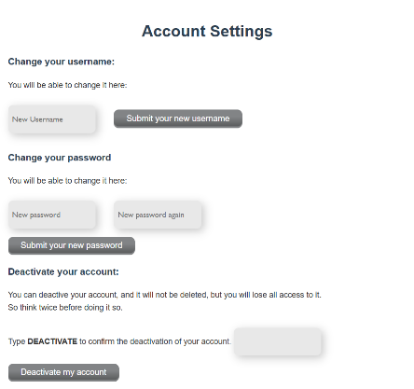
Settings:
You will get some account modification options like username change, password change, and account deactivation. When changing the username or the password you will also need to follow the criterias around what does your password can or can contain, and how long can, or does it need to be as well as your username's length and what does it can or can't contain.
Approach the account deactivation part with much caution, because once you deactivate your account you will need outside assistance from the support. Yes, we can reactivate your account, but only from the database. After typing DEACTIVATE in the input field and pressing the "Deactivate my account" button, you will instantly get logged out as well as a random password change will happen.
Additional Info:
In additions to all of this, all of the sites are responsive. Also, the Register, the Login and the UCP site does contain a size filter, which checks your device's screen size. For example, using a mobile device will end in that warning showing and blocking you from further activity on the site.

