Computer architecture

# Exercises for the laboratory

1. Build the truth table and design a digital circuit for the function:
   1. f(x,y) = (x ∩ ~y) ∪ ~(~y ∪ ~x)
   2. f(x,y,z) = ~(~x ∪ z) ∪ (x ∩ ~y) ∪ (z ∩ x)
   3. f(x,y,z) = x ∩ ~(~x ∪ z) ∩ (~y ∪ ~z)
   4. f(x,y,z) = ~z ∪ ~(z ∩ ~x ∩ (y ∪ ~z))
2. Write the function formula and build the truth table for the following digital circuit:

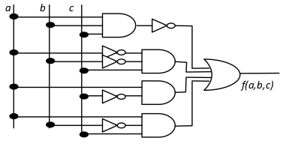

1. Construct 4-bit Gray code with the use of a table.
2. Construct a digital circuit for transcoding binary to 4-bit Gray code.
3. Construct a full adder.

# Homework

1. Build the truth table and design a digital circuit for the function (**2 pkt**):
   1. f(x,y) = (~x ∪ ~y) ∩ ~(y ∪ ~x)
   2. f(x,y,z) = ~z ∪ (x ∩ y ∩ ~z)
   3. f(x) = ~x ∩ x
   4. f(x,y,z) = x ∪ y ∪ (~x ∩ ~z)
2. Construct a full subtractor circuit (**2 pkt**).
3. Write the function formula and build the truth table for the following digital circuit (**1 pkt**):

