Documents and spreadsheets

# Exercises for the laboratory

1. In the MS Word editor write the text from the file TekstMat.pdf (including the formulas).
2. Computer science students have to pass 3 mathematical and 4 computer science courses. If their total average exceeds 4.0, the student receives 1000PLN of scholarship. If the average is between 3.8 and 4.0 and the average from computer science courses is above 4.2, the student receives 500PLN of scholarship. Create a spreadsheet with at least ten students. Prepare a formula for calculating the scholarship.
3. Plot the following functions in a spreadsheet chart:
   1. f(x) = 5x – 6 in <-5, 5>, step 0.2
   2. f(x) = 3x3+ 2x2+ x – 10 in <-5, 5>, step 0.2
   3. f(x) = sin(x) + 2cos(x) in <-2π, 2π>, step 0.1

# Homework

1. Write the following expressions in equation editor: **(2 pkt)**
   1. 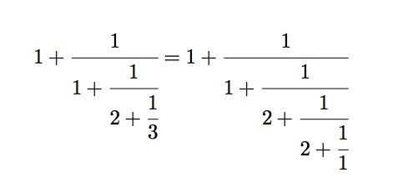
   2. 
   3. 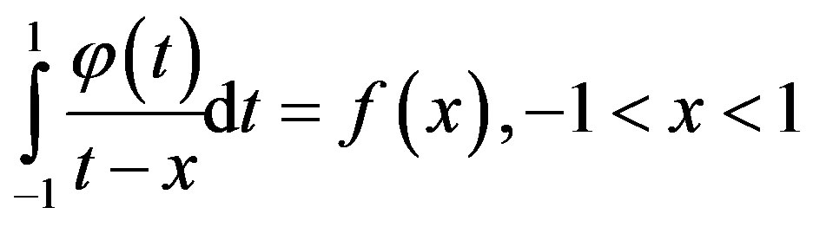
2. Plot the following functions in a spreadsheet: **(2 pkt)**
   1. f(x) = 3x + 4 in <-5, 5>, step 0.2
   2. f(x) = x3– 2x2+4x – 4 in <-5, 5>, step 0.2
   3. f(x) = 2sin(x) + cos(x) in <-2π, 2π>, step 0.1