Pillows 4 Paws

**Company Profile**

T

he leader in the pet bed industry, Pillows 4 Paws is committed to providing the best quality dog and cat pillows in the industry. Not only are our pillows comfortable and attractive for pets of all sizes, they are hypoallergenic and guaranteed to last for many years. At Pillows 4 Paws, lots of love goes into everything we do, so sleepy cats and dogs everywhere can have sweet dreams every night.

Our History

Pillows 4 Paws was founded over ten years ago by two sisters, Carole and Pat Anderson. Fed up with dog and cat beds that fell apart after a few washings, Carole and Pat made new beds for their own dogs, Maddy and Hannah. They used the sturdiest materials they could find for the pillow covers, and stuffed them with hypoallergenic material made especially for sensitive snouts. They ended up with the best pet beds they’d ever seen, either in a store or in a catalog. They began giving the beds as gifts for their pet-loving friends, and soon the demand was so high that they were able to concentrate on Pillows 4 Paws full time.

Our Product

Today, Pillows 4 Paws has over 50 employees and occupies office space and a warehouse in Grand Rapids, Michigan. Our company makes a variety of cat and dog beds in different patterns and sizes. No matter what style or size you choose, all of our pillows have the same basic materials as the originals made by Pat and Carole. Each pillow is hand-stitched by our experts and thoroughly tested for quality and comfort before finally receiving the Pillows 4 Paws seal of approval. We also wash every pillow once before shipping it to make sure that it stands up to real-world conditions. That way, the first time your pooch or kitty curls up on his or her new bed, you can be sure that the pillow will already be soft and cozy – perfect for a catnap or a long snooze! Even though Pillows 4 Paws gets hundreds of orders every week from all over the globe, we still commit to the same homespun quality in every pillow we make, so you and your furry friends can rest assured!

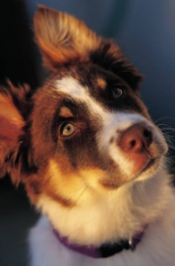Customer Testimonials

“We’ve had our Pillow for over five years. It’s Buster’s favorite place in the house!”

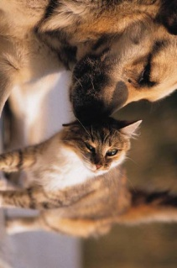“Lola and Otis curl up on their Pillow and sleep together. They look so cozy and cute.”

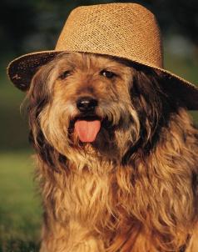

“Last summer, we took Buddy on a camping trip with us, but forgot to bring his Pillow. He whined every night. Finally, we had to send for it!”

Our Pillows

Check below for a sampling of our pillows and prices. Orders of more than $50.00 get free shipping, too!

Join Pillows 4 Paws

Having trouble balancing work and family? At Pillows 4 Paws, we are advocates of alternative employment options for parents and other busy people. That’s why we created Pillows 4 Paws In House.

When you become a Pillows 4 Paws consultant, you can sell our quality pillows from your living room.

You’ll have fun and catch up with your pals. You can even invite some furry friends to try out the Pillows for themselves!

As a Pillows 4 Paws consultant, you can:

* Add to your existing income.
* Make Pillow Parties your full time job.
* Set your own hours.
* Be your own boss.

See below for the average sales of a Pillow Party in different regions of the country.

If you’re interested in becoming a Pillows 4 Paws consultant, please go to our website at [www.pillows4paws.com](http://www.pillows4paws.com)